SECURITIES AND EXCHANGE COMMISSION

Washington, D.C. 20549

FORM T-1

STATEMENT OF ELIGIBILITY UNDER

THE TRUST INDENTURE ACT OF 1939 OF A

CORPORATION DESIGNATED TO ACT AS TRUSTEE

Check if an Application to Determine Eligibility of

a Trustee Pursuant to Section 305(b)(2) [X]

U.S. BANK NATIONAL ASSOCIATION

(Exact name of Trustee as specified in its charter)

 | 31-0841368
 | I.R.S. Employer Identification No.
800 Nicollet Mall
Minneapolis, Minnesota | 55402
(Address of principal executive offices) |  |  | (Zip Code)

Wally Jones

U.S. Bank National Association

333 Commerce Street, Suite 800

Nashville, TN 37201

(615) 251-0733

(Name, address and telephone number of agent for service)

Harrow Health, Inc.

(Issuer with respect to the Securities)

Delaware |  |  | 45-0567010
(State or other jurisdiction of incorporation or organization) |  |  | (I.R.S. Employer Identification No.)
102 Woodmont Blvd., Suite 610
Nashville, Tennessee |  |  | 37215
(Address of Principal Executive Offices) |  |  | (Zip Code)
8.625% Senior Notes due 2026
(Title of the Indenture Securities)

FORM T-1

Item 1. GENERAL INFORMATION. Furnish the following information as to the Trustee.

- Name and address of each examining or supervising authority to which it is subject.

- Whether it is authorized to exercise corporate trust powers.

Item 2. AFFILIATIONS WITH THE OBLIGOR. If the obligor is an affiliate of the Trustee, describe each such affiliation. None

Items 3-15 Items 3-15 are not applicable because to the best of the Trustee’s knowledge, the obligor is not in default under any Indenture for which the Trustee acts as Trustee.

Item 16. LIST OF EXHIBITS: List below all exhibits filed as a part of this statement of eligibility and qualification.

  - A copy of the Articles of Association of the Trustee.*

  - A copy of the certificate of authority of the Trustee to commence business, attached as Exhibit 2.

  - A copy of the certificate of authority of the Trustee to exercise corporate trust powers, attached as Exhibit 3.

  - A copy of the existing bylaws of the Trustee.**

  - A copy of each Indenture referred to in Item 4. Not applicable.

  - The consent of the Trustee required by Section 321(b) of the Trust Indenture Act of 1939, attached as Exhibit 6.

  - Report of Condition of the Trustee as of December 31, 2020 published pursuant to law or the requirements of its supervising or examining authority, attached as Exhibit 7.

* Incorporated by reference to Exhibit 25.1 to Amendment No. 2 to registration statement on S-4, Registration Number 333-128217 filed on November 15, 2005.

- Incorporated by reference to Exhibit 25.1 to registration statement on form S-3ASR, Registration Number 333-199863 filed on November 5, 2014.

2

SIGNATURE

Pursuant to the requirements of the Trust Indenture Act of 1939, as amended, the Trustee, U.S. BANK NATIONAL ASSOCIATION, a national banking association organized and existing under the laws of the United States of America, has duly caused this statement of eligibility and qualification to be signed on its behalf by the undersigned, thereunto duly authorized, all in the City of Nashville, State of Tennesee on the 12th of April, 2021.

By: /s/ Wally Jones

Wally Jones

Vice President

3

Exhibit 2
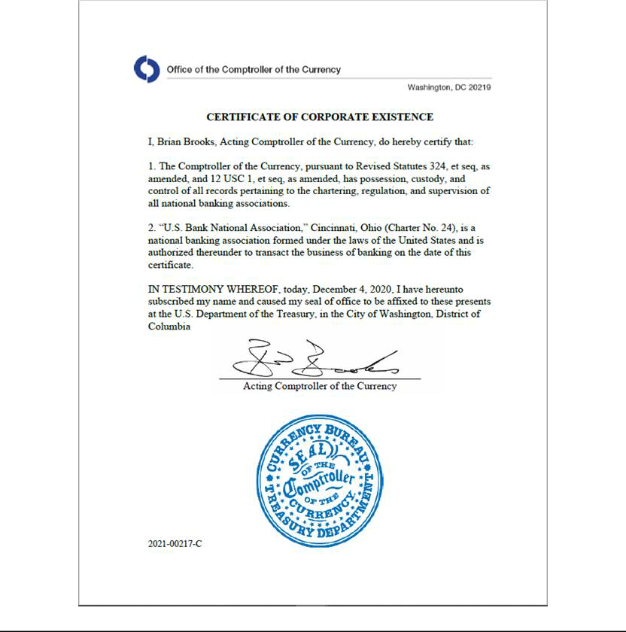

Exhibit 3
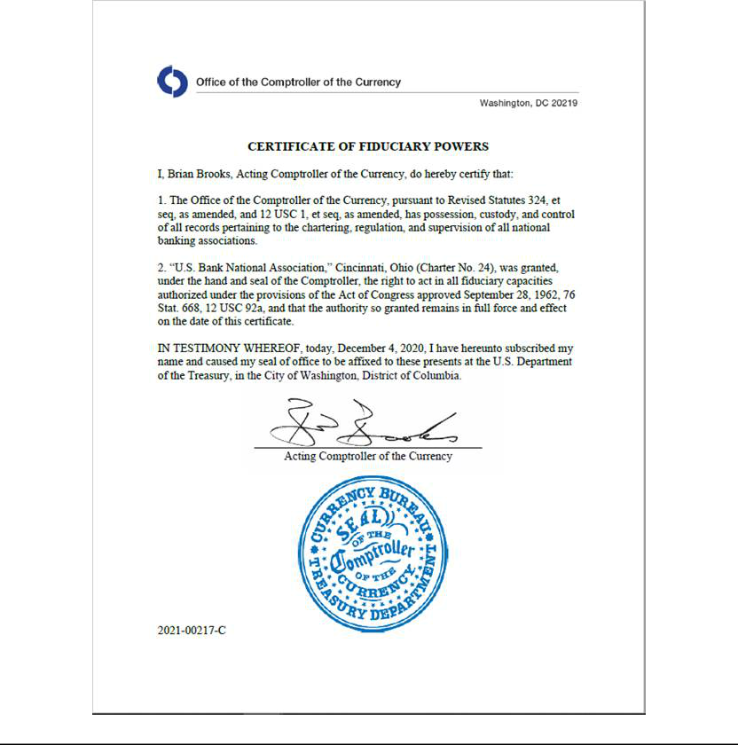

Exhibit 6

CONSENT

In accordance with Section 321(b) of the Trust Indenture Act of 1939, the undersigned, U.S. BANK NATIONAL ASSOCIATION hereby consents that reports of examination of the undersigned by Federal, State, Territorial or District authorities may be furnished by such authorities to the Securities and Exchange Commission upon its request therefor.

Dated: April 12, 2021

By: /s/ Wally Jones

Wally Jones

Vice President

 |  | Exhibit 7
 | U.S. Bank National Association
 | Statement of Financial Condition
 | As of 12/31/2020
 |  | ($000’s)
 |  |  |  |  | 12/31/2020
Assets
Cash and Balances Due From | $ |  |  |  | 62,424,852
Depository Institutions
Securities |  |  |  |  | 135,372,305
Federal Funds |  |  |  |  | 149
Loans & Lease Financing Receivables |  |  |  |  | 299,153,643
Fixed Assets |  |  |  |  | 7,454,095
Intangible Assets |  |  |  |  | 12,786,750
Other Assets |  |  |  |  | 27,582,366
Total Assets |  |  |  | $ | 544,774,160
Liabilities
Deposits | $ |  |  |  | 442,835,836
Fed Funds |  |  |  |  | 1,175,229
Treasury Demand Notes |  |  |  |  | 0
Trading Liabilities |  |  |  |  | 1,036,903
Other Borrowed Money |  |  |  |  | 27,992,840
Acceptances |  |  |  |  | 0
Subordinated Notes and Debentures |  |  |  |  | 3,850,000
Other Liabilities |  |  |  |  | 14,494,315
Total Liabilities |  |  |  | $ | 491,385,123
Equity
Common and Preferred Stock |  |  |  |  | 18,200
Surplus |  |  |  |  | 14,266,915
Undivided Profits |  |  |  |  | 38,303,599
Minority Interest in Subsidiaries |  |  |  |  | 800,323
Total Equity Capital |  |  |  | $ | 53,389,037
Total Liabilities and Equity Capital | $ |  |  |  | 544,774,160

