SECURITIES AND EXCHANGE COMMISSION

_________________________

FORM SB-2

REGISTRATION STATEMENT

UNDER

THE SECURITIES ACT OF 1933

_________________________

BYWATER RESOURCES INC

(Exact Name of Small Business Issuer in its Charter)

DELAWARE

----

(State of Incorporation)

(Primary Standard

Classification Code)

(IRS Employer ID No.)

9301 Wilshire Blvd. Suite 311

Beverly Hills, California 90210

(310) 622-9712

(Address and Telephone Number of Registrant’s Principal

Executive Offices and Principal Place of Business)

ROLF HARMS

PRESIDENT

BYWATER RESOURCES INC

9301 Wilshire Blvd. Suite 311

Beverly Hills, California

90210

(310) 622-9712

(Name, Address and Telephone Number of Agent for Service)

Copies of communications to:

GREGG E. JACLIN, ESQ.

ANSLOW & JACLIN, LLP

195 Route 9 South, Suite 204

Manalapan, New Jersey 07726

TELEPHONE NO.: (732) 409-1212

FACSIMILE NO.: (732) 577-1188

APPROXIMATE DATE OF COMMENCEMENT OF PROPOSED SALE TO THE PUBLIC: As soon as practicable after this Registration Statement becomes effective.

If any of the securities being registered on this Form are to be offered on a delayed or continuous basis pursuant to Rule 415 under the Securities Act of 1933, check the following box. |X|

If this Form is filed to register additional securities for an offering pursuant to Rule 462(b) under the Securities Act of 1933, please check the following box and list the Securities Act registration statement number of the earlier effective registration statement for the same offering. |_|

If this Form is a post-effective amendment filed pursuant to Rule 462(c) under the Securities Act of 1933, check the following box and list the Securities Act registration statement number of the earlier effective registration statement for the same offering.|_|

If this Form is a post-effective amendment filed pursuant to Rule 462(d) under the Securities Act of 1933, check the following box and list the Securities Act registration statement number of the earlier effective registration statement for the same offering.|_|

If delivery of the prospectus is expected to be made pursuant to Rule 434, please check the following box. |_|

CALCULATION OF REGISTRATION FEE

 |  | Proposed
 |  | Maximum | Proposed | Amount of
Class Of | Amount | Aggregate | Maximum | Title of Each
Securities to be | to be | Offering Price | Aggregate | Registration
Registered | Registered | per share | Offering Price | fee
Common Stock, | 4,000,000 | $0.02 | $80,000 | $9.42
par value $0.0001

The offering price has been estimated solely for the purpose of computing the amount of the registration fee in accordance with Rule 457(c). Our common stock is not traded and any national exchange and in accordance with Rule 457, the offering price was determined by the price shares were sold to our shareholders in a private placement memorandum. The price of $0.02 is a fixed price at which the selling security holders will sell their shares until our common stock is quoted on the OTC Bulletin Board at which time the shares may be sold at prevailing market prices or privately negotiated prices.

PRELIMINARY PROSPECTUS SUBJECT TO COMPLETION DATED JULY, 2006

THE REGISTRANT HEREBY AMENDS THIS REGISTRATION STATEMENT ON SUCH DATE OR DATESAS MAY BE NECESSARY TO DELAY ITS EFFECTIVE DATE UNTIL THE REGISTRANT SHALL FILE A FURTHER AMENDMENT WHICH SPECIFICALLY STATES THAT THIS REGISTRATION STATEMENT SHALL THEREAFTER BECOME EFFECTIVE IN ACCORDANCE WITH SECTION 8(A) OF THE SECURITIES ACT OF 1933 OR UNTIL THE REGISTRATION STATEMENT SHALL BECOME\ EFFECTIVE ON SUCH DATE AS THE COMMISSION, ACTING PURSUANT TO SAID SECTION 8(A), MAY DETERMINE.

PROSPECTUS

BYWATER RESOURCES INC

4,000,000 SHARES

COMMON STOCK

Our selling stockholders are offering to sell 4,000,000 shares of our common stock. Currently, our common stock is not trading on any public market. Although there is no established public trading market for our securities we intend to seek a market maker to apply for a quotation on the OTC Electronic Bulletin Board once this registration statement is deemed effective. The 4,000,000 shares of our common stock will be sold by selling security holders at a fixed price of $0.02 per share until our shares are quoted on the OTC Bulletin Board and thereafter at prevailing market prices or privately negotiated prices. We have agreed to bear the expenses of the registration of the shares, including legal and accounting fees, and such expenses are estimated to be approximately $25,000.

THE SECURITIES OFFERED IN THIS PROSPECTUS INVOLVED A HIGH DEGREE OF RISK. YOU SHOULD CAREFULLY CONSIDER THE FACTORS DESCRIBED UNDER THE HEADING “RISK FACTORS” BEGINNING ON PAGE 3.

NEITHER THE SECURITIES AND EXCHANGE COMMISSION NOR ANY STATE SECURITIES COMMISSION HAS APPROVED OR DISAPPROVED OF THESE SECURITIES OR DETERMINED IF THIS PROSPECTUS IS TRUTHFUL OR COMPLETE. ANY REPRESENTATION TO THE CONTRARY IS A CRIMINAL OFFENSE.

THE INFORMATION IN THIS PROSPECTUS IS NOT COMPLETE AND MAY BE CHANGED. THE SHAREHOLDERS MAY NOT SELL THESE SECURITIES UNTIL THE REGISTRATION STATEMENT FILED WITH THE SECURITIES AND EXCHANGE COMMISSION IS EFFECTIVE. THIS PROSPECTUS IS NOT AN OFFER TO SELL THESE SECURITIES AND IT IS NOT SOLICITING AN OFFER TO BUY THESE SECURITIES IN ANY STATE WHERE THE OFFER OR SALE IS NOT PERMITTED.

The date of this prospectus is July , 2006

TABLE OF CONTENTS
ABOUT OUR COMPANY | 1
HOW OUR COMPANY IS ORGANIZED | 1
WHERE YOU CAN FIND US . | 1
SUMMARY FINANCIAL DATA | 1
RISK FACTORS | 2
SPECIAL INFORMATION REGARDING FORWARD LOOKING STATEMENTS | 5
USE OF PROCEEDS | 6
PENNY STOCK CONSIDERATIONS | 6
MANAGEMENT’S DISCUSSION AND ANALYSIS | 6
DISCRIPTION OF BUSINESS | 7
DESCRIPTION OF PROPERTY | 12
MANAGEMENT | 15
PRINCIPAL STOCKHOLDERS | 18
SELLING STOCKHOLDERS | 19
PLAN OF DISTRIBUTION | 20
CERTAIN RELATIONSHIPS AND RELATED TRANSACTIONS | 21
DESCRIPTION OF SECURITIES | 21
INDEMNIFICATION OF DIRECTORS AND OFFICERS | 22
WHERE YOU CAN FIND MORE INFORMATION | 22
TRANSFER AGENT | 23
LEGAL MATTERS | 23
EXPERTS | 23
INDEX TO FINANCIAL STATEMENTS | F-1

ABOUT OUR COMPANY

Bywater Resources Inc. is a resource exploration stage company that was formed on January 11, 2006. We are not a blank check company as defined in Rule 419 of Regulation C, and we have not been formed for the purpose of arranging an acquisition.

On February 6, 2006, we entered into a Property Acquisition Agreement ("Property Acquisition Agreement"). Pursuant to the Property Acquisition Agreement, we purchased a 100% interest in a mineral claim less a 21/2% Net Smelter Royalty. We refer to the mineral claim as the CARTER 1 mineral claim. Pursuant to the agreement, all of the rights, title and interest in the CARTER 1 mineral claim were transferred to Rolf Harms, our president, with a Trust Agreement dated May 31, 2006 for Mr. Harms holds a Free Miner License with the B.C. Mineral Titles Branch. We are required to pay the vendor $40,000 for the CARTER 1 claim. We have expended $40,000 in relation to our acquisition of the CARTER 1 mineral claim.

We purchased this specific mineral claim based upon the recommendation of William Timmins, P.Eng., our consulting geologist. Mr. William Timmins P.Eng will carry out all of our exploration work and is responsible for filing geological assessment reports with the B.C. Mineral Titles Branch in respect of our exploration expenditures. The CARTER 1 property is located 8 kilometres west of Port Alice, British Columbia on Vancouver Island. Access is provided to the claims off the main Port Alice Forest Service Road to Mahatta along the Cayuse Main Logging road and via the logging roads and access trails off it and the main Mahatta Creek Road. It has recently been further opened by logging operations which provide new access to the region.

The Property Acquisition Agreement obligates us to incur sufficient exploration expenditures to keep the claim in good standing. We intend to explore the CARTER 1 claim property with the intent of putting the property into commercial production should both a feasibility report recommending commercial production be obtained and a decision to commence commercial production be made. It is possible that results may be positive from the exploration program, but not sufficiently positive to warrant proceeding at a particular point in time. To date, we have not commenced our exploration program on this property.

Our plan of operations is to conduct mineral exploration activities on the CARTER 1 mineral claim in order to assess whether this claim possesses commercially exploitable mineral deposits. Our exploration program is designed to explore for commercially viable deposits of copper-gold minerals. We have not, nor has any predecessor, identified any commercially exploitable reserves of these minerals on our mineral claim. We are an exploration stage company and there is no assurance that a commercially viable mineral deposit exists on our mineral claim.

Prior to acquiring the CARTER 1 mineral claim, we retained the service of Mr. Timmins P.Eng, a professional consulting engineer. After we acquired the CARTER 1 claim our consultant prepared a geological report on the mineral exploration potential of the claim. Included in this report is a recommended initial exploration program with a budget of $8,000. All dollar amounts provided in this prospectus are stated or quantified in U.S. currency.

The mineral exploration program, consisting of geological mapping and sampling, is oriented toward defining drill targets on mineralized zones within the CARTER 1 mineral claim.

At this time, we are uncertain of the number of mineral exploration phases we will conduct before concluding that there are, or are not, commercially viable minerals on our claim. Further phases beyond the current exploration program will be dependent upon a number of factors such as our consulting engineer’s recommendations based upon ongoing exploration program results and our available funds.

Since we are in the exploration stage of our business plan, we have not yet earned any revenues from our planned operations. As of May 31, 2006, we had $39,944 cash on hand and liabilities in the amount of $4,950. Accordingly, our working capital position as of May 31, 2006 was $34,994. Since our inception through May 31, 2006, we have incurred a net loss of $46,206. We attribute our net loss to having no revenues to offset our expenses and the professional fees related to the creation and operation of our business. Our working capital may be sufficient to enable us to perform limited exploration phases beyond the first geological exploration phase on the property. Accordingly, we may require additional financing in the event that further exploration is needed.

Our fiscal year end is May 31.

We have not generated any revenue to date, and we have a total accumulated deficit of $46,206. During the next 12 months our general and administrative expenses are expected to average $200 per month. We will need to raise additional capital to continue our operations, and there is no assurance we will be successful in raising the needed capital. We plan on raising additional funds through public or private debt or sale of equity to achieve our current business strategy. However, at this time, we do not have any lines of credit or other forms of financing available to us. Therefore, our auditors have raised substantial doubt about our ability to continue as a going concern.

Terms of the Offering

The selling shareholders named in this prospectus are offering all of the shares of common stock offered through this prospectus. The selling stockholders are selling shares of common stock covered by this prospectus for their own account.

We will not receive any of the proceeds from the resale of these shares. The offering price of $0.02 was determined by the price at which shares were sold to our shareholders in a private placement memorandum and is a fixed price at which the selling security holders will sell their shares until our common stock is quoted on the OTC Bulletin Board, at which time the shares may be sold at prevailing market prices or privately negotiated prices. We have agreed to bear the expenses relating to the registration of the shares for the selling security holders.

Summary Financial Data

The following summary financial data should be read in conjunction with “Management’s Discussion and Analysis or Plan of Operation” and the Financial Statements and Notes thereto, included elsewhere in this Prospectus. The statement of operations and balance sheet data from inception (January 11, 2006) through May 31, 2006 are derived from our audited financial statements.

The operating results for the period ended May 31, 2006 are not necessarily indicative of the results to be expected for the full year or for any future period.

Statement of Operations Data:
 |  | From Inception
 |  | Through
 |  | May 31, 2006
REVENUE | $ | 0
GENERAL AND ADMINISTRATIVE EXPENSES | $ | 6,206
GENERAL EXPLORATION | $ | 40,000
OPERATING LOSS | $ | (46,206)

 |  | As of
 |  | May 31, 2006
Balance Sheet Data:
Cash | $ | 39,944
Receivables | $ | 0
Property and Equipment | $ | 0
Total Assets | $ | 39,944
Accounts Payable | $ | 0
Accrued Expenses | $ | 4,950
Stockholders Equity | $ | 34,994
Total Liabilities and Equity | $ | 39,944

WHERE YOU CAN FIND US

Our corporate offices are located at 9301 Wilshire Blvd. Suite 311 Beverly Hills, California 90210. Our telephone number is (310) 622-9712.

RISK FACTORS

You should carefully consider the following risk factors and other information in this prospectus before deciding to become a shareholder of our common stock.

Your investment in our common stock is highly speculative and involves a high degree of risk. You should not invest in our common stock unless you can afford to lose your entire investment and you are not dependent on the funds you are investing.

WE CURRENTLY HAVE NO MINERAL RESERVES AND CONSEQUENTLY NO INCOME, THEREFORE WE WILL REQUIRE ADDITIONAL FUNDS TO IMPLEMENT OUR CURRENT BUSINESS STRATEGY AND OUR INABILITY TO OBTAIN ADDITIONAL FINANCING COULD HAVE A MATERIAL ADVERSE EFFECT ON OUR ABILITY TO MAINTAIN BUSINESS OPERATIONS.

We will need to raise additional funds through public or private debt or sale of equity to implement our current business strategy of exploration on the property located on Vancouver Island, British Columbia. We are a small operation and accordingly we must limit our exploration. If we have to limit our exploration because of a lack of financing, we may not find sufficient copper-gold even though our property may contain copper-gold. Financing may not be available when needed. Even if this financing is available, it may be on terms that we deem unacceptable or are materially adverse to your interests with respect to dilution of book value, dividend preferences, liquidation preferences, or other terms. At the present time, we have not made any plans to raise additional money and there is no assurance that we would be able to raise additional money in the future. Therefore, you may be investing in a company that will not have the funds necessary to commence operations. Our inability to obtain financing would have a material adverse effect on our ability to implement our exploration strategy, and as a result, could require us to diminish or suspend our exploration strategy and possibly cease our operations.

If we are unable to obtain financing on reasonable terms, we could be forced to delay exploration programs. In addition, such inability to obtain financing on reasonable terms could have a material adverse effect on our business, operating results, or financial condition to such extent that we are forced to restructure, file for bankruptcy, sell assets or cease operations, any of which could put your investment dollars at significant risk.

WE LACK AN OPERATING HISTORY AND HAVE LOSSES WHICH WE EXPECT TO CONTINUE INTO THE FUTURE.

We were incorporated in January 2006 and we have not started our proposed business operations or realized any revenues. We have no operating history upon which an evaluation of our future success or failure can be made. Our net loss since inception is $46,206. Our ability to achieve and maintain profitability and positive cash flow is dependent upon:

- our ability to locate a profitable mineral property

- our ability to generate revenues by developing and marketing the minerals that may be found in such property.
- our ability to raise the capital necessary to continue exploration of the property.

Based upon current plans, we expect to incur operating losses in future periods. Such expenses will result from the research and exploration of our mineral properties. Therefore, our auditors have raised substantial doubt about our ability to continue as a going concern. We cannot guarantee that we will be successful in generating revenues in the future. Failure to generate revenues may cause us to go out of business.

WE HAVE NO PROVEN RESERVES, AND WE CANNOT GUARANTEE WE WILL FIND COPPER-GOLD. IF WE FIND COPPER-GOLD RESERVES, THERE CAN BE NO GUARANTEE THAT PRODUCTION WILL BE PROFITABLE.

We have no proven copper-gold reserves. Even if we find that there is copper-gold on our property, we cannot guarantee that we will be able to develop and market the copper-gold. Even if we produce copper-gold, we cannot guarantee that such production will be profitable.

WE WILL NEED ADDITIONAL CAPITAL TO PAY THE PROPERTY ADVANCE ROYALTY PAYMENTS.

We are obligated to commence paying an annual advance royalty of $25,000 on or before February 6, 2010. If we fail to pay this payment, we will lose the CARTER 1 claim and be forced to cease business operations.

WE MAY NOT HAVE ACCESS TO ALL OF THE SUPPLIES AND MATERIALS WE NEED TO BEGIN EXPLORATION WHICH COULD CAUSE US TO DELAY OR SUSPEND OPERATIONS.

Competition and unforeseen limited sources of supplies in the industry could result in occasional spot shortages of supplies and certain equipment such as bulldozers and excavators that we might need to conduct exploration. We have not attempted to locate or negotiate with any suppliers of products, equipment or materials. We will attempt to locate products, equipment and materials after this offering is complete. If we cannot find the products, equipment and materials we need, we will have to suspend our exploration plans until we do find the products, equipment and materials we need.

IF WE DO NOT FIND COPPER-GOLD ORE, WE WILL CEASE OPERATIONS.

Our success depends on finding copper-gold ore reserves. If we do not find copper-gold reserves or we cannot remove and sell the copper-gold, either because we do not have the money to do it or because it is not economically feasible to do it, we will cease operations and you will lose your investment.

THE PRODUCTION OF MINERALS IN BRITISH COLUMBIA REQUIRES THE APPROVAL OF APPLICABLE GOVERNMENTAL AGENCIES. IF WE ARE UNABLE TO OBTAIN SUCH APPROVAL, WE WILL NOT BE ABLE EXECUTE OUR BUSINESS PLAN AND WE WILL CEASE OPERATIONS.

The production of minerals requires the approval of certain government agencies. There is no guarantee that we will obtain this approval. The costs and delay of obtaining such approval cannot be known in advance, but could potentially have a material effect on our business operations. Accordingly, we may not become profitable even if we do locate minerals on our property due to the potential withholding of such production approval.

OUR REVENUES ARE DEPENDENT ON THE MARKET PRICE OF MINERALS. IF THE CURRENT MARKET PRICE OF MINERALS IS NOT FAVORABLE, WE WILL NOT BE PROFITABLE.

The prices of minerals are subject to market fluctuations. Even if we are able to locate and produce copper-gold or other minerals from our properties, our revenues could be materially affected by the current market price of such minerals.

IT IS POSSIBLE THAT THERE MAY BE NATIVE OR ABORIGINAL CLAIMS TO OUR PROPERTY WHICH COULD AFFECT OUR ABILITY TO EXPLORE THIS PROPERTY.

Although we believe that we have the right to explore this property, we cannot substantiate that there are no native or aboriginal claims to our property. If a native or aboriginal claim is made to this property, it would negatively affect our ability to explore this property. If it is determined that there is a legitimate claim to this property then we may be forced to return this property without adequate consideration. Even if there is no legal basis for such claim, the costs involved in resolving such matter may force us to delay or curtail our exploration completely.

WE DEPEND ON ACQUISITIONS OF SUITABLE EXPLORATION PROPERTIES FOR GROWTH AND SUCCESSFUL INTEGRATION OF COMPLETED ACQUISITIONS.

Our ability to execute our growth strategy depends in part on our ability to identify and acquire desirable exploration properties to acquire. There can be no assurance that we will finalize and close any transactions or be able to identify suitable acquisition of exploration properties or, if such candidates are identified, to negotiate their acquisition at prices or on terms and conditions favorable to us. Our failure to implement our acquisition strategy successfully could limit our potential growth.

We compete for the acquisition of suitable exploration properties with other entities, some of which have greater financial resources than us. Increased competition for such candidates may result in fewer acquisition opportunities being available to us, as well as less attractive acquisition terms, including increased purchase prices. These circumstances may increase acquisition costs to levels that are beyond our financial capability or pricing parameters or that may have an adverse effect on our results of operations and financial condition.

We believe the property selection process will evolve over time. Initially we will seek exploration properties held by individuals or small private corporations. We need to diversify our property holdings to improve the likelihood that we secure a property that can be developed into a mine. The properties will be paid for by cash, the issuance of shares of our company, or a combination of the two. The issuance of shares of our company may have the effect of diluting your investment.

In the future, the implementation of our growth strategy will depend on our ability to successfully integrate and develop any exploration properties acquired. Because we have been in business for a short time and have not had experience in integrating acquired exploration properties, there can be no assurance that our management team will succeed in integrating our future acquisitions or to fully realize expected cost savings, economies of scale or other business efficiencies. Any difficulties we encounter in the integration process could have a material adverse effect on our business, financial condition and results of operations.

A LARGE NUMBER OF OUR SHARES ARE HELD BY ONE INDIVIDUAL. SPECIFICALLY ROLF HARMS OWNS 75.0% OF OUR COMMON STOCK. HIS CONTROL MAY PREVENT YOU FROM CAUSING A CHANGE IN THE COURSE OF OUR OPERATIONS AND MAY AFFECT THE PRICE OF OUR COMMON STOCK.

Rolf Harms owns 12,000,000 shares of our common stock. Accordingly, for as long as Mr. Harms own more than 50% of our common stock, he will be able to elect our entire board of directors, control all matters that require a stockholder vote (such as mergers, acquisitions and other business combinations) and will exercise a significant amount of influence over our management and operations. Therefore, regardless of the number of our common shares sold through this offering, your ability to cause a change in our operations is eliminated. As such, the value attributable to the right to vote your shares is limited. This concentration of ownership could result in a reduction to the value of our common shares you own because of the ineffective voting power and could have the effect of preventing us from undergoing a change of control in the future.

THE LOSS OF OUR KEY MANAGEMENT STAFF, ROLF HARMS, WOULD BE DETRIMENTAL TO OUR BUSINESS.

We are presently dependent to a great extent upon the experience, abilities and continued services of Rolf Harms, our sole officer and director. As we currently have no suitable replacements in the event of his departure, the loss of services of Robert could have a material adverse effect on our business, financial condition or results of operation.

OUR SOLE OFFICER AND DIRECTOR HAS A CONFLICT OF INTEREST IN THAT HE IS AN OFFICER AND DIRECTOR OF OTHER COMPANIES WHICH WILL PREVENT HIM FROM DEVOTING FULL-TIME TO OUR OPERATIONS WHICH MAY AFFECT OUR OPERATIONS.

Our sole officer and Director have a conflict of interest in that he is an officer and director of other companies. His other activities will prevent him from devoting full-time to our operations. This will slow our operations and may reduce our financial results because of the slow down in operations. Mr. Harms is expected to spend approximately eighty (80) hours per month on our business. However, Mr. Harms may spend additional time as needed if we are successful in obtaining additional funding.

OUR MANAGEMENT HAS MINIMAL EXPERIENCE IN THE MINING/MINERAL EXPLORATION INDUSTRY.

Rolf Harms has limited prior experience in the mining or mineral exploration industry. This lack of experience could have a detrimental effect on our business.

WEATHER INTERRUPTIONS IN THE PROVINCE OF BRITISH COLUMBIA MAY AFFECT AND DELAY OUR PROPOSED EXPLORATION OPERATIONS.

While we plan to conduct our exploration year round, it is possible that snow or rain could cause roads leading to our claim to be impassible. When roads are impassible, we will be unable to continue exploration work. In addition, severe weather may interfere with our exploration processes.

THERE IS NO ASSURANCE OF A PUBLIC MARKET OR THAT THE COMMON STOCK WILL EVER TRADE ON A RECOGNIZED EXCHANGE. THEREFORE, YOU MAY BE UNABLE TO LIQUIDATE YOUR INVESTMENT IN OUR STOCK.

There is no established public trading market for our securities. Our shares are not and have not been listed or quoted on any exchange or quotation system.

There can be no assurance that a market maker will agree to file the necessary documents with the National Association of Securities Dealers, which operates the OTC Electronic Bulletin Board, nor can there be any assurance that such an application for quotation will be approved or that a regular trading market will develop or that if developed, will be sustained. In the absence of a trading market, an investor may be unable to liquidate their investment.

OUR COMMON STOCK IS CONSIDERED A PENNY STOCK, WHICH IS SUBJECT TO RESTRICTIONS ON MARKETABILITY, SO YOU MAY NOT BE ABLE TO SELL YOUR SHARES.

If our common stock becomes tradable in the secondary market, we will be subject to the penny stock rules adopted by the Securities and Exchange Commission that require brokers to provide extensive disclosure to their customers prior to executing trades in penny stocks. These disclosure requirements may cause a reduction in the trading activity of our common stock, which in all likelihood would make it difficult for our shareholders to sell their securities indefinitely.

SPECIAL INFORMATION REGARDING FORWARD LOOKING STATEMENTS

Some of the statements in this prospectus under “Risk Factors,” Plan of Operation,” “Business,” and elsewhere are forward- looking statements. These statements involve known and unknown risks, uncertainties and other factors which may cause our or our industry’s actual results, performance or achievements to be materially different from any future results, performance or achievements expressed or implied by these forward-looking statements. These factors include, among others, the factors set forth above under “Risk Factors.”

In some cases, you can identify forward-looking statements by the words “believe,” “expect,” “anticipate,” “intend” and “plan” and similar expressions or the negative of these terms or other comparable terminology.

Although we believe that the expectations reflected in the forward-looking statements are reasonable, we cannot guarantee future results, events, levels of activity, performance or achievements. We caution you not to place undue reliance on these forward- looking statements.

USE OF PROCEEDS

The selling stockholders are selling shares of common stock covered by this prospectus for their own account. We will not receive any of the proceeds from the resale of these shares. We have agreed to bear the expenses relating to the registration of the shares for the selling security holders.

DETERMINATION OF OFFERING PRICE

Since our shares are not listed or quoted on any exchange or quotation system, the offering price of the shares of common stock was arbitrarily determined. The offering price was determined by the price shares were sold to our shareholders in our Regulation D Rule 506 private placement in February 2006.

The offering price of the shares of our common stock has been determined arbitrarily by us and does not necessarily bear any relationship to our book value, assets, past operating results, financial condition or any other established criteria of value. The facts considered in determining the offering price were our financial condition and prospects, our limited operating history and the general condition of the securities market. Although our common stock is not listed on a public exchange, we will be filing to obtain a listing on the Over The Counter Bulletin Board (OTCBB) concurrently with the filing of this prospectus. In order to be quoted on the Bulletin Board, a market maker must file an application on our behalf in order to make a market for our common stock. There is no assurance that our common stock will trade at market prices in excess of the initial public offering price as prices for the common stock in any public market which may develop will be determined in the marketplace and may be influenced by many factors, including the depth and liquidity of the market for the common stock, investor perception of us and general economic and market conditions.

DILUTION

The common stock to be sold by the selling shareholders is common stock that is currently issued and outstanding.

Accordingly, there will be no dilution to our existing shareholders.

PENNY STOCK CONSIDERATIONS

Our common stock will be penny stock; therefore, trading in our securities is subject to penny stock considerations. Broker-dealer practices in connection with transactions in “penny stocks” are regulated by certain penny stock rules adopted by the Securities and Exchange Commission.

Penny stocks generally are equity securities with a price of less than $5.00 (other than securities registered on certain national securities exchanges or quoted on the NASDAQ system). Penny stock rules require a broker-dealer, prior to a transaction in a penny stock not otherwise exempt from the rules, to deliver a standardized risk disclosure document that provides information about penny stocks and the risks in the penny stock market. The broker-dealer also must provide the customer with current bid and offer quotations for the penny stock, the compensation of the broker-dealer and its salesperson in the transaction, and monthly account statements showing the market value of each penny stock held in the customer’s account. The broker-dealer must also make a special written determination that the penny stock is a suitable investment for the purchaser and receive the purchaser’s written agreement to the transaction. These requirements may have the effect of reducing the level of trading activity, if any, in the secondary market for a security that becomes subject to the penny stock rules. The additional burdens imposed upon broker-dealers by such requirements may discourage broker-dealers from effecting transactions in our securities, which could severely limit their market price and liquidity of our securities. These requirements may restrict the ability of broker-dealers to sell our common stock and may affect your ability to resell our common stock.

MANAGEMENT’S DISCUSSION AND ANALYSIS

The following discussion and analysis provides information which management believes is relevant to an assessment and understanding of our results of operations and financial condition. On May 31, 2006 we had $39,944 cash in the bank. We estimate that in order to carry forward to the next 12 months we will need $25,400 to pay for office expenses and an exploration program. The discussion should be read in conjunction with our financial statements and notes thereto appearing in this prospectus.

The accompanying financial statements have been prepared assuming that the company will continue as a going concern. As discussed in the notes to the financial statements, the Company has experienced losses from inception. The Company’s financial position and operating results raise substantial doubt about its ability to continue as a going concern. The financial statements do not include any adjustments that might result from the outcome of this uncertainty.

The following discussion and analysis contains forward-looking statements, which involve risks and uncertainties. Our actual results may differ significantly from the results, expectations and plans discussed in these forward-looking statements.

Organization

We were organized as a Delaware Corporation on January 11, 2006 for the purpose of locating and developing copper-gold exploration properties in British Columbia.

Overview

Pursuant to our business plan we searched for available copper-gold mineral exploration properties in Vancouver Island British Columbia. In February 2006, we entered into an option agreement with Gillian Wells to acquire a 100% interest in the CARTER 1 claim. Our mineral claim is located 8 kilometres west of Port Alice, British Columbia on Vancouver Island. The property has been acquired from Wells by paying her a purchase payment of $40,000.

Upon commercial production, the property will be subject to a 2½% Net Smelter Return (“NSR”) of which 1 1/2% can be purchased for $1,000,000. However, if we are unable to delineate commercial quantities of copper-gold on the CARTER 1 claim we may have to cease operations on the CARTER 1 claim. We would seek out other properties with mineral potential to carry out exploration programs to replace the CARTER 1 claim.

Our ability to execute our growth strategy depends in part on our ability to identify and acquire desirable acquisition candidates consisting of suitable exploration properties. Initially we will seek exploration properties held by individuals or small private corporations. We need to diversify our property holdings to improve the likelihood that we secure a property that can be developed into a mine. There can be no assurance that we will finalize and close any transactions or be able to identify suitable acquisition candidates or, to negotiate their acquisition at prices or on terms and conditions favorable to us.

Property Payments

Pursuant to our agreement, we are required to pay Ms. Wells a single payment and then annual Advance Royalties of $25,000 commencing February 6, 2010 to keep our agreement in good standing. We paid $40,000 in February 2006 and we are in good standing until the commencement of the advance royalties on or before February 6, 2010.

Exploration stage expenses from inception through May 31, 2006 were $40,000 for general exploration costs related to the mineral rights of the exploration property and $6,206 of general and administrative costs for a total expense of $46,206 as captioned in the financial statement’s statement of operations. Fees were incurred in the start-up costs of our company as well as the fees to prepare our audited financial statements and this registration statement. These fees were included in the general and administrative expense as discussed in this paragraph.

Our plan of operations for the next twelve months is to continue exploration activities on the property. We are planning to spend $8,000 on further exploration on the property. If we are successful in raising sufficient capital we hope to carry out most or all of the work described under Further Exploration in the CARTER 1 claim section of this prospectus in the next twelve months. We are current in all of our obligations.

The following is a 12 month budget:

Exploration and site work (samples) | 8,000
General and administrative | 17,400
Total | $25,400

At present, we have sufficient cash on hand to complete the filing of this prospectus and meeting our exploration, general and administration expenses and we must raise more capital by the summer of 2007 to carry out further exploration programs to maintain our interest in the CARTER 1 claim. If we are unable to raise sufficient capital to meet our obligations we could lose our interest in the properties or a portion thereof. We intend to pursue financing activities in the spring of 2007.

We plan to raise a minimum of $45,000 to continue minimum exploration of our properties during the next 12 months through a private placement of debt, convertible securities, or common equity. If we are successful in raising the necessary capital, we may have to significantly dilute the current shareholders. We plan to initially offer the debt or equity to our current shareholders and management. If we are not successful in raising the required capital, we will offer our debt or equity to new investors. At present, we have no specific plans regarding a debt or equity offering, but intend to actively commence raising the required capital during the spring of 2007. As an alternative to raising capital through the selling of debt or equity, we will attempt to negotiate a joint venture with an industry partner. If the company is required to enter into a joint venture, we could end up with a minority interest in our properties. We have not contacted another party in the industry regarding a joint venture. There is no assurance we will raise the necessary capital, therefore there is a significant risk that the company may have to abandon or reduce the size of our property.

HOW OUR COMPANY IS ORGANIZED

We were incorporated under the name Bywater Resources Inc. in the State of Delaware on January 11, 2006. Since January 2006, we have spent a total of $40,000 for research and exploration in the Purchase Agreement. This amount represents the total amount expended on research and exploration to date. All of such expenses were used to purchase research information on the prospective resources and exploration.

We have not been involved in any bankruptcy, receivership or similar proceeding. We have not been involved in any material reclassification, merger, consolidation, or purchase or sale of a significant amount of assets not in the ordinary course of business.

DESCRIPTION OF BUSINESS

We are a Delaware corporation formed on January 11, 2006 to search for available properties on Vancouver Island British Columbia. In February 2006, we entered into an agreement which was negotiated at arms length with Gillian Wells to acquire a 100% interest in the CARTER 1 claim. The CARTER 1 property is located 8 kilometres west of Port Alice, British Columbia on Vancouver Island. The property was acquired from Wells by paying a total of $40,000. The property is subject to annual advance Royalty payments of $25,000 commencing January 17, 2010. After we have commenced commercial product on the CARTER 1 claim, the property will be subject to a 2½% Net Smelter Return ("NSR") of which 1 ½% can be purchased for $1,000,000 within 12 months of the commencement of commercial production.

We are an exploration stage company engaged in the acquisition and exploration of mineral properties. We own a 100% interest in a mineral claim that we refer to as the CARTER 1 mineral claim. Further exploration of this mineral claim is required before a final determination as to their viability can be made. Although there is evidence of exploratory work on the claim conducted by prior owners, reliable records of this work are limited. Our plan of operations is to carry out exploration work on this claim in order to ascertain whether it possess commercially exploitable quantities of copper-gold. We will not be able to determine whether or not our mineral claim contain a commercially exploitable mineral deposit, or reserve, until appropriate exploratory work is done and an economic evaluation based on that work concludes economic viability. Mr. Harms, our president, has not visited our mineral claim.

Once we receive the results of our first exploration program, our board of directors in consultation with our consulting engineer will assess whether to proceed with further exploration. Our Phase II program will cost approximately $10,000 and the report of our consulting engineer should be available in the winter of 2007. In the event that a Phase III exploration program is undertaken, the costs are expected to be approximately $15,000 and the engineer's report should be available by fall of 2008. The existence of commercially exploitable mineral deposits in the CARTER 1 mineral claim is unknown at the present time and we will not be able to ascertain such information until we receive and evaluate the results of our exploration program. If we are unable to delineate commercial quantities of copper-gold on the CARTER 1 claim we may have to cease operations on the CARTER 1 claim. We would seek out other properties with mineral potential to carry out exploration programs to replace the CARTER 1 claim.

Acquisition of the CARTER 1 mineral claim

We entered into an agreement with Gillian Wells to acquire a 100% interest in the CARTER 1 claim. The CARTER 1 property is located 8 kilometres west of Port Alice, British Columbia on Vancouver Island. The property has been acquired from Wells by paying a total of $40,000. A total of $40,000 has been paid as required by the agreement. The property is subject to annual advance Royalty payments of $25,000 commencing February 6, 2010.

Property Purchase Payment

We have paid Wells a total of $40,000 to secure our 100% interest in the CARTER 1 claim. The property will be subject to a 2½% Net Smelter Return (“NSR”) of which 1 ½% can be purchased for $1,000,000 within 12 months of the commencement of commercial production.

In order to minimize cost and any inconvenience, we have not registered the CARTER 1 mineral claim in our name with the B.C. Mineral Titles Branch but have registered the claim in the name of our President, Rolf Harms, who holds the CARTER 1 claim in trust. We intend to register the claim in our name following the completion of our second exploration program. William Timmins P.Eng our engineer is responsible for filing geological assessment reports with the B.C. Mineral Titles Branch in respect of our exploration expenditures.

We selected these properties based upon the advice of Mr. Timmins P.Eng. In his report dated February 10, 2006, our consultant recommended that we launch an initial exploration program on our claim which will cost us approximately $8,000. As our consulting engineer, Mr. Timmins P.Eng, has performed the research on public exploration documents. Mr. Timmins P.Eng has not conducted the prospecting, mapping, and sampling or rock and soil sample assays which are required to complete the first phase of the exploration program. We expect that this work will be completed in the fall of 2006.

William Timmins P.Eng is an independent engineering consultant offering professional geological, exploration, and consulting services. He has been in business for 39 years. As such, he has been engaged to provide these services for various clients located in North America Latin and South America, Australia and New Zealand. William Timmins P.Eng is a graduate of the Provincial Institute of Mining, Haileybury Ontario (1956) and attended Michigan Technological University 1962 - 1965. He is a member of the Association of Professional Engineers and Geoscientists of British Columbia. He is capable of developing mineral projects, initiating exploration programs from the "grass roots" level and carrying these projects through all phases of exploration to the mining feasibility stage. William Timmins P.Eng is also a free miner in British Columbia. He is qualified to write and submit reports to the British Columbia Ministry of Energy and Mines for assessment work purposes.

Upon the completion of the initial exploration phase, we intend to request that our consulting engineer review the results of the exploration program and report back to us with his recommendations, if any, with regard to further exploration programs. To date, we completed the research of public exploration documents in the preparation of the geological report.

The eventual goal is to explore the CARTER 1 claim property with the intent of putting the property into commercial production should both a feasibility report recommending commercial production be obtained and a decision to commence commercial production be made. The feasibility report refers to a detailed written report of the results of a comprehensive study on the economic feasibility of placing the property or a portion of the property into commercial production. It is possible that results may be positive from the exploration program, but not sufficiently positive to warrant proceeding at a particular point in time. World prices for minerals may dictate a delay in proceeding. Due to the fluctuation in the prices for minerals, it is also possible that mineral exploration ventures may not be profitable resulting in our inability to attract funding from investors to finance further exploration.

Description and Location of the CARTER 1 mineral claim

The CARTER 1 mineral claim is a mineral claim located within the Nanaimo Mining Division of British Columbia.

Name | Record Number | Units | Anniversary Date
CARTER 1 | 524224 | 515.797 | December 22, 2006

The CARTER 1 group total area is 515.797 hectares. For assessment purposes in British Columbia, assessment work of $4.00 per hectare per year is applicable for years 1 through 3, increasing thereafter to $8.00 per hectare. In addition, filing fees of $0.40 per hectare are due in years 1-3 rising to $0.80 thereafter. It is our intention to continue exploration work and expend the necessary amounts to maintain our claim in good standing.

Annual Assessment Work and Filing Fees

The CARTER 1 claim will require that the annual minimum amount of exploration work that must be expended and filed along with an engineering report describing the work. The report and the description of the work must be accepted by the BC Government. The following table computes the actual minimal amount of acceptable work expenditures to be incurred. Any work carried out in a year that exceeds the minimal annual requirement, that excess dollar amount can be carried forward to future years.

Annual Assessment Work and Filing Fees (Cdn$)

Date | Assessment per ha | Filing Fee per ha | Total Cdn$ | Acc Total
Dec 22, 2006 | $4.00 | $0.40 | $2,269 | $2,269
Dec 22, 2007 | $4.00 | $0.40 | $2,269 | $5,938
Dec 22, 2008 | $4.00 | $0.40 | $2,269 | $8,907
Dec 22, 2009 | $8.00 | $0.80 | $5,938 | $14,845

It is our intention to apply all funds expended on our CARTER 1 mineral claim as assessment work on the claim. In the event that all $8,000US of our first stage exploration program funds are expended prior to December 22, 2006 that amount of expenditure will hold the claim in good standing for approximately three years.

The Province of British Columbia owns the land covered by the mineral claim. Currently, we are not aware of any native land claim that might affect our title to the mineral claim or to British Columbia’s title of the property. Although we are unaware of any situation that would threaten our claim, it is possible that a native land claim could be made in the future. The federal and provincial government policy at this time is to consult with all potentially affected native bands and other stakeholders in the area of any potential commercial production. If we should encounter a situation where a native person or group claims an interest in our claim, we may choose to provide compensation to the affected party in order to continue with our exploration work, or if such an option is not available, we may have to relinquish our interest in this claim.

Prior to the expiration dates listed above, we plan to file for an extension of our mineral claim. In order to extend the expiration dates of a mineral claim, the government requires either (1) completion of exploration work on the mineral claim valued at an amount stipulated by the government and the payment of a filing fee; or (2) payment to the Province of British Columbia in lieu of completing exploration work to maintain the mineral claim. A maximum of ten years of work credit may be filed on a claim. If the required exploration work expenditure is not completed and filed with the Province in any year or if a payment is not made to the Province of British Columbia in lieu of the required work within this year, the mineral claim will lapse and title with revert to the Province of British Columbia.

Geological Exploration Program in General

Mining Business in British Columbia

The mining industry in the 1990s was plagued by an anti-mining government, First Nations land claims and low commodity prices. In a 2002 report prepared by the Fraser Institute, a Canadian think tank, British Columbia was
ranked a lowly 44th out of 64 world-wide mining districts. Soon after the new British Columbia provincial government was voted in 2001, it established a task force with a mandate to review the negative issues and to recommend policies to improve the mineral exploration investment back to the province. The government enacted incentives to change the tax regime, for the streamlining of regulatory and approval processes, for the extension of private investor tax breaks and to develop land management plans that provide security for the land base. The British Columbia government released “The B.C. Mining Plan” in January 2005 helping to focus British Columbia’s resources to ensure that the province remains globally competitive in the mineral extraction sector.

British Columbia has eight operating mines, of which six produce copper-gold. The exploration expenditures bottomed out at $25.0 million Cdn in 2001 and were over $100.0 million Cdn in 2004, according to the B.C. Mine Plan.

The B.C. Mine Plan outlines the following:

- B.C. Mineral potential is good

- B.C. Has untapped reserves of metals

- Competitive taxes

- Streamlined regulatory requirements

- Electricity rates are among the lowest in North America

- Highly skilled work force

- Well developed infrastructure

The plan addresses a range of factors that set the stage for a healthy mining industry that delivers community benefits and is sustainable for years to come.

The Canadian Federal Government and the Provinces offer very attractive tax breaks for investors in exploration companies. The Federal and Provincial Tax Credits are a tax advantage investment that is made into a company carrying out grassroots exploration work in Canada. The mining company enters into an agreement with an investor and “flow-through mining expenditure” is incurred by the company and the individual can claim over 100% of that investment off earned income. The B.C. Government will grant in addition to the Federal 15% tax credit a further 20% non-refundable tax credit for qualified investments made in new B.C. mineral exploration. Hence, an investor who is taxed at the highest marginal rate would receive a 141% tax deduction from earned income. The company must be publicly trading in order to deal with this tax advantage investment.

Vancouver Island British Columbia

The area covered by the CARTER 1 claim is underlain by the Palaeozoic Sicker Group sediments and Upper Triassic basalts with minor carbonates and clastic sediments, which in turn are overlain by the Lower Jurassic Bonanza Group of andesitic to rhyodacitic volcanic flows, tuffs and breccias. This later unit which underlies the subject property of this report has been intruded by the Early –Middle Jurassic Island Plutonic Suite (granodiorite

– monzonite – diorite) which is coeval or late stage part of the volcanic island arc sequence. CARTER 1 Claim
We have selected the CARTER 1 claim because of promising geology and the geochemical signature. The CARTER 1 property is located 8 kilometres west of Port Alice, British Columbia on Vancouver Island. The CARTER 1 claim is located in the Nanaimo Mining Division on Map Sheet M092L 05E.

Access is provided to the claims off the main Port Alice Forest Service Road to Mahatta along the Cayuse Main Logging road and via the logging roads and access trails off it and the main Mahatta Creek Road. It has recently been further opened by logging operations which provide new access to the region.

The area is an active logging region with plenty of heavy equipment and operators available for hire. Most live in Port Alice, Port MacNeil or Port Hardy. All these population centers totaling almost 20,000 people are within a two hour drive of the project and provide all amenities including police, hospitals, groceries, fuel, helicopter services, hardware and other necessary items. Drilling companies and assay facilities are located in Campbell River on the island or in the City of Vancouver on the mainland.

Climatic Conditions

The CARTER 1 claim topography and relief is fairly rugged extending from 300 meters to 1000 meters in elevation. The forested slopes are actively being logged with some areas of re-growth typical of this area in British Columbia. There is a mix of cedar, hemlock, spruce trees with alder, willow and cottonwood on old roads and poorly drained areas. Undergrowth brush is typical with salal, devil's club and assorted berry bushes. Climate is also typical of the upper Vancouver Island area and is such that the lower and middle elevations will be workable year round with little

difficulty. Higher ground may require snow machines or similar track mounted vehicles. The most snow occurs in late January. All the major river drainages flow year round as do many subsidiary creeks.

Geology of the CARTER 1 Mineral Claim

The CARTER 1 claim is part of the Insular belt of the Cordillera of volcanics, crystalline rocks and minor sediments of the geological province of Wrangellia and represents its western most portion. The eastern portion of Vancouver Island is underlain by the Palaeozoic Sicker Group sediments and Upper Triassic basalts with minor carbonates and clastic sediments, which in turn are overlain by the Lower Jurassic Bonanza Volcanic Group which has been intruded by the Early –Middle Jurassic Island Plutonic Suite of the volcanic island arc sequence.

Three types of deposits are associated with these rock units and the indicated geological environment underlying the claim group. A intrusive into the overlying Bonanza Volcanics, copper molybdenum deposit as mined to the north of the CARTER 1 claim at the Island Copper Mine; a volcanic belt related oxide sulphide phase iron formation gold zone and a skarnified precious metal - base metal contact zone, all have elements of their host geology present on the property.

The Island Copper deposit lies within moderately south dipping brecciated tuff, lapilli and tuff breccia of andesitic and basaltic composition, which have been subjected to contact thermal metamorphism and hydrothermal alteration. Pyrite is the most abundant sulphide, with chalcopyrite and molybdenite as the ore. Magnetite iron formations like the Merry Widow deposit, in volcanics have been traced to the sulphide phase which can be related to gold deposition. The mineralization in the lenses is massive, with sharp contacts with small amounts of arsenopyrite with pyrrhotite, sphalerite, marcasite, cuprite, chalcopyrite and calcite. Skarn mineralization associated with intrusives is in altered tuff. Mineralization includes pyrrhotite, chalcopyrite and sparse pyrite.

On the property, andesite volcanics and tuffs are in fault contact with tholeiitic basalts where a intrusive diorite has intruded. Quartz stringers with copper-molybdenum mineralization cover a wide area.

The immediate area of the claims is located on the south end of an area of high magnetics associated with volcanics and just north of an east west trending anomalous magnetic break. Geochemical reconnaissance surveys have published values in copper and gold for the drainages and the tills in the vicinity of the property with molybdenum, zinc, lead and mercury values also noted.

Exploration Potential

Our consulting engineer concluded that the CARTER 1 mineral claim exhibits an environment favorable to the discovery of economic copper and gold mineralization in the Bonanza volcanic belt. The Phase I budget will cover initial geological mapping; geochemical sampling and prospecting. It is estimated to cost $8,000.

Our geological consultant further concludes that an airborne magnetometer survey carried out by Geological Survey of Canada highlighted certain, highly anomalous magnetic features associated with the property.

Regional government stream sediment and till sampling geochemical surveying was completed which identifies the Property as an area of anomalous base metal and indicator values. It should be noted that anomalous values, correlate with the magnetic flexure associated with the property identified from the 1972 government airborne geophysical survey.

The Carter 1 property which is located in the Bonanza volcanic belt provides an attractive exploration prospect for copper and gold mineralization. The belt has not been subjected to exploration despite being south of the former Island Copper Mine, one of British Columbia's most profitable copper- molybdenum mines.

Recommendations

Our geological consultant recommends an exploration program on the CARTER 1 mineral claim to test for the presence of large body type mineral deposits. The initial stage of this program will be to complete research of public records to assist in determining the outcomes of exploration programs conducted by others in past years.

Work to date shows that the mineralization is responsive to geophysical techniques and to soil geochemistry. Exploration on the property should include re-evaluating any old geochemical data available, testing the correlation between gold geochemistry and copper-gold geochemistry, and then doing any further soil sampling required to cover the potential mineralized zone.

This work should be followed up by trenching of prospective areas not previously trenched. Trenching may not always possible due to the depth of the overburden. Assay results from trench sampling may not provide good results due to strong weathering, but the strength of mineralization should be apparent.

A diamond drill program should then be undertaken to test the best mineralized/altered areas previously uncovered and any new zones outlined.

Due to the elevation of the property, field work should not start until next fall. The geochemical and geophysical work could be done in September followed by backhoe trenching in late spring of 2007.

Our consultant further recommended a program of prospecting, mapping, and sampling. In addition, prior to diamond drilling of defined targets, additional geological or geochemical surveys may be necessary, provided we receive successful results from these surveys.

The property will be explored by a series of work phases and each following phase is dependent on the success of the prior phase. To date we have engaged William Timmins P.Eng. to assess and write a report on the CARTER 1 claim outlining what has been done to date and his recommended work program.

The CARTER 1 claim will develop on a planned three-phase exploration program.

Phase 1

The first phase will be carried out in the fall of 2006 and the results and the engineering report is expected to be ready in the late fall. Mr. William Timmins P.Eng recommends that an engineer carry out an on-site review and examine in detail the mineralization. The previous work carried out is outlined in William Timmins's engineering report.

The $8,000 budget for the first phase of exploration is as outlined in the table below:

 | All US $
Budget – Phase I
1. | Senior Geologist 5 days @ $500/day | $ | 2,500
2. | Geological technician 5 days @ $350/day | $ | 1,750
3. | Equipment rental 1-4 wheel drive vehicles @$100/day | $ | 500
 | Fuel, Food, Field Supplies | $ | 1,000
 | Assays 50 @ $25 each | $ | 1,250
 | Report | $ | 1,000
 | Subtotal | $ | 8,000

If the initial site inspection is favorable, we would carry out the geochem phase of the program as outlined below.

Phase II

Once the site observations and assays are received and the information plotted and analyzed, geochem program will be designed. The program would commence in the summer of 2007 depending on weather and the availability of an appropriate contractor.

All US $

Phase II
1. | Follow-up Geochem and Detailed Geology sampling | $ | 6,000
2. | Assays 75 @ $25 per assay | $ | 1,875
3. | Report Preparation | $ | 1,500
4. | Contingency | $ | 625
 | Subtotal | $ | 10,000
 | TOTAL PHASE I & II | $ | 18,000

Phase III

Based on the satisfactory results in the Phase II, a number of steps would be taken. Additional trenching work would be carried out to help select drill targets. This work would be carried out in the summer of 2008. If the results are very encouraging then steps could be taken to secure additional mineral claim in the area either by staking if it is available or by joint venture if it is owned. The budget for this phase is as follows:

Phase III
5. | Follow-up trenching and Geology mapping, sampling | $ | 7,000
6. | Assays 150 @ $20 per assay | $ | 3,000
7. | Reporting and Supervision | $ | 3,500
8. | Contingency | $ | 1,500
 | Subtotal | $ | 15,000
 | GRAND TOTAL – Phase I, II & III | $ | 33,000

Based on acceptable results from the above site exploration program and a preliminary market analysis, a diamond drilling program would be developed. A diamond drill has a carbide steel head imbedded with diamonds. The diamond drilling activity produces a small diameter (1 1/2 to 3 inches) solid rock core.

Compliance with Government Regulation

We will be required to comply with all regulations, rules and directives of governmental authorities and agencies applicable to the exploration of minerals in the Province of British Columbia. In addition, if we progress to the production phase, production of minerals in the Province of British Columbia will require prior approval of applicable governmental regulatory agencies. We cannot be certain that such approvals will be obtained. The cost and delay involved in attempting to obtain such approvals cannot be known in advance.

The main agency that governs the exploration of minerals in the Province of British Columbia, Canada, is the Ministry of Energy and Mines.

The Ministry of Energy and Mines manages the development of British Columbia’s mineral resources, and implements policies and programs respecting their development while protecting the environment. In addition, the Ministry regulates and inspects the exploration and mineral production industries in British Columbia to protect workers, the public and the environment.

The material legislation applicable to Bywater Resources is the Mineral Tenure Act, administered by the Mineral Titles Branch of the Ministry of Energy and Mines. The initial phase of our exploration program will consist of hand trenching, sampling, mapping, and possibly a segment of an electronic based geological exploration technique referred to as Induced Polarization. The practice in British Columbia under this act has been to request permission for such a program in a letter to the British Columbia Ministry of Energy and Mines. Permission is usually granted within one week. Should a follow-up exploration program be undertaken, it would probably be intended to refine information garnered in the first phase employing the same methods of exploration.

In addition, the B.C. Ministry of Energy and Mines administers the Mines Act, the Health, Safety and Reclamation Code and the Mineral Exploration Code. Ongoing exploration programs likely will be expanded to include activities such as line cutting, machine trenching and drilling. In such circumstance, a reclamation deposit is usually required in the amount of $3,000 to $5,000. The process of requesting permission and posting the deposit usually takes about 2 weeks. The deposit is refundable upon a Ministry of Energy and Mines inspector’s determination that the exploration program has resulted in no appreciable disturbance to the environment.

The Mineral Tenure Act and its regulations govern the procedures involved in the location, recording and maintenance of mineral and placer titles in British Columbia. The Mineral Tenure Act also governs the issuance of mining leases, which are long term entitlements to minerals, designed as production tenures. At this phase in the process, a baseline environmental study would have to be produced. Such a study could take many months and cost in excess of $100,000.

All mineral exploration activities carried out on a mineral claim or mining lease in British Columbia must be in compliance with the Mines Act. The Mines Act applies to all mines during exploration, development, construction, production, closure, reclamation and abandonment. Additionally, the provisions of the Health, Safety and Reclamation Code for mines in British Columbia contain standards for employment, occupational health and safety, accident investigation, work place conditions, protective equipment, training programs, and site supervision. Also, the Mineral Exploration Code contains standards for exploration activities including construction and maintenance, site preparation, drilling, trenching and work in and about a water body.

Additional approvals and authorizations may be required from other government agencies, depending upon the nature and scope of the proposed exploration program. If the exploration activities require the falling of timber, then either a free use permit or a license to cut must be issued by the Ministry of Forests. Items such as waste approvals may be required from the Ministry of Environment, Lands and Parks if the proposed exploration activities are significantly large enough to warrant them.

We will also have to sustain the cost of reclamation and environmental remediation for all exploration work undertaken. Both reclamation and environmental remediation refer to putting disturbed ground back as close to its original state as possible. Other potential pollution or damage must be cleaned-up and renewed along standard guidelines outlined in the usual permits. Reclamation is the process of bringing the land back to its natural state after completion of exploration activities. Environmental remediation refers to the physical activity of taking steps to remediate, or remedy any environmental damage caused such as refilling trenches after sampling or cleaning up fuel spills. Our initial exploration program does not require any reclamation or remediation because of minimal disturbance to the ground. The amount of these costs is not known at this time because we do not know the extent of the exploration program we will undertake, beyond completion of the recommended exploration phase described above, or if we will enter into production on the property. Because there is presently no information on the size, tenor, or quality of any resource or reserve at this time, it is impossible to assess the impact of any capital expenditures on our earnings or competitive position in the event a commercially viable deposit is discovered.

DESCRIPTION OF PROPERTY

We currently use approximately 200 square feet of leased office space at 9301 Wilshire Blvd. Suite 311 Beverly Hills, California 90210. We lease such space from Rolf Harms, our sole officer and principal shareholder, for $200 per month which covers the use of the telephone, office equipment and furniture.

Mineral Property Agreement

On February 6, 2006, we entered into an agreement with Gillian Wells to acquire a 100% interest in the CARTER 1 claim. Bywater’s CARTER 1 mineral claim is located 8 kilometres west of Port Alice, British Columbia on Vancouver Island. The property was acquired from Ms. Wells by paying her a payment totaling $40,000. The property will be subject to a 2½% Net Smelter Return (“NSR”) of which 1 1/2% can be purchased for $1,000,000.

Net Smelter Royalty

Net Smelter Returns means the Gross Value of all Minerals, less the following costs, charges and expenses actually paid by the Grantee with respect to the treatment of such Minerals:

- Charges for treatment in the smelting and refining processes (including handling, processing, interest and provisional settlement fees, sampling, assaying and representation costs; penalties and other processor deductions);

- Actual costs of transportation (including freight, insurance, security, transaction taxes, handling, port, demurrage, delay and forwarding expenses incurred by reason of or in the course of such transportation) of Minerals concentrates or dore metal from the Property to the place of treatment, including any costs incurred by Grantee for transportation of such Minerals concentrates and dore metal from the Property to the place of sale;

- Actual sales and brokerage costs on Minerals for which the Net Smelter Returns royalty is payable; and

- Sales and use taxes applicable under local, Province and federal law assessed on the sale of the Minerals on which the Net Smelter Returns Royalty is payable (other than taxes based upon income).

Location and Land Status

The CARTER 1 mineral claim consists of a mineral claim within the Nanaimo Mining Division of British Columbia.

Name | Record | Units | Anniversary Date
 | Number
CARTER 1 | 524224 | 515.797 | December 22,
 |  |  | 2006

The CARTER 1 group total area is 515.797 hectares. The claim is presently in good standing until December 22, 2006.

The claim has not been legally surveyed.

WEBSITE

We will construct a website to provide our shareholders and investors with information relating to the exploration of the CARTER 1 claim. We anticipate that our website will be operational by the end of 2006.

OFFICES

Our corporate offices are located at 9301 Wilshire Blvd. Suite 311 Beverly Hills, California 90210. Our telephone number is (310) 622-9712.

EMPLOYEES

We currently have no employees. We have one person in management. We do not have an employment contract with our management employee. We plan to employ additional people as we deem necessary as we continue to implement our plan of operation and exploration of the CARTER 1 property.

LEGAL PROCEEDINGS

To the best of our knowledge, there are no known or pending litigation proceedings against us.

MANAGEMENT

Director and Executive Officer

The following table sets forth information about our executive Officers and Directors.

Name

Age

Position

ROLF HARMS

76

President/Chief Executive Officer, Chief Financial

Officer, Secretary, Treasurer/Director

Rolf Harms is our founder and has been our Chief Executive Officer, Chief Financial Officer, President and Director since our inception. Rolf Harms was employed in the German printing industry after 3 years of trade school from 1948 to 1952. After immigrating to Canada in July 21, 1952, he was employed in the Canadian printing industry from 1952 until 1963. He owned and operated a mink ranch in British Columbia from 1963 to 1973 after which he purchased and operated the Vancouver Supper Club, a night club from 1973 to 1979. In 1979 Rolf became the president and part owner of Wild Boar Enterprises Ltd. and operated a placer mine near Mayo, Y.T. for a period of 2 years. From 1981 to date became a part owner and director of Orlon Resources Ltd., a private company, which manufactures and distributes specialized placer gold recovery equipment. In the mid 1980’s he was actively involved as a director in Baha Resources Ltd. and Gulderand Mining Corporation which were both public companies that traded on a Canadian Stock Exchange. In the mid-1980’s, Rolf was employed by private individuals and companies to provide management and consulting services for their placer gold operations located in north/south America and China. Rolf is presently retired except for his work on Bywater Resources Inc.

None of our Officers and/or Directors have filed any bankruptcy petition, been convicted of or been the subject of any criminal proceedings or the subject of any order, judgment or decree involving the violation of any state or federal securities laws within the past five (5) years.

BOARD OF DIRECTORS

The board of directors consists of one Director.

BOARD COMMITTEES

In February 2006, our Board of Directors created the Compensation Committee, which is comprised of Rolf Harms. The Compensation Committee has the authority to review all compensation matters relating to us.

The Compensation Committee has not yet formulated compensation policies for senior management and executive officer. However, it is anticipated that the Compensation Committee will develop a company-wide program covering all employees and that the goals of such program will be to attract, maintain, and motivate our employees.

It is further anticipated that one of the aspects of the program will be to link an employee’s compensation to his or her performance, and that the grant of stock options or other awards related to the price of the Common Shares will be used in order to make an employee’s compensation consistent with shareholders gains.

It is expected that salaries will be set competitively relative to the mineral exploration industry and that individual experience and performance will be considered in setting salaries.

In February 2006, our Board of Directors created an Audit Committee, which is comprised of Rolf Harms. The Audit Committee is charged with reviewing the following matters and advising and consulting with the entire Board of Directors with respect thereto:

- the preparation of our annual financial statements in collaboration with our independent accountants;
- annual review of our financial statements and annual report; and

- all contracts between us and our officer, Director and other affiliates. The Audit Committee, like most independent committees of public companies, does not have explicit authority to veto any actions of the entire Board of Directors relating to the foregoing or other matters; however, our senior management, recognizing their own fiduciary duty to us and our stockholders, is committed not to take any action contrary to the recommendation of the Audit Committee in any matter within the scope of its review.

MARKET FOR COMMON EQUITY AND RELATED STOCKHOLDER MATTERS

Lack of Market for Our Common Stock

There is presently no public market for our common stock. We anticipate applying for trading of our common stock on the Over the Counter Bulletin Board upon the effectiveness of the registration statement of which this prospectus forms apart. However, we can provide no assurance that our shares will be traded on the Bulletin Board or, if traded, that a public market will materialize.

Holders of Our Common Stock

As of July 13, 2006, we have 43 registered shareholders.

Rule 144 Shares

As of July 13, 2006, we have a total of 16,000,000 shares of our common stock issued and outstanding. As of January 11, 2007, the 12,000,000 shares owned by Mr. Harms will become available for resale to the public in accordance with the volume and trading limitations of Rule 144 of the Act. After February 2007, a total of 4,000,000 shares held by the 42 shareholders who purchased their shares in the offering by us in February 2006 will become available for resale to the public in accordance with the volume and trading limitations of Rule 144 of the Act. In general, under Rule 144 as currently in effect, a person who has beneficially owned shares of a company’s common stock for at least one year is entitled to sell within any three month period a number of shares that does not exceed 1% of the number of shares of the company’s common stock then outstanding which, in our case, would equal approximately 160,000 shares as of the date of this prospectus.

Sales under Rule 144 are also subject to manner of sale provisions and notice requirements and to the availability of current public information about the company.

Under Rule 144(k), a person who is not one of the company’s affiliates at anytime during the three months preceding a sale, and who has beneficially owned the shares proposed to be sold for at least two years, is entitled to sell shares without complying with the manner of sale, public information, volume limitation or notice provisions of Rule 144.

Dividends

To date, we have not declared or paid any dividends on our common stock. We currently do not anticipate paying any cash dividends in the foreseeable future on our common stock, when issued pursuant to this offering. Although we intend to retain our earnings, if any, to finance the exploration and growth of our business, our Board of Directors will have the discretion to declare and pay dividends in the future.

Payment of dividends in the future will depend upon our earnings, capital requirements, and other factors, which our Board of Directors may deem relevant.

EXECUTIVE COMPENSATION

The table below summarizes all compensation awarded to, earned by, or paid to our executive officer by any person for all services rendered in all capacities to us from the date of our inception until July 21, 2006.

ANNUAL COMPENSATION LONG TERM COMPENSATION

 | ANNUAL COMPENSATION |  |  |  | LONG TERM COMPENSATION
NAME AND |  |  |  | RESTRICTED | SECURITIES | OPTIONS
PRINCIPAL | FISCAL | CASH | ANNUAL | STOCK | UNDERLYING | (NO. OF | ALL OTHER
POSITION | YEAR | SALARY | BONUS | COMPENSATION | AWARDS | SHARES) | COMPENSATION
ROLF
HARMS | 2006 | 0 | 0 | 12,000,000(1) | 0 | 0 | 0

President,
CEO, CFO
Treasurer

- Mr. Harms received 12,000,000 founders’ shares for services rendered to us. He will not receive such compensation in the future.

We do not have written employment agreements with Rolf Harms. In the future, we will determine on an annual basis how much compensation our officer and director will receive.

PRINCIPAL STOCKHOLDERS

The following table sets forth, as of July 21, 2006, certain information with respect to the beneficial ownership of the common stock by (1) each person known by us to beneficially own more than 5% of our outstanding shares,
- each of our Directors, (3) each Named Executive Officer and (4) all of our executive officer and Director as a group. Except as otherwise indicated, each person listed below has sole voting and investment power with respect to the shares of common stock set forth opposite such person’s name.

 | NAME AND ADDRESS OF | AMOUNT | PERCENT OF
 | BENEFICIAL OWNER (1) | AND NATURE | OUTSTANDING
 |  | OF | SHARES
 |  | BENEFICIAL
 |  | OWNERSHIP
 | 5% STOCKHOLDERS, DIRECTOR AND
 | NAMED EXECUTIVE OFFICER
 | ROLF HARMS | 12,000,000 | 75.00%
 | 9301 WILSHIRE BLVD. SUITE 311
 | BEVERLY HILLS, CALIFORNIA 90210
 | OFFICERS AND DIRECTORS | 12,000,000 | 75.00%
 | AS A GROUP

- Under the rules of the SEC, a person is deemed to be the beneficial owner of a security if such person has or shares the power to vote or direct the voting of such security or the power to dispose or direct the disposition of such security. A person is also deemed to be a beneficial owner of any securities if that person has the right to acquire beneficial ownership within 60 days of the date hereof. Unless otherwise indicated by footnote, the named entities or individuals have sole voting and investment power with respect to the shares of common stock beneficially owned.

- This table is based upon information obtained from our stock records. Unless otherwise indicated in the footnotes to the above table and subject to community property laws where applicable, we believe that each shareholder named in the above table has sole or shared voting and investment power with respect to the shares indicated as beneficially owned.

Stock Option Grants

We have not granted any stock options to our executive officer since our incorporation.

SELLING STOCKHOLDERS

The shares being offered for resale by the 42 selling stockholders consist of the shares of common stock sold to a total of 42 investors in a Regulation D Rule 506 offering in February 2006. None of the selling stockholders have had within the past three years any position, office or other material relationship with us or any of our predecessors or affiliates.

The following table sets forth the name of the selling stockholders, the number of shares of common stock beneficially owned by each of the selling stockholders as of July 21, 2006 and the number of shares of common stock being offered by the selling stockholders. The shares being offered hereby are being registered to permit public secondary trading, and the selling stockholders may offer all or part of the shares for resale from time to time. However, the selling stockholders are under no obligation to sell all or any portion of such shares nor are the selling stockholders obligated to sell any shares immediately upon effectiveness of this prospectus. All information with respect to share ownership has been furnished by the selling stockholders.

 |  | Shares of
 |  | Common | Percent of |  | Shares of
 |  | Stock Owned | Common Stock | Shares of | Common Stock
 | Name of Selling | Prior To | Owned Prior to | Common Stock | Owned After
 | Stockholder | Offering | Offering | To Be Sold(1) | Offering
 | Alexander, George | 150,000 | 0.9375 | 150,000 | 0
 | Anderson, Ashley | 125,000 | 0.7813 | 125,000 | 0
 | Barrillion, Ernest | 50,000 | 0.3125 | 50,000 | 0
 | Baxter, Shawn | 125,000 | 0.7813 | 125,000 | 0
 | Baxter, Tracie | 50,000 | 0.3125 | 50,000 | 0
 | Beardsley, Anthony | 50,000 | 0.3125 | 50,000 | 0
 | Blaker, Leonard | 50,000 | 0.3125 | 50,000 | 0
 | Broughton, Wright | 75,000 | 0.4688 | 75,000 | 0
 | Carson, Andrew | 200,000 | 1.2500 | 200,000 | 0
 | Chaffey, James | 50,000 | 0.3125 | 50,000 | 0
 | Chaffey, Susan | 50,000 | 0.3125 | 50,000 | 0
 | Clark, Alan | 100,000 | 0.6250 | 100,000 | 0
 | Clark, Fiona | 100,000 | 0.6250 | 100,000 | 0
 | Dahl, Ernest | 50,000 | 0.3125 | 50,000 | 0
 | Davies, Jim | 200,000 | 1.2500 | 200,000 | 0
 | Eleizegui, Tommy | 200,000 | 1.2500 | 200,000 | 0
 | Fischer, Michael | 50,000 | 0.3125 | 50,000 | 0
 | Fleming, Thomas | 150,000 | 0.9375 | 150,000 | 0
 | Foran, Daniel | 50,000 | 0.3125 | 50,000 | 0
 | Gilmour, Arthur | 125,000 | 0.7813 | 125,000 | 0
 | Gunderson, Jennifer | 50,000 | 0.3125 | 50,000 | 0

Hart, Michael | 50,000 | 0.3125 | 50,000 | 0
Heer, Balkeet | 50,000 | 0.3125 | 50,000 | 0
Hodgson, Bruce | 50,000 | 0.3125 | 50,000 | 0
Hodgson, Linda | 50,000 | 0.3125 | 50,000 | 0
Kelly, Donal | 75,000 | 0.4688 | 75,000 | 0
Kirk, David | 125,000 | 0.7813 | 125,000 | 0
Kirk, Fern | 125,000 | 0.7813 | 125,000 | 0
Maharey, Isabel | 150,000 | 0.9375 | 150,000 | 0
Minshull, Gordi | 100,000 | 0.6250 | 100,000 | 0
Minshull, Ronald | 150,000 | 0.9375 | 150,000 | 0
Newland, Phillip | 175,000 | 1.0938 | 175,000 | 0
Newland, William | 175,000 | 1.0938 | 175,000 | 0
Parker, Gary | 50,000 | 0.3125 | 50,000 | 0
Raleigh, Carolyn | 50,000 | 0.3125 | 50,000 | 0
Raleigh, Guy | 75,000 | 0.4688 | 75,000 | 0
Raleigh, Hamsh | 150,000 | 0.9375 | 150,000 | 0
Raleigh, Paula | 75,000 | 0.4688 | 75,000 | 0
Stewart, Douglas | 125,000 | 0.7813 | 125,000 | 0
Sturgeon, Shawn | 50,000 | 0.3125 | 50,000 | 0
Talbot, Ralph | 50,000 | 0.3125 | 50,000 | 0
Van Enter, Tom | 50,000 | 0.3125 | 50,000 | 0

- Assumes that all of the shares of common stock offered in this prospectus are sold and no other shares of common stock are sold or issued during the offering period.

To our knowledge, none of the selling shareholders or their beneficial owners:

- has had a material relationship with us other than as a shareholder at any time within the past three years; or

- has ever been one of our Officers or Directors or an officer or director of our predecessors or affiliates

- are broker-dealers or affiliated with broker-dealers.

PLAN OF DISTRIBUTION

The selling security holders may sell some or all of their shares at a fixed price of $0.02 per share until our shares are quoted on the OTC Bulletin Board and thereafter at prevailing market prices or privately negotiated prices. Sales by selling security holder must be made at the fixed price of $0.02 until a market develops for the stock.

There currently is no market to trade our common stock. Quotation on the OTC Bulletin Board would provide liquidity for our common stock, as parties to a transaction would have a market on which to trade our common stock. In order for our stock to be quoted on the OTC Bulletin Board, a market maker must submit a 15c-211 application on our behalf in order to make a market for our common stock. Our application must then be approved by NASD before our stock can be quoted. The application process to be quoted on the OTC Bulletin Board takes approximately two to three months. We have not yet engaged a market maker to submit our application.

The shares may be sold or distributed from time to time by the selling stockholders directly to one or more purchasers (including pledgees) or through brokers or dealers who act solely as agents or may acquire shares as principals, at market prices prevailing at the time of sale, at prices related to such prevailing market prices, at negotiated prices or at fixed prices, which may be changed. The distribution of the shares may be effected in one or more of the following methods:

- ordinary brokers transactions, which may include long or short sales,

- transactions involving cross or block trades on any securities or market where our common stock is trading,

- purchases by brokers or dealers as principal and resale by such purchasers for their own accounts pursuant to this prospectus,

- in other ways not involving market makers or established trading markets, including direct sales to purchasers or sales effected through agents,

- through transactions in options, swaps or other derivatives (whether exchange listed or otherwise), or

- any combination of the foregoing.

In addition, the selling stockholders may enter into hedging transactions with broker-dealers who may engage in short sales, if short sales were permitted, of shares in the course of hedging the positions they assume with the selling stockholders. The selling stockholders may also enter into option or other transactions with broker-dealers that require the delivery by such broker-dealers of the shares, which shares may be resold thereafter pursuant to this prospectus. Short sales of common stock “against the box” that are covered with shares subject to this registration statement cannot be made before the registration statement becomes effective, as such sales would constitute a violation of Section 5.

We have informed security holders that, during such time as they may be engaged in a distribution of any of the shares we are registering by this registration statement, they are required to comply with Regulation M. In general, Regulation M precludes any selling security holder, any affiliated purchasers and any broker-dealer or any other person who participates in a distribution from bidding for or purchasing, or attempting to induce any person to bid for or purchase, any security which is the subject of the distribution until the entire distribution is complete. Regulation M defines a “distribution” as an offering of securities that is distinguished form ordinary trading efforts and selling methods. Regulation M also defines a “distribution participant” as an underwriter, prospective underwriter, broker, dealer, or other person who has agreed to participate in a distribution.

Regulation M prohibits any bids or purchases made in order to stabilize the price of a security in connection with the distribution of the security, except as specifically permitted by Rule 144 of Regulation M. These stabilizing transactions may cause the price of our common stock to be more than it would otherwise be in the absence of these transactions. We have informed the selling stockholders that stabilizing transactions permitted by Regulation M allow bids to purchase our common stock of the stabilizing bids do not exceed a specified maximum. Regulation M specifically prohibits stabilizing that is the result of fraudulent, manipulative, or deceptive practices. Selling stockholders and distribution participants are required to consult with their own legal counsel to ensure compliance with Regulation M.

Brokers, dealers, or agents participating in the distribution of the shares may receive compensation in the form of discounts, concessions or commissions from the selling stockholders and/or the purchasers of shares for whom such broker-dealers may act as agent or to whom they may sell as principal, or both (which compensation as to a particular broker-dealer may be in excess of customary commissions). Neither the selling stockholders nor we can presently estimate the amount of such compensation. We know of no existing arrangements between the selling stockholders and any other stockholder, broker, dealer or agent relating to the sale or distribution of the shares. We do not anticipate that either our shareholders or we will engage an underwriter in the selling or distribution of our shares.

We will not receive any proceeds from the sale of the shares of the selling security holders pursuant to this prospectus. We have agreed to bear the expenses of the registration of the shares, including legal and accounting fees, and such expenses are estimated to be approximately $25,000.

CERTAIN RELATIONSHIPS AND RELATED TRANSACTIONS

We currently use approximately 200 square feet of leased office space at 9301 Wilshire Blvd. Suite 311 Beverly Hills, California 90210. We lease such space from Rolf Harms, our President, for $200 month which covers the use of the telephone, office equipment and furniture.

Our sole officer, Director and founder, Rolf Harms is deemed to be our promoter. Bywater Resources, Inc was incorporated in the State of Delaware on January 11, 2006 and 12,000,000 shares were issued to Rolf Harms as founder’s shares for services rendered as our President. Other than the lease and share issuance set forth herein there have been no other transactions with our promoter.

DESCRIPTION OF SECURITIES

The following is a summary description of our capital stock and certain provisions of our certificate of incorporation and by-laws, copies of which have been incorporated by reference as exhibits to the registration statement of which this prospectus forms a part. The following discussion is qualified in its entirety by reference to such exhibits.

General

Our authorized capital stock consists of 100,000,000 shares of common stock at a par value of $0.0001 per share and 50,000,000 shares of preferred stock at a par price of $0.0001 per share. There are no provisions in our charter or by-laws that would delay, defer or prevent a change in our control.

Common Stock

As of July 21, 2006, 16,000,000 shares of common stock are issued and outstanding and held by 43 shareholders. The holders of the common stock are entitled to one vote for each share held of record on all matters submitted to a vote of stockholders. Our certificate of incorporation and by-laws do not provide for cumulative voting rights in the election of directors. Accordingly, holders of a majority of the shares of common stock entitled to vote in any election of directors may elect all of the directors standing for election. Holders of common stock are entitled to receive ratably such dividends as may be declared by the Board out of funds legally available therefore. In the event of our liquidation, dissolution or winding up, holders of common stock are entitled to share ratably in the assets remaining after payment of liabilities. Holders of common stock have no preemptive, conversion or redemption rights.

Preferred Stock

We have no shares of preferred stock authorized.

Liquidation Rights

Upon our liquidation or dissolution, each outstanding Common Share will be entitled to share equally in our assets legally available for distribution to shareholders after the payment of all debts and other liabilities.

Dividend Rights

We do not have limitations or restrictions upon the rights of our Board of Directors to declare dividends, and we may pay dividends on our shares of stock in cash, property, or our own shares, except when we are insolvent or when the payment thereof would render us insolvent subject to the provisions of the Delaware Statutes. We have not paid dividends to date, and we do not anticipate that we will pay any dividends in the foreseeable future.

Voting Rights

Holders of our Common Shares are entitled to cast one vote for each share held of record at all shareholders meetings for all purposes.

Other Rights

Common Shares are not redeemable, have no conversion rights and carry no preemptive or other rights to subscribe to or purchase additional Common Shares in the event of a subsequent offering.

There are no other material rights of the common shareholders not included herein. There is no provision in our charter or by-laws that would delay, defer or prevent a change in control of us. We have not issued debt securities.

Warrants

There are no outstanding warrants to purchase our securities.

Options

There are no options to purchase our securities outstanding. We may in the future establish an incentive stock option plan for our directors, employees and consultants.

INDEMNIFICATION OF DIRECTORS AND OFFICERS

Section 102(b)(7) of the DGCL enables a corporation in its original certificate of incorporation or an amendment thereto to eliminate or limit the personal liability of a director to a corporation or its stockholders for violations of the director’s fiduciary duty, except:

- for any breach of a director’s duty of loyalty to the corporation of its stockholders,

- for acts or omissions not in good faith or which involve intentional misconduct or a knowing violation of law,

- pursuant to Section 174 of the DGCL (providing for liability of directors for unlawful payment of dividends or unlawful stock purchases or redemptions), or

- for any transaction from which a director derived an improper personal benefit.

Our certificate of incorporation provides in effect for the elimination of the liability of directors to the extent permitted by the DGCL.

Section 145 of the DGCL provides, in summary, that directors and officers of Delaware corporations are entitled, under certain circumstances, to be indemnified against all expenses and liabilities (including attorney’s fees) incurred by them as a result of suits brought against them in their capacity as a director or officer, if they acted in good faith and in a manner they reasonably believed to be in or not opposed to the best interests of the corporation, and, with respect to any criminal action or proceeding, if they had no reasonable cause to believe their conduct was unlawful; provided, that no indemnification may be made against expenses in respect of any claim, issue or matter as to which they shall have been adjudged to be liable to the corporation, unless and only to the extent that the court in which such action or suit was brought shall determine upon application that, despite the adjudication of liability but in view of all the circumstances of the case, they are fairly and reasonably entitled to indemnity for such expenses which the court shall deem proper. Any such indemnification may be made by the corporation only as authorized in each specific case upon a determination by the stockholders or disinterested directors that indemnification is proper because the indemnitee has met the applicable standard of conduct. Our bylaws entitle our officers and directors to indemnification to the fullest extent permitted by the DGCL.

We have agreed to indemnify each of our directors and certain officers against certain liabilities, including liabilities under the Securities Act of 1933.

Insofar as indemnification for liabilities arising under the Securities Act of 1933 may be permitted to our directors, officers and controlling persons pursuant to the provisions described above, or otherwise, we have been advised that in the opinion of the Securities and Exchange Commission such indemnification is against public policy as expressed in the Securities Act of1933 and is, therefore, unenforceable. In the event that a claim for indemnification against such liabilities (other than our payment of expenses incurred or paid by our director, officer or controlling person in the successful defense of any action, suit or proceeding) is asserted by such director, officer or controlling person in connection with the securities being registered, we will, unless in the opinion of our counsel the matter has been settled by controlling precedent, submit to a court of appropriate jurisdiction the question whether such indemnification by it is against public policy as expressed in the Securities Act and will be governed by the final adjudication of such issue.

TRANSFER AGENT

The Company has not appointed a transfer agent for its common stock at this time.

LEGAL MATTERS

The validity of the shares of common stock offered in this prospectus has been passed upon for us by Anslow & Jaclin, LLP, 195 Route 9 South, Suite 204, Manalapan, New Jersey 07726. Its telephone number is (732) 409-1212.

EXPERTS

No expert or counsel named in this prospectus as having prepared or certified any part of this prospectus or having given an opinion upon the validity of the securities being registered or upon other legal matters in connection with the registration or offering of the common stock was employed on a contingency basis, or had, or is to receive, in connection with the offering, a substantial interest, direct or indirect, in the registrant or any of its parents or subsidiaries. Nor was any such person connected with the registrant or any of its parents or subsidiaries as a promoter, managing or principal underwriter, voting trustee, director, officer, or employee.

The financial statements included in this prospectus included elsewhere in the registration statement have been audited by Gately & Associates, LLC independent auditors, as stated in their report appearing herein and elsewhere in the registration statement and have been so included in reliance upon the reports of such firm given upon their authority as experts in accounting and auditing.

DISCLOSURE OF COMMISSION POSITION OF INDEMNIFICATION

FOR SECURITIES ACT LIABILITIES

Our director and officer is indemnified as provided by the Delaware Statutes and our Bylaws. We have been advised that in the opinion of the Securities and Exchange Commission indemnification for liabilities arising under the Securities Act is against public policy as expressed in the Securities Act, and is, therefore, unenforceable. In the event that a claim for indemnification against such liabilities is asserted by one of our directors, officers, or controlling persons in connection with the securities being registered, we will, unless in the opinion of our legal counsel the matter has been settled by controlling precedent, submit the question of whether such indemnification is against public policy to a court of appropriate jurisdiction. We will then be governed by the court’s decision.

AVAILABLE INFORMATION

We have filed a registration statement on Form SB-2 under the Securities Act of 1933 with the Securities and Exchange Commission with respect to the shares of our common stock offered through this prospectus. This prospectus is filed as apart of that registration statement and does not contain all of the information contained in the registration statement and exhibits. We refer you to our registration statement and each exhibit attached to it for a more complete description of matters involving us, and the statements we have made in this prospectus are qualified in their entirety by reference to these additional materials. You may inspect the registration statement and exhibits and schedules filed with the Securities and Exchange Commission at the Commission’s principal office in Washington, D.C. Copies of all or any part of the registration statement may be obtained from the Public Reference Section of the Securities and Exchange Commission, 100 F Street, NE, Washington, D.C. 20549. Please call the Commission at 1-800-SEC-0330 for further information on the operation of the public reference rooms. The Securities and Exchange Commission also maintains a web site at http://www.sec.gov that contains reports, proxy statements and information regarding registrants that file electronically with the Commission. In addition, we will file electronic versions of our annual and quarterly reports on the Commission’s Electronic Data Gathering Analysis and Retrieval, or EDGAR System. Our registration statement and the referenced exhibits can also be found on this site as well as our quarterly and annual reports. We will not send the annual report to our shareholders unless requested by the individual shareholders.

BYWATER RESOURCES, INC.
(an exploration stage company)
FINANCIAL STATEMENTS
As Of May 31, 2006
INDEPENDENT AUDITORS REPORT | F-1
BALANCE SHEET | F-2
STATEMENT OF OPERATIONS | F-3
STATEMENT OF STOCKHOLDERS’ EQUITY | F-4
STATEMENT OF CASH FLOWS | F-5
FINANCIAL STATEMENT FOOTNOTES | F-6

REPORT OF INDEPENDENT REGISTERED ACCOUNTANT

To the Board of Directors and Stockholders

Bywater Resources, Inc.

We have audited the accompanying balance sheet of Bywater Resources, Inc, as of May 31, 2006, and the related statements of operations, stockholders equity and cash flows from inception, January 11, 2006, through May 31, 2006. These financial statements are the responsibility of the Company’s management. Our responsibility is to express an opinion on these financial statements based on our audit.

We conducted our audit in accordance with the standards of the Public Company Accounting Oversight Board (United States). Those standards require that we plan and perform the audit to obtain reasonable assurance about whether the financial statements are free of material misstatement. An audit includes examining, on a test basis, evidence supporting the amounts and disclosures in the financial statements. An audit also includes assessing the accounting principles used and significant estimates made by management, as well as evaluating the overall financial statement presentation. We believe that our audit provides a reasonable basis for our opinion.

In our opinion, the financial statements referred to above present fairly, in all material respects, the financial position of Bywater Resources, Inc., as of May 31, 2006, and the results of its operations and its cash flows for the months then ended in conformity with generally accepted accounting principles.

/s/Gately & Associates, LLC

Gately & Associates, LLC

Certified Public Accountants

Altamonte Springs, Florida

June 15, 2006

F-1

BYWATER RESOURCES, INC.

(an exploration stage company)

BALANCE SHEET

From Inception (January 11, 2006) through May 31, 2006

 |  |  |  | ASSETS
 |  |  |  |  |  |  |  |  | FROM
 |  |  |  |  |  |  |  |  | INCEPTION
CURRENT ASSETS |  |  |  |  |  |  |  |  | TO 5/31/2006
Cash |  |  |  |  |  |  | $ |  | 39,944
 |  | Total Current Assets |  |  |  |  |  |  | 39,944
 |  | TOTAL ASSETS |  |  |  |  | $ |  | 39,944
 | LIABILITIES AND STOCKHOLDERS' EQUITY
CURRENT LIABILITIES
Accrued Expenses |  |  |  |  |  |  | $ |  | 4,950
 |  | Total Current Liabilities |  |  |  |  |  |  | 4,950
 |  | TOTAL LIABILITIES |  |  |  |  | $ |  | 4,950
STOCKHOLDERS' EQUITY
Preferred Stock - Par value $0.0001;
Authorized: 50,000,000
None issued and outstanding |  |  |  |  |  |  | $ |  | -
Common Stock - Par value $0.0001;
Authorized: 100,000,000
Issued and Outstanding: 16,000,000 |  |  |  |  |  |  |  |  | 1,600
Additional Paid-In Capital |  |  |  |  |  |  |  |  | 79,600
Accumulated Deficit |  |  |  |  |  |  |  |  | (46,206)
 |  | Total Stockholders' Equity |  |  |  |  |  |  | 34,994
 |  | TOTAL LIABILITIES AND EQUITY |  |  |  |  | $ |  | 39,944

The accompanying notes are an integral part of these financial statements.

F-2

BYWATER RESOURCES, INC.

(an exploration stage company)

STATEMENT OF OPERATIONS

From Inception (January 11, 2006) through May 31, 2006

 |  |  |  |  |  |  |  | FROM
 |  |  |  |  |  |  |  | INCEPTION
REVENUE |  |  |  |  |  |  |  | TO 5/31/2006
 |  |  |  |  |  |  | $ | -
GENERAL AND ADMINISTRATIVE EXPENSES |  |  |  |  |  |  |  | 6,206
EXPLORATION COSTS |  |  |  |  |  |  |  | 40,000
NET INCOME (LOSS) |  |  |  |  |  |  | $ | (46,206)
Basic and diluted earnings(loss) per share
 |  |  |  |  |  |  | $ | (0.01)
Weighted average number of common shares |  |  |  |  |  |  |  | 4,841,667

The accompanying notes are an integral part of these financial statements.

F-3

BYWATER RESOURCES, INC.

(an exploration stage company)

STATEMENT OF STOCKHOLDERS' EQUITY

From inception (January 11, 2006) through May 31, 2006

 |  |  |  |  | ADDITIONAL
 | COMMON |  | PAR |  | PAID IN |  | ACCUM |  | TOTAL
 | STOCK |  | VALUE |  | CAPITAL |  | DEFICIT |  | EQUITY
Common stock issued as | 12,000,000 | $ | 1,200 |  |  |  |  | $ | 1,200
compensation upon company
inception (January 11, 2006)
at $0.0001 per share
Common stock issued for cash | 2,100,000 |  | 210 |  | 41,790 |  |  |  | 42,000
February 16, 2006 at $0.02
per share on private placement
Common stock issued for cash | 1,900,000 |  | 190 |  | 37810 |  |  |  | 38,000
March 3, 2006 at $0.02
per share on private placement
Net income (loss) |  |  |  |  |  |  | (46,206) |  | (46,206)
Balance, May 31, 2006 | 16,000,000 | $ | 1,600 | $ | 79,600 | $ | (46,206) | $ | 34,994

The accompanying notes are an integral part of these financial statements.

F-4

BYWATER RESOURCES, INC.

(an exploration stage company)

STATEMENTS OF CASH FLOWS

from inception (January 11, 2006) through May 31, 2006

 |  |  |  |  |  |  | FROM
 |  |  |  |  |  |  | INCEPTION
CASH FLOWS FROM OPERATING ACTIVITIES |  |  |  |  |  |  | TO 5/31/2006
Net income (loss) |  |  |  |  |  | $ | (46,206)
Compensation in the form of stock |  |  |  |  |  |  | 1,200
Increase (Decrease) in Accrued Expenses |  |  |  |  |  |  | 4,950
Total adjustments to net income |  |  |  |  |  |  | 6,150
Net cash provided by (used in) operating activities |  |  |  |  |  |  | (40,056)
CASH FLOWS FROM INVESTING ACTIVITIES
None |  |  |  |  |  |  | -
Net cash flows provided by (used in) investing activities |  |  |  |  |  |  | -
CASH FLOWS FROM FINANCING ACTIVITIES
Proceeds from stock issuance |  |  |  |  |  |  | 80,000
Net cash provided (used in) financing activities |  |  |  |  |  |  | 80,000
CASH RECONCILIATION
Net increase (decrease) in cash |  |  |  |  |  |  | 39,944
Cash - beginning balance |  |  |  |  |  |  | -
CASH BALANCE - END OF PERIOD |  |  |  |  |  | $ | 39,944

The accompanying notes are an integral part of these financial statements.

F5

BYWATER RESOURCES, INC.

(an exploration stage company)

NOTES TO FINANCIAL STATEMENTS

NOTE 1 - OPERATIONS AND BASIS OF PRESENTATION

Bywater Resources, Inc. (the Company), an exploration stage company, was incorporated on January 11, 2006 in the State of Delaware. The Company is an exploration stage mining company. On February 6, 2006 the Company became actively engaged in acquiring mineral properties, raising capital, and preparing properties for production. The Company did not have any significant mining operations or activities from inception; accordingly, the Company is deemed to be in the exploration stage.

The Company’s financial statements have been presented on the basis that it is a going concern, which contemplates the realization of the mineral properties and other assets and the satisfaction of liabilities in the normal course of business. The Company has incurred losses of from inception. These factors raise substantial doubt about the Company’s ability to continue as a going concern. Management continues to actively seek additional sources of capital to fund current and future operations. There is no assurance that the Company will be successful in continuing to raise additional capital, establishing probable or proven reserves, or determining if the mineral properties can be mined economically. These financial statements do not include any adjustments that might result from the outcome of these uncertainties.

The fiscal year end of the Company is May 31.

NOTE 2 - SUMMARY OF SIGNIFICANT ACCOUNTING POLICIES

Revenue and Cost Recognition

The Company uses the accrual basis of accounting for financial statement reporting. Revenues and expenses are recognized in accordance with Generally Accepted Accounting Principles for the industry. Certain period expenses are recorded when obligations are incurred.

Use of Estimates

The preparation of the financial statements in conformity with generally accepted accounting principles requires management to make estimates and assumptions that affect the reported amount of assets and liabilities, and disclosure of contingent liabilities at the date of the financial statements, and the reported amount of revenues and expenses during the reporting period. Actual results could differ from those results.

Accounts Payable and Accrued Expenses

Accounts payable and accrued expenses consist of trade payables created from the normal course of business.

Non-mining Property and Equipment

Property and equipment purchased by the Company are recorded at cost. Depreciation is computed by the straight-line method based upon the estimated useful lives of the respective assets. Expenditures for repairs and maintenance are charged to expense as incurred as are any items purchased which are below the Company’s capitalization threshold of $1,000.

For assets sold or otherwise disposed of, the cost and related accumulated depreciation are removed from accounts, and any related gain or loss is reflected in income for the period.

F-6

BYWATER RESOURCES, INC.

(an exploration stage company)

NOTES TO FINANCIAL STATEMENTS

Income Taxes

The Company accounts for income taxes using the liability method which requires recognition of deferred tax liabilities and assets for the expected future tax consequences of events that have been included in the financial statements or tax returns. Deferred tax assets and liabilities are determined based on the difference between the financial statements and tax basis of assets and liabilities using enacted tax rates in effect for the year in which the differences are expected to reverse.

The Company’s management determines if a valuation allowance is necessary to reduce any tax benefits when the available benefits are more likely than not to expire before they can be used.

Stock Based Compensation

In October 1995, the Financial Accounting Standards Board issued Statement of Financial Accounting Standards No. 123, “Accounting for Stock-Based Compensation,” (SFAS 123), which is effective for periods beginning after December 15, 1995. SFAS 123 requires that companies either recognize compensation expense for grants of stock, stock options, and other equity instruments based on fair value or provide pro-forma disclosure of the effect on net income and earnings per share in the Notes to the Financial Statements. The Company has adopted SFAS 123 in accounting for stock-based compensation.

Cash and Cash Equivalents, and Credit Risk

For purposes of reporting cash flows, the Company considers all cash accounts with maturities of 90 days or less and which are not subject to withdrawal restrictions or penalties, as cash and cash equivalents in the accompanying balance sheet.

The portion of deposits in a financial institution that insures its deposits with the FDIC up to $100,000 per depositor in excess of such insured amounts are not subject to insurance and represent a credit risk to the Company.

Foreign Currency Translation and Transactions

The Company’s functional currency is the US dollar. No material translations or transactions have occurred. Upon the occurrence of such material transactions or the need for translation adjustments, the Company will adopt Financial Accounting Standard No. 52 and other methods in conformity with Generally Accepted Accounting Principles.

Earnings Per Share

In February 1997, the Financial Accounting Standards Board (FASB) issued Statement of Financial Accounting Standards No. 128 (SFAS 128), “Earnings Per Share”. SFAS 128 replaces the presentation of primary earnings per share with a presentation of basic earnings per share based upon the weighted average number of common shares for the period.

NOTE 3 - AFFILIATES AND RELATED PARTIES

Significant relationships with (1) companies affiliated through common ownership and/or management, and (2)

other related parties are as follows:

The Company has compensated officers of the Company with compensation in the form of stock as described in the equity footnote.

F-7

BYWATER RESOURCES, INC.

(an exploration stage company)

NOTES TO FINANCIAL STATEMENTS

NOTE 4 - INCOME TAXES

The Company may have available net operating loss carryforwards for financial statement and federal income tax purposes. These loss carryforwards expire if not used within 20 years from the year generated. The Company’s management has decided a valuation allowance is necessary to reduce any tax benefits because the available benefits are more likely than not to expire before they can be used.

The Company has $46,206 in net operating losses that were generated from normal operations which will expire in 2026 if not used. The tax benefit of this net operating loss is $9,300 for which the Company’s management has set a valuation allowance.

NOTE 5 - LONG-TERM DEBT

The Company has no long-term debt.

NOTE 6 - SHAREHOLDERS’ EQUITY

Preferred Stock

The Company has authorized one hundred million (50,000,000) shares of preferred stock with a par value of $.0001, none of which have been issued.

Common Stock

The Company has authorized one hundred million (100,000,000) shares of common

Stock with a par value of $.0001. The Company has 16,000,000 shares of common stock issued and outstanding.

On January 11, 2006 the Company issued 12,000,000 shares of common stock to the Company President, Rolf Harms, as compensation for the formation of the corporation and services rendered for a value of $1,200 or $0.0001 per share.

On February 16, 2006 the Company issued 2,100,000 shares of common stock at a price of $.02 per share in an offering exempt from registration at Section 4 (2) of the Securities Act of 1933 for a total value of $42,000.

On March 3, 2006 the Company issued 1,900,000 shares of common stock at a price of $.02 per share in an offering exempt from registration at Section 4 (2) of the Securities Act of 1933 for a total value of $38,000.

Common Stock Recorded as Compensation

The Company does not have an employee stock compensation package set up at this time. The stock compensation that has been granted falls under Rule 144. Compliance with Rule 144 is discussed in the following paragraph.

In general, under Rule 144 as currently in effect, a person who has beneficially owned shares of a company’s common stock for at least one year is entitled to sell within any three month period a number of shares that does not exceed the greater of:

F-8

BYWATER RESOURCES, INC.

(an exploration stage company)

NOTES TO FINANCIAL STATEMENTS

- 1% of the number of shares of the company’s common stock then outstanding.

- The average weekly trading volume of the company’s common stock during the four calendar weeks preceding the filing of a notice on form 144 with respect to the sale.

Sales under Rule 144 are also subject to manner of sale provisions and notice requirements and to the availability of current public information about the company.

NOTE 7 – CONTRACTS AND AGREEMENTS

The Company entered into an option agreement on February 6, 2006 with Ms. Gillian Wells (“Wells”) to earn a 100% interest in the CARTER 1 claim located approximately 8 kilometres west of the Town of Port Alice, British Columbia for a total of $40,000. 1½% of the NSR (Net Smelter Royalty) can be acquired for $1.0 million within 12 months from commencement of commercial production. Advance royalties of $25,000 are payable commencing 48 months from February 28, 2006.

NOTE 8 - COMMITMENTS AND CONTINGENCIES

Commitments of the Company include the responsibility to the registration costs of the proposed filing.

Management is not aware of any contingent matters that could have a material adverse effect on the Company’s financial condition, results of operations, or liquidity.

NOTE 9 - LITIGATION, CLAIMS AND ASSESSMENTS

From time to time in the normal course of business the Company may be involved in litigation. The Company’s management has determined any asserted or unasserted claims to be immaterial to the financial statements.

NOTE 10 – GOING CONCERN

The accompanying financial statements have been prepared assuming that the company will continue as a going concern. As discussed in the notes to the financial statements, the Company has experienced losses from inception. The Company’s financial position and operating results raise substantial doubt about its ability to continue as a going concern. The financial statements do not include any adjustments that might result from the outcome of this uncertainty.

The Company lacks an operating history and has losses which we expect to continue into the future.

F-9

BYWATER RESOURCES, INC.

(an exploration stage company)

NOTES TO FINANCIAL STATEMENTS

The Company was incorporated in January 2006 and has not started the proposed business operations or realized any revenues. The Company has no operating history upon which an evaluation of our future success or failure can be made. The ability to achieve and maintain profitability and positive cash flow is dependent upon:

- ability to locate a profitable mineral property

- ability to generate revenues

- ability to raise the capital necessary to continue exploration of the property.

Based upon current plans, the Company expects to incur operating losses in future periods. This will happen because there are expenses associated with the research and exploration of mineral properties. The Company cannot guarantee that it will be successful in generating revenues in the future. Failure to generate revenues may cause the Company to go out of business.

The company intends to generate additional capital from the public markets to increase its ability to locate profitable mineral property and generate revenues. The Company may also consider public or private debt transactions and/or private placement, but has no such actions in place at this time.

F-10

BYWATER RESOURCES INC.

4,000,000 SHARES COMMON STOCK

PROSPECTUS

YOU SHOULD RELY ONLY ON THE INFORMATION CONTAINED IN THIS DOCUMENT OR THAT WE HAVE REFERRED YOU TO. WE HAVE NOT AUTHORIZED ANYONE TO PROVIDE YOU WITH INFORMATION THAT IS DIFFERENT. THIS PROSPECTUS IS NOT AN OFFER TO SELL COMMON STOCK AND IS NOT SOLICITING AN OFFER TO BUY COMMON STOCK IN ANY STATE WHERE THE OFFER OR SALE IS NOT PERMITTED.

Until _____________, all dealers that effect transactions in these securities whether or not participating in this

offering, may be required to deliver a prospectus. This is in addition to the dealers obligation to deliver a prospectus when acting as underwriters and with respect to their unsold allotments or subscriptions.

PART II

INFORMATION NOT REQUIRED IN THE PROSPECTUS

ITEM 24. INDEMNIFICATION OF DIRECTORS AND OFFICERS

The Delaware Statutes provides for the indemnification of officers, directors, employees, and agents. A corporation shall have power to indemnify any person who was or is a party to any proceeding (other than an action by, or in the right of, the corporation), by reason of the fact that he or she is or was a director, officer, employee, or agent of the corporation or is or was serving at the request of the corporation as a director, officer, employee, or agent of another corporation, partnership, joint venture, trust, or other enterprise against liability incurred in connection with such proceeding, including any appeal thereof, if he or she acted in good faith and in a manner he or she reasonably believed to be in, or not opposed to, the best interests of the corporation and, with respect to any criminal action or proceeding, had no reasonable cause to believe his or her conduct was unlawful. The termination of any proceeding by judgment, order, settlement, or conviction or upon a plea of nolo contendere or its equivalent shall not, of itself, create a presumption that the person did not act in good faith and in a manner which he or she reasonably believed to be in, or not opposed to, the best interests of the corporation or, with respect to any criminal action or proceeding, had reasonable cause to believe that his or her conduct was unlawful.

We have agreed to indemnify each of our directors and certain officers against certain liabilities, including liabilities under the Securities Act of 1933. Insofar as indemnification for liabilities arising under the Securities Act of 1933 may be permitted to our directors, officers and controlling persons pursuant to the provisions described above, or otherwise, we have been advised that in the opinion of the Securities and Exchange Commission such indemnification is against public policy as expressed in the Securities Act of1933 and is, therefore, unenforceable. In the event that a claim for indemnification against such liabilities (other than our payment of expenses incurred or paid by our director, officer or controlling person in the successful defense of any action, suit or proceeding) is asserted by such director, officer or controlling person in connection with the securities being registered, we will, unless in the opinion of our counsel the matter has been settled by controlling precedent, submit to a court of appropriate jurisdiction the question whether such indemnification by it is against public policy as expressed in the Securities Act and will be governed by the final adjudication of such issue.

ITEM 25. OTHER EXPENSES OF ISSUANCE AND DISTRIBUTION

Securities and Exchange | $ | 9.42
Commission registration fee
Federal Taxes | $ | 0.00
State Taxes and Fees | $ | 0.00
Transfer Agent Fees | $ | 0.00
Accounting fees and expenses | $ | 5,000.00
Legal fees and expenses | $ | 20,000.00
Blue Sky fees and expenses | $ | 0.00
Miscellaneous | $ | 0.00
Total | $ | 25,009.42

All amounts are estimates other than the Commission’s registration fee. We are paying all expenses of the offering listed above. No portion of these expenses will be borne by the selling shareholders. The selling shareholders, however, will pay any other expenses incurred in selling their common stock, including any brokerage commissions or costs of sale.

ITEM 26. RECENT SALES OF UNREGISTERED SECURITIES

Bywater Resources Inc was incorporated in the State of Delaware on January 11, 2006 and 12,000,000 shares were issued to Rolf Harms for founders shares. These shares were issued in reliance on the exemption under Section 4(2) of the Securities Act of 1933, as amended (the “Act”).

These shares of our common stock qualified for exemption under Section 4(2) of the Securities Act of 1933 since the issuance shares by us did not involve a public offering. The offering was not a “public offering” as defined in Section4(2) due to the insubstantial number of persons involved in the deal, size of the offering, manner of the offering and number of shares offered. We did not undertake an offering in which we sold a high number of shares to a high number of investors. In addition, Mr. Harms had the necessary investment intent as required by Section 4(2) since he agreed to and received share certificates bearing a legend stating that such shares are restricted pursuant to Rule 144 of the 1933 Securities Act. This restriction ensures that these shares would not be immediately redistributed into the market and therefore not be part of a “public offering.” Based on an analysis of the above factors, we have met the requirements to qualify for exemption under Section 4(2) of the Securities Act of 1933 for these transactions.

In February 2006, we completed a Regulation D, Rule 506 Offering in which we issued a total of 4,000,000 shares of our common stock to a total of 42 investors, at a price per share of $.02 for an aggregate offering price of $80,000. Each investor received a copy of our private placement memorandum and completed a questionnaire to confirm that they were either “accredited” or “sophisticated” investors.

The following sets forth the identity of the class of persons to whom we sold these shares and the amount of shares for each shareholder:

Alexander, George | 150,000
Anderson, Ashley | 125,000
Barrillion, Ernest | 50,000
Baxter, Shawn | 125,000
Baxter, Tracie | 50,000
Beardsley, Anthony | 50,000
Blaker, Leonard | 50,000
Broughton, Wright | 75,000
Carson, Andrew | 200,000
Chaffey, James | 50,000
Chaffey, Susan | 50,000
Clark, Alan | 100,000
Clark, Fiona | 100,000
Dahl, Ernest | 50,000
Davies, Jim | 200,000
Eleizegui, Tommy | 200,000
Fischer, Michael | 50,000
Fleming, Thomas | 150,000
Foran, Daniel | 50,000
Gilmour, Arthur | 125,000
Gunderson, Jennifer | 50,000
Hart, Michael | 50,000
Heer, Balkeet | 50,000
Hodgson, Bruce | 50,000
Hodgson, Linda | 50,000
Kelly, Donal | 75,000
Kirk, David | 125,000
Kirk, Fern | 125,000
Maharey, Isabel | 150,000

Minshull, Gordi | 100,000
Minshull, Ronald | 150,000
Newland, Phillip | 175,000
Newland, William | 175,000
Parker, Gary | 50,000
Raleigh, Carolyn | 50,000
Raleigh, Guy | 75,000
Raleigh, Hamsh | 150,000
Raleigh, Paula | 75,000
Stewart, Douglas | 125,000
Sturgeon, Shawn | 50,000
Talbot, Ralph | 50,000
Van Enter, Tom | 50,000

The Common Stock issued in our Regulation D, Rule 506 Offering was issued in a transaction not involving a public offering in reliance upon an exemption from registration provided by Rule 506 of Regulation D of the Securities Act of 1933. In accordance with Section 230.506 (b)(1) of the Securities Act of 1933, these shares qualified for exemption under the Rule 506 exemption for this offerings since it met the following requirements set forth in Reg. ss.230.506:

- No general solicitation or advertising was conducted by us in connection with the offering of any of the Shares.
- At the time of the offering we were not: (1) subject to the reporting requirements of Section 13 or 15 (d) of the Exchange Act; or (2) an “investment company” within the meaning of the federal securities laws.

- Neither we, nor any of our predecessors, nor any of our directors, nor any beneficial owner of 10% or more of any class of our equity securities, nor any promoter currently connected with us in any capacity has been convicted within the past ten years of any felony in connection with the purchase or sale of any security.

- The offers and sales of securities by us pursuant to the offerings were not attempts to evade any registration or resale requirements of the securities laws of the United States or any of its states.
- None of the investors are affiliated with any of our directors, officers or promoters or any beneficial owner of 10% or more of our securities.

Please note that pursuant to Rule 506, all shares purchased in the Regulation D Rule 506 offering completed in February 2006 were restricted in accordance with Rule 144 of the Securities Act of 1933.

ITEM 27. EXHIBITS.

Exhibit | Description
Number
3.1 | Articles of Incorporation
3.2 | By-Laws
5.1 | Opinion of Anslow & Jaclin, LLP
10.1 | CARTER 1 Property Purchase Agreement
10.2 | Trust Agreement
10.3 | Geological Summary Report on the CARTER 1 Claims
10.4 | Consent of William Timmins P.Eng.
23.1 | Consent of Gately & Associates
23.2 | Consent of Counsel, as in Exhibit 5.1

ITEM 28. UNDERTAKINGS.

The undersigned registrant hereby undertakes:

- To file, during any period in which offers or sales are being made, a post-effective amendment to this registration statement:

  - To include any prospectus required by Section 10(a)(3) of the Securities Act of 1933;

  - To reflect in the prospectus any facts or events arising after the effective date of this registration statement, or most recent post-effective amendment, which, individually or in the aggregate, represent a fundamental change in the information set forth in this registration statement; and Notwithstanding the foregoing, any increase or decrease in volume of securities offered (if the total dollar value of securities offered would not exceed that which was registered) and any deviation From the low or high end of the estimated maximum offering range may be reflected in the form of prospects filed with the Commission pursuant to Rule 424(b) if, in the aggregate, the changes in the volume and price represent no more than a 20% change in the maximum aggregate offering price set forth in the “Calculation of Registration Fee” table in the effective registration statement; and

  - To include any material information with respect to the plan of distribution not previously disclosed in this registration statement or any material change to such information in the registration statement.

- That, for the purpose of determining any liability under the Securities Act, each such post-effective amendment shall be deemed to be a new registration statement relating to the securities offered herein, and the offering of such securities at that time shall be deemed to be the initial bona fide offering thereof.

- To remove from registration by means of a post-effective amendment any of the securities being registered hereby which remain unsold at the termination of the offering.

Insofar as indemnification for liabilities arising under the Securities Act maybe permitted to our directors, officers and controlling persons pursuant to the provisions above, or otherwise, we have been advised that in the opinion of the Securities and Exchange Commission such indemnification is against public policy as expressed in the Securities Act, and is, therefore, unenforceable. In the event that a claim for indemnification against such liabilities, other than the payment by us of expenses incurred or paid by one of our directors, officers, or controlling persons in the successful defense of any action, suit or proceeding, is asserted by one of our directors, officers, or controlling persons in connection with the securities being registered, we will, unless in the opinion of our counsel the matter has been settled by controlling precedent, submit to a court of appropriate jurisdiction the question whether such indemnification is against public policy as expressed in the Securities Act, and we will be governed by the final adjudication of such issue.

SIGNATURES

In accordance with the requirements of the Securities Act of 1933, the registrant certifies that it has reasonable grounds to believe that it meets all of the requirements for filing on Form SB-2 and authorized this registration statement to be signed on its behalf by the undersigned, in the City of Beverly Hills, State of California on July 21, 2006.

By: | /s/ ROLF HARMS
 | ROLF HARMS
 | President, Chief Executive Officer,
 | Chief Financial Officer,
 | Principal Accounting Officer, and
 | Chairman of the Board of Directors

POWER OF ATTORNEY

ALL MEN BY THESE PRESENT, that each person whose signature appears below constitutes and appoints ROLF HARMS, true and lawful attorney-in-fact and agent, with full power of substitution and re-substitution, for him and in his name, place and stead, in any and all capacities, to sign any and all pre- or post-effective amendments to this registration statement, and to file the same with all exhibits thereto, and other documents in connection therewith, with the Securities and Exchange Commission, granting unto said attorneys-in-fact and agents, and each of them, full power and authority to do and perform each and every act and thing requisite or necessary to be done in and about the premises, as fully to all intents and purposes as he might or could do in person, hereby ratifying and confirming all that said attorneys-in-fact and agents, or any one of them, or their or his substitutes, may lawfully do or cause to be done by virtue hereof. In accordance with the requirements of the Securities Act of1933, this registration statement was signed by the following persons in the capacities and on the dates stated.

By: | /s/ROLF HARMS | President, Chief Executive Officer,
 | ROLF HARMS | Chief Financial Officer,
 |  | Principal Accounting Officer, and
 |  | Chairman of the Board of Directors

Dated: July 21, 2006

CERTIFICATE OF INCORPORATION

FIRST: The name of this corporation shall be: BYWATER RESOURCES INC.

SECOND: Its registered office in the State of Delaware is to be located at 2711 Centerville Road, Suite 400, Wilmington, County of New Castle, Delaware, 19808. The name of its registered agent at such address is The Company Corporation

THIRD: The purpose or purposes of the corporation shall be:

To engage in any lawful act or activity for which corporations may be organized under the General Corporation Law of Delaware.

FOURTH: The total number of shares of stock, which this corporation is authorized to issue, is One Hundred Million (100,000,000) shares of common stock with $0.0001 par value and Fifty Million (50,000,000) shares of preferred stock with $accol par value

FIFTH: The name and address of the incorporator is as follows:

The Company Corporation

2711 Centerville Road

Suite 400

Wilmington, Delaware 19808

SIXTH: The Board of Directors shall have the power to adopt, amend or repeal the by-laws.

SEVENTH: No director shall be personally liable to the Corporation or its stockholders for• monetary damages for any breach of fiduciary duty by such director as a director. Notwithstanding the foregoing sentence, a director shall be liable to the extent provided by applicable law, (i) for breach of the director’s duty of loyalty to the Corporation or its stockholders, (ii) for acts or omissions not in good faith or which involve intentional misconduct or a knowing violation of law, (iii) pursuant to Section 174 of the Delaware General Corporation Law or (iv) for any transaction from which the director derived an improper personal benefit. No amendment to or repeal of this Article Seventh shall apply to or have any effect on the liability or. alleged liability of any director. of the Corporation for or’ with respect to any acts or omissions of such director occurring prior to such amendment.

IN WITNESS WHEREOF, the undersigned, being the incorporator herein before named, has executed signed and acknowledged this certificate of incorporation this 11 day of January, 2006 A.D

The Company Corporation Incorporator

By: /s/ Keith R. Jones

Name: Keith R. Assistant

Secretary

BY-LAWS

ARTICLE I

The Corporation

Section 1 Name. The legal name of this corporation (hereinafter called the “Corporation”) is Bywater Resources, Inc.

Section 2 Offices. The Corporation shall have its principal office in the State of Delaware. The Corporation may also have offices at such other places within and without the United States as the Board of Directors may from time to time appoint or the business of the Corporation may require.

Section 3 Seal. The corporate seal shall have inscribed thereon the name of the Corporation, the year of its organization and the words “Corporate Seal, Delaware”. One or more duplicate dies for impressing such seal may be kept and used.

ARTICLE II

Meetings of Shareholders

Section 1 Place of Meetings. All meetings of the shareholders shall be held at the principal office of the Corporation in the State of New Delaware or at such other place, within or without the State of Delaware, as is fixed in the notice of the meeting.

Section 2 Annual Meeting. An annual meeting of the shareholders of the Corporation for the election of directors and the transaction of such other business as may properly come before the meeting shall be held on the 1st day of February in each year if not a legal holiday, and if a legal holiday, then on the next secular day. If for any reason any annual meeting shall not be held at the time herein specified, the same may be held at any time thereafter upon notice, as herein provided, or the business thereof may be transacted at any special meeting called for the purpose.

Section 3 Special Meetings. Special meetings of shareholders may be called by the President whenever he deems it necessary or advisable. A special meeting of the shareholders shall be called by the President whenever so directed in writing by a majority of the entire Board of Directors or whenever the holders of one third (1/3) of the number of shares of the capital stock of the Corporation entitled to vote at such meeting shall, in writing, request the same.

Section 4 Notice of Meetings. Notice of the time and place of the annual and of each special meeting of the shareholders shall be given to each of the shareholders entitled to vote at such meeting by mailing the same in a postage prepaid wrapper addressed to each such shareholders at his address as it appears on the books of the Corporation, or by delivering the same personally to any such shareholder in lieu of such mailing, at least ten (10) and not more than fifty (50) days prior to each meeting. Meetings may be held without notice if all of the shareholders entitled to vote thereat are present in person or by proxy, or if notice thereof is waived by all such shareholders not present in person or by proxy, before or after the meeting. Notice by mail shall be deemed to be given when deposited, with postage thereon prepaid, in the United States mail. If a meeting is adjourned to another time, not more than thirty (30) days hence, or to another place, and if an announcement of the adjourned time or place is made at the meeting, it shall not be necessary to give notice of the adjourned meeting unless the Board of Directors, after adjournment fix a new record date for the adjourned meeting. Notice of the annual and each special meeting of the shareholders shall indicate that it is being issued by or at the direction of the person or persons calling the meeting, and shall state the name and capacity of each such person. Notice of each special meeting shall also state the purpose or purposes for which it has been called. Neither the business to be transacted at nor the purpose of the annual or any special meeting of the shareholders need be specified in any written waiver of notice.

Section 5 Record Date for Shareholders. For the purpose of determining the shareholders entitled to notice of or to vote at any meeting of shareholders or any adjournment thereof, or to express consent to corporate action in writing without a meeting, or for the purpose of determining shareholders entitled to receive payment of

1

any dividend or other distribution or the allotment of any rights, or entitled to exercise any rights in respect of any change, conversion, or exchange of stock or for the purpose of any other lawful action, the Board of Directors may fix, in advance, a record date, which shall not be more than fifty (50) days nor less than ten (10) days before the date of such meeting, nor more than fifty (50) days prior to any other action. If no record date is fixed, the record date for determining shareholders entitled to notice of or to vote at a meeting of shareholders shall be at the close of business on the day next preceding the day on which notice is given, or, if no notice is given, the day on which the meeting is held; the record date for determining shareholders entitled to express consent to corporate action in writing without a meeting, when no prior action by the Board of Directors is necessary, shall be the day on which the first written consent is expressed; and the record date for determining shareholders for any other purpose shall be at the close of business on the day on which the Board of Directors adopts the resolution relating thereto. A determination of shareholders of record entitled to notice of or to vote at any meeting of shareholders shall apply to any adjournment of the meeting; provided, however, that the Board of Directors may fix a new record date for the adjourned meeting.

Section 6 Proxy Representation. Every shareholder may authorize another person or persons to act for him by proxy in all matters in which a shareholder is entitled to participate, whether by waiving notice of any meeting, voting or participating at a meeting, or expressing consent or dissent without a meeting. Every proxy must be signed by the shareholder or by his attorney-in-fact. No proxy shall be voted or acted upon after eleven

- months from its date unless such proxy provides for a longer period. Every proxy shall be revocable at the pleasure of the shareholder executing it, except as otherwise provided in Section 608 of the Delaware Business Corporation Law.

Section 7 Voting at Shareholders’ Meetings. Each share of stock shall entitle the holder thereof to one vote. In the election of directors, a plurality of the votes cast shall elect. Any other action shall be authorized by a majority of the votes cast except where the Delaware Business Corporation Law prescribes a different percentage of votes or a different exercise of voting power. In the election of directors, and for any other action, voting need not be by ballot.

Section 8 Quorum and Adjournment. Except for a special election of directors pursuant to the Delaware Business Corporation Law, the presence, in person or by proxy, of the holders of a majority of the shares of the stock of the Corporation outstanding and entitled to vote thereat shall be requisite and shall constitute a quorum at any meeting of the shareholders. When a quorum is once present to organize a meeting, it shall not be broken by the subsequent withdrawal of any shareholders. If at any meeting of the shareholders there shall be less than a quorum so present, the shareholders present in person or by proxy and entitled to vote thereat, may adjourn the meeting from time to time until a quorum shall be present, but no business shall be transacted at any such adjourned meeting except such as might have been lawfully transacted had the meeting not adjourned.

Section 9 List of Shareholders. The officer who has charge of the stock ledger of the Corporation shall prepare, make and certify, at least ten (10) days before every meeting of shareholders, a complete list of the shareholders, as of the record date fixed for such meeting, arranged in alphabetical order, and showing the address of each shareholder and the number of shares registered in the name of each shareholder. Such list shall be open to the examination of any shareholder, for any purpose germane to the meeting, during ordinary business hours, for a period of at least ten (10) days prior to the meeting, either at a place within the city or other municipality or community where the meeting is to be held. The list shall also be produced and kept at the time and place of the meeting during the whole time thereof, and may be inspected by any shareholder who is present. If the right to vote at any meeting is challenged, the inspectors of election, if any, or the person presiding thereat, shall require such list of shareholders to be produced as evidence of the right of the persons challenged to vote at such meeting, and all persons who appear from such list to be shareholders entitled to vote thereat may vote at such meeting.

Section 10 Inspectors of Election. The Board of Directors, in advance of any meeting, may, but need not, appoint one or more inspectors of election to act at the meeting or any adjournment thereof. If an inspector or inspectors are not appointed, the person presiding at the meeting may, and at the request of any shareholder entitled to vote thereat shall, appoint one or more inspectors.

In case any person who may be appointed as an inspector fails to appear or act, the vacancy may be filled by appointment made by the Board of Directors in advance of the meeting or at the meeting by the person presiding thereat. Each inspector, if any, before entering upon the discharge of his duties, shall take and sign an oath faithfully to execute the duties of the inspector at such meeting with strict impartiality and according to the best of his ability.

2

The inspectors, if any, shall determine the number of shares of stock outstanding and the voting power of each, the shares of stock represented at the meeting, the existence of a quorum, the validity and effect of proxies, and shall receive votes, ballots or consents, hear and determine all challenges and questions arising in connection with the right to vote, count and tabulate all votes, ballots or consents, determine the result, and do such acts as are proper to conduct the election or vote with fairness to all shareholders. On request of the person presiding at the meeting or any shareholder entitled to vote thereat, the inspector or inspectors, if any, shall make a report in writing of any challenge, question or matter determined by him or them and execute a certificate of any fact found by him or them. Any report or certificate made by the inspector or inspectors shall be prima facie evidence of the facts stated and of the vote as certified by them.

Section 11 Action of the Shareholders without Meetings. Any action which may be taken at any annual or special meeting of the shareholders may be taken without a meeting on written consent, setting forth the action so taken, signed by the holders of all outstanding shares entitled to vote thereon. Written consent thus given by the holders of all outstanding shares entitled to vote shall have the same effect as a unanimous vote of the shareholders.

ARTICLE III

Directors

Section 1 Number of Directors. The number of directors which shall constitute the entire Board of Directors shall be at least one (1). Subject to the foregoing limitation, such number may be fixed from time to time by action of a majority of the entire Board of Directors or of the shareholders at an annual or special meeting, or, if the number of directors is not so fixed, the number shall be one (1). No decrease in the number of directors shall shorten the term of any incumbent director.

Section 2 Election and Term. The initial Board of Directors shall be elected by the incorporator and each initial director so elected shall hold office until the first annual meeting of shareholders and until his successor has been elected and qualified. Thereafter, each director who is elected at an annual meeting of shareholders, and each director who is elected in the interim to fill a vacancy or a newly created directorship, shall hold office until the next annual meeting of shareholders and until his successor has been elected and qualified.

Section 3 Filling Vacancies, Resignation and Removal. Any director may tender his resignation at any time. Any director or the entire Board of Directors may be removed, with or without cause, by vote of the shareholders. In the interim between annual meetings of shareholders or special meetings of shareholders called for the election of directors or for the removal of one or more directors and for the filling of any vacancy in that connection, newly created directorships and any vacancies in the Board of Directors, including unfilled vacancies resulting from the resignation or removal of directors for cause or without cause, may be filled by the vote of a majority of the remaining directors then in office, although less than a quorum, or by the sole remaining director.

Section 4 Qualifications and Powers. Each director shall be at least eighteen (18) years of age. A director need not be a shareholder, a citizen of the United States or a resident of the State of Delaware. The business of the Corporation shall be managed by the Board of Directors, subject to the provisions of the Certificate of Incorporation. In addition to the powers and authorities by these By-Laws expressly conferred upon it, the Board may exercise all such powers of the Corporation and do all such lawful acts and things as are not by statute or by the Certificate of Incorporation or by these By-Laws directed or required to be exercised or done exclusively by the shareholders.

Section 5 Regular and Special Meetings of the Board. The Board of Directors may hold its meetings, whether regular or special, either within or without the State of Delaware. The newly elected Board may meet at such place and time as shall be fixed by the vote of the shareholders at the annual meeting, for the purpose of organization or otherwise, and no notice of such meeting shall be necessary to the newly elected directors in order legally to constitute the meeting, provided a majority of the entire Board shall be present; or they may meet at such place and time as shall be fixed by the consent in writing of all directors. Regular meetings of the Board may be held with or without notice at such time and place as shall from time to time be determined by resolution of the Board. Whenever the time or place of regular meetings of the Board shall have been determined by resolution of the Board, no regular meetings shall be held pursuant to any resolution of the Board altering or modifying its previous

3

resolution relating to the time or place of the holding of regular meetings, without first giving at least three (3) days written notice to each director, either personally or by telegram, or at least five (5) days written notice to each director by mail, of the substance and effect of such new resolution relating to the time and place at which regular meetings of the Board may thereafter be held without notice. Special meetings of the Board shall be held whenever called by the President, Vice-President, the Secretary or any director in writing. Notice of each special meeting of the Board shall be delivered personally to each director or sent by telegraph to his residence or usual place of business at least three (3) days before the meeting, or mailed to him to his residence or usual place of business at least five (5) days before the meeting. Meetings of the Board, whether regular or special, may be held at any time and place, and for any purpose, without notice, when all the directors are present or when all directors not present shall, in writing, waive notice of and consent to the holding of such meeting, which waiver and consent may be given after the holding of such meeting. All or any of the directors may waive notice of any meeting and the presence of a director at any meeting of the Board shall be deemed a waiver of notice thereof by him. A notice, or waiver of notice, need not specify the purpose or purposes of any regular or special meeting of the Board.

Section 6 Quorum and Action. A majority of the entire Board of Directors shall constitute a quorum except that when the entire Board consists of one director, then one director shall constitute a quorum, and except that when a vacancy or vacancies prevents such majority, a majority of the directors in office shall constitute a quorum, provided that such majority shall constitute at least one-third (1/3) of the entire Board. A majority of the directors present, whether or not they constitute a quorum, may adjourn a meeting to another time and place. Except as herein otherwise provided, and except as otherwise provided by the Delaware Business Corporation Law, the vote of the majority of the directors present at a meeting at which a quorum is present shall be the act of the Board.

Section 7 Telephonic Meetings. Any member or members of the Board of Directors, or of any committee designated by the Board, may participate in a meeting of the Board, or any such committee, as the case may be, by means of conference telephone or similar communications equipment allowing all persons participating in the meeting to hear each other at the same time, and participation in a meeting by such means shall constitute presence in person at such meeting.

Section 8 Action Without a Meeting. Any action required or permitted to be taken at any meeting of the Board of Directors, or of any committee thereof, may be taken without a meeting if all members of the Board or committee, as the case may be, consent thereto in writing, and the writing or writings are filed with the minutes of proceedings of the Board or committee.

Section 9 Compensation of Directors. By resolution of the Board of Directors, the directors may be paid their expenses, if any, for attendance at each regular or special meeting of the Board or of any committee designated by the Board and may be paid a fixed sum for attendance at such meeting, or a stated salary as director, or both. Nothing herein contained shall be construed to preclude any director from serving the Corporation in any other capacity and receiving compensation therefor; provided, however, that directors who are also salaried officers shall not receive fees or salaries as directors.

ARTICLE IV

Committees

Section 1 In General. The Board of Directors may, by resolution or resolutions passed by the affirmative vote therefore of a majority of the entire Board, designate an Executive Committee and such other committees as the Board may from time to time determine, each to consist of one (1) or more directors, and each of which, to the extent provided in the resolution or in the Certificate of Incorporation or in the By-Laws, shall have all the powers of the Board, except that no such Committee shall have power to fill vacancies in the Board, or to change the membership of or to fill vacancies in any committee, or to make, amend, repeal or adopt By-Laws of the Corporation, or to submit to the shareholders any action that needs shareholder approval under these By-Laws or the Delaware Business Corporation Law, or to fix the compensation of the directors for serving on the Board or any committee thereof, or to amend or repeal any resolution of the Board which by its terms shall not be so amendable or repealable. Each committee shall serve at the pleasure of the Board. The Board may designate one or more directors as alternate members of any committee, who may replace any absent or disqualified member at any meeting of the committee. In the absence or disqualification of a member of a committee, the member or members thereof present at any meeting and not disqualified from voting, whether or not he or they constitute a quorum, may

4

unanimously appoint another member of the Board of Directors to act at the meeting in the place of any such absent or disqualified member.

Section 2 Executive Committee. Except as otherwise limited by the Board of Directors or by these By-Laws, the Executive Committee, if so designated by the Board of Directors, shall have and may exercise, when the Board is not in session, all the powers of the Board of Directors in the management of the business and affairs of the Corporation, and shall have power to authorize the seal of the Corporation to be affixed to all papers which may require it. The Board shall have the power at any time to change the membership of the Executive Committee, to fill vacancies in it, or to dissolve it. The Executive Committee may make rules for the conduct of its business and may appoint such assistance as it shall from time to time deem necessary. A majority of the members of the Executive Committee, if more than a single member, shall constitute a quorum.

ARTICLE V

Officers

Section 1 Designation, Term and Vacancies. The officers of the Corporation shall be a President, one or more Vice-Presidents, a Secretary, a Treasurer, and such other officers as the Board of Directors may from time to time deem necessary. Such officers may have and perform the powers and duties usually pertaining to their respective offices, the powers and duties respectively prescribed by law and by these By-Laws, and such additional powers and duties as may from time to time be prescribed by the Board. The same person may hold any two or more offices, except that the offices of President and Secretary may not be held by the same person unless all the issued and outstanding stock of the Corporation is owned by one person, in which instance such person may hold all or any combination of offices.

The initial officers of the Corporation shall be appointed by the initial Board of Directors, each to hold office until the meeting of the Board of Directors following the first annual meeting of shareholders and until his successor has been appointed and qualified. Thereafter, the officers of the Corporation shall be appointed by the Board as soon as practicable after the election of the Board at the annual meeting of shareholders, and each officer so appointed shall hold office until the first meeting of the Board of Directors following the next annual meeting of shareholders and until his successor has been appointed and qualified. Any officer may be removed at any time, with or without cause, by the affirmative note therefor of a majority of the entire Board of Directors. All other agents and employees of the Corporation shall hold office during the pleasure of the Board of Directors. Vacancies occurring among the officers of the Corporation shall be filled by the Board of Directors. The salaries of all officers of the Corporation shall be fixed by the Board of Directors.

Section 2 President. The President shall preside at all meetings of the shareholders and at all meetings of the Board of Directors at which he may be present. Subject to the direction of the Board of Directors, he shall be the chief executive officer of the Corporation, and shall have general charge of the entire business of the Corporation. He may sign certificates of stock and sign and seal bonds, debentures, contracts or other obligations authorized by the Board, and may, without previous authority of the Board, make such contracts as the ordinary conduct of the Corporation’s business requires. He shall have the usual powers and duties vested in the President of a corporation. He shall have power to select and appoint all necessary officers and employees of the Corporation, except those selected by the Board of Directors, and to remove all such officers and employees except those selected by the Board of Directors, and make new appointments to fill vacancies. He may delegate any of his powers to a Vice-President of the Corporation.

Section 3 Vice-President. A Vice-President shall have such of the President’s powers and duties as the President may from time to time delegate to him, and shall have such other powers and perform such other duties as may be assigned to him by the Board of Directors. During the absence or incapacity of the President, the Vice-President, or, if there be more than one, the Vice-President having the greatest seniority in office, shall perform the duties of the President, and when so acting shall have all the powers and be subject to all the responsibilities of the office of President.

Section 4 Treasurer. The Treasurer shall have custody of such funds and securities of the Corporation as may come to his hands or be committed to his care by the Board of Directors. Whenever necessary or proper, he shall endorse on behalf of the Corporation, for collection, checks, notes, or other obligations, and shall deposit the

5

same to the credit of the Corporation in such bank or banks or depositaries, approved by the Board of Directors as the Board of Directors or President may designate. He may sign receipts or vouchers for payments made to the Corporation, and the Board of Directors may require that such receipts or vouchers shall also be signed by some other officer to be designated by them. Whenever required by the Board of Directors, he shall render a statement of his cash accounts and such other statements respecting the affairs of the Corporation as may be required. He shall keep proper and accurate books of account. He shall perform all acts incident to the office of Treasurer, subject to the control of the Board.

Section 5 Secretary. The Secretary shall have custody of the seal of the Corporation and when required by the Board of Directors, or when any instrument shall have been signed by the President duly authorized to sign the same, or when necessary to attest any proceedings of the shareholders or directors, shall affix it to any instrument requiring the same and shall attest the same with his signature, provided that the seal may be affixed by the President or Vice-President or other officer of the Corporation to any document executed by either of them respectively on behalf of the Corporation which does not require the attestation of the Secretary. He shall attend to the giving and serving of notices of meetings. He shall have charge of such books and papers as properly belong to his office or as may be committed to his care by the Board of Directors. He shall perform such other duties as appertain to his office or as may be required by the Board of Directors.

Section 6 Delegation. In case of the absence of any officer of the Corporation, or for any other reason that the Board of Directors may deem sufficient, the Board may temporarily delegate the powers or duties, or any of them, of such officer to any other officer or to any director.

ARTICLE VI

Stock

Section 1 Certificates Representing Shares. All certificates representing shares of the capital stock of the Corporation shall be in such form not inconsistent with the Certificate of Incorporation, these By-Laws or the laws of the State of Delaware of the Business Corporation Law. Such shares shall be approved by the Board of Directors, and shall be signed by the President or a Vice-President and by the Secretary or the Treasurer and shall bear the seal of the Corporation and shall not be valid unless so signed and sealed. Certificates countersigned by a duly appointed transfer agent and/or registered by a duly appointed registrar shall be deemed to be so signed and sealed whether the signatures be manual or facsimile signatures and whether the seal be a facsimile seal or any other form of seal. All certificates shall be consecutively numbered and the name of the person owning the shares represented thereby, his residence, with the number of such shares and the date of issue, shall be entered on the Corporation’s books. All certificates surrendered shall be cancelled and no new certificates issued until the former certificates for the same number of shares shall have been surrendered and cancelled, except as provided for herein. In case any officer or officers who shall have signed or whose facsimile signature or signatures shall have been affixed to any such certificate or certificates, shall cease to be such officer or officers of the Corporation before such certificate or certificates shall have been delivered by the Corporation, such certificate or certificates may nevertheless be adopted by the Corporation, and may be issued and delivered as though the person or persons who signed such certificates, or whose facsimile signature or signatures shall have been affixed thereto, had not ceased to be such officer or officers of the Corporation.

Any restriction on the transfer or registration of transfer of any shares of stock of any class or series shall be noted conspicuously on the certificate representing such shares.

Section 2 Fractional Share Interests. The Corporation, may, but shall not be required to, issue certificates for fractions of a share. If the Corporation does not issue fractions of a share, it shall: (1) arrange for the disposition of fractional interests by those entitled thereto; (2) pay in cash the fair value of fractions of a share as of the time when those entitled to receive such fractions are determined; or (3) issue scrip or warrants in registered or bearer form which shall entitle the holder to receive a certificate for a full share upon the surrender of such scrip or warrants aggregating a full share. A certificate for a fractional share shall, but scrip or warrants shall not unless otherwise provided therein, entitle the holder to exercise voting rights, to receive dividends thereon, and to participate in any distribution of the assets of the Corporation in the event of liquidation. The Board of Directors may cause scrip or warrants to be issued subject to the conditions that they shall become void if not exchanged for certificates representing full shares before a specified date, or subject to the condition that the shares for which scrip

6

or warrants are exchangeable may be sold by the Corporation and the proceeds thereof distributed to the holders of scrip or warrants, or subject to any other conditions which the Board of Directors may impose.

Section 3 Addresses of Shareholders. Every shareholder shall furnish the Corporation with an address to which notices of meetings and other notices may be served upon or mailed to him, and in default thereof notices may be addressed to him at his last known post office address.

Section 4 Stolen, Lost or Destroyed Certificates. The Board of Directors may in its sole discretion direct that a new certificate or certificates of stock be issued in place of any certificate or certificates of stock theretofore issued by the Corporation, alleged to have been stolen, lost or destroyed, and the Board of Directors when authorizing the issuance of such new certificate or certificates, may, in its discretion, and as a condition precedent thereto, require the owner of such stolen, lost or destroyed certificate or certificates or his legal representatives to give to the Corporation and to such registrar or registrars and/or transfer agent or transfer agents as may be authorized or required to countersign such new certificate or certificates, a bond in such sum as the Corporation may direct not exceeding double the value of the stock represented by the certificate alleged to have been stolen, lost or destroyed, as indemnity against any claim that may be made against them or any of them for or in respect of the shares of stock represented by the certificate alleged to have been stolen, lost or destroyed.

Section 5 Transfers of Shares. Upon compliance with all provisions restricting the transferability of shares, if any, transfers of stock shall be made only upon the books of the Corporation by the holder in person or by his attorney thereunto authorized by power of attorney duly filed with the Secretary of the Corporation or with a transfer agent or registrar, if any, upon the surrender and cancellation of the certificate or certificates for such shares properly endorsed and the payment of all taxes due thereon. The Board of Directors may appoint one or more suitable banks and/or trust companies as transfer agents and/or registrars of transfers, for facilitating transfers of any class or series of stock of the Corporation by the holders thereof under such regulations as the Board of Directors may from time to time prescribe. Upon such appointment being made all certificates of stock of such class or series thereafter issued shall be countersigned by one of such transfer agents and/or one of such registrars of transfers, and shall not be valid unless so countersigned.

ARTICLE VII

Dividends and Finance

Section 1 Dividends. The Board of Directors shall have power to fix and determine and to vary, from time to time, the amount of the working capital of the Corporation before declaring any dividends among its shareholders, and to direct and determine the use and disposition of any net profits or surplus, and to determine the date or dates for the declaration and payment of dividends and to determine the amount of any dividend, and the amount of any reserves necessary in their judgment before declaring any dividends among its shareholder, and to determine the amount of the net profits of the Corporation from time to time available for dividends.

Section 2 Fiscal Year. The fiscal year of the Corporation shall end on the last day of December in each year and shall begin on the next succeeding day, or shall be for such other period as the Board of Directors may from time to time designate with the consent of the Department of Taxation and Finance, where applicable.

ARTICLE VIII

Miscellaneous Provisions

Section 1 Stock of Other Corporations. The Board of Directors shall have the right to authorize any director, officer or other person on behalf of the Corporation to attend, act and vote at meetings of the shareholders of any corporation in which the Corporation shall hold stock, and to exercise thereat any and all rights and powers incident to the ownership of such stock, and to execute waivers of notice of such meetings and calls therefor; and authority may be given to exercise the same either on one or more designated occasions, or generally on all occasions until revoked by the Board. In the event that the Board shall fail to give such authority, such authority may be exercised by the President in person or by proxy appointed by him on behalf of the Corporation. Any stocks or securities owned by this Corporation may, if so determined by the Board of Directors, be registered either in the

7

name of this Corporation or in the name of any nominee or nominees appointed for that purpose by the Board of Directors.

Section 2 Books and Records. Subject to the Delaware Business Corporation Law, the Corporation may keep its books and accounts outside the State of Delaware.

Section 3 Notices. Whenever any notice is required by these By-Laws to be given, personal notice is not meant unless expressly so stated, and any notice so required shall be deemed to be sufficient if given by depositing the same in a post office box in a sealed postpaid wrapper, addressed to the person entitled thereto at his last known post office address, and such notice shall be deemed to have been given on the day of such mailing. Whenever any notice whatsoever is required to be given under the provisions of any law, or under the provisions of the Certificate of Incorporation or these By-Laws a waiver in writing, signed by the person or persons entitled to said notice, whether before or after the time stated therein, shall be deemed equivalent thereto.

Section 4 Amendments. Except as otherwise provided herein, these By-Laws may be altered, amended or repealed and By-Laws may be made at any annual meeting of the shareholders or at any special meeting thereof if notice of the proposed alteration, amendment or repeal, or By-Law or By-Laws to be made be contained in the notice of such special meeting, by the holders of a majority of the shares of stock of the Corporation outstanding and entitled to vote thereat; or by a majority of the Board of Directors at any regular meeting of the Board of Directors, or at any special meeting of the Board of Directors, if notice of the proposed alteration, amendment or repeal, or By-Law or By-Laws to be made, be contained in the notice of such special meeting.

8

ANSLOW & JACLIN, LLP | RICHARD I. ANSLOW
Counselors at Law | EMAIL: RANSLOW@ANSLOWLAW.COM
 | GREGG E. JACLIN
 | EMAIL: GJACLIN@ANSLOWLAW.COM

July 21, 2006

Bywater Resources, Inc.

9301 Wilshire Blvd. Suite 311

Beverly Hills, California 90210

Gentlemen:

You have requested our opinion, as counsel for Bywater Resources, Inc. a Delaware corporation (the “Company”), in connection with the registration statement on Form SB-2, (the “Registration Statement”), under the Securities Act of 1933 (the “Act”), filed by the Company with the Securities and Exchange Commission.

The Registration Statement relates to an offering of 4,000,000 shares of the Company’s common stock.

We have examined such records and documents and made such examination of laws as we have deemed relevant in connection with this opinion. It is our opinion that the shares of common stock to be sold by the selling shareholders have been duly authorized and are legally issued, fully paid and non-assessable.

No opinion is expressed herein as to any laws other than the State of Delaware of the United States. This opinion opines upon Delaware law including the statutory provisions, all applicable provisions of the Delaware Constitution and reported judicial decisions interpreting those laws.

We hereby consent to the filing of this opinion as an exhibit to the Registration Statement and to the reference to our firm under the caption “Experts” in the Registration Statement. In so doing, we do not admit that we are in the category of persons whose consent is required under Section 7 of the Act and the rules and regulations of the Securities and Exchange Commission promulgated thereunder.

Very truly yours,

ANSLOW & JACLIN, LLP

By: | /s/ Gregg E. Jaclin
 | GREGG E. JACLIN

195 Route 9 South, Suite 204, Manalapan, New Jersey 07726

THIS PURCHASE AGREEMENT BETWEEN:

BYWATER RESOURCES INC.

Howard Hughes Center

6080 Center Drive

6th Floor

Los Angeles, California 90045

Attention: Rolf Harms, President

and

GILLIAN WELLS

Suite 302 15015 Victoria Avenue

White Rock, BC

V4B 3W1

RE: SALE AND ACQUISITION OF THE CARTER 1 MINERAL CLAIM,

VANCOUVER ISLAND BRITISH COLUMBIA, CANADA

The following terms and conditions are applicable for the sale of one mineral claim near Port Alice, British Columbia, Canada by Gillian Wells (herein after referred to as “GW”) to Bywater Resources Inc. (herein after referred to as “BRI”). Both GW and BRI agree to the following:

- GW will transfer title to the CARTER 1 mineral claim listed in Exhibit “A” and outlined in Exhibit “B” to BRI within 90 days of this agreement. This claim is a contiguous hard rock mineral claim covering 515.797 hectares.

- GW will provide to BRI within 10 days of this agreement a geological report summarizing the mineral claim, particulars of recent sampling and geological investigation, copies of all records, a budget for further work and recommendations, and all other information and material relevant to a geological report requisite for filing with the regulatory bodies.

Page 2 of 11

- GW will ensure that the claims shall be maintained in good standing for up to 10 months from the date of agreement and can provide geological consulting services for the claim. All assessment work is the responsibility of BRI.

- GW shall sell 100% (one hundred percent) interest in the claims to BRI subject to a 2½% Net Smelter Royalty (NSR) for a total of $40,000.00 which is due and payable. 1½% of the NSR can be acquired for $1.0 million within 12 months from commencement of commercial production. Advance royalties of $25,000 shall be paid annually commencing 48 months from date of signature of this agreement.

- If BRI fails to make the advance royalty payments on the 48 month anniversary of the signature of this agreement, as described in (d) above, then BRI agrees to transfer ownership of the subject mining claims to GW within no less than a 10 day period.

BRI shall:

- Pay $40,000 to GW on or before February 28, 2006.

- Provide the name and number of an individual or a corporate Free Miner Certificate to transfer the claims into.

By signature witnessed below, the undersigned hereby acknowledge that they have read and understood and agree to the aforementioned terms.

Dated at Vancouver, British Columbia, Canada this 6th day of February, 2006.

_______________________________ | _____________________________
per Bywater Resources Inc | Gillian Wells
Witness | Witness
_____________________________ | _____________________________
_____________________________ | _____________________________
Print name | Print Name

Page 3 of 11

Footnotes to Agreement

- All dollar figures are denoted in the currency of the United States of America.

- The total to be paid by BRI to GW, or his agents or appointed third parties, for the claims is $40,000 inclusive of assessment.

- To maintain claims in British Columbia annual assessment work is required of $4.00 per hectare (CDN) in year 1-3 per claim, followed by $8.00 per hectare thereafter. There is a filing fee of $0.40 per hectare.

- Attached is the definition of NSR.

Page 4 of 11

Advance Royalty Payments means from time to time payments to the Optionor by the Optionee before Commencement of Commercial Production of Minerals.

Commencement of Commercial Production, with respect to Minerals, as the case may be, means:

- if a mill is located on the subject property, the last day of a period of forty (40) consecutive days in which, for not less than thirty (30) days, the mill processed Mineral from the Property at 60% of its rated capacity; or

- if no Mill is located on the Property, the last day of the first period of thirty (30) consecutive days during which Mineral has been shipped from the Property on a reasonably regular basis for the purpose of earning revenues; or

No period of time during which ore or concentrate is shipped from the Property for testing purposes or during which milling operations are undertaken as initial tune-up will be taken into account in determining the date of Commencement of Commercial Production.

Minerals means the ores or concentrates of minerals, as that term is defined in the Mineral Tenure Act (British Columbia), and the rock that is part of such ores and concentrates sold by the Optionee.

Net Smelter Return means, for any period the difference between:

- the sum of:

  - the gross proceeds received by the Optionee in that period from the sale of Minerals produced from the property to a party that is arm’s length to the Optionee, or that would have been received by the Optionee if the purchase of the Minerals were at arm’s length to the Optionee; and

  - in the case of the sale of Minerals that are ores that have not been processed in a Mill, the estimated cost that would have been incurred in crushing and beneficiating such Minerals in a Mill as agreed by the parties or otherwise determined by a competent mining or metallurgical engineer;

and

- the sum of:

Page 5 of 11

- all amounts paid on account of Advance Royalty Payments;

- any insurance costs in connection with shipping such Minerals;

- any costs of transport;

- all costs of the Optionee associated with such sales involving handling, weighing, sampling, determination of water content, insuring and packaging;

- the costs of marketing, adjusted for rebates or allowance made or given;

- any sales, severance, gross production, privilege or similar taxes (other than income taxes or mining taxes based on income) assessed on or in connection with the Minerals or the value thereof; and

- any treatment, beneficiation or other charges or penalties deducted by any smelter or refinery to which such Minerals are shipped that have not been previously deducted in the computation of gross proceeds.

Net Smelter Royalty means the percentage of Net Smelter Return from time to time payable to the Optionor after Commencement of Commercial Production from the sale of Minerals.

Page 6 of 11

EXHIBIT A:

Mineral Claims

Page 7 of 11

Page 8 of 11

EXHIBIT B:

Claim Map

Page 10 of 11
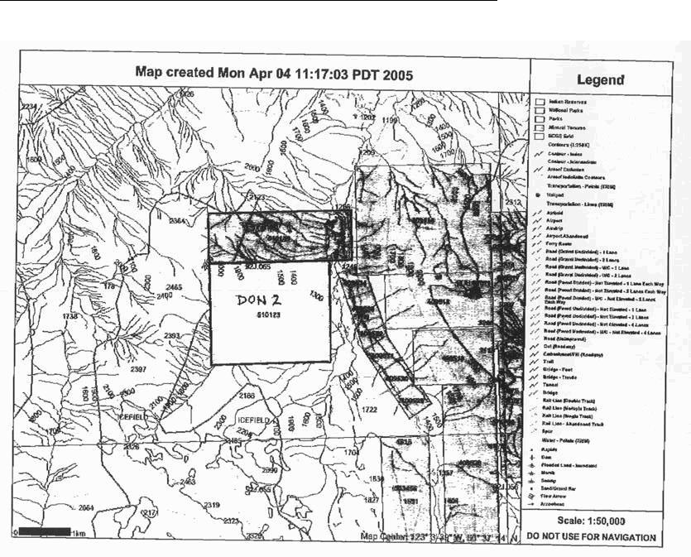

BYWATER RESOURCES INC.

9301 WILSHIRE BLVD. SUITE 311

BEVERLY HILLS, CALIFORNIA

90210

TRUST AGREEMENT

May 31, 2006

In accordance with the instructions of the Board of Directors of the Corporation I, Rolf Harms, President will hold the CARTER 1 Claim as described in Appendix A attached to this TRUST AGREEMENT IN Trust for the CORPORATION as President of the CORPORATION. If I resign from position of President than I will immediately transfer the CARTER 1 Claim to the new President of the CORPORATION.

.

Rolf Harms, President

.

Free Miner License Number: ___________________

APPENDIX “A”

CARTER 1 Claim Description

Nanaimo Mining Division

UTM Zone 10

Map Sheet M092L 05E

Centered Approximately

Latitude 50° 19’ N

Longitude 127° 35’ W

The following claim comprise the CARTER 1 mineral claim group as described in the Trust Agreement dated April 24, 2006:

 |  | Tenure
Claim Name | Cells | Record # | Expiry Date | Map Sheet | Owner
Carter 1 | 25 | 524224 | Dec22/06 | MO92L05E | G. Wells
TOTAL | 25 | UNITS | 515.797 | Hectares

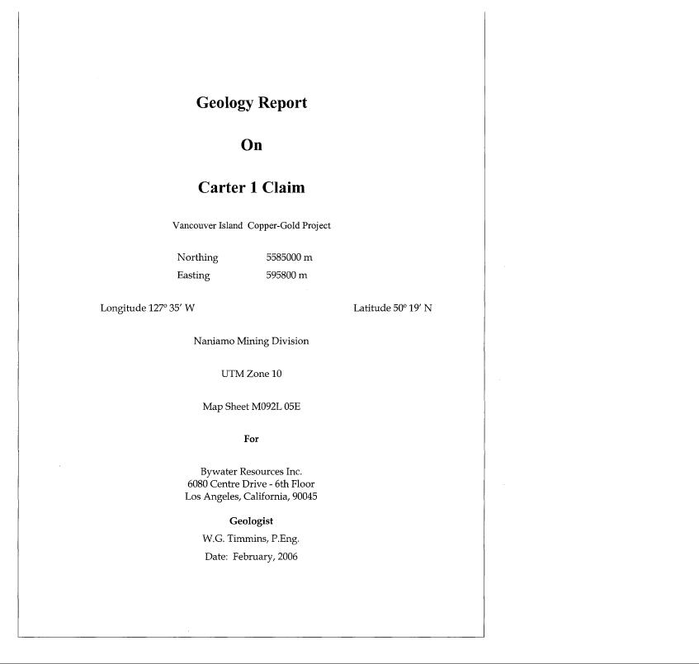

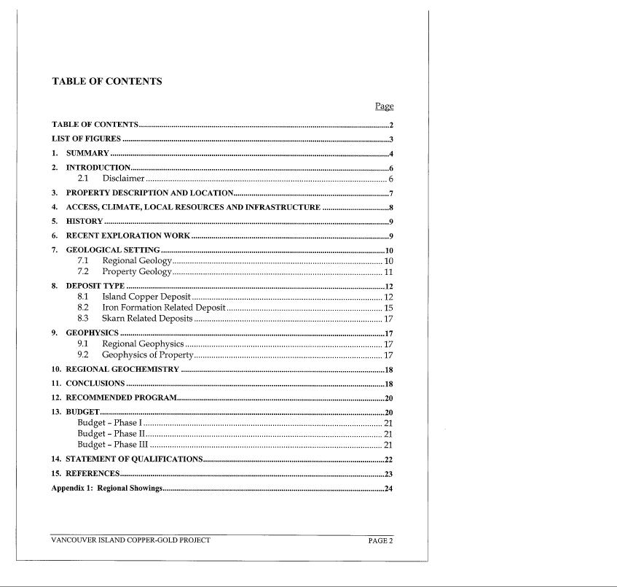

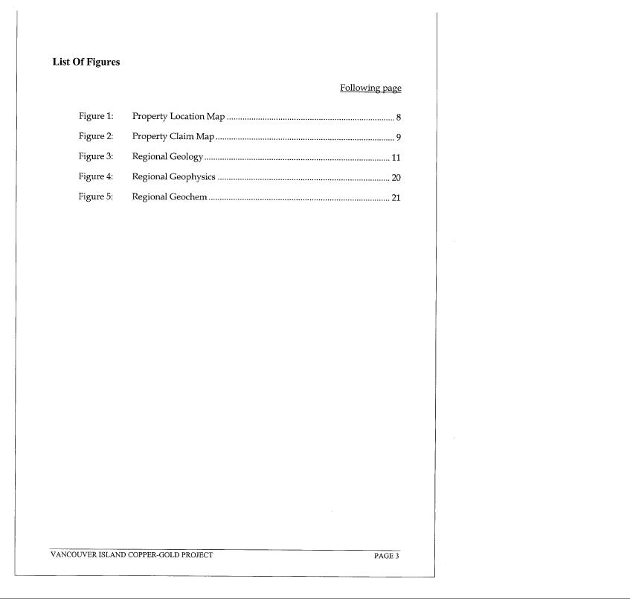

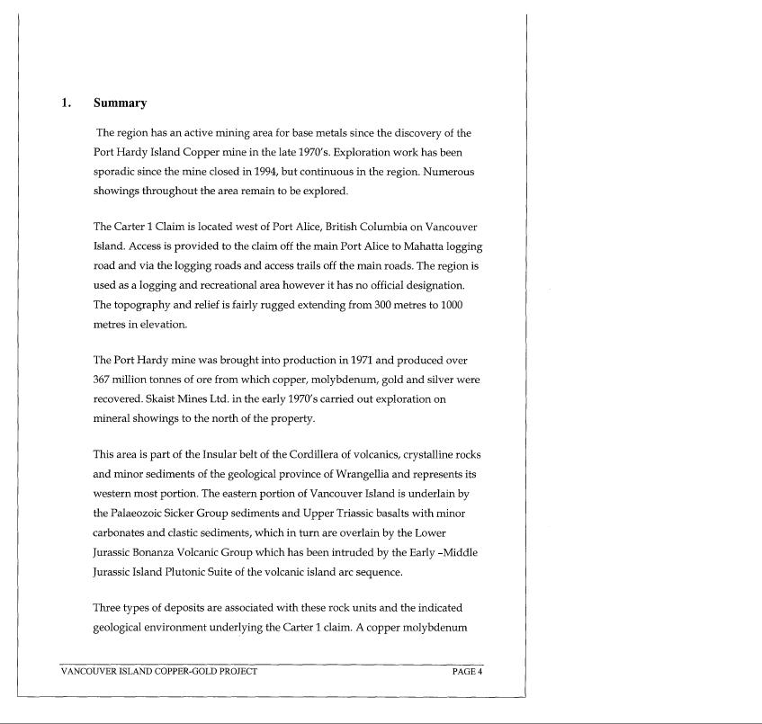

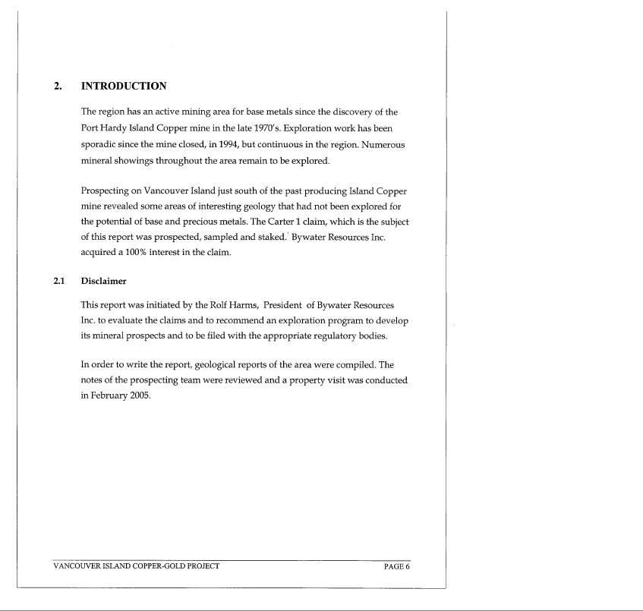

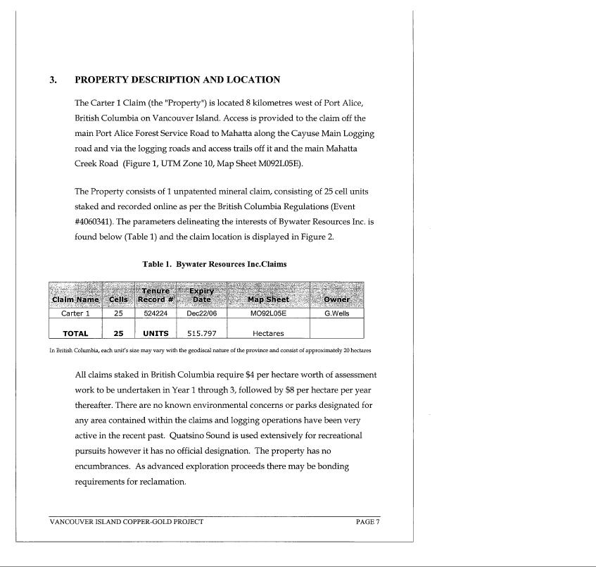

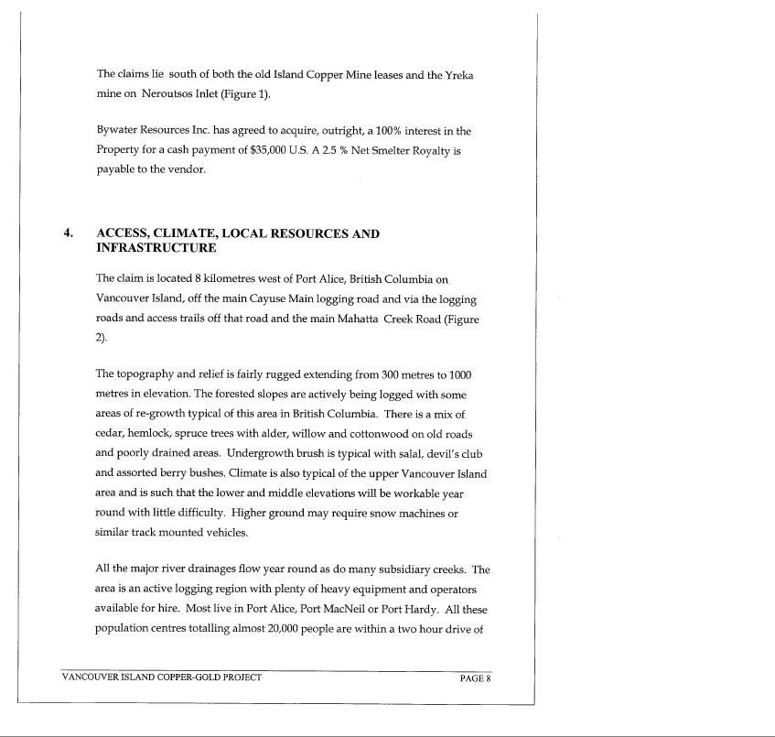

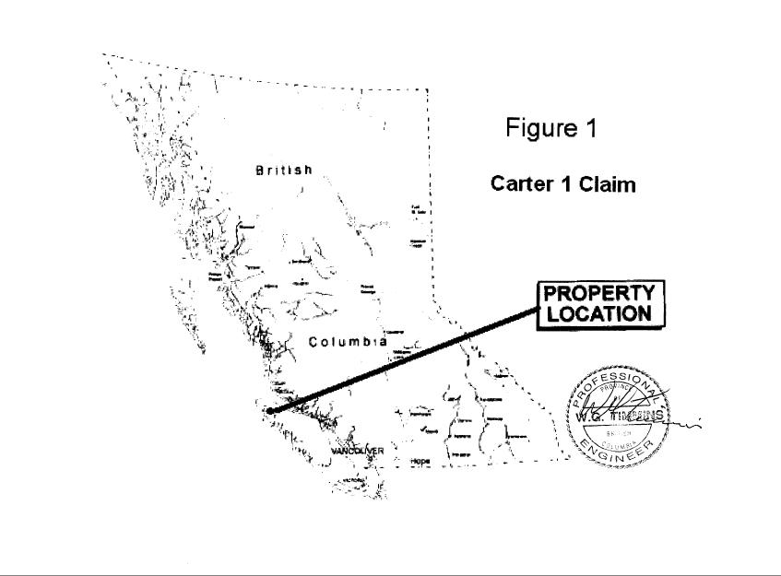

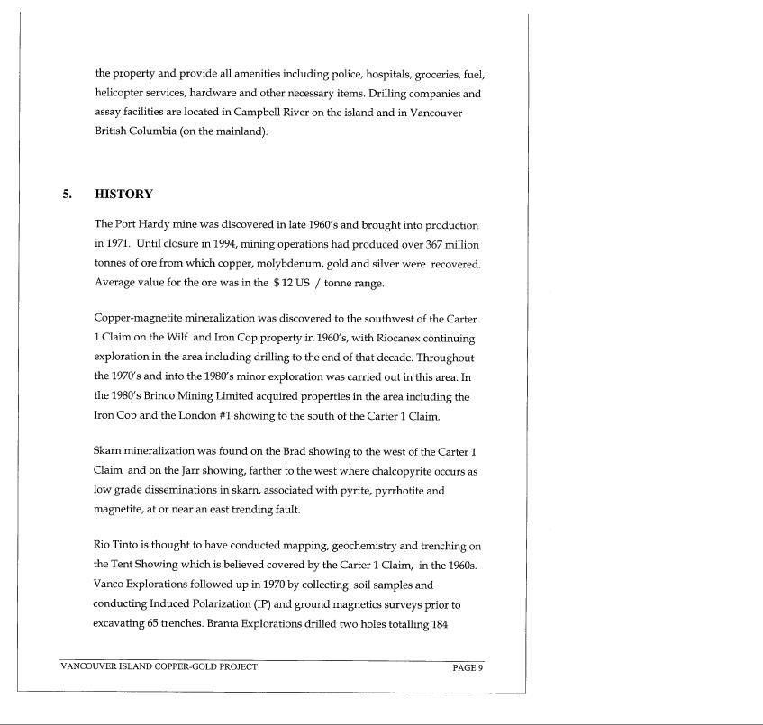

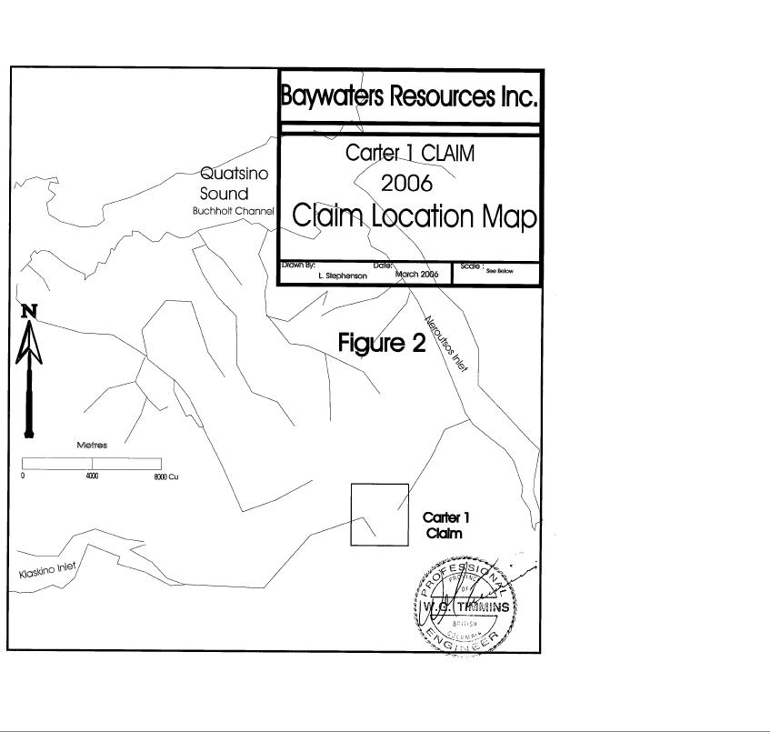

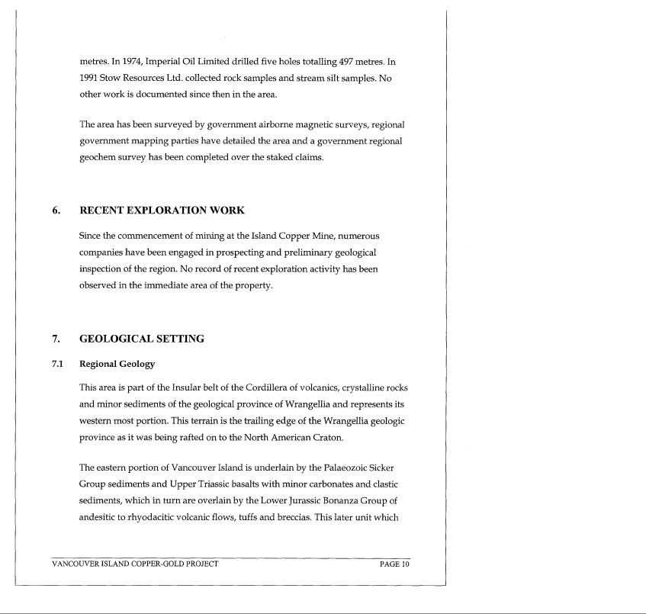

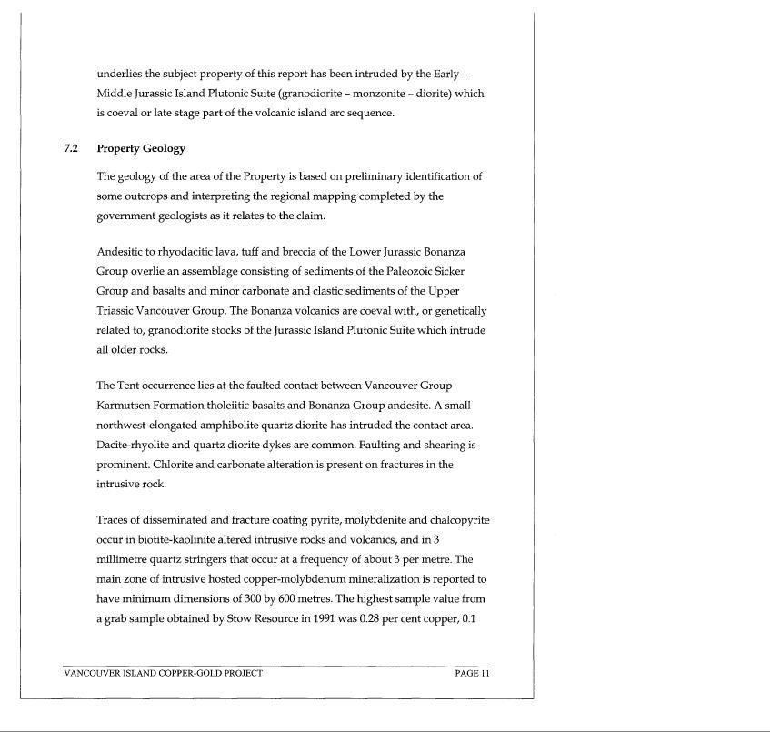

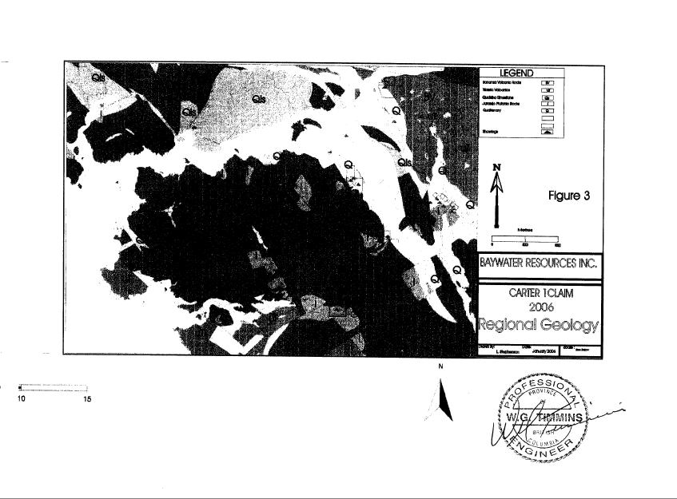

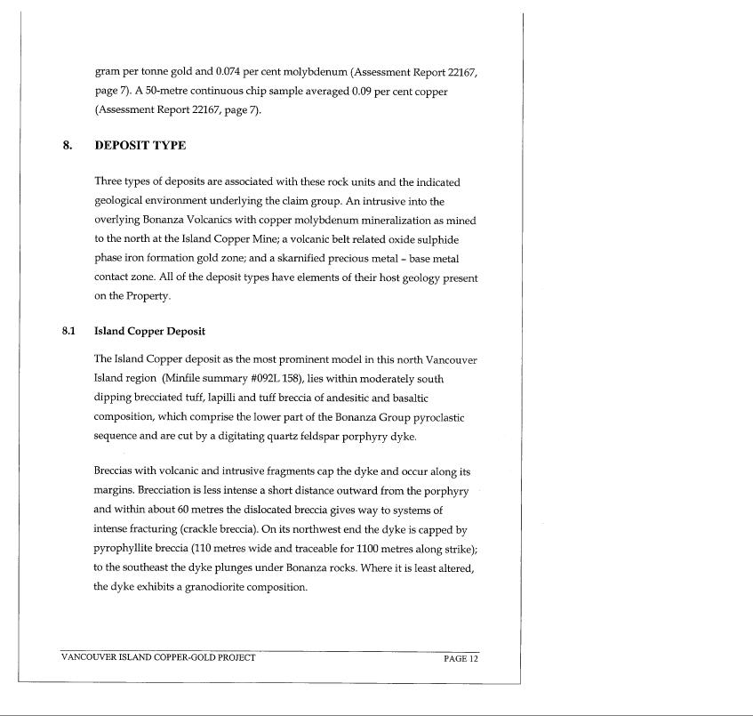

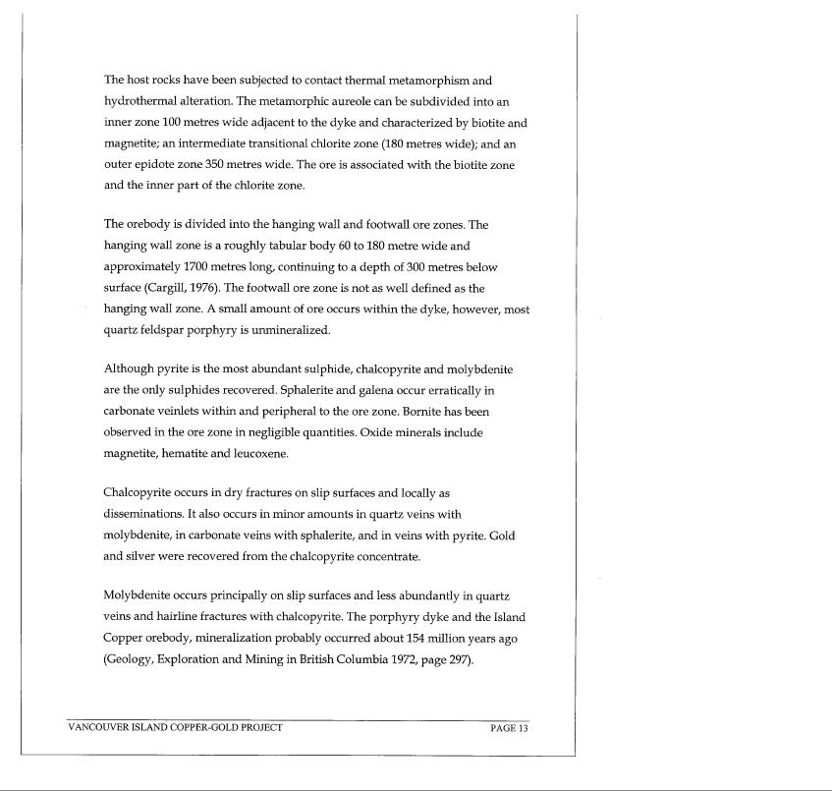

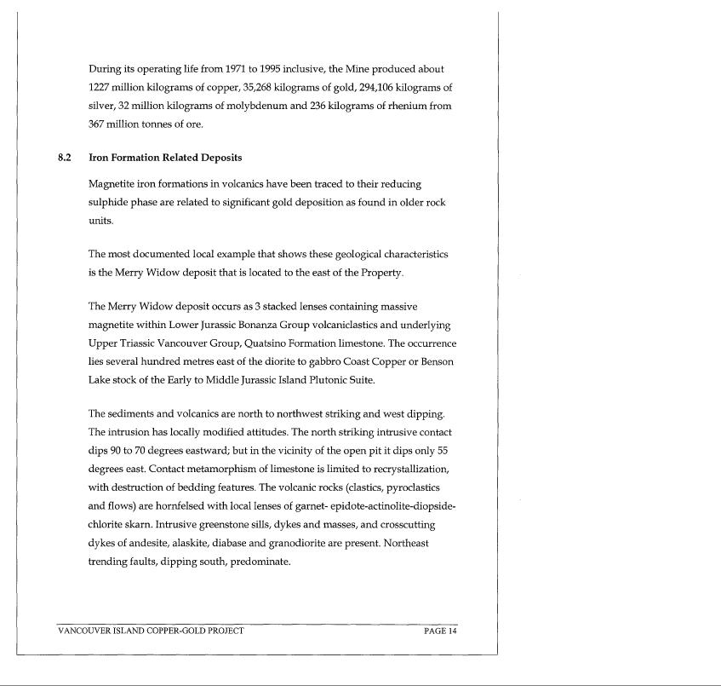

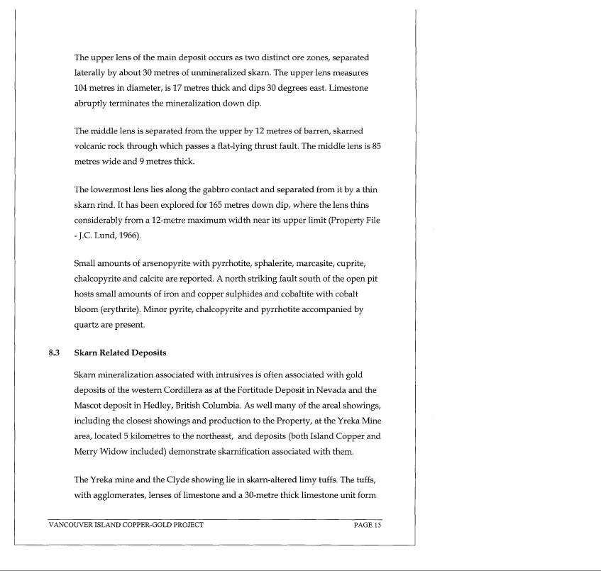

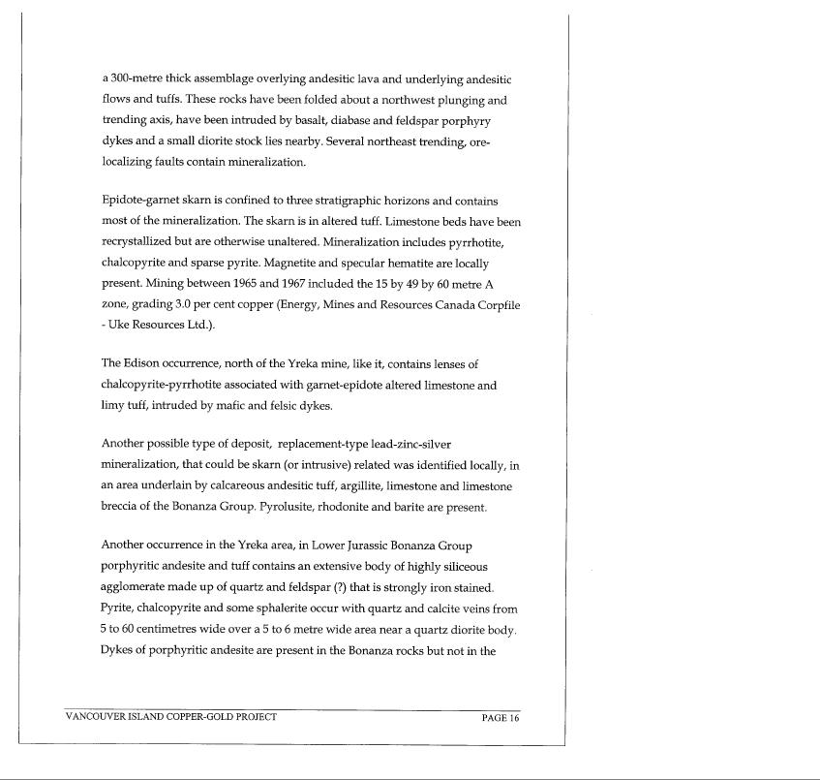

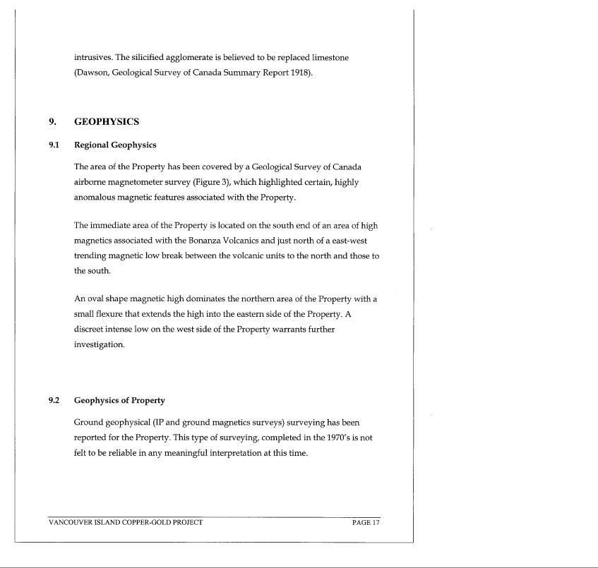

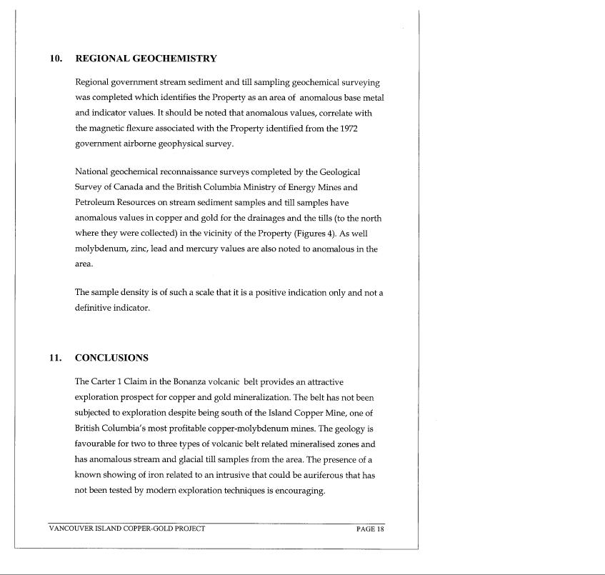

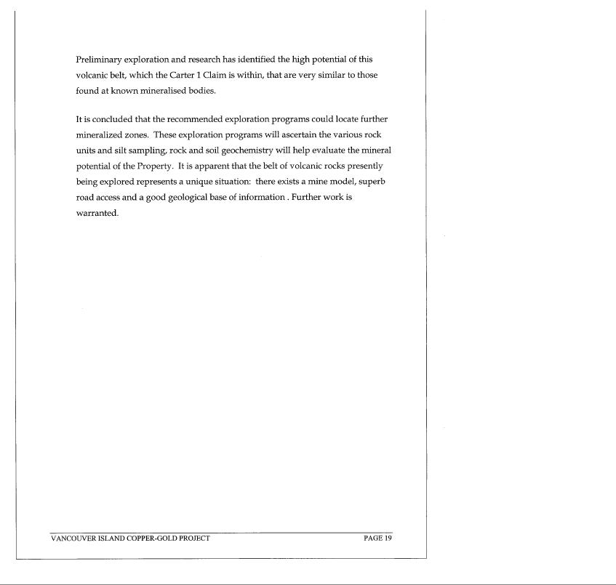

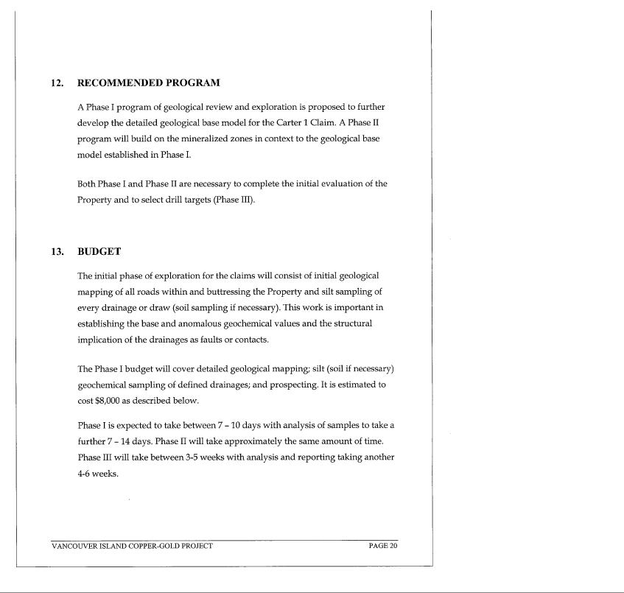

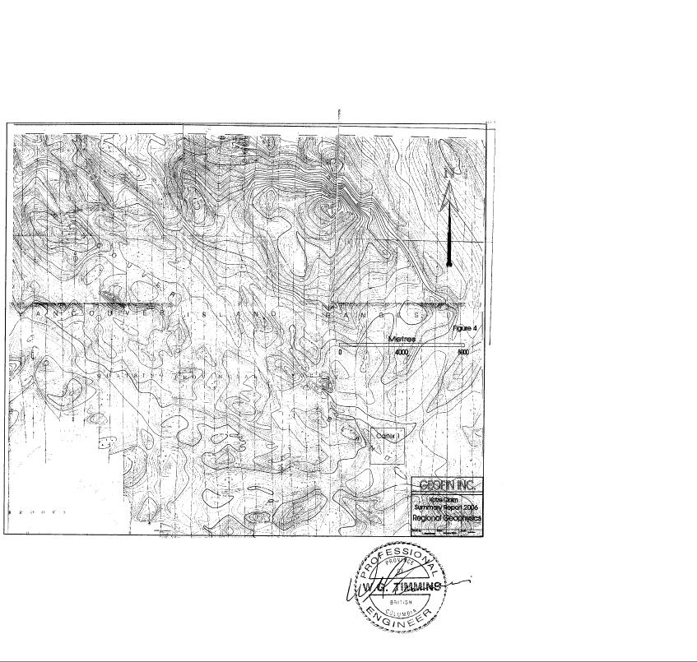

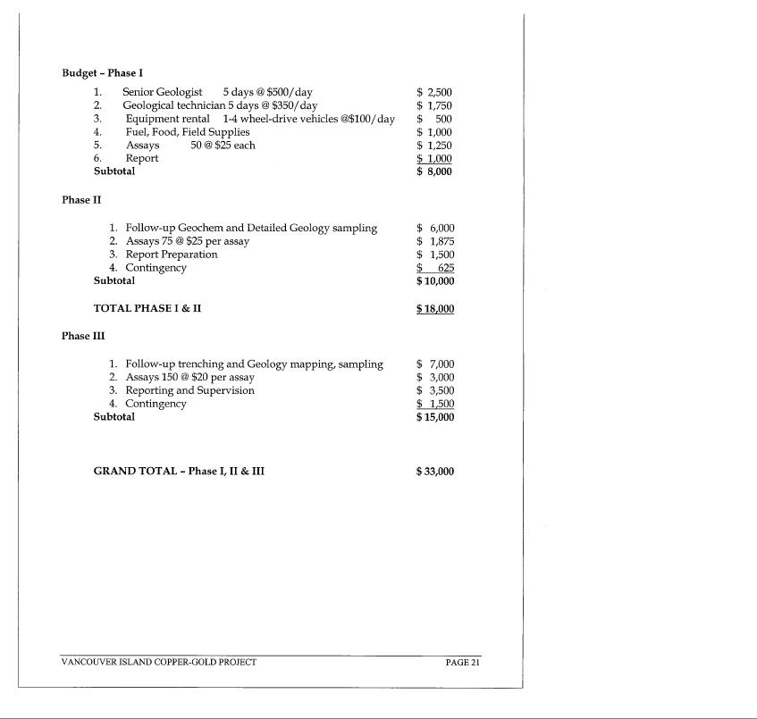

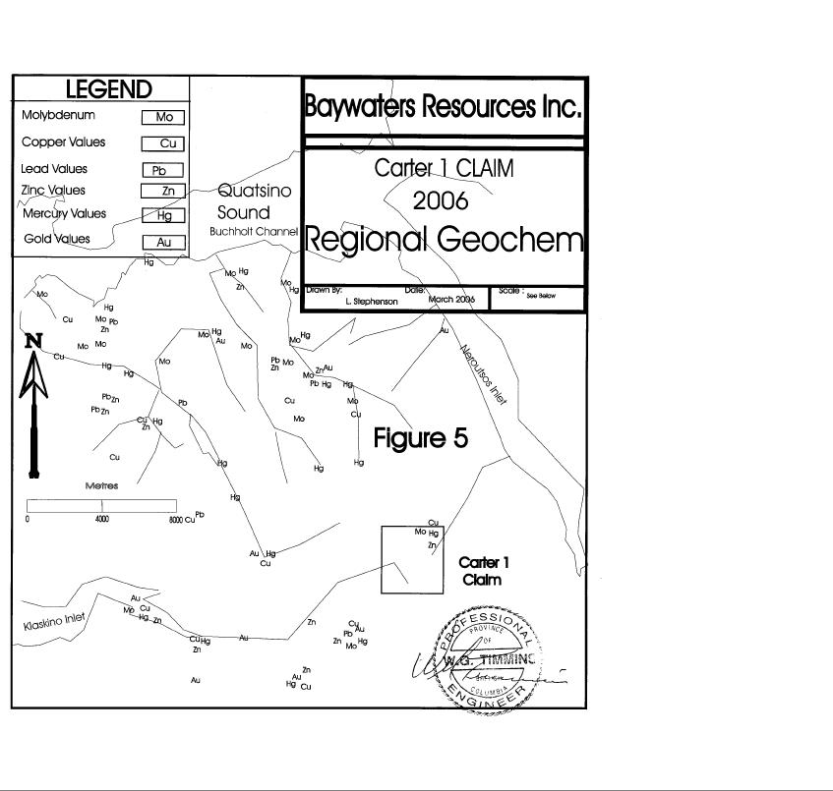

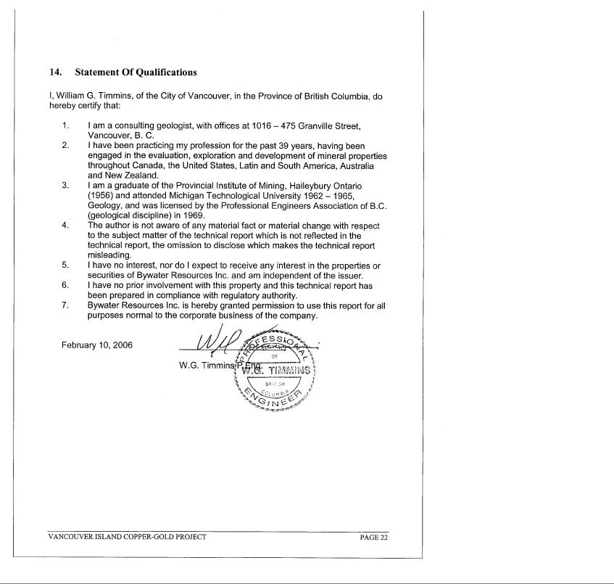

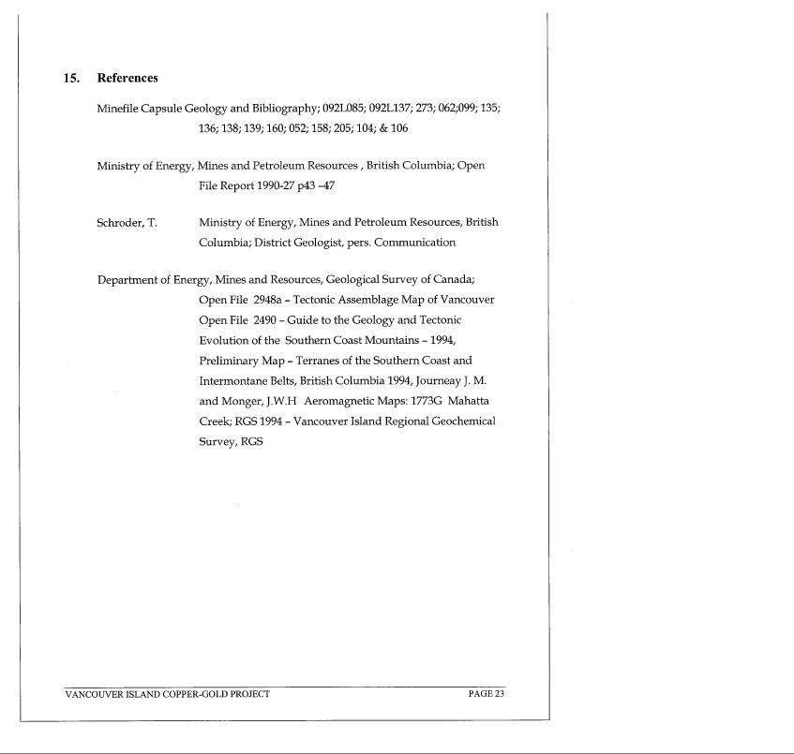

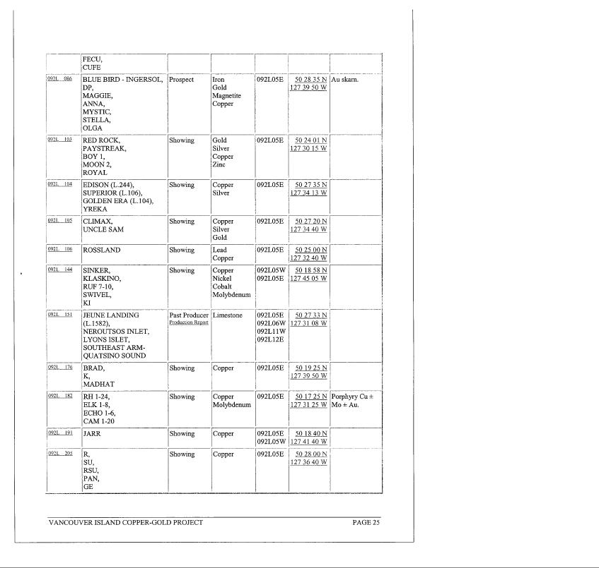

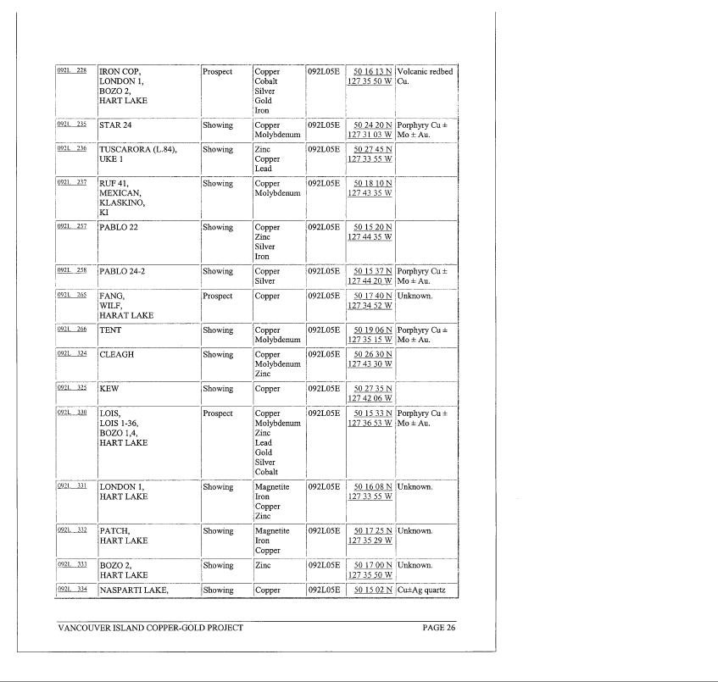

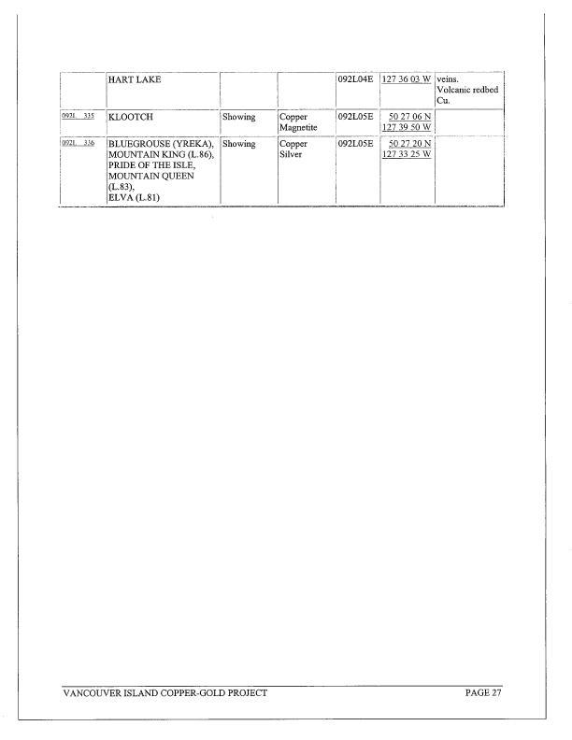

W.G. TIMMINS

1016-470 Granville Street

Tel/Fax:604-682-5281

CONSENT OF AUTHOR

To: United States Securities and Exchange Commission

I, William G. Timmins, P.Eng. do hereby consent to the filing, with the regulatory authorities referred to above, of the technical report titled “Geology Report on Carter 1 Claim” dated February, 2006 (the “Technical Report”) and to the written disclosure of the Technical Report and of extracts from or a summary of the Technical Report in the written disclosure in any Offering Memorandum, other offering documents, or an Annual Information Form of Bywater Resources Inc.

I hereby certify that I have read Bywater’s Form SB-2 and I do not have any reason to believe that there are any misrepresentations in the information derived from the Technical Report in the written disclosure in the Offering Memorandum, other offering documents, or an Annual Information Form of Bywater Resources Inc.

I hereby consent to the use of my name as a consultant to the Company.

Dated: July 19, 2006

/s/ William G. Timmins

WILLIAM G. TIMMINS

INDEPENDENT AUDITORS’CONSENT

We hereby consent to the use in this Registration Statement on Form SB-2 of our report dated June 15, 2006, relating to the consolidated financial statements of Bywater Resources Inc.

We also consent to the reference to our firm under the caption “Experts” in the Registration Statement.

/s/ Gately & Associates, LLC.

GATELY & ASSOCIATES, LLC.

July 21, 2006

