•Over 16,000 deaths every year from GI NSAID complications
Convenient / Cream
Elegant Formulation
Safe / Cutaneous
Proprietary
Cream
10% Ketoprofen
Competitive Landscape
© Imprimis Pharmaceuticals, Inc. | A6
Widespread Usage With Serious Side Effects
•NSAID GI Toxicity - the 15th most common cause of death in US
Accudel Delivery System
Local AEs 1-2%
•Hospitalizations alone cost more than $2B per year
•Over 100,000 per year are hospitalized from NSAID complications
Result: Toxicity to Gastro Intestinal (GI) Tract, Kidneys and Liver
•Usage of oral NSAIDs is increasing
•70% of all 65+ Year Olds Take NSAIDs Weekly
•Regularly used by more than 60M Americans (Arch Intern Med. 2005;165:171-177)
•70 Million prescriptions for NSAIDs each year in US (Wiegard in Medscape)
Fact: Extremely Large Population Uses NSAIDs
Solution is to deliver NSAIDs topically to the specific site of pain or inflammation
The Problem With Oral NSAIDs
FLECTOR PATCH
Chronic OA of hand
and knee
Local AEs 7%
Odor / Staining
Sticky / Greasy
Large Quantities
4 x per day =
16 grams/day
2-4 gram
sodium
1% Diclofenac
(Pfizer/IBSA)
© Imprimis Pharmaceuticals, Inc. | A5
Acute soft tissue
injury (positive data
in ankle sprain)
Local AEs 11%
Not to be worn in water
Adherence issues
Fixed one size patch
10 x 14 cm patch
2 x per day
1.3% Diclofenac
epolamine
(Imprimis)
IMPRACOR
Seeking label sprains,
strains, and joint pain
© Imprimis Pharmaceuticals, Inc. | *
Lecithin Phase
Pluronic Phase
Hydrophillic APIs
Lipophillic APIs
Pluronic Lecithin Organogel (PLO) Platform
Introduction to Accudel™
© Imprimis Pharmaceuticals, Inc. | A2
Accudel™ Topical
Delivery Technology
© Imprimis Pharmaceuticals, Inc. | A1
Appendix - Investment
Summary & Support
• Accudel™ is a cream that “carries” drugs
through the skin, penetrating to the problem site
mark@imprimispharma.com
(858) 433-2816 - Direct
Mark L. Baum, J.D.
FOR MORE INFORMATION CONTACT:
Delivering Safe, Effective and Direct Solutions
Imprimis Pharmaceuticals, Inc.
Questions & Discussion
• Highly Capable Team
• Cash Resources to Execute
• Key Strategic Relationships
Drug
Impracor™ Topical
NSAID
Competition and Market
© Imprimis Pharmaceuticals, Inc. | A4
Faculty of Pharmacy Rhodes University, Grahamstown
ii. Thesis Tettey-Amlalo, Dec 2005
i. DPT Study Report TC.0706.01
• (Fastum, Ketum, Oruvail) 2.5% topical ketoprofen were tested
in a Franz Cell Apparatus (Silicon membrane). Less than 20%
of ketoprofen present in the formulation was made available to
diffuse out of the formulation into the receptor phase in the un-
ionized formii.
• 63% - 70% of ketoprofen in Impracor that was available for
release diffused through the membrane (0.45 μ Nylon) of a
Franz Cell Apparatus within 4 hoursi.
In Vitro Penetration Data for Impracor™ and
European Marketed Products (Fastum®, Ketum®, Oruvail®)
Introduction to Accudel™
Pluronic Phase
VOLTAREN GEL
Lecithin Phase
© Imprimis Pharmaceuticals, Inc. | A3
Drug
• Thermodynamically stable, insensitive to moisture
and resistant to microbial contamination
• Low toxicity and biodegradable; components are
non-immunogenic and are “Generally Regarded
As Safe” (GRAS) by the US FDA
• Quickly absorbed and aesthetically pleasing
• Works with drugs with different physicochemical
properties
• Accommodates different size molecules and large
quantities of active drugs
• Pluronic Lecithin Organogel (PLO) drug carrier
* Cannavino, C. et al. Efficacy of Transdermal Ketoprofen in delayed onset muscular soreness,Clinical Journal of Sports Medicine, 13: 200-208,
2003 and Clinical Study Report Project No. 990808, Phase 1/2 Study Report Aug 2007
© Imprimis Pharmaceuticals, Inc. | A14
Additional Corporate
Information
Orudis**
© Imprimis Pharmaceuticals, Inc. | A13
2g t.i.d. (48hr)
1g t.i.d. (48hr)
Oruvail**
10% ketoprofen cream
Impracor*
**Orudis ketoprofen extended release capsule/ Oruvail capsule prescription information
Board of Directors
Pharmacokinetics: Low Systemic
Absorption
*
*
**
**
**
**
**
40 drops, 4x daily
4g, 4x daily
Director since 1998; Co-developer of Accudel drug delivery technology and Impracor topical NSAID
(Unaudited and Abbreviated)
© Imprimis Pharmaceuticals, Inc. | A16
Balance Sheet
© Imprimis Pharmaceuticals, Inc. | A15
Member of the 2010 - 2015 United States Pharmacopeia (USP) Council of Experts
Shareholder in PCCA; Vice-President of Consulting, R&D and Formulations at PCCA
Gus S. Bassani, Pharm.D
Manages audit, SEC, Sarbanes-Oxley and business consulting engagements with a focus on technology,
manufacturing, service, real estate, social media and non-profit organizations
Audit Committee Chairman; Significant BOD Experience; Partner, Swenson Advisors, LLP since May
1998
Stephen Austin, C.P.A.
180mg, 2x daily
Jeff Abrams, M.D.
Drugs: Celebrex, Bextra, Arthrotec, Soliris, Inspra and Aldactone/Soldactone
Paul Finnegan, M.D., M.B.A.
Senior Positions: Avalon Ventures, Alexion, Pharmacia/Searle); Univ. of Chicago MBA
Responsible for Restructuring Imprimis, including $24M New Equity Investment and PCCA transaction
Founder of 3 private investment funds; Restructured numerous companies (private-to-public)
15+ Years of Senior Executive Experience
Mark L. Baum, J.D. (Co-Founder)
Retired Associate Professor & Course Director - Orofacial Pain, University of Colorado
Active Clinical Research & Consulting Practice; Diplomate, American Board of Orofacial Pain
Robert J. Kammer, D.D.S. (Co-Founder)
PENNSAID
Ketoprofen vs. Diclofenac
The Impracor Solution

BMC Family Practice 2004, 5:10
Lorna Mason, R Andrew Moore*, Jayne E Edwards, Sheena Derry and Henry J McQuay
Topical NSAIDs for acute pain: a meta-analysis
“Meta-analysis of 26 trials (n=2,853) … showed that Ketoprofen was
significantly better than all other topical NSAIDs. In terms of efficacy,
Ketoprofen was significantly better than ibuprofen, felbinac, piroxicam and
indomethacin.”
Ketoprofen vs. Ibuprofen
© Imprimis Pharmaceuticals, Inc. | A7
(Covidien/Nuvo)
The proportion of participants experiencing successful treatment with topical
ketoprofen in seven clinical studies was 73% (251/346, range 57% to 89%)
Chronic OA of knee
Local AEs 47%
Causes garlic taste/breath
Complicated application
Dimethyl sulfoxide
(DMSO); Safety concerns
3-4 x per day =
160 drops/day
40 drops of liquid
(10 drops to each of 4 sides of knee)
sodium
1.5% Diclofenac
(Endo/Novartis)
© Imprimis Pharmaceuticals, Inc. | A10
1g, 3x daily
© Imprimis Pharmaceuticals, Inc. | A12
• Low incidence of cutaneous AEs
• No related gastrointestinal (GI), cardiac, liver, or other serious AEs
** Prescribing Information for Flector Patch, Voltaren Gel and Pennsaid Solution
* Clinical Study Report: TDLP-110-001, September 2010
Safety: Low Incidence of Adverse Events
© Imprimis Pharmaceuticals, Inc. | A11
Sprain-Strain Soft Tissue Study
Initial Phase 3 Trial
• Robust and Compelling Development Assets
Topical NSAIDs in Acute OA Knee Pain Model
© Imprimis Pharmaceuticals, Inc. | A9
Additional Impracor™
Clinical Materials
Cochrane Database Syst Rev. 2010;6:CD007402
Massey T, Derry S, Moore RA, McQuay HJ
Topical NSAIDs for acute pain in adults.
© Imprimis Pharmaceuticals, Inc. | A8
Ketoprofen is a Superior Active Ingredient
The proportion of participants experiencing successful treatment with topical
diclofenac in three clinical studies was 52% (166/319, range 39% to 92%)
• PCCA invested $4M into Imprimis at $4.80 per share
• Partner
• Selectively internal
development
•Monetize vast 505(b)(2)
development assets
Drive Shareholder Value
© Imprimis Pharmaceuticals, Inc. | *
Imprimis Vision
© Imprimis Pharmaceuticals, Inc. | *
+
Proprietary Drug Pipeline
505(b)(2) Focused
• Out-license
• Our strategic relationship is exclusive
5. Exclusive access to review PCCA member IP
4. Analytics (Eagle Analytics)
3. Market data (>100,000 inbound calls per year)
2. Proprietary and proven drug delivery technologies
(Lipoderm® and others)
1. Proprietary and proven drug formulations
• PCCA relationship gives Imprimis exclusive access to:
• Over 4,000 pharmacy businesses/chains worldwide
1. Supply chemicals, equipment, accredited training, software,
and business/pharmacy consulting assistance
• Professional Compounding Centers of America
(PCCA) is the largest compounding pharmacy
organization in North America
• Number of Annual RX
• Out-License or Develop
• Field Experience
• Drug Master File
• Market Data
Projects
Candidates
Ideas
Imprimis Growth & Development Process
Partner, Out-License
Internally Develop
PCCA Strategic Relationship
• Dollar Size
• Reimbursement Landscape
• Competition
X-Axis: Drug Administration
Step 1: Opportunity Matrix
Monetizing the PCCA Relationship
• Increase therapeutic
benefit to patients
• Reduce or eliminate
negative side effect
profiles
•Novel drug administration
Improve Patient Care
© Imprimis Pharmaceuticals, Inc. | *
• Exclusive access to review PCCA member IP
• Vast market “unmet need” database
• 10+ drug delivery technologies
• 10,000+ drug formulations
• Exclusive commercial rights to PCCA development IP
• Phase 3 topical NSAID pivotal to start in Q3 2013
• Nominal debt; no preferred instruments
• Approx. $19.0M in cash as of 03/31/13
© Imprimis Pharmaceuticals, Inc. | *
Imprimis Snapshot
• Experienced science and management teams
Imprimis Overview
© Imprimis Pharmaceuticals, Inc. | *
You are cautioned not to place undue reliance on these forward-looking statements, which speak only as of the
date hereof, given these risks and uncertainties. All forward-looking statements are qualified in their entirety by
this cautionary statement and the Company undertakes no obligation to revise or update any forward-looking
statements as a result of new information or future events or developments.

Some of the potential risks and uncertainties that could cause actual results to differ from those predicted include
the difficulties related to the Company’s ability to obtain regulatory approval to market Impracor™, capitalize on
its perceived potential benefits arising from its relationship with Professional Compounding Centers of America,
Inc., leverage compounded generic drugs to create a development pipeline and otherwise pursue its business
plan, and leverage its Accudel technology in the development of potential product candidates. In addition, the
outcome of the final analyses of the data from the past and future Phase 3 clinical trial may vary from the
Company’s initial conclusions, the FDA may not agree with the Company’s interpretation of such results or may
challenge the adequacy of the Company’s future Impracor clinical trial design or the execution of the same clinical
trials, the FDA may require the Company to complete additional clinical trials for Impracor before the Company
can submit a 505(b)(2) NDA application, the results of any future clinical trials may not be favorable and the
Company may never receive regulatory approval for Impracor™, the Company may be unable to raise additional
funding to complete its product development plans, or be unable to acquire, develop or commercialize new
products and or enter into strategic alliances and transactions. Other risks include uncertainties inherent in pre-
clinical studies and clinical trials, difficulties in conducting its clinical trials, unexpected new data, safety and
technical issues, competition and market conditions. More detailed information about the Company and the risk
factors that may affect the realization of forward-looking statements is set forth in the Company’s filings with the
Securities and Exchange Commission, including its Annual Report on Form 10-K and its Quarterly Reports on
Form 10-Q filed with the SEC. Such documents may be read free of charge on the SEC’s web site at
www.sec.gov.
This presentation contains "forward-looking statements" as defined in the Private Securities Litigation Reform Act
of 1995. You are cautioned not to rely on these forward-looking statements. These statements are based on
current expectations of future events. If underlying assumptions prove inaccurate or unknown risks or
uncertainties materialize, actual results could vary materially from our expectations and projections.
Safe Harbor Statement
Mark L. Baum, C.E.O.
July 2013
“A Unique Approach to 505(b)(2)”
• 505(b)(2) Development Budget Comparison: $2-7M versus $100M+ for (b)(1)
99%
1%
Compounders
Pharmaceutical
to the >$300B U.S. Pharmaceutical Industry
from Pharmaceutical Compounders
Imprimis Brings Innovation
© Imprimis Pharmaceuticals, Inc. | *
Imprimis Development Model
© Imprimis Pharmaceuticals, Inc. | 6
• Complete Phase 3
• 505(b)(2) products can have Orange Book-listed patents, can enjoy 30-month protection against
generic competitors; NCE (5 yrs); Orphan Drug (7 yrs); Pediatric Extension (6 mos.)
Less Development Time & Lower Cost
FDA 505(b)(2) drug development pathway
Our mission is to develop proprietary drugs using the
505(b)(2) … Lower Risk | Higher Margin
Low Margin
Low Risk
© Imprimis Pharmaceuticals, Inc. | *
Imprimis Overview
8+ years of experience in small capitalization company financial reporting; focus on restructured businesses;
Professor of Medicine, Division of Rheumatology/Immunology at UCLA ; 35+ yrs clinical experience
Senior Clinical Advisor: Roy D. Altman, M.D.
Two terms on the BOD of the American College of Rheumatology; 110 Original Publications
Senior consultant to Pharmacia/Searle on COX-2 development
Senior Regulatory Advisor: Lee S. Simon, M.D.
FDA Division Director of Analgesic, Anti-Inflammatory & Ophthalmologic Drug Products (2001-2003)
Served on multiple FDA advisory committees; 12 years as an NIH funded investigator
Clinical and Regulatory Team Snapshot
© Imprimis Pharmaceuticals, Inc. | *
15+ years of clinical and corporate development experience with both large-cap pharmaceutical companies
(e.g. Eli Lilly and Pfizer) as well as start-up ventures including extensive capital raising, licensing, and M&A
transactions
VP, Corporate Development: Gary Seelhorst, MS, MBA
Led forensic-type accounting and financial reporting of historical Imprimis records during restructuring
Founding Member/Past President of the Osteoarthritis Research Society International
VP, Accounting and Public Reporting: Andrew R. Boll
Drugs: Voltaren line extensions, Apligraf, Femara, Exjade and Sandoglobulin
Chief Medical Officer: Joachim P.H. Schupp, M.D.
Senior Positions: Ciba-Geigy, Novartis, ProSanos, Adventrx, Apricus Biosciences
Drugs: Botox, Ketorolac (Cataracts), Restasis (Dry Eye), Lumigam, Latisse, Alphagan and 8 other drugs
Senior Positions: Lederle/Wyeth, SmithKline & Beckman, and Allergan
25 Years of Senior Drug Development Experience
Senior Advisor, Pre-Clinical Services: Balbir Brar, D.V.M., Ph.D.
Responsible for Restructuring Imprimis, including ~$24M new equity investment and PCCA transaction
Founder of 3 private investment funds; Restructured numerous companies (private-to-public)
15+ Years of Senior Executive Experience; Founder/President, YesRx.com (1999)
Operating and Management Experience with Numerous Biomedical Companies
• Near Term Catalysts
• Unique Drug Development Model
• Imprimis is a Company with Vision
© Imprimis Pharmaceuticals, Inc. | *
Summary
© Imprimis Pharmaceuticals, Inc. | *
Capital Structure
© Imprimis Pharmaceuticals, Inc. | *
Teaches Food and Drug Law at Boston College Law School
Of Counsel to Mintz, Levin, Cohn, Ferris, Glovsky and Popeo, P.C.
Chief Executive Officer: Mark L. Baum, J.D.
Physician, Attorney, Inventor and Research Scientist
Senior Regulatory Advisor: Allan M. Green, M.D., PhD, J.D.
PI of NIH and Dep’t Vet. Affairs funded studies, and is a Co-investigator on several other studies
Focus on clinical epidemiology of musculoskeletal diseases, osteoarthritis and osteoporosis
Head of the Division of Rheumatology and Clinical Immunology at University of Maryland SOM
Faculty, The Johns Hopkins University SOM & University of Maryland SOM
Senior Clinical Advisor: Marc C. Hochberg, M.D.
Co-editor:Seminars in Arthritis and Rheumatism and Editor and Chief of Osteoarthritis and Cartilage
Edited the 4th edition of Osteoarthritis: Diagnosis and Management.
Chairman for the Design and Conduct of Clinical Trials in Osteoarthritis as well as the Chairman on
Clinical Trials in Osteoarthritis; Over 200 juried manuscripts and over 60 books
Improving Patient Care:
Impracor™ Phase 3
Topical NSAID
• Despite Suboptimal Products, U.S. Topical NSAID Market is Growing
• FDA Guidance: Voltaren™ generics must complete clinical trials prior to ANDA
• Voltaren Gel (1% diclofenac) has ~75% Rx share
• The $10B+ US NSAID Market is Transitioning to Topicals
• Market Analysis:
© Imprimis Pharmaceuticals, Inc. | *
The Case for Impracor™
© Imprimis Pharmaceuticals, Inc. | 15
The Topical NSAID Market
© Imprimis Pharmaceuticals, Inc. | *
• 2016 Topical NSAID Market Possibly >$1B
Pain and Sexual Dysfunction
Additional compounds in late stage assessment are in the therapeutic areas of
© Imprimis Pharmaceuticals, Inc. | *
Imprimis Pipeline
© Imprimis Pharmaceuticals, Inc. | *
Imprimis Pipeline
Candidate
NDA & LAUNCH
• Market Launch/Partner
• NDA via 505(b)(2)
• Seek “sprains, strains and joint pain” label
Compensation weighted in equity
Strong operational and management experience within our leadership group
Management Team Snapshot
© Imprimis Pharmaceuticals, Inc. | *
Executive Team and
Select Financial Data
Trial Data - 1H 2014
Phase 3 Clinical Trials Planned - Q3 2013
© Imprimis Pharmaceuticals, Inc. | *
• OA Flare trial protocol IRB Approved
• Could be the only acute pain topical NSAID (if FDA approved)
Imprimis Pharmaceuticals, Inc.
• Use proprietary tools to reduce placebo effect
• Leading pain trial experts have designed protocol
• Two adequate/well controlled acute pain trials (one in label)
New Acute Pain Clinical Trials to Achieve FDA Approval
• Per protocol analysis: p=0.034
• mITT analysis: p=0.038
Initial Phase 3 Trial
Impracor™ Phase 3 Program
• There is a compelling unmet need for an effective semi-solid NSAID

UNITED STATES
SECURITIES AND EXCHANGE COMMISSION
Washington, D.C. 20549

FORM 8-K

CURRENT REPORT
Pursuant to Section 13 OR 15(d) of The Securities Exchange Act of 1934

Date of Report (Date of earliest event reported): July 23, 2013

IMPRIMIS PHARMACEUTICALS, INC.
(Exact name of registrant as specified in its charter)

Delaware |  | 001-35814 |  | 45-0567010
(State or other jurisdiction  of incorporation) |  | (Commission File Number) |  | (IRS Employer Identification No.)

12626 High Bluff Dr. Ste 150
San Diego, CA |  | 92130
(Address of principal executive offices) |  | (Zip Code)

Registrant’s telephone number, including area code: (858) 704-4040

N/A
(Former name or former address if changed since last report.)

Check the appropriate box below if the Form 8-K filing is intended to simultaneously satisfy the filing obligation of the registrant under any of the following provisions:

o |  | Written communications pursuant to Rule 425 under the Securities Act (17 CFR 230.425)
o |  | Soliciting material pursuant to Rule 14a-12 under the Exchange Act (17 CFR 240.14a-12)
o |  | Pre-commencement communications pursuant to Rule 14d-2(b) under the Exchange Act (17 CFR 240.14d-2(b))
o |  | Pre-commencement communications pursuant to Rule 13e-4(c) under the Exchange Act (17 CFR 240.13e-4(c))

Item 7.01. Regulation FD Disclosure

Attached as Exhibit 99.1 to this Item 7.01 is a presentation that is being used by the management of Imprimis Pharmaceuticals, Inc. (the “Company") in meetings describing the Company.

The information contained in Item 7.01 of this report and in Exhibit 99.1 shall not be deemed “filed" for purposes of Section 18 of the Securities Exchange Act of 1934, as amended (the “Exchange Act"), or incorporated by reference in any filing under the Securities Act of 1933, as amended, or the Exchange Act, except as shall be expressly set forth by specific reference in such a filing.

Item 9.01. Financial Statements and Exhibits

(d) Exhibits

99.1 | Presentation dated July 2013

2

SIGNATURES

Pursuant to the requirements of the Securities Exchange Act of 1934, the registrant has duly caused this report to be signed on its behalf by the undersigned hereunto duly authorized.

 | IMPRIMIS PHARMACEUTICALS, INC.
Dated: July 23, 2013 | By: | /s/ Andrew R. Boll
 |  | Name: Andrew R. Boll
 |  | Title: Vice President, Accounting and Public Reporting

3

EXHIBIT INDEX

99.1 | Presentation dated July 2013

4

Exhibit 99.1

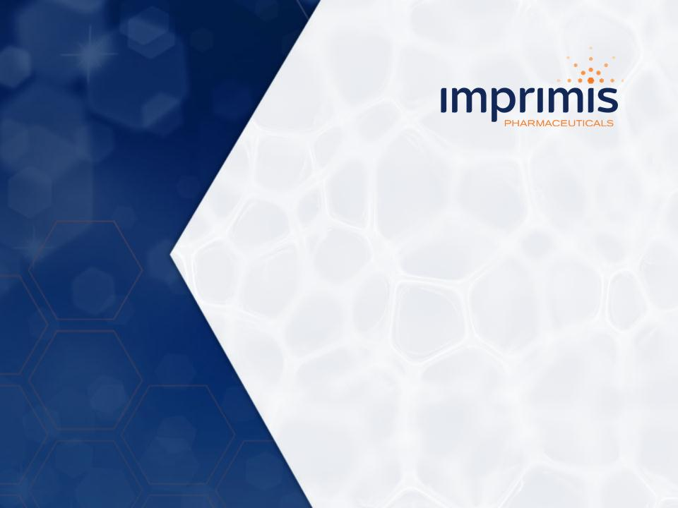

1



2



3

4

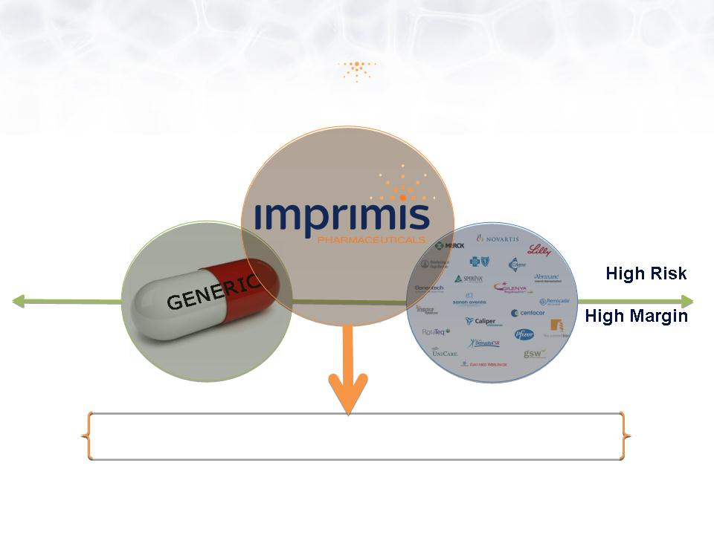

5

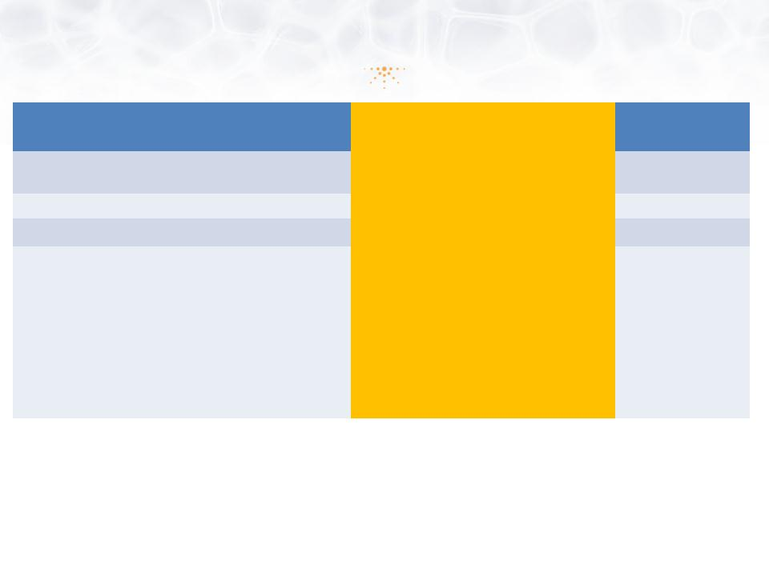
Application | 505(b)(1) NDA | 505(b)(2) NDA | 505(j) ANDA
New Chemical Entity  (NCE) | Yes | Yes/No  (Rely on RLD and Prior Investigation) | No  (RLD is off patent)
New Indication | Yes | Yes | No
New Form/Dose | Yes | Yes | No
Required Data for  Approval | • Complete Pharmacology  • Complete Preclinical  Safety, including long  term carcinogenicity in 2  species  • Complete analytical  development and quality  manufacturing  • Complete Phase 1-3  clinical trials | • Data from published literature  • FDA findings on efficacy/safety of  approved drug/formulation  • Studies to support change  • Dermal/Eye Safety (topical drugs)  • Clinical Efficacy/Safety  • CMC (3 registration batches with  stability data) | • Bioequivalence

6

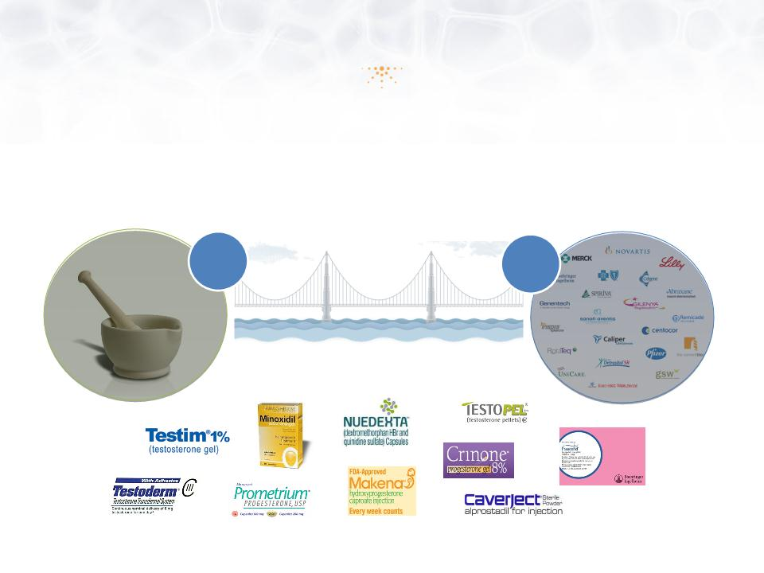

7

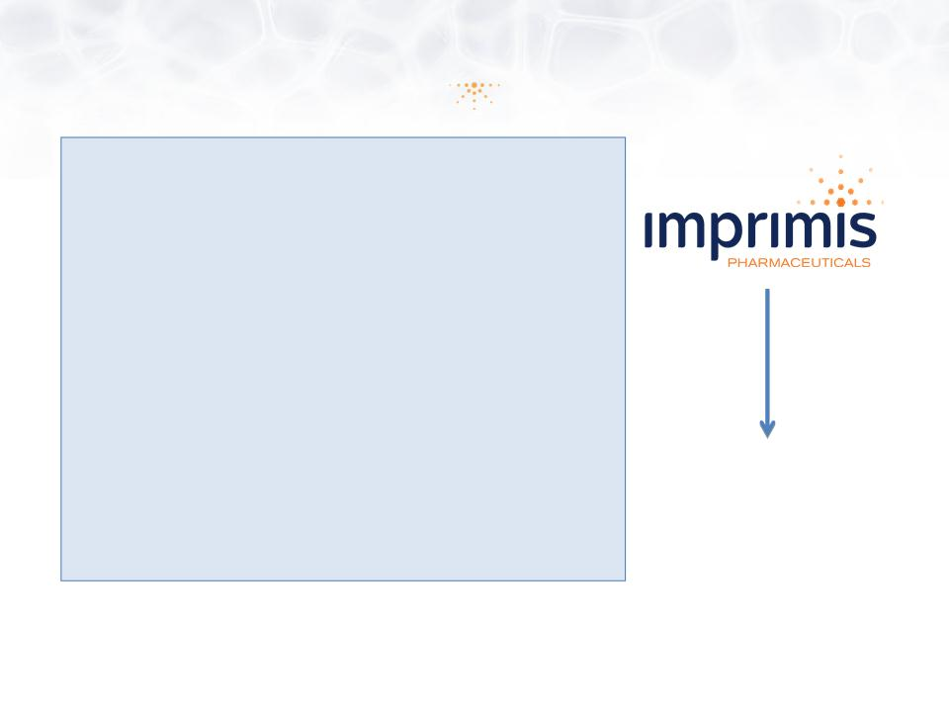

8

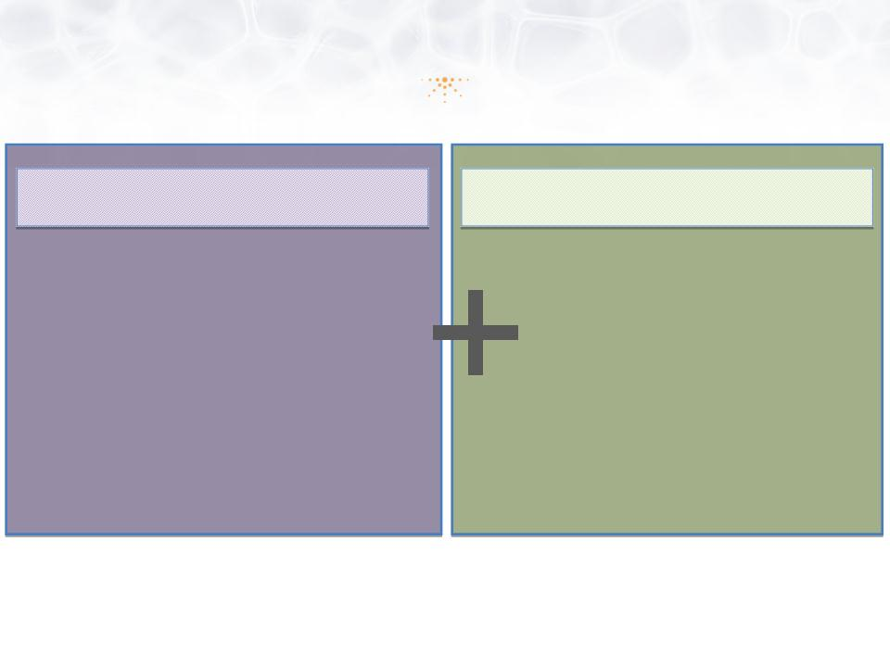

9

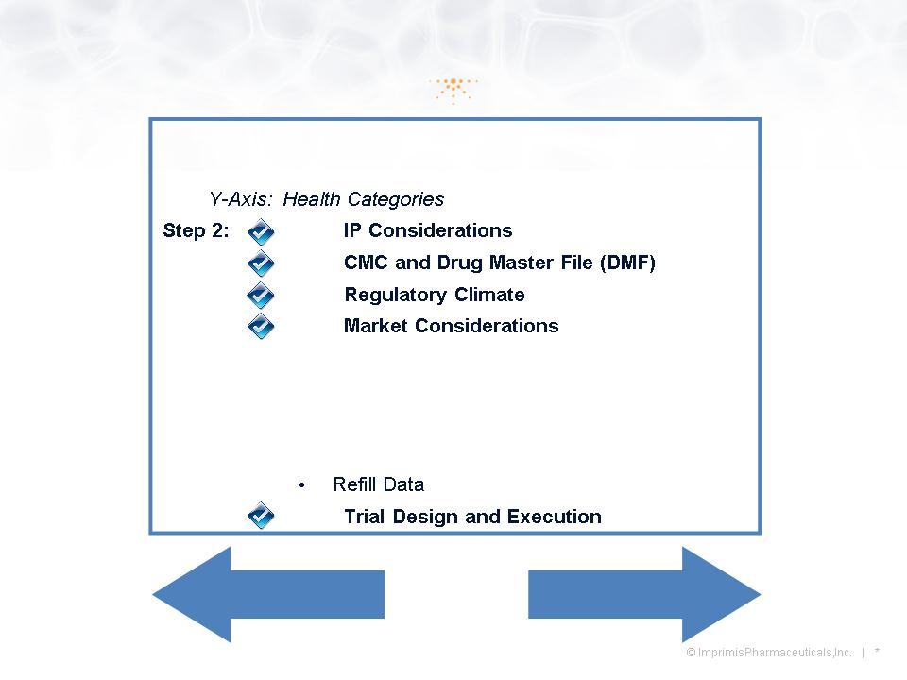

10

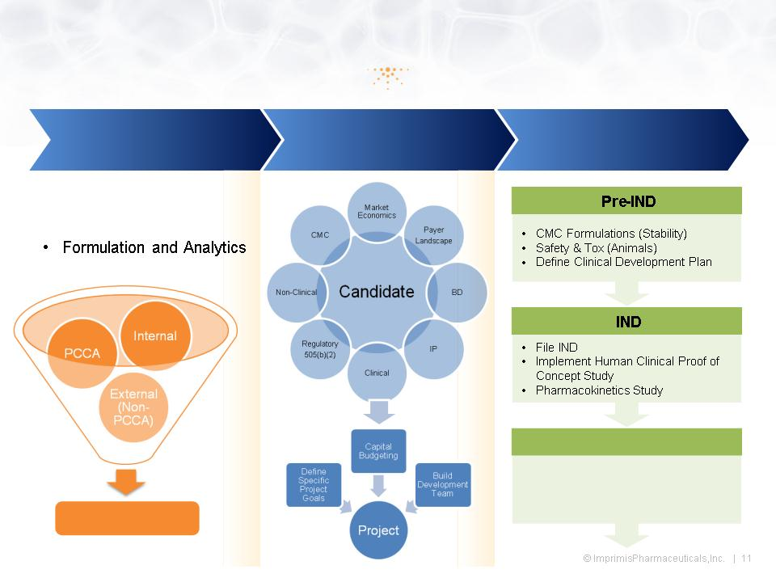

11

12


Therapeutic  Area | Compound | Indication | Market Analysis
PAIN | IPI110  Impracor™, Ketoprofen 10%  Cream | Sprains, Strains and  Joint Pain | $10B US NSAID Market  Transitioning to Topicals due to high incidence of AEs  Voltaren Gel has 75% Rx Share  Topical NSAID market may  exceed $1B by 2015
OPHTHALMOLOGY | IPI004**  Corticosteroid +  Antibiotic | Prophylaxis of Post-  Operative Complication  following Cataract,  Glaucoma, and Retinal  Surgery | 19M Global Cataract Surgeries (2011); $200-  $300/drugs/US surgery  Growing Market due to Aging Pop. and Demand to have  surgery at an earlier age  Combination (single injection) will minimize risk for injury  and infection versus multiple injections
WOUND HEALING | IPI120  Tranexamic Acid + Antibiotic | Topical wound care  treatment of genetic  and acquired bleeding  disorders | $9B Global Bleeding and Clotting Disorders Market  $17B US Wound Care Market  7M American suffering from chronic wound, annually
** Imprimis has an exclusive option and right to negotiate to acquire this drug formulation and intellectual property based on substantially prenegotiated terms.

13

14

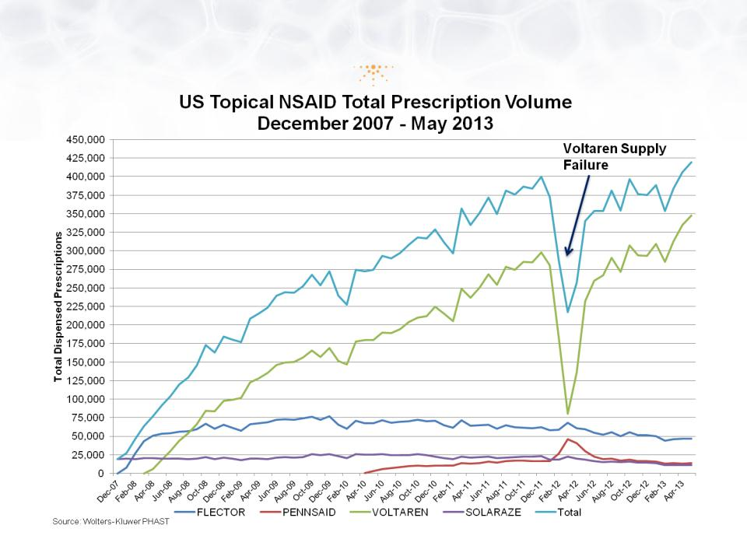

15

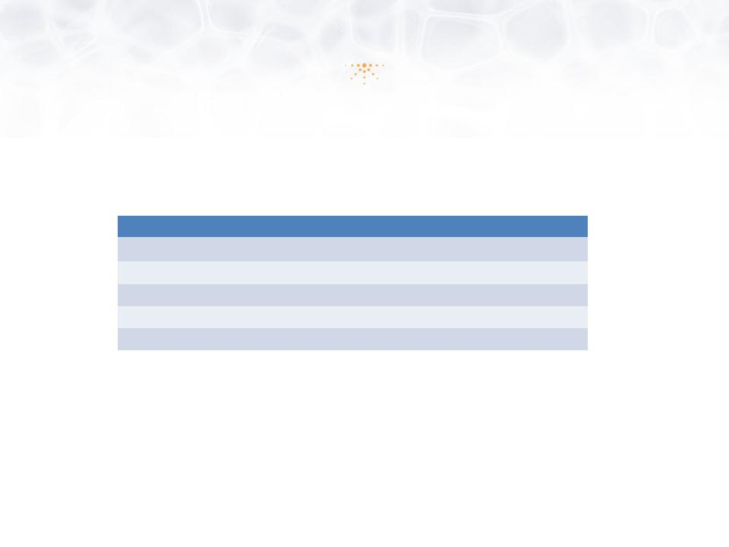
Factor | Impracor™ | Voltaren®
Delivery Technology | Patented Accudel™ Micelles | None; Alcohol
API | 10% Ketoprofen | 1% Diclofenac
COX Selectivity | Cox 1 | Cox 2
Smell | Neutral | Insect Repellant
Tactile | Smooth | Greasy

16

17

18

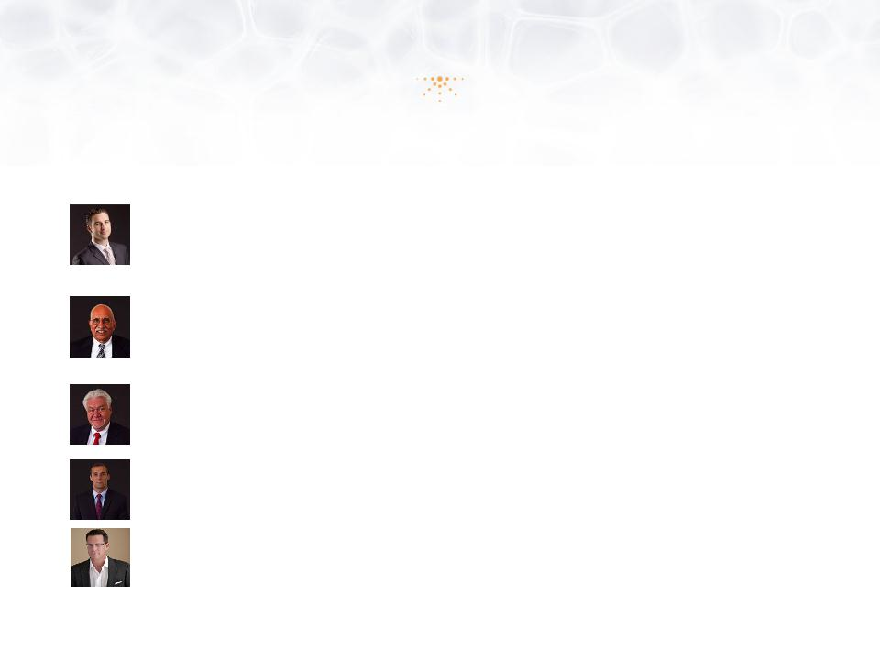

19

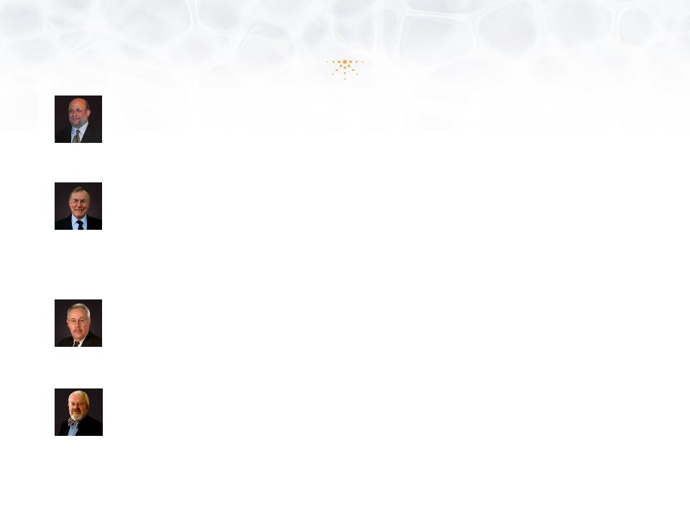

20


 | Capital Structure  March 31, 2013  (Unaudited) | Percent
Common Shares | 8,888,250 | 82.72%
Total Restricted Stock Units | 200,000 | 1.86%
Total Options & Warrants - Weighted Avg. Ex. Price  $5.42 | 1,656,258 | 15.42%
Total Common Shares - Diluted | 10,744,508 | 100.00%

21

22



23

24

25

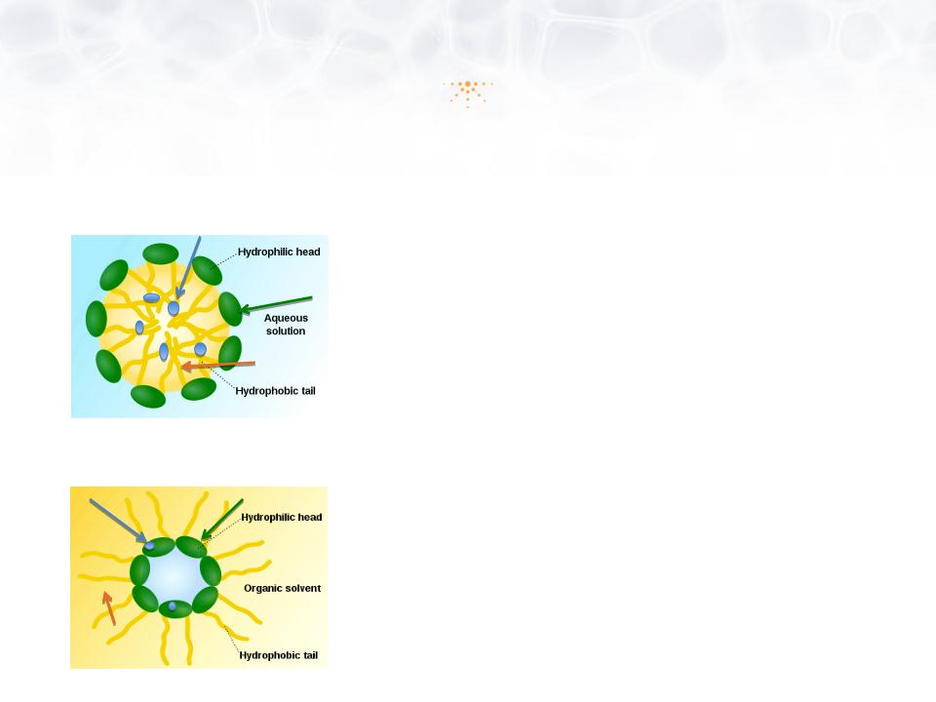

26

27

28

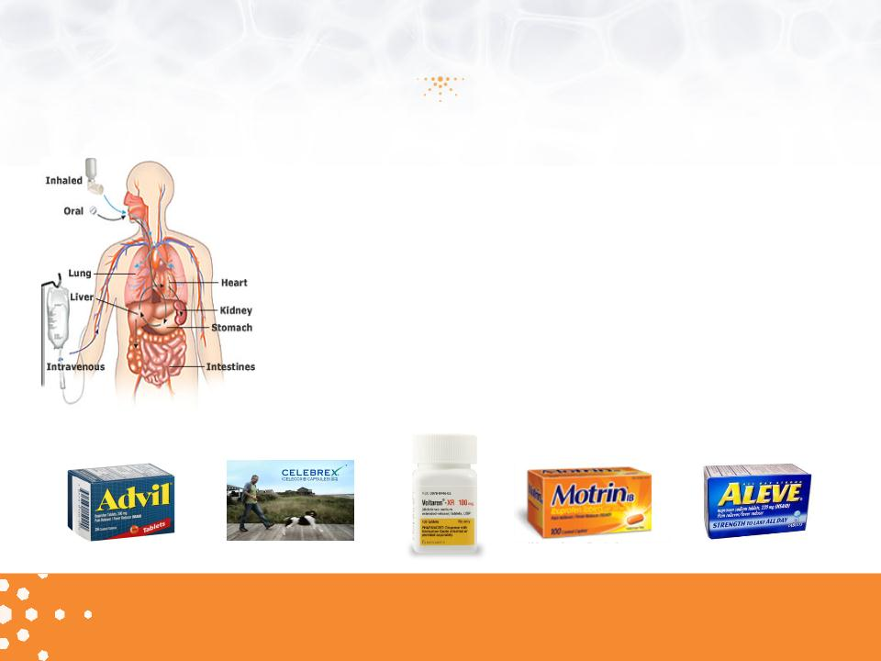

29

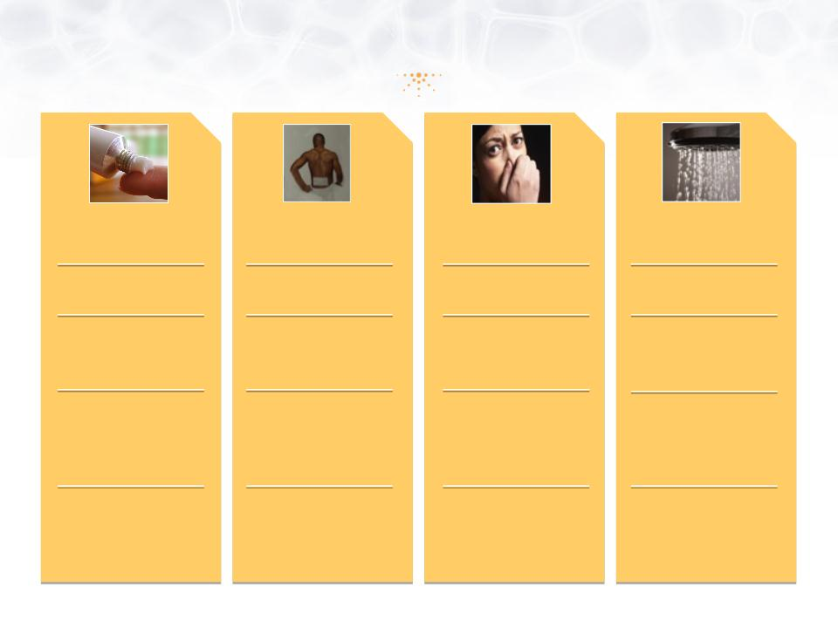

30

31

32

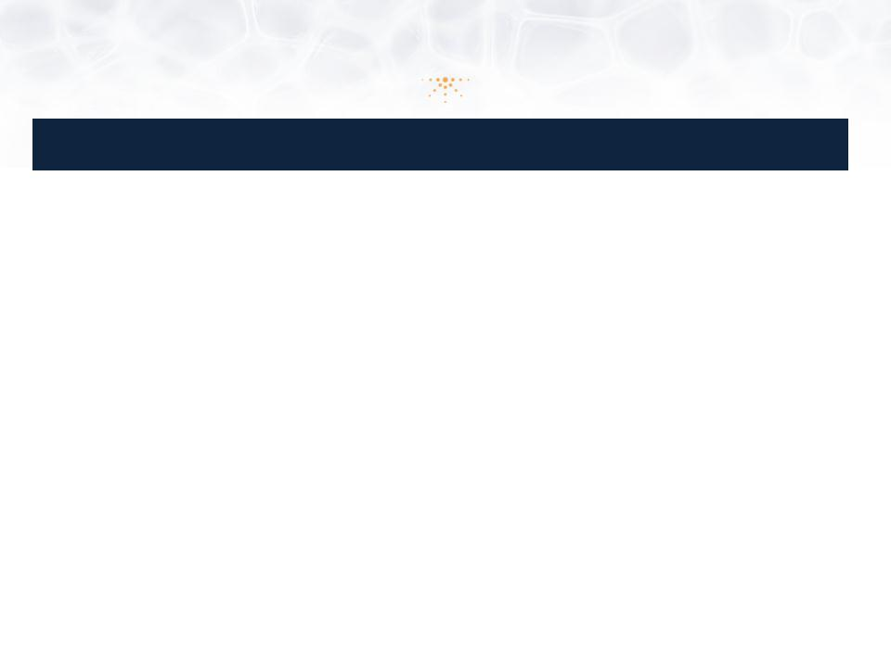
 | Ketoprofen 20% Patch  (ENDO) | Ketoprofen Transfersome  Gel, Diractin™ (IDEA) | Diclofenac Solution  Pennsaid™ (Nuvo)
Phase | 3 | 2/3 | 2
Study Dates | Aug 2006 - May 2007 | Jul 2003 - Jan 2004 | Jul 2010 - Mar 2011
# of Subjects/ Age | 309 / above 18 years | 397/ above 40 years | 248 / 18 -80 years
Regimen/ Duration | Ketoprofen Patch applied o.d.  4 weeks | 110 mg ketoprofen b.i.d. (n=138)  6 weeks  (1 placebo capsule b.i.d.  100 mg celecoxib capsule b.i.d.) | 1.3 mL applied to front, back and sides of knee  b.i.d. (n=84)  Vehicle and placebo controlled  4 weeks
Selection | Diagnosis of knee (unilateral or bilateral),  CRO: PPD | Morning stiffness < 30’, crepitus, at least 3 on  Likert’s 5 point scale, not on NSAIDS | Patients using NSAIDs underwent a 1-week  washout  This was a non-flare study
Primary Endpoint | WOMAC (pain) week 2 | WOMAC (pain ) week 6• | WOMAC (pain ) week 4
Secondary Endpoints | Pain Intensity/ relief (diary)  WOMAC (function), Rescue Medication,  quality of sleep, lost days of work. Pat./Phys.  global assessment | WOMAC (function)-week 6.  Patient global assessment  (5 Point Likert)• | WOMAC (stiffness) , WOMAC (function), WOMAC  (pain on walking) - - week 4  Patient global assessment  Pain assessment 11 point scale
Conclusions | ITT Primary Endpoint met: Significant  differences vs placebo (p=0.014). All  secondary endpoints met. Previously two  Phase 3 sprain/strain trials failed,  program discontinued. ENDO 10Q 2007 | WOMAC pain LS mean reduction - 18.2 (-22.1 to -  14.3), -20.3 (-24.3 to -16.2) and -9.9 (-13.9 to -  5.8) osteoarthritis (p <0.01)  All WOMAC subscale scores were normalized to  a scale of 0 to 100 by dividing the sum subscale  score by the number of questions of each score.  Ann Rheum Dis. 2007; 66(9): 1178-83.  Swissmedic approval based on single study | WOMAC pain reduction (5-Point Likert) from  baseline (-3.9 [- 4.8 to -2.9]) compared with vehicle  -control solution (-2.5 [- 3.3 to -1.7]; p = 0.023) or  the placebo solution (-2.5 [-3.3 to -1.7]; p = 0.016).  CMAJ • AUG. 17, 2004; 171 (4)  5 Phase 3 trials have achieved all 3 primary end  points in OA.

33

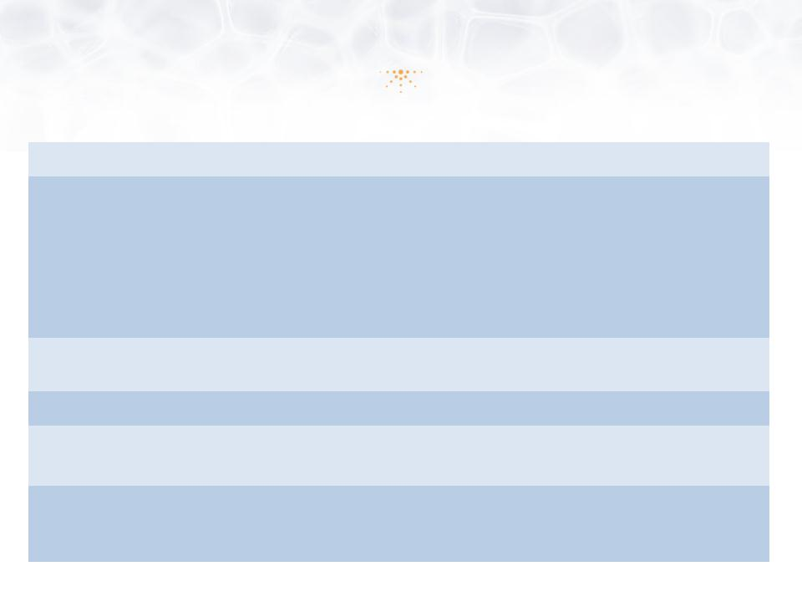
Design: | Randomized, double-blind, placebo-controlled at 26 sites
Study Population: | Efficacy, n = 361  Uncomplicated acute soft tissue injuries  Ankle (n=97), Shoulder (n=87), Knee (n=59), Wrist (n=57), Elbow (n=30), Calf/Anterior Tibialis  (n=11), Hamstring/Quadriceps (n=8), Forearm (n=5), Biceps/Triceps (n=3), Hand (n=3)  Safety, n = 364  Ranging in age from 18 - 75 years
Key Entry Criteria: | Injury occurred within 72 hours, pain intensity ≥ 60mm on 100 mm Visual Analogue Scale  (VAS); no intake of unallowable medication
Dosing Regimen: | Impracor vs. Placebo (Vehicle) cream, 1g t.i.d. x 7 days
Primary Endpoint: | Change from baseline in pain intensity during daily activities on Day 3 office  visit (+1, +2 days) with 100 mm VAS measurement
Secondary  Endpoints: | • Change from baseline in three times daily pain intensity immediately prior to medication  • Various other treatment satisfaction and safety assessments  • Pharmacokinetics in subset of patients

34

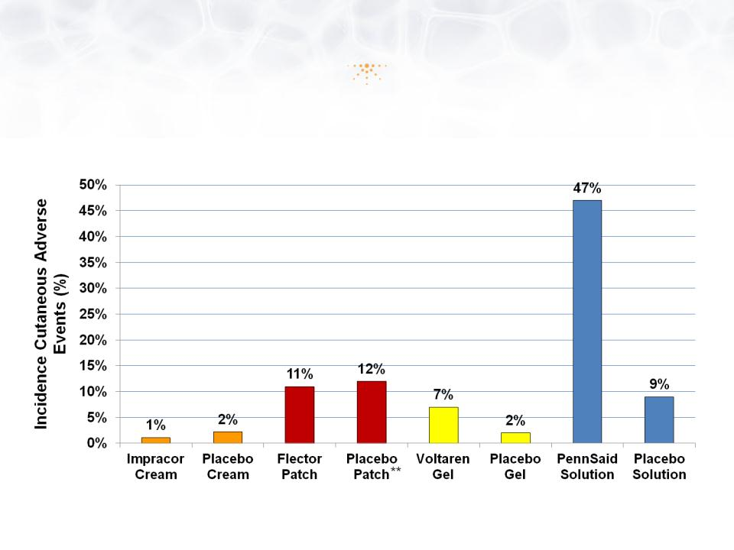

35

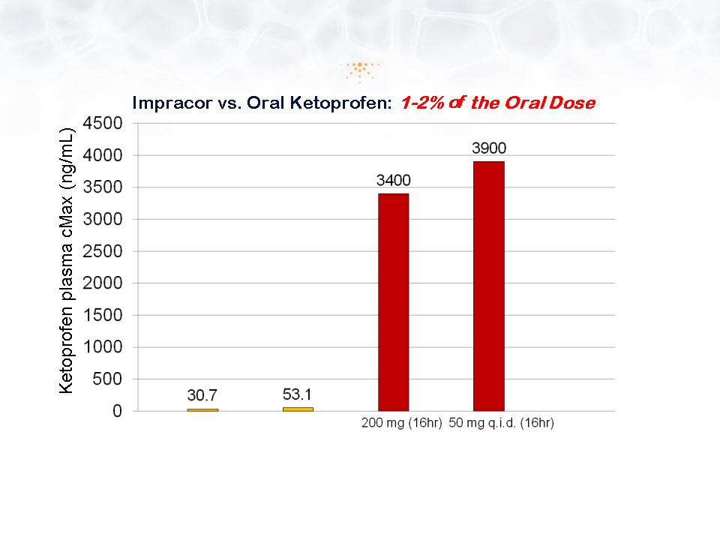

36

37

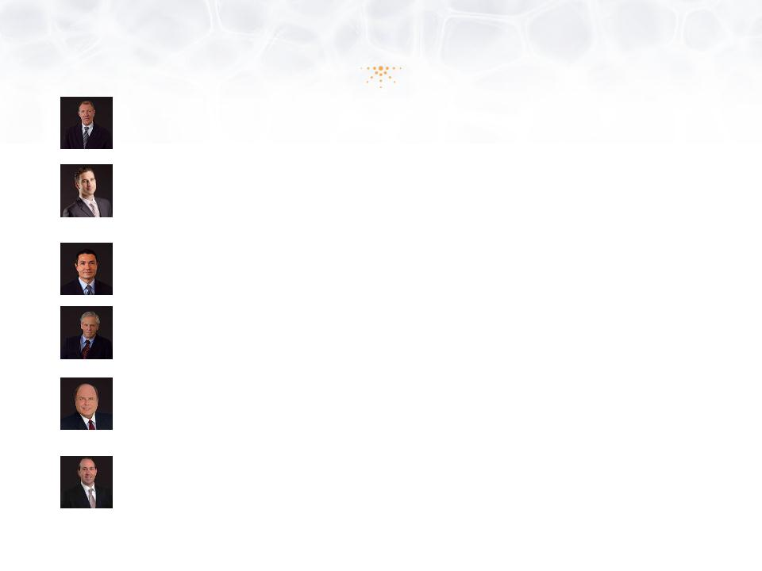

38

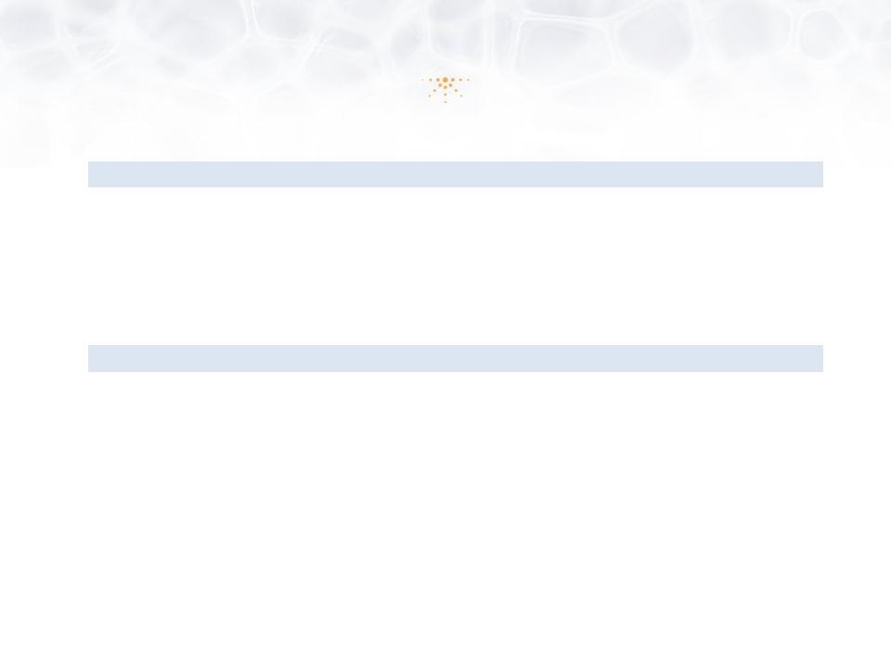
ASSETS |  |  |  | March 31, 2013
Current Assets
 | Cash and short term investments |  | $ | 19,029,031
 | Other assets |  |  | 217,540
 |  | TOTAL ASSETS | $ | 19,246,579
LIABILITIES AND STOCKHOLDERS' EQUITY
 | Accounts payable and other accruals |  | $ | 848,549
 |  | TOTAL LIABILITIES |  | 848,549
Stockholder’s Equity
 | Common stock, $0.001 par value, 395,000,000 shares authorized,
 |  | 8,888,250 shares issued and outstanding |  | 8,888
 | Additional paid-in capital |  |  | 43,958,891
 | Deficit accumulated during the development stage |  |  | (25,569,749)
 |  | TOTAL STOCKHOLDERS' EQUITY |  | 18,398,030
 |  | TOTAL LIABILITIES AND STOCKHOLDERS' EQUITY | $ | 19,246,579

39

