UNITED STATES

SECURITIES AND EXCHANGE COMMISSION
Washington, D.C. 20549

FORM 8-K

CURRENT REPORT

Pursuant to Section 13 OR 15(d) of The Securities Exchange Act of 1934

Date of Report (Date of earliest event reported): November 6, 2013

IMPRIMIS PHARMACEUTICALS, INC.

(Exact name of registrant as specified in its charter)

Delaware

(State or other jurisdiction

of incorporation)

001-35814

(Commission

File Number)

45-0567010

(IRS Employer

Identification No.)

12626 High Bluff Dr. Ste 150

San Diego, CA

(Address of principal executive offices)

92130

(Zip Code)

Registrant’s telephone number, including area code: (858) 704-4040

N/A

(Former name or former address if changed since last report.)

Check the appropriate box below if the Form 8-K filing is intended to simultaneously satisfy the filing obligation of the registrant under any of the following provisions:

- ] Written communications pursuant to Rule 425 under the Securities Act (17 CFR 230.425)

- ] Soliciting material pursuant to Rule 14a-12 under the Exchange Act (17 CFR 240.14a-12)

- ] Pre-commencement communications pursuant to Rule 14d-2(b) under the Exchange Act (17 CFR 240.14d-2(b))

- ] Pre-commencement communications pursuant to Rule 13e-4(c) under the Exchange Act (17 CFR 240.13e-4(c))

Item 7.01. Regulation FD Disclosure

Attached as Exhibit 99.1 to this Item 7.01 is a presentation that is being used by the management of Imprimis Pharmaceuticals, Inc. (the “Company”) in meetings describing the Company.

The information contained in Item 7.01 of this report and in Exhibit 99.1 shall not be deemed “filed” for purposes of Section 18 of the Securities Exchange Act of 1934, as amended (the “Exchange Act”), or incorporated by reference in any filing under the Securities Act of 1933, as amended, or the Exchange Act, except as shall be expressly set forth by specific reference in such a filing.

Item 8.01. Other Events

On November 6, 2013, the Company issued a press release included as Exhibit 99.2 to this Current Report on Form 8-K.

Item 9.01. Financial Statements and Exhibits

- Exhibits

99.1 Presentation dated November 2013

99.2 Press Release dated November 6, 2013

SIGNATURES

Pursuant to the requirements of the Securities Exchange Act of 1934, the registrant has duly caused this report to be signed on its behalf by the undersigned hereunto duly authorized.

 | IMPRIMIS PHARMACEUTICALS, INC.
Dated: November 7, 2013 | By: | /s/ Andrew R. Boll
 | Name: | Andrew R. Boll
 | Title: | Vice President, Accounting and Public Reporting

EXHIBIT 99.1
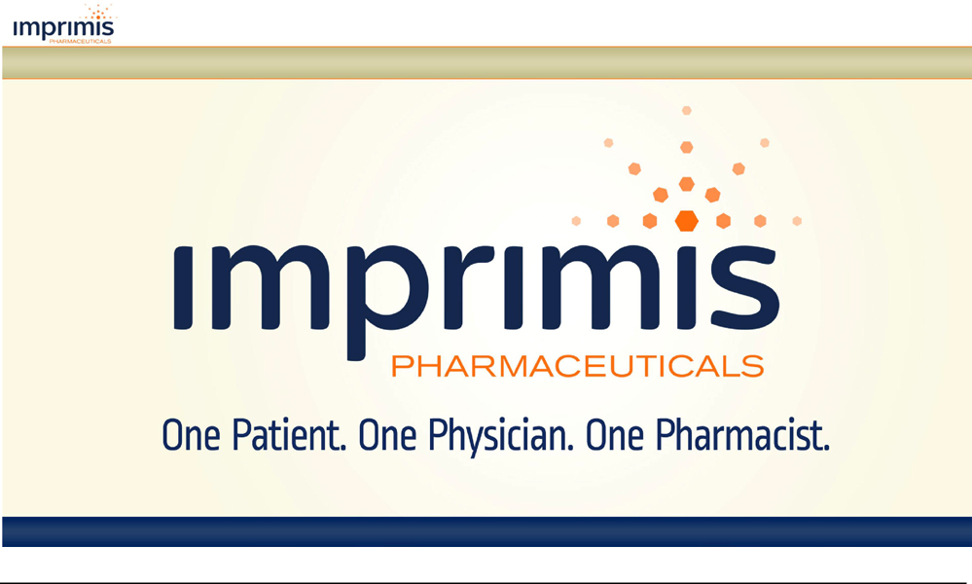

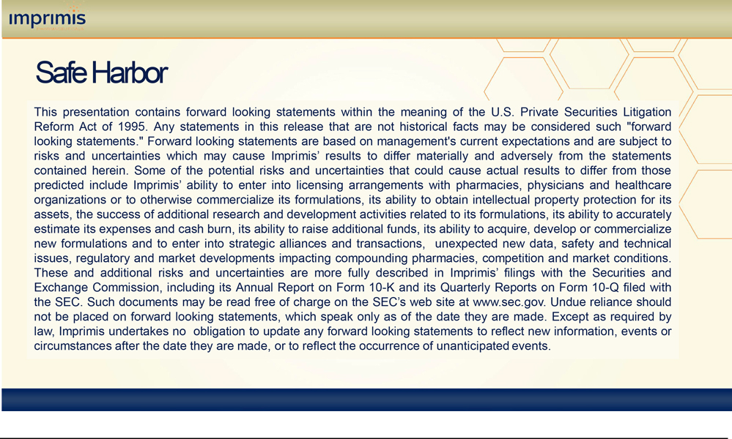

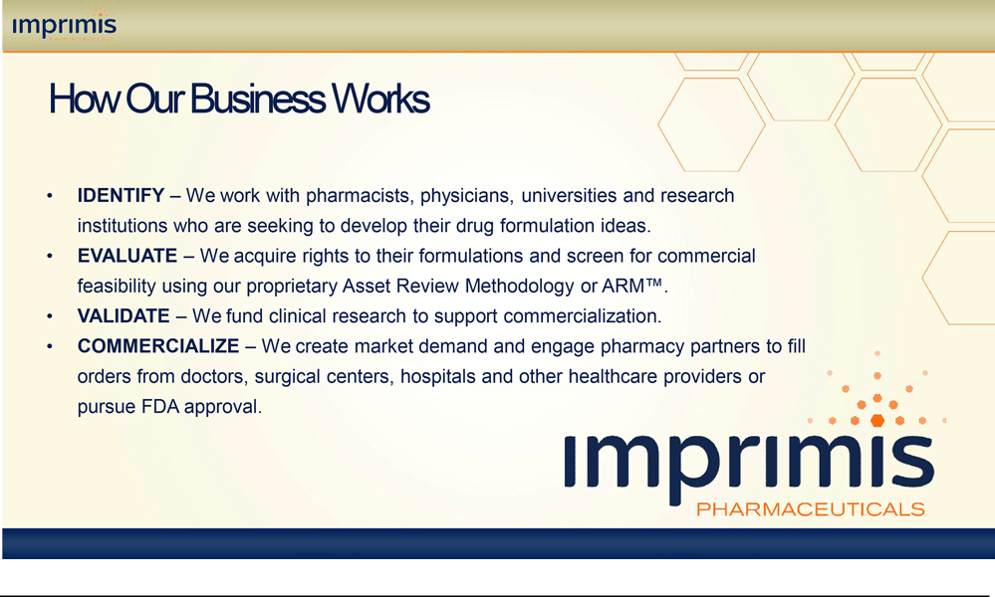

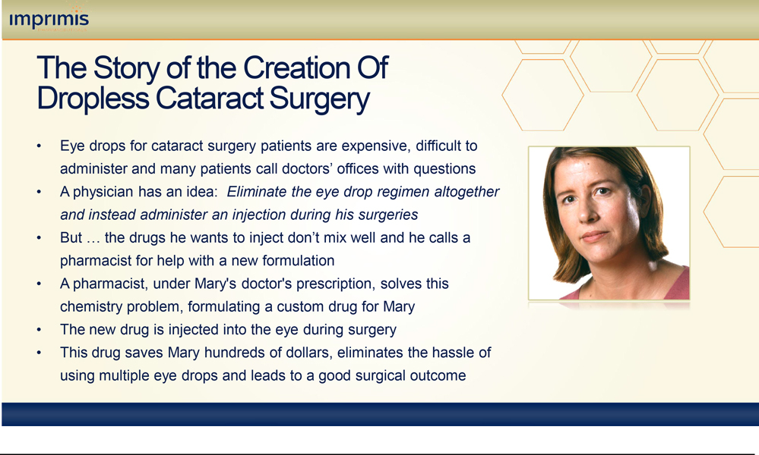

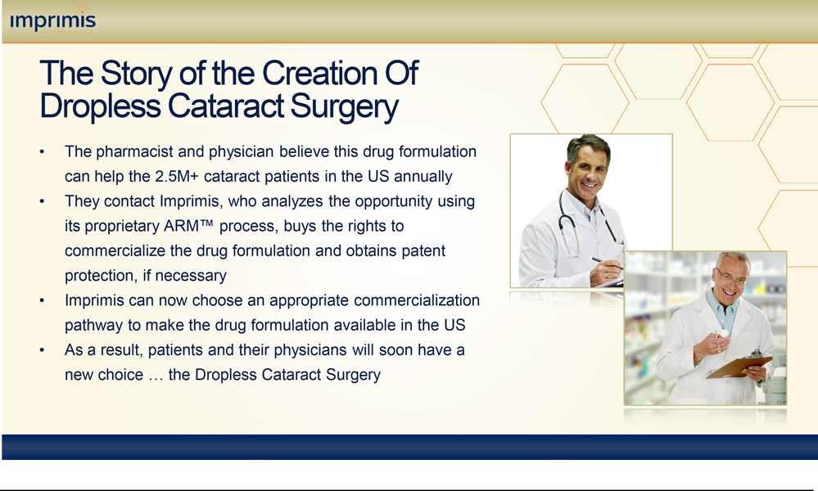

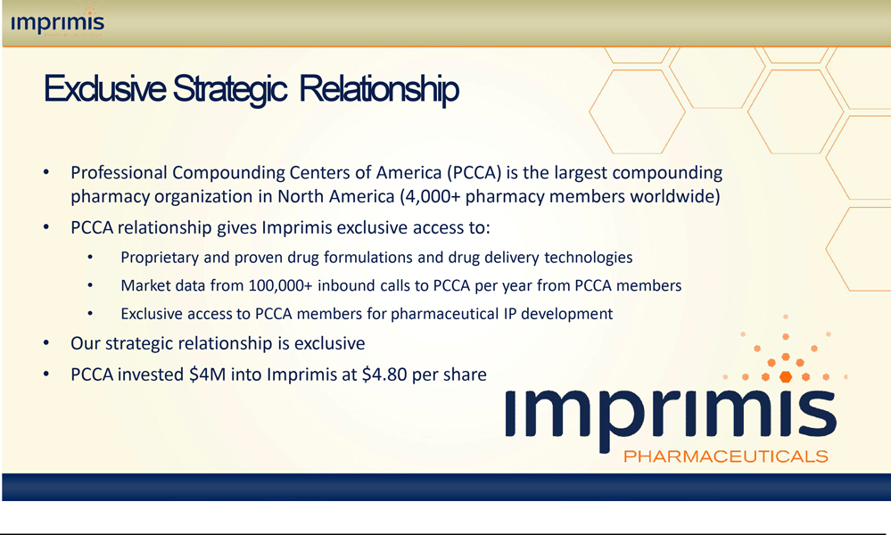

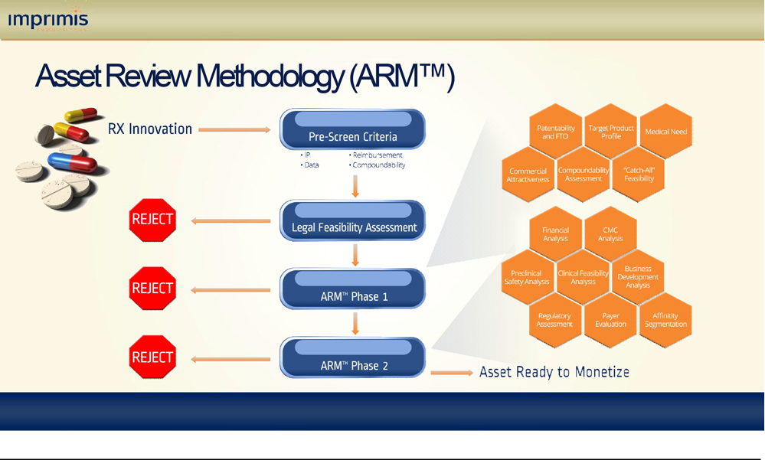

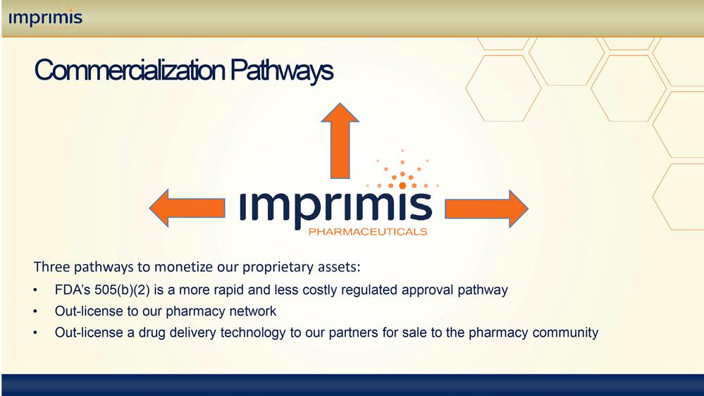

.

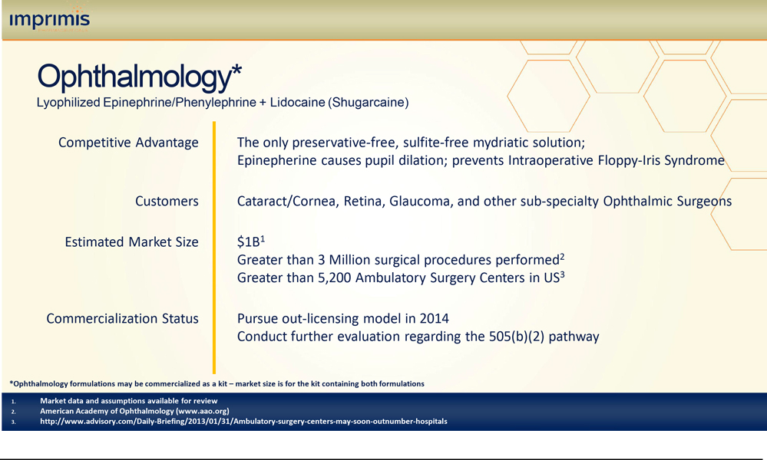

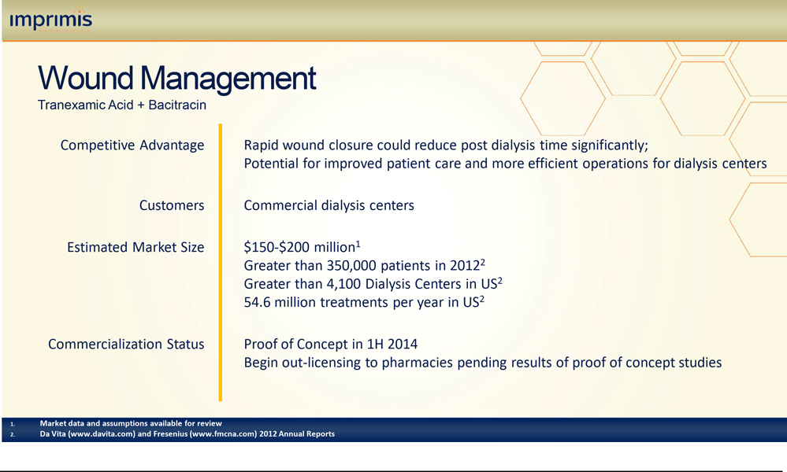

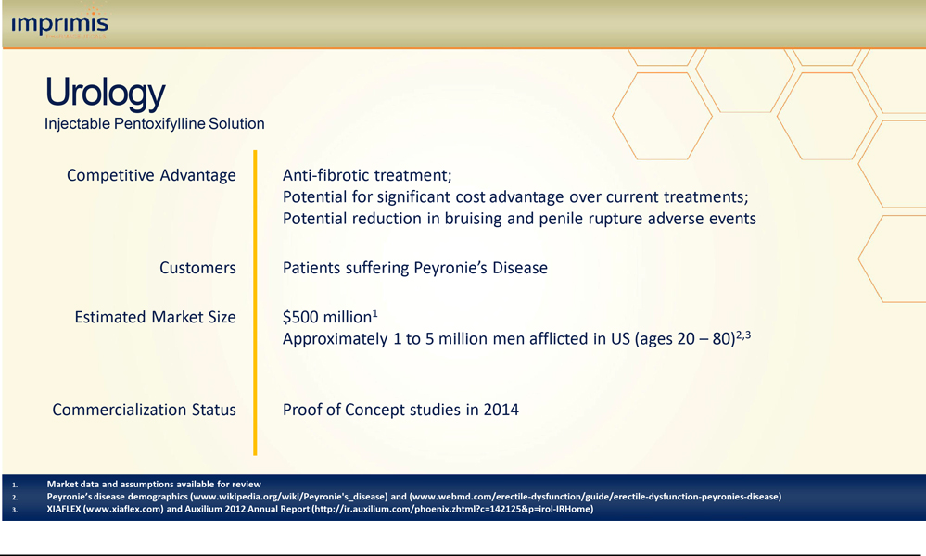

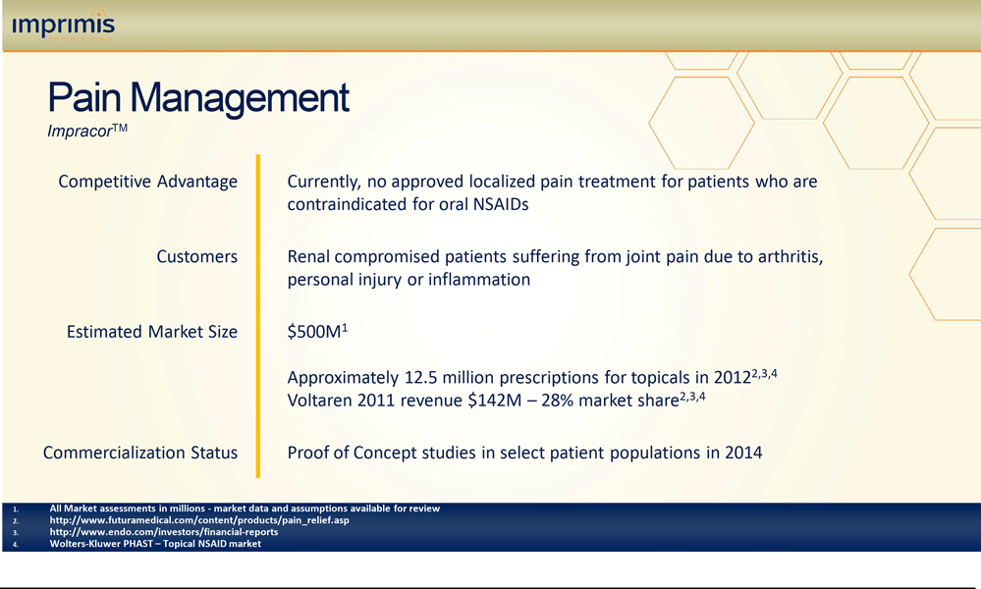

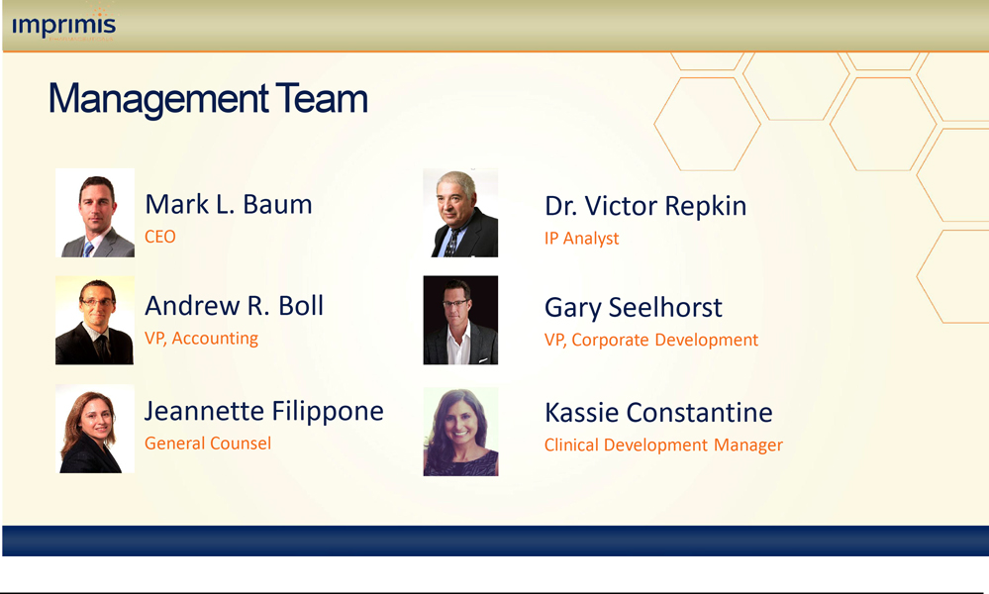

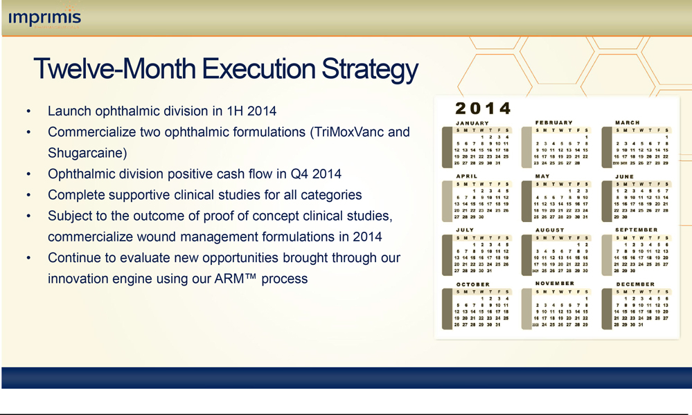

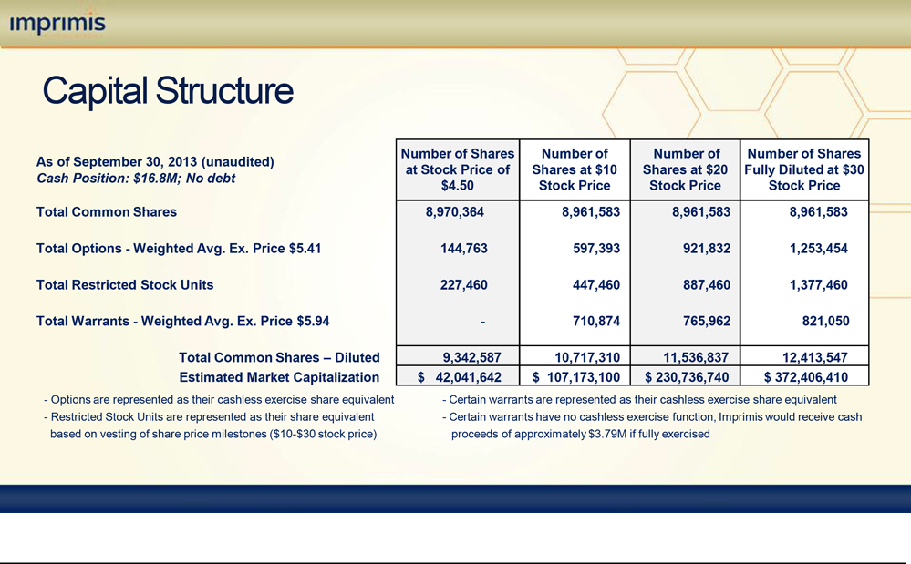

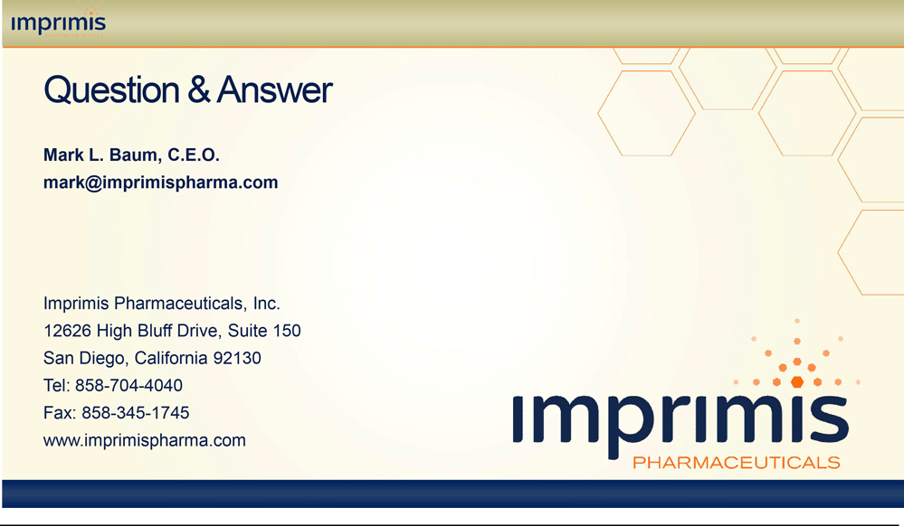

EXHIBIT 99.2

Imprimis Pharmaceuticals Inc. Announces Shift in Strategic Direction

Leveraging its relationships with physicians and pharmacists, Imprimis plans to focus on drug commercialization in four therapeutic areas: Ophthamology, Wound Management, Urology and Pain

SAN DIEGO, Calif., November 6, 2013—Imprimis Pharmaceuticals, Inc. (NASDAQ: IMMY), a pharmaceutical company focused on commercializing novel drug formulations invented by physicians and pharmacists through their clinical experience with patients, today announced a shift in the focus of its strategic direction, aimed at diversifying its development and commercialization activities and shortening time to market.

Under a strategic plan adopted by Imprimis on Friday, Imprimis plans to develop and commercialize its proprietary formulations in the ophthalmic, wound management, urology and pain therapeutic areas utilizing multiple commercialization pathways, including the FDA’s Section 505(b)(2) pathway, and, uniquely, by selectively out-licensing its novel formulations to accredited pharmacies in order to satisfy physician and patient interest in Imprimis’ drug assets. For Imprimis’ non-drug assets, such as drug-delivery vehicles, Imprimis will seek partnerships with wholesalers in order to make these technologies available to pharmacies across North America.

“We believe this is truly a new dawn for Imprimis,” said Mark L. Baum, the company’s Chief Executive Officer. “We are a company that believes that meaningful pharmaceutical innovation comes from the clinical interaction between one physician and one pharmacist in order to serve a patient’s need. In many cases, innovation generated from this interaction can create new drug development and commercialization opportunities that may serve much broader patient populations. In such cases, through our strong relationship with a growing number of innovative physicians, pharmacists and research institutions, Imprimis will subject these formulations to our rigorous, proprietary evaluation process, seek to acquire ownership rights, build supportive clinical efficacy data and then choose the most expeditious commercialization pathway to make these therapies available to patients in the U.S. and abroad.”

Gary Seelhorst, Vice President of Corporate Development, added, “At Imprimis, we have developed a proprietary Asset Review Methodology, or ARM, process, which is designed to produce a complete development and commercialization profile on a product candidate. Using ARM as a guide for decision-making, Imprimis is currently focused on four key therapeutic areas: Ophthalmology, Wound Management, Urology and Pain. We believe these areas maximize the associated commercial opportunity as well as the ability to satisfy unmet medical needs.”

In each of these therapeutic areas, Imprimis owns formulations that it believes offer unique competitive advantages in the drug prescribing value chain. Over the past year Imprimis has acquired drug formulations and related intellectual property for formulations it hopes to launch beginning in 2014.

Imprimis 2014 Formulation Portfolio Development and Commercialization Plan

Therapeutic Area | Disease or Care Setting | Formulation | Projected Potential | Commercialization Status
Therapeutic Area | Disease or Care Setting | Formulation | Market Size | Commercialization Status

Ophthalmology

Wound Management

Urology

Pain

Cataract and Glaucoma Surgery Patients

Mydriatic Agent and For Intraoperative Floppy-Iris Syndrome (IFIS) in Ocular Surgery Patients

Rapid Wound Closure for Patients in Kidney Dialysis Centers

Patients with Peyronie’s Disease

Renal-Compromised Patients with Osteoarthritis, Joint Pain, or Inflammation

Two or more of Triamcinolone + Moxifloxicin + Vancomycin injectable solutions

Lyophilized Epinephrine + Lidocaine/ Phenylephrine + Lidocaine (Shugarcaine)

Tranexamic Acid + Bacitracin

Injectable Pentoxifyline Solution

Impracor

10% Ketoprofen Cream

>$1B

$100 M - $200 M

$500 M

$500 M

Pursue out-licensing to pharmacies during 2014

Pursue a pre-IND Meeting during 2014

Proof of concept (POC) studies in first half 2014; begin out-licensing to pharmacies pending results

POC studies in first half 2014; pursue commercialization strategy pending results

POC studies in select patient populations in 2014; begin out-licensing to pharmacies pending outcome of results

Seelhorst continued, “Because of the near-term opportunities in the Ophthalmology therapy area, Imprimis has already begun to build a world-class commercialization team to execute in this specialized market. This team brings a wealth of experience from giants in the industry in developing and commercializing ophthalmic drugs.”

Imprimis’ new strategy will be supported by clinical data to either support a 505(b)(2) development program or to give sufficient clinical confidence to a prescribing physician that their patients will benefit from the proposed therapy choice. To support these clinical-development efforts, Imprimis has hired a Clinical Project Manager to develop and execute proof-of-concept studies for its ophthalmic, wound management and urology products.

As part of Imprimis’ shift in strategic direction, Imprimis plans to consider alternative commercialization pathways for Impracor, which may include an improvement of its formulation and the licensing of such a formulation to a network of partner pharmacies. As a result of careful consideration of the totality of circumstances surrounding Impracor, the current Impracor Phase 3 clinical program has been discontinued.

With the adoption of Imprimis’ new strategic initiatives, projected cash burn is expected to decrease by more than $7.5 million over the next 12 months as compared with its previous estimates. “We believe that our reduced burn rate and the near term commercialization of some of our key formulations will allow us to reach positive cash flows from our operations before our current cash position of over $16 million is exhausted,” Baum said.

“We believe in the power of the clinical interaction of one patient, one physician and one pharmacist to build new, personalized therapies that have broad market appeal,” Baum said. “Our story is about how real people benefit from our drugs. Our philosophy is to bring the best of these personalized medicines to patients around the country through our spirit of innovation, our partnerships with physicians and pharmacists and our proprietary review and commercialization process. Through our relationship with many innovative physicians and pharmacists across the United States, we have built a valuable innovation network that has generated significant drug innovation and related intellectual property. Our focus on intellectual property development, combined with our formulation development capabilities, our ability to support a project with capital, and our collaborative approach, all have resonated well with our inventor partners. We believe that this approach provides us with advantages over other development and investment partners and will offer Imprimis continuing access to new opportunities. We look forward to an exciting new era of innovation and value creation for our shareholders.”

On December 16, 2013, Imprimis will host a shareholder event in Denver, Colorado. This event will take place at the offices of Morrison & Foerster LLP in Denver, Colorado, and will be recorded and made available for replay by visiting the Investor Relations section of the Imprimis new corporate website at www.imprimispharma.com. Additional information about the planned shareholder event will be made available on the Imprimis corporate website.

ABOUT IMPRIMIS PHARMACEUTICALS

Imprimis Pharmaceuticals, Inc. (NASDAQ:IMMY) is a pharmaceutical company focused on the commercial development of novel drug formulations and proprietary drug delivery vehicles. Imprimis believes in the power of the clinical interaction of one patient, one physician and one pharmacist to build new therapies that have broad market appeal. Drug formulations created by pharmacists and physicians for a specific patient’s use are investigated through a proprietary and rigorous evaluation process, the Asset Review Methodology (ARM™), in order to assess safety, efficacy and potential for commercialization. Following sufficient clinical development, the company will use the FDA’s 505(b)(2) development pathway, or selectively make its formulations available to the market using alternative commercialization pathways in order to satisfy physician and patient interest in Imprimis’ drug assets. For Imprimis’ non-drug assets, such as drug delivery vehicles, Imprimis will seek partnerships with wholesalers in order to make these technologies available to compounding pharmacies across North America. The company’s current focus is in the Ophthalmology, Wound Management, Urology and Pain therapeutic areas.

SAFE HARBOR

This press release contains forward looking statements within the meaning of the U.S. Private Securities Litigation Reform Act of 1995. Any statements in this release that are not historical facts may be considered such “forward looking statements.” Forward looking statements are based on management’s current expectations and are subject to risks and uncertainties which may cause Imprimis’ results to differ materially and adversely from the statements contained herein. Some of the potential risks and uncertainties that could cause actual results to differ from those predicted include Imprimis’ ability to enter into licensing arrangements with pharmacies, physicians and healthcare organizations or to otherwise commercialize its formulations, its ability to obtain intellectual property protection for its assets, the success of additional research and development activities related to its formulations, its ability to accurately estimate its expenses and cash burn, its ability to raise additional funds, its ability to acquire, develop, commercialize or market new formulations and to enter into strategic alliances and transactions, the projected size of the potential market for our product candidates, unexpected new data, safety and technical issues, regulatory and market developments impacting compounding pharmacies, competition and market conditions. These and additional risks and uncertainties are more fully described in Imprimis’ filings with the Securities and Exchange Commission, including its Annual Report on Form 10-K and its Quarterly Reports on Form 10-Q filed with the SEC. Such documents may be read free of charge on the SEC’s web site at www.sec.gov. Undue reliance should not be placed on forward looking statements, which speak only as of the date they are made. Except as required by law, Imprimis undertakes no obligation to update any forward looking statements to reflect new information, events or circumstances after the date they are made, or to reflect the occurrence of unanticipated events.

For Media Inquiries:

Contact: Arielle Sklar or Robert Zito

212-403-6812

For Investor Inquiries:

BPC Financial Marketing

Contact: John Baldissera

800-368-1217

