Vane S J Thorax 2000;55:S3-S9
Topical NSAIDs in Acute OA Knee Pain Model
© Imprimis Pharmaceuticals, Inc. | A10
Additional Impracor™
Clinical Materials
© Imprimis Pharmaceuticals, Inc. | A9
3
2
1
0
-1
-2
-3
<5-fold
COX-2
selective
selective
5-50 fold
COX-2
© Imprimis Pharmaceuticals, Inc. | A11
Relative COX-1/COX-2 Selectivity
Cochrane Database Syst Rev. 2010;6:CD007402
Massey T, Derry S, Moore RA, McQuay HJ
Topical NSAIDs for acute pain in adults.
© Imprimis Pharmaceuticals, Inc. | A8
Ketoprofen is a Superior Active Ingredient
The proportion of participants experiencing successful treatment with topical
diclofenac in three clinical studies was 52% (166/319, range 39% to 92%)
The proportion of participants experiencing successful treatment with topical
ketoprofen in seven clinical studies was 73% (251/346, range 57% to 89%)
Ketoprofen vs. Diclofenac
The Impracor Solution

BMC Family Practice 2004, 5:10
Lorna Mason, R Andrew Moore*, Jayne E Edwards, Sheena Derry and Henry J McQuay
Study Mgmt Errors
• Low incidence of cutaneous AEs
• No related gastrointestinal (GI), cardiac, liver, or other serious AEs
** Prescribing Information for Flector Patch, Voltaren Gel and Pennsaid Solution
* Clinical Study Report: TDLP-110-001, September 2010
Safety: Low Incidence of Adverse Events
© Imprimis Pharmaceuticals, Inc. | A14
Sprain-Strain Soft Tissue Study
Initial Phase 3 Trial
© Imprimis Pharmaceuticals, Inc. | A13
New Impracor Phase 3 Program: 1H 2013
Change from baseline
in pain intensity
during daily activities
over the past 24
hours on Day 3 Visit
(Day 3, +1 or +2 days)
© Imprimis Pharmaceuticals, Inc. | A12
p = 0.034
Topical NSAIDs for acute pain: a meta-analysis
mPP *** (n=250)
Design & Execution Optimization Lead to Statistical Significance (p = <0.05)
*** mPP = Modified per protocol (mPP) analysis of mITT patients -- who complied with the protocol? (52) improperly dosed,
(22) no valid Day 3 primary endpoint assessment, and (4) were misdiagnosed
** mITT = Modified ITT of ITT patients - 35 met study entry criteria, but were excluded from ITT due to exclusionary criteria:
(1) misdiagnosis, (30) positive drug screen, (4) other lab values at baseline making the patient ineligible for the trial
* ITT = Intent-to-treat (ITT) population
“Once randomized, you’re analyzed” p = 0.087
mm
Mean reduction from baseline in mm (100 mm Visual Analogue Scale)
ITT * (n=361)
Study Design Error
mITT ** (n=326)
p = 0.038
Retrospective Analysis of 1st Phase 3 Study
1 gram
3 x per day =
3 grams/day
Local AEs 11%
Not to be worn in water
Adherence issues
Fixed one size patch
10 x 14 cm patch
2 x per day
1.3% Diclofenac
epolamine
(Imprimis)
IMPRACOR
Seeking acute
musculoskeletal pain label
Accudel Delivery System
Local AEs 1-2%
Convenient / Cream
Elegant Formulation
Safe / Cutaneous
Acute soft tissue
injury (positive data
in ankle sprain)
Cream
10% Ketoprofen
Competitive Landscape
© Imprimis Pharmaceuticals, Inc. | A6
Widespread Usage With Serious Side Effects
• NSAID GI Toxicity - the 15th most common cause of death in US
• Over 16,000 deaths every year from GI NSAID complications
• Hospitalizations alone cost more than $2B per year
• Over 100,000 per year are hospitalized from NSAID complications
Result: Toxicity to Gastro Intestinal (GI) Tract, Kidneys and Liver
• Usage of oral NSAIDs is increasing
• 70% of all 65+ Year Olds Take NSAIDs Weekly
• Regularly used by more than 60M Americans (Arch Intern Med. 2005;165:171-177)
1.5% Diclofenac
“Meta-analysis of 26 trials (n=2,853) … showed that Ketoprofen was
significantly better than all other topical NSAIDs. In terms of efficacy,
Ketoprofen was significantly better than ibuprofen, felbinac, piroxicam and
indomethacin.”
Ketoprofen vs. Ibuprofen
© Imprimis Pharmaceuticals, Inc. | A7
(Covidien/Nuvo)
PENNSAID
Chronic OA of knee
Local AEs 47%
Causes garlic taste/breath
Complicated application
Dimethyl sulfoxide
(DMSO); Safety concerns
3-4 x per day =
160 drops/day
40 drops of liquid
(10 drops to each of 4 sides of knee)
sodium
© Imprimis Pharmaceuticals, Inc. | A15
(Endo/Novartis)
VOLTAREN GEL
Chronic OA of hand
and knee
Local AEs 7%
Odor / Staining
Sticky / Greasy
Large Quantities
4 x per day =
16 grams/day
2-4 gram
sodium
1% Diclofenac
(Pfizer/IBSA)
FLECTOR PATCH
1/2 Active/Placebo on R or L Legs
Responsible for Restructuring Imprimis, including $7.95M New Equity Investment and PCCA transaction
Founder of 3 private investment funds; Restructured numerous companies (private-to-public)
15+ Years of Senior Executive Experience; Founder/President, YesRx.com (1999)
Mark L. Baum, J.D.
Retired Associate Professor & Course Director - Orofacial Pain, University of Colorado
30+ Years Clinical Practice - Diplomate, American Board of Orofacial Pain
Active Clinical Research & Consulting Practice
Managing Member of financial group that restructured Imprimis
Robert J. Kammer, D.D.S.
Board of Directors
© Imprimis Pharmaceuticals, Inc. | A20
Additional Corporate
Information
© Imprimis Pharmaceuticals, Inc. | A19
n=16
Paul Finnegan, M.D., M.B.A.
13+ Years Commercialization and Development Experience
Ops Experience: Avalon Ventures, Alexion, Pharmacia/Searle); Univ. of Chicago MBA
n=16
Either Active o (both legs) Placebo
p=0.0104
p=0.0118
No Adverse Events Reported
VAS muscle soreness means ± SE at 0, 24 and 48 hours.
Significantly less soreness in the Impracor vs placebo
(p=0.0104) between 24 and 48 hours
VAS muscle soreness means ± SE 0, 24 and 48 hours,
significantly less soreness in the Impracor vs placebo group
(p=0.0118) between 24 and 48 hours
Placebo
Impracor
6
5
4
3
(Abbreviated)
Candidate
NDA & LAUNCH
• Market Launch/Partner
• NDA via 505(b)(2)
• Complete Phase 3
• Out-License or Develop
• Field Experience
• Drug Master File
• Market Data
Projects
Candidates
Ideas
Imprimis Development Process
2
© Imprimis Pharmaceuticals, Inc. | A22
Balance Sheet
© Imprimis Pharmaceuticals, Inc. | A21
Manages audit, SEC, Sarbanes-Oxley and business consulting engagements with a focus on technology,
manufacturing, service, real estate, social media and non-profit organizations
Partner at Swenson Advisors, LLP since May 1998
Audit Committee Chairman; Board service on over 12 boards and related board committees
Stephen Austin, C.P.A.
Co-developer of our Accudel drug delivery technology and Impracor topical NSAID
Practicing primary care clinician for 20+ years
Founder and Director since 1998
Jeff Abrams, M.D.
Drugs: Celebrex, Bextra, Arthrotec, Soliris, Inspra and Aldactone/Soldactone
Senior Positions: Avalon Ventures, Alexion Pharmaceuticals, Pharmacia/Searle/Monsanto
**Orudis ketoprofen extended release capsule/ Oruvail capsule prescription information
p = 0.041*
© Imprimis Pharmaceuticals, Inc. | A17
* =.statistically significant
All ITT patients (n=361)
Mean Change from Baseline in 3X/daily
Pain Intensity Prior to Medication (from Patient Diary)
Clear Separation of Data Day 4 Onwards
Orudis**
© Imprimis Pharmaceuticals, Inc. | A16
2g t.i.d. (48hr)
1g t.i.d. (48hr)
Oruvail**
10% ketoprofen cream
Impracor*
We Believe We Know What Body Part to Study
* Cannavino, C. et al. Efficacy of Transdermal Ketoprofen in delayed onset muscular soreness,Clinical Journal of Sports Medicine, 13: 200-208,
2003 and Clinical Study Report Project No. 990808, Phase 1/2 Study Report Aug 2007
Pharmacokinetics: Low Systemic
Absorption
*
*
**
**
**
**
**
40 drops, 4x daily
4g, 4x daily
180mg, 2x daily
1g, 3x daily
1
1
0
48h
24h
0h
Time
Placebo
Impracor
6
5
4
3
2
• 70 Million prescriptions for NSAIDs each year in US (Wiegard in Medscape)
0
48h
24h
0h
Time
Cannavino, C. et al. Efficacy of Transdermal Ketoprofen in delayed onset muscular soreness,Clinical Journal of Sports Medicine, 13: 200-208, 2003
and Clinical Study Report Project No. 990808, Phase 1/2 Study Report Aug 2007
Phase 1/2 Study - Investigator IND Efficacy by Assessing DOMS
Average Change in Pain Intensity from Baseline
© Imprimis Pharmaceuticals, Inc. | A18
Knees and Adjacent Muscle Injuries
p=0.0396
n=77
Day 7
X Axis: Drug Administration
The Topical NSAID Market
• 100,000 hospitalizations (US/yr)
• 16,000 deaths (US/yr)
Resultant Complications from Systemic (Oral) NSAID Use
© Imprimis Pharmaceuticals, Inc. | *
The Case for a Topical NSAID
© Imprimis Pharmaceuticals, Inc. | *
Improving Patient Care:
Impracor™ Phase 3
Topical NSAID
Partner, Out-License
Internally Develop
• Number of Annual RX
• Dollar Size
• Competition
Y Axis: Health Categories
© Imprimis Pharmaceuticals, Inc. | 13
Step 1: Opportunity Matrix
Monetizing the PCCA Relationship
• Increase therapeutic
benefit to patients
• Reduce or eliminate
negative side effect
profiles
• Novel drug administration
Improve Patient Care
• Out-license
• Partner
• Selective internal
development
• Monetize vast PCCA IP
and development assets
Drive Shareholder Value
© Imprimis Pharmaceuticals, Inc. | *
Imprimis Vision
• Two adequate and well controlled acute pain trials
• Potentially more margin for pharmacies for FDA-approved
product
• Patients prefer insurance reimbursement
• Doctors prefer FDA approved product
• Capture existing compounded topical ketoprofen market
Impracor™ Commercialization
Initial Trial Data - Q1 2014
Phase 3 Clinical Trials Planned - Mid 2013
© Imprimis Pharmaceuticals, Inc. | *
• Could be the only acute pain topical NSAID (if FDA approved)
• Seek “sprains, strains and joint pain” label
• Rapid trial enrollment from “banking” of qualified patients
• Use patented tools and methods to reduce placebo effect
• Analgesic Solutions (Dr. Nathaniel Katz) design/execute program
© Imprimis Pharmaceuticals, Inc. | *
New Acute Pain Clinical Trials to Achieve FDA Approval
• Remove subjects who did not comply with the protocol: p=0.034
• Removing subjects who should not have entered the trial: p=0.038
Initial Phase 3 Trial
Impracor™ Phase 3 Program
• There is a compelling unmet need for an effective semi-solid NSAID
• 2016 Topical NSAID Market Possibly >$1B
• Despite Suboptimal Products, U.S. Topical NSAID Market is Growing
• Voltaren Gel (1% diclofenac) has ~75% Rx share
• The $10B+ US NSAID Market is Transitioning to Topicals
• Market Analysis:
© Imprimis Pharmaceuticals, Inc. | *
The Case for Impracor™
• Approx. $19.5M in cash1
505(b)(2) … Lower Risk | Higher Margin
Low Margin
Low Risk
© Imprimis Pharmaceuticals, Inc. | *
Imprimis Overview
• Experienced science and management teams

1) Cash position at December 31, 2012 ($10M), and net proceeds $(9.5M) of public offering and over-allotment exercise February/March, 2013
• Accudel™ targeted drug delivery platforms
• Vast market “unmet need” database
• 10+ drug delivery technologies
• 10,000+ drug formulations
• Exclusive commercial rights to PCCA development IP
• Phase 3 topical NSAID pivotal to start mid 2013
• Nominal debt; no preferred instruments
We develop proprietary drug assets using the 505(b)(2) pathway
© Imprimis Pharmaceuticals, Inc. | *
Imprimis Snapshot
© Imprimis Pharmaceuticals, Inc. | *
Imprimis Overview
© Imprimis Pharmaceuticals, Inc. | *
You are cautioned not to place undue reliance on these forward-looking statements, which speak only as of the
date hereof, given these risks and uncertainties. All forward-looking statements are qualified in their entirety by
this cautionary statement and the Company undertakes no obligation to revise or update this presentation to
reflect events or circumstances after the date hereof.
More detailed information about the Company and the risk factors that may affect the realization of forward-
looking statements is set forth in the Company’s filings with the Securities and Exchange Commission, including
its Annual Report on Form 10-K and its Quarterly Reports on Form 10-Q filed with the SEC. Such documents
may be read free of charge on the SEC’s web site at www.sec.gov.
These forward-looking statements are based on management’s current expectations, estimates, forecasts and
projections about the Company and are subject to risks and uncertainties that could cause actual results and
events to differ materially from those stated in the forward-looking statements. Actual results may differ materially
from those set forth in this presentation due to the risks and uncertainties inherent in the Company’s business,
including, without limitation: the outcome of the final analyses of the data from the past and future Phase 3 clinical
trial may vary from the Company’s initial conclusions; the FDA may not agree with the Company’s interpretation
of such results or may challenge the adequacy of the Company’s future Impracor™ clinical trial design or the
execution of the same clinical trials; the FDA may continue to require the Company to complete additional clinical
trials for Impracor™ before the Company can submit a 505(b)(2) NDA application; the results of any future clinical
trials may not be favorable and the Company may never receive regulatory approval for Impracor™; and the
Company’s possible need to raise additional funding to complete its product development plans.
The Company cautions you that the statements included in this presentation are not a description of historical
facts and are forward-looking statements within the meaning of Section 27A of the Securities Act of 1933 and
Section 21E of the Securities Exchange Act of 1934. These include statements regarding the Company’s
interpretation of the results of its Phase 3 clinical trial for Impracor™, the Company’s ability to obtain regulatory
approval to market Impracor™, the Company’s potential benefits arising from the Company’s relationship with
Professional Compounding Centers of America, Inc., the Company’s ability to leverage compounded generic
drugs to create a development pipeline and otherwise pursue its business plan and the Company’s ability to
leverage its Accudel™ technology in the development of potential product candidates.
Safe Harbor Statement
Mark L. Baum, C.E.O.
April 2013
“Positioned to Monetize One of the Largest
Databases of Compounded Drug Formulations”
PCCA Strategic Relationship
+
Proprietary Drug Pipeline
Risk Mitigated
• PCCA invested $4M into Imprimis at $4.80 per share
• Our strategic relationship is exclusive
4. Analytics
3. Market data (>100,000 inbound calls per year)
2. Proprietary and proven drug delivery technologies
(Lipoderm® and others)
1. Proprietary and proven drug formulations
• PCCA relationship gives Imprimis exclusive access to:
• Over 3,900 pharmacy businesses/chains worldwide
1. Supply chemicals, equipment, accredited training, software,
and business/pharmacy consulting assistance
• Professional Compounding Centers of America
(PCCA) is the largest compounding pharmacy
organization in North America
• Option to utilize PCCA member network to launch in US
99%
1%
Compounders
Pharmaceutical
to the >$300B U.S. Pharmaceutical Industry
from Pharmaceutical Compounders
Imprimis Brings Innovation
© Imprimis Pharmaceuticals, Inc. | *
Imprimis Development Model
© Imprimis Pharmaceuticals, Inc. | 6
• 505(b)(2) Development Budget Comparison: $2-7M versus $100M+ for (b)(1)
• 505(b)(2) products can have Orange Book-listed patents, can enjoy 30-month protection against
generic competitors; NCE (5 yrs); Orphan Drug (7 yrs); Pediatric Extension (6 mos.)
Less Development Time & Lower Cost
Imprimis Pharmaceuticals, Inc.
Lipophillic APIs
Pluronic Lecithin Organogel (PLO) Platform
Introduction to Accudel™
© Imprimis Pharmaceuticals, Inc. | A2
Accudel™ Topical
Delivery Technology
© Imprimis Pharmaceuticals, Inc. | A1
Appendix - Investment
Summary & Support
© Imprimis Pharmaceuticals, Inc. | *
mark@imprimispharma.com
(858) 433-2816 - Direct
Mark L. Baum, J.D.
FOR MORE INFORMATION CONTACT:
Delivering Safe, Effective and Direct Solutions
Hydrophillic APIs
Questions & Discussion
• Highly Capable Team
• Cash Resources to Execute
• Key Strategic Relationships
• Robust and Compelling Development Assets
• Near Term Catalysts
• Unique Drug Development Model
• Imprimis is a Company with Vision
© Imprimis Pharmaceuticals, Inc. | *
Summary
© Imprimis Pharmaceuticals, Inc. | *
Capital Structure
© Imprimis Pharmaceuticals, Inc. | *
Pluronic Phase
Fact: Extremely Large Population Uses NSAIDs
Solution is to deliver NSAIDs topically to the specific site of pain or inflammation
The Problem With Oral NSAIDs
© Imprimis Pharmaceuticals, Inc. | A5
Impracor™ Topical
NSAID
Competition and Market
© Imprimis Pharmaceuticals, Inc. | A4
Faculty of Pharmacy Rhodes University, Grahamstown
ii. Thesis Tettey-Amlalo, Dec 2005
i. DPT Study Report TC.0706.01
• (Fastum, Ketum, Oruvail) 2.5% topical ketoprofen were tested
in a Franz Cell Apparatus (Silicon membrane). Less than 20%
of ketoprofen present in the formulation was made available to
diffuse out of the formulation into the receptor phase in the un-
ionized formii.
• 63% - 70% of ketoprofen in Impracor that was available for
release diffused through the membrane (0.45 μ Nylon) of a
Franz Cell Apparatus within 4 hoursi.
In Vitro Penetration Data for Impracor™ and
European Marketed Products (Fastum®, Ketum®, Oruvail®)
Introduction to Accudel™
Teaches Food and Drug Law at Boston College Law School
Drug
Lecithin Phase
© Imprimis Pharmaceuticals, Inc. | A3
Drug
• Thermodynamically stable, insensitive to moisture
and resistant to microbial contamination
• Low toxicity and biodegradable; components are
non-immunogenic and are “Generally Regarded
As Safe” (GRAS) by the US FDA
• Quickly absorbed and aesthetically pleasing
• Works with drugs with different physicochemical
properties
• Accommodates different size molecules and large
quantities of active drugs
• Pluronic Lecithin Organogel (PLO) drug carrier
• Accudel™ is a cream that “carries” drugs
through the skin, penetrating to the problem site
Lecithin Phase
Pluronic Phase
USPTO Protections
President: Balbir Brar, D.V.M., Ph.D.
Responsible for Restructuring Imprimis, including ~$24M new equity investment and PCCA transaction
Founder of 3 private investment funds; Restructured numerous companies (private-to-public)
15+ Years of Senior Executive Experience; Founder/President, YesRx.com (1999)
Chief Executive Officer: Mark L. Baum, J.D.
Compensation weighted in equity
Strong operational and management experience within our leadership group
Management Team Snapshot
© Imprimis Pharmaceuticals, Inc. | *
Executive Team and
Select Financial Data
© Imprimis Pharmaceuticals, Inc. | *
• New Impracor™ packaging applications filed
• Core Accudel™ US/Canadian patents issued
25 Years of Senior Drug Development Experience
• Conclusion: Bioequivalence for an ANDA for topical drugs is difficult to establish
• Generic drug companies are not in the business of conducting clinical trials
• FDA Guidance: Voltaren™ generics must complete clinical studies prior to ANDA
• There are currently no generics in the topical NSAID market:
• Voltaren™ - off exclusivity and off patent for years - no generics
*** FDA “High Hurdles” for Topical Generics
• “Paragraph IV” claims can prevent generics for up to 30 months
• FDA protection with up to 3 years of new drug exclusivity
FDA Exclusivity
Impracor™ Intellectual Property
© Imprimis Pharmaceuticals, Inc. | *
• Benefit from format, feel, potency, dosing & smell
advantages
• Out-license and compete against Voltaren in the large and
growing US topical NSAID market
Professor of Medicine, Division of Rheumatology/Immunology at UCLA ; 35+ yrs clinical experience
Of Counsel to Mintz, Levin, Cohn, Ferris, Glovsky and Popeo, P.C.
Operating and Management Experience with Numerous Biomedical Companies
Physician, Attorney, Inventor and Research Scientist
Senior Regulatory Advisor: Allan M. Green, M.D., PhD, J.D.
PI of NIH and Dep’t Vet. Affairs funded studies, and is a Co-investigator on several other studies
Focus on clinical epidemiology of musculoskeletal diseases, osteoarthritis and osteoporosis
Head of the Division of Rheumatology and Clinical Immunology at University of Maryland SOM
Faculty, The Johns Hopkins University SOM & University of Maryland SOM
Senior Clinical Advisor: Marc C. Hochberg, M.D.
Co-editor :Seminars in Arthritis and Rheumatism and Editor and Chief of Osteoarthritis and Cartilage
Edited the 4th edition of Osteoarthritis: Diagnosis and Management.
Chairman for the Design and Conduct of Clinical Trials in Osteoarthritis as well as the Chairman on
Clinical Trials in Osteoarthritis; Over 200 juried manuscripts and over 60 books
Founding Member/Past President of the Osteoarthritis Research Society International
Imprimis Pharmaceuticals,
Inc.
Senior Clinical Advisor: Roy D. Altman, M.D.
Two terms on the BOD of the American College of Rheumatology; 110 Original Publications
Senior consultant to Pharmacia/Searle on COX-2 development
Senior Regulatory Advisor: Lee S. Simon, M.D.
FDA Division Director of Analgesic, Anti-Inflammatory & Ophthalmologic Drug Products (2001-2003)
Served on multiple FDA advisory committees; 12 years as an NIH funded investigator
Clinical and Regulatory Team Snapshot
© Imprimis Pharmaceuticals, Inc. | *
Led forensic-type accounting and financial reporting of historical Imprimis records during restructuring
8+ years of experience in small capitalization company financial reporting; focus on restructured businesses
VP, Accounting and Public Reporting: Andrew R. Boll
Drugs: Voltaren line extensions, Apligraf, Femara, Exjade and Sandoglobulin
Chief Medical Officer: Joachim P.H. Schupp, M.D.
Senior Positions: Ciba-Geigy, Novartis, ProSanos, Adventrx, Apricus Biosciences
Drugs: Botox, Ketorolac (Cataracts), Restasis (Dry Eye), Lumigam, Latisse, Alphagan and 8 other drugs
Senior Positions: Lederle/Wyeth, SmithKline & Beckman, and Allergan

UNITED STATES
SECURITIES AND EXCHANGE COMMISSION
Washington, D.C. 20549

FORM 8-K

CURRENT REPORT
Pursuant to Section 13 OR 15(d) of The Securities Exchange Act of 1934

Date of Report (Date of earliest event reported): April 12, 2013

IMPRIMIS PHARMACEUTICALS, INC.
(Exact name of registrant as specified in its charter)

Delaware |  | 001-35814 |  | 45-0567010
(State or other jurisdiction  of incorporation) |  | (Commission File Number) |  | (IRS Employer Identification No.)

437 South Hwy 101, Suite 209 |  | 92075
Solana Beach, CA
(Address of principal executive offices) |  | (Zip Code)

Registrant’s telephone number, including area code: (858) 704-4040

N/A
(Former name or former address if changed since last report.)

Check the appropriate box below if the Form 8-K filing is intended to simultaneously satisfy the filing obligation of the registrant under any of the following provisions:

o |  | Written communications pursuant to Rule 425 under the Securities Act (17 CFR 230.425)
o |  | Soliciting material pursuant to Rule 14a-12 under the Exchange Act (17 CFR 240.14a-12)
o |  | Pre-commencement communications pursuant to Rule 14d-2(b) under the Exchange Act (17 CFR 240.14d-2(b))
o |  | Pre-commencement communications pursuant to Rule 13e-4(c) under the Exchange Act (17 CFR 240.13e-4(c))

Item 7.01. Regulation FD Disclosure

Attached as Exhibit 99.1 to this Item 7.01 is a presentation that is being used by the management of Imprimis Pharmaceuticals, Inc. (the “Company") in meetings describing the Company.

The information contained in Item 7.01 of this report and in Exhibit 99.1 shall not be deemed “filed" for purposes of Section 18 of the Securities Exchange Act of 1934, as amended (the “Exchange Act"), or incorporated by reference in any filing under the Securities Act of 1933, as amended, or the Exchange Act, except as shall be expressly set forth by specific reference in such a filing.

Item 9.01. Financial Statements and Exhibits

(d) Exhibits

99.1 | Presentation dated April 2013

2

SIGNATURES

Pursuant to the requirements of the Securities Exchange Act of 1934, the registrant has duly caused this report to be signed on its behalf by the undersigned hereunto duly authorized.

 | IMPRIMIS PHARMACEUTICALS, INC.
Dated: April 12, 2013 | By: | /s/ Mark L. Baum
 |  | Name: Mark L. Baum
 |  | Title: Chief Executive Officer

3

EXHIBIT INDEX

99.1 | Presentation dated April 2013

4

Exhibit 99.1

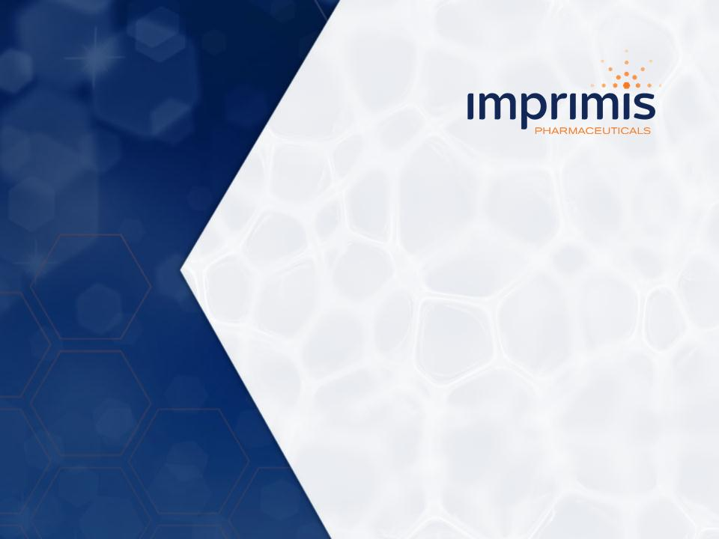

1



2



3

4

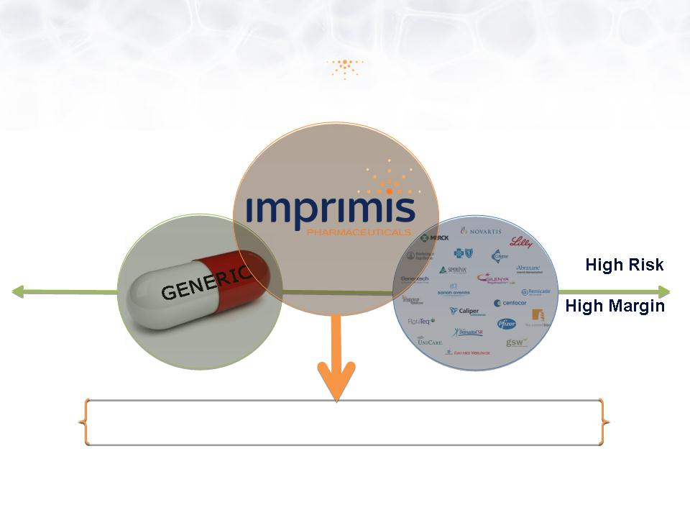

5

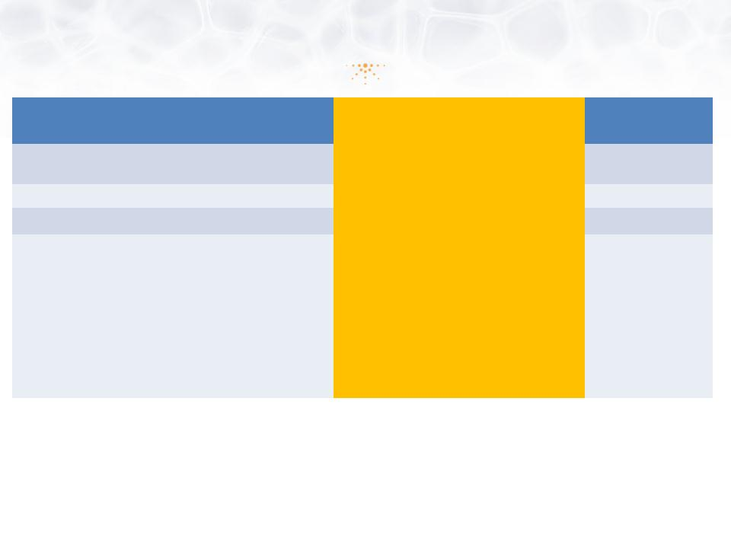
Application | 505(b)(1) NDA | 505(b)(2) NDA | 505(j) ANDA
New Chemical Entity  (NCE) | Yes | Yes/No  (Rely on RLD and Prior Investigation) | No  (RLD is off patent)
New Indication | Yes | Yes | No
New Form/Dose | Yes | Yes | No
Required Data for  Approval | • Complete Pharmacology  • Complete Preclinical  Safety, including long  term carcinogenicity in 2  species  • Complete analytical  development and quality  manufacturing  • Complete Phase 1-3  clinical trials | • Data from published literature  • FDA findings on efficacy/safety of  approved drug/formulation  • Studies to support change  • Dermal/Eye Safety (topical drugs)  • Clinical Efficacy/Safety  • CMC (3 registration batches with  stability data) | • Bioequivalence

6

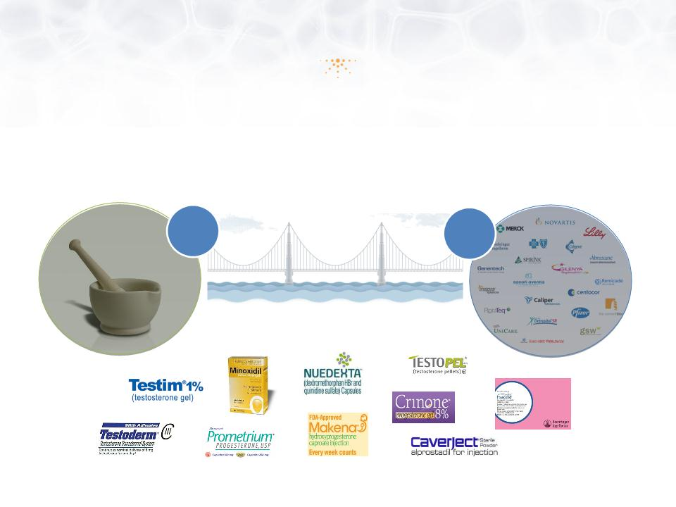

7

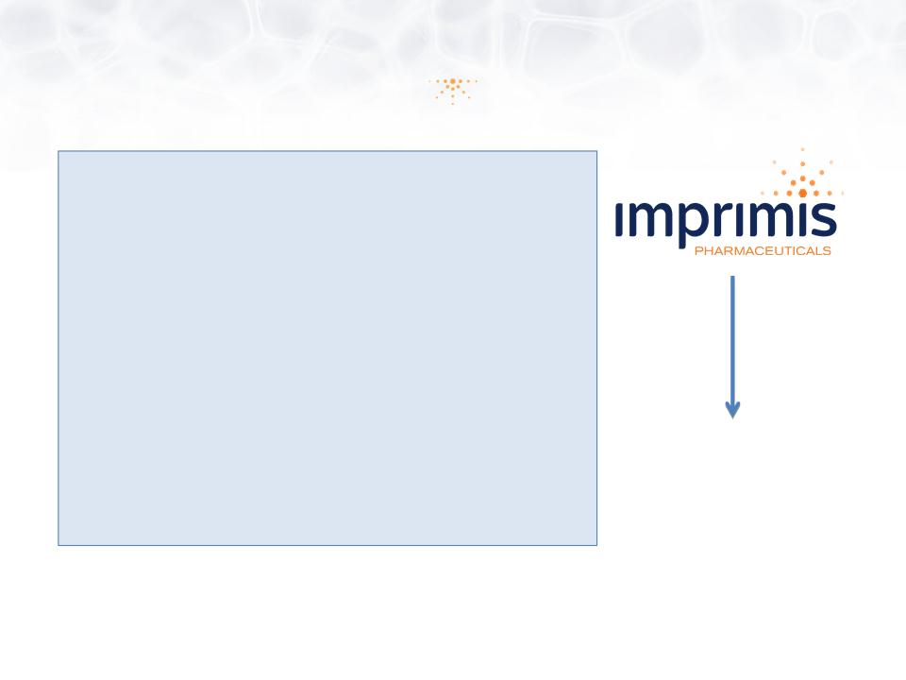

8

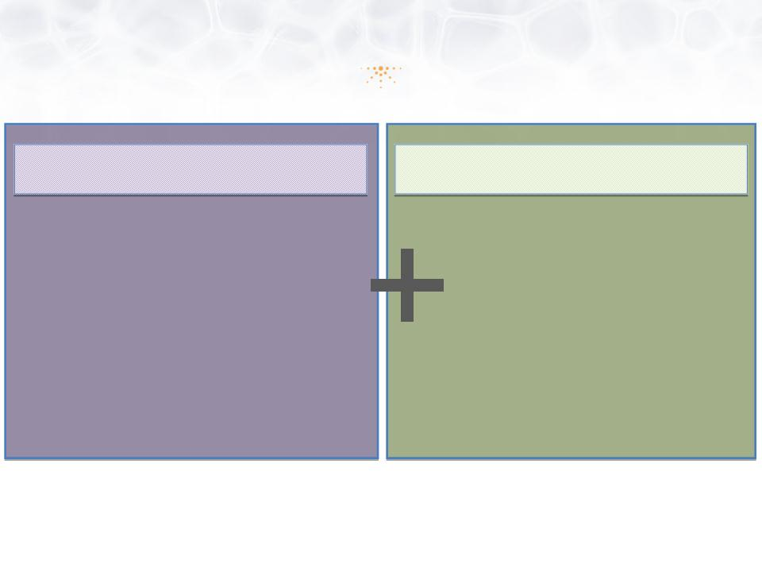

9

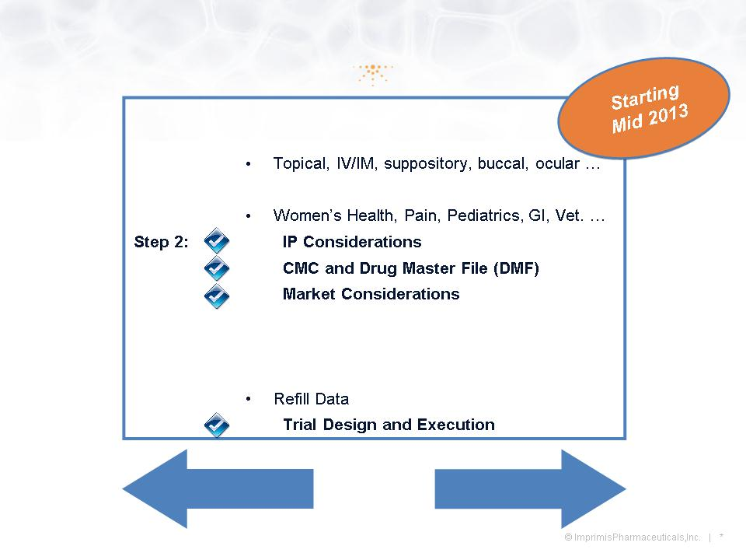

10

11

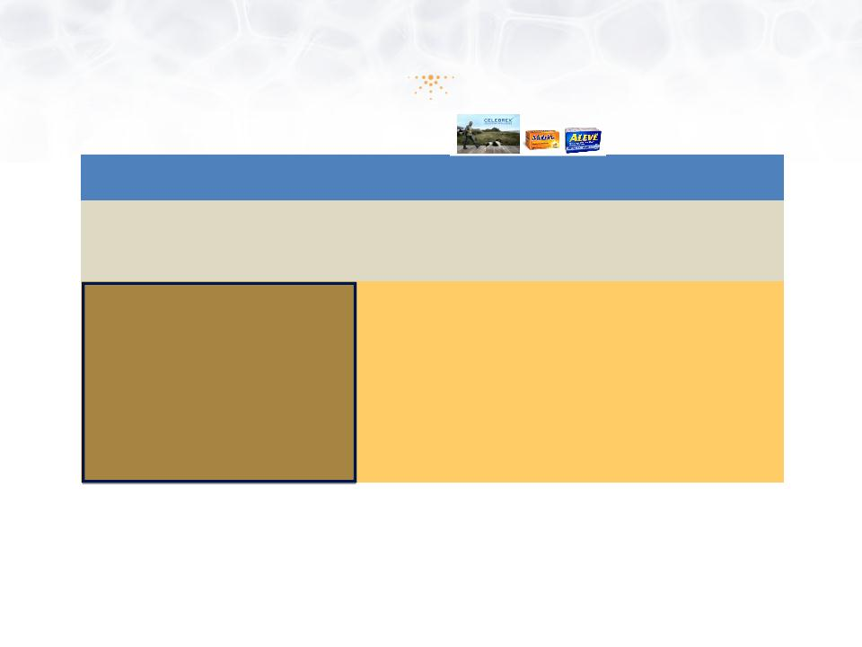
 | Oral NSAIDs | Topical NSAIDs
Efficacy in Acute Soft Tissue Injuries | Good | Good
Efficacy in Osteoarthritis | Good | Good
Incidence of Adverse Events | High | Low
GI Safety (Stomach) | Poor | Good
Hepatic Safety (Liver) | Poor | Good
Renal Safety (Kidney) | Poor | Good
Cardiovascular Safety (Heart) | Poor | Good

12

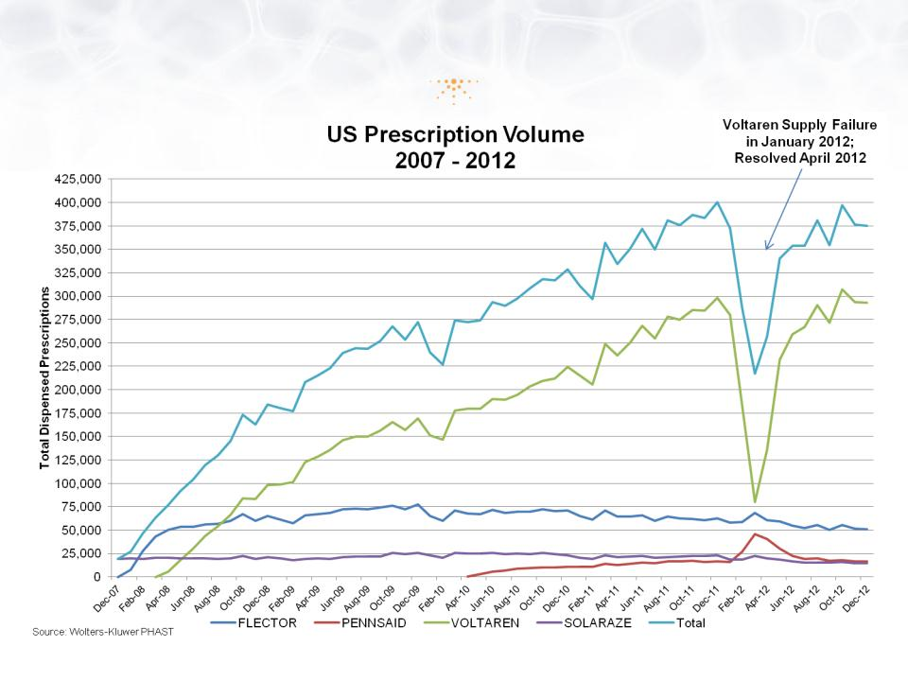

13

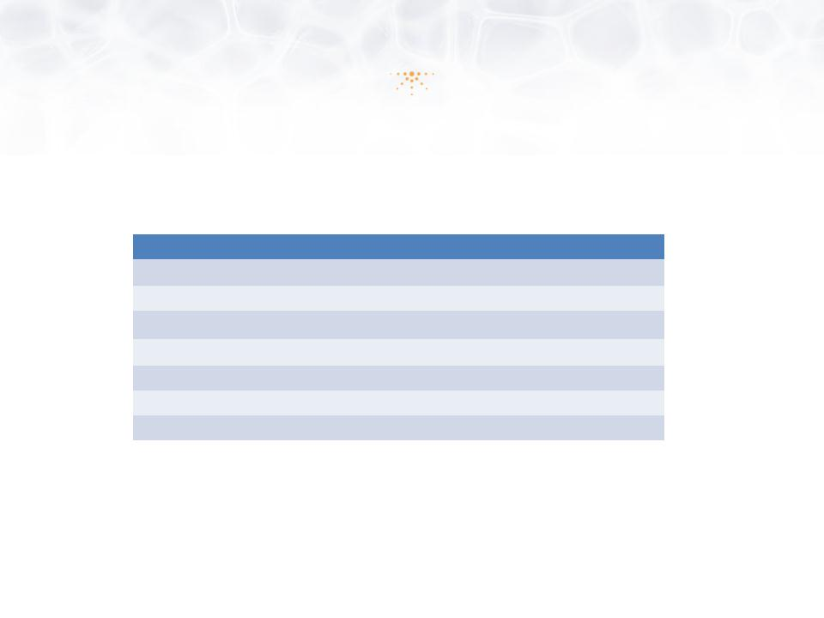
Factor | Impracor™ | Voltaren®
Delivery Technology | Patented Accudel™ Micelles | None; Alcohol
Per Dose Quantity | 3g | 4g
Dose Frequency | BID (2X Daily) | QID (4X Daily)
API | 10% Ketoprofen | 1% Diclofenac
COX Selectivity | Cox 1 | Cox 2
Smell | Neutral | Insect Repellant
Tactile | Smooth | Greasy

14

15

16

17

18

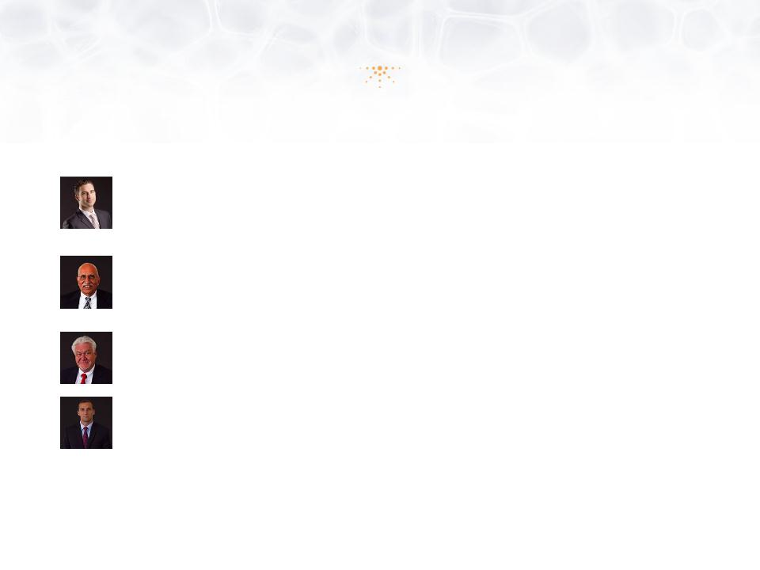

19

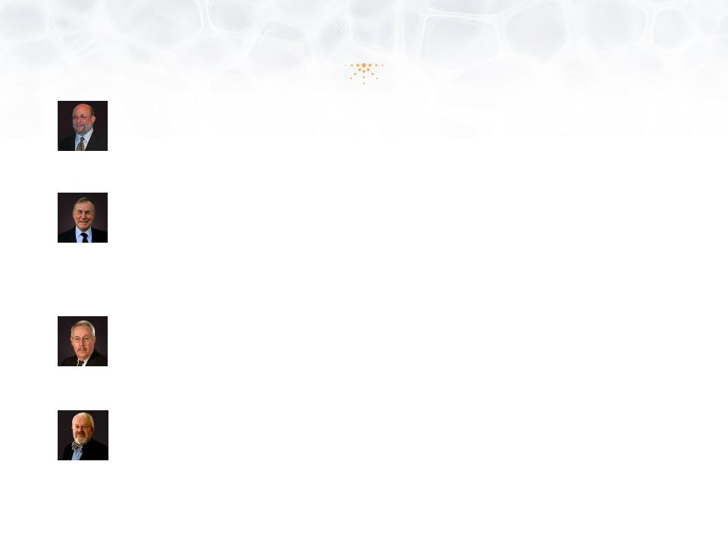

20


 | Capital Structure  March 14, 2013  (Unaudited) | Percent
Common Shares | 8,888,250 | 82.58%
Total Restricted Stock Units | 200,000 | 1.86%
Total Options & Warrants - Weighted Avg. Ex. Price $5.49 | 1,675,487 | 15.56%
Total Common Shares - Diluted | 10,763,737 | 100.00%

21

22



23

24

25

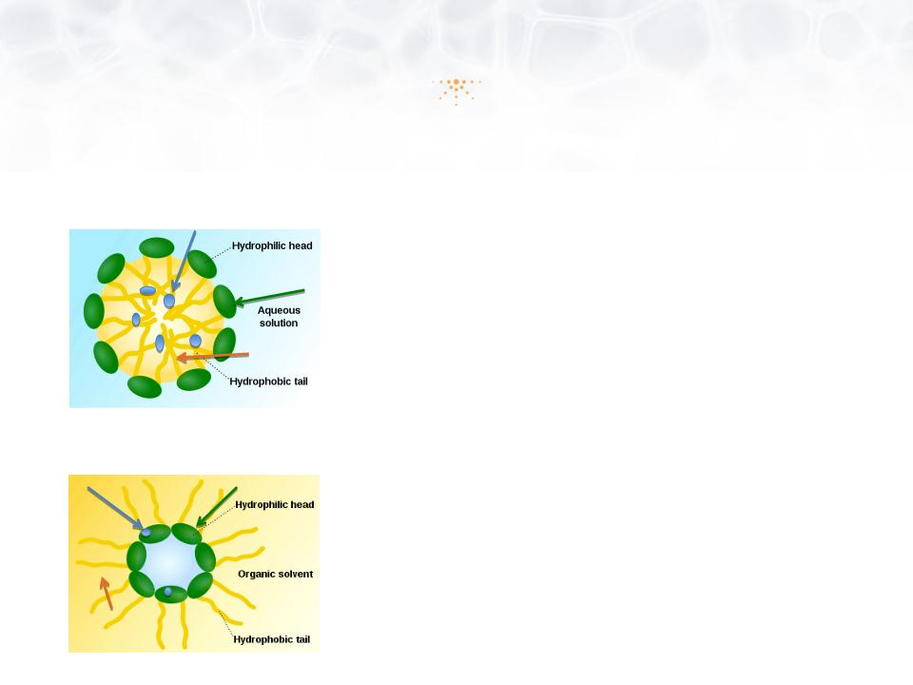

26

27

28

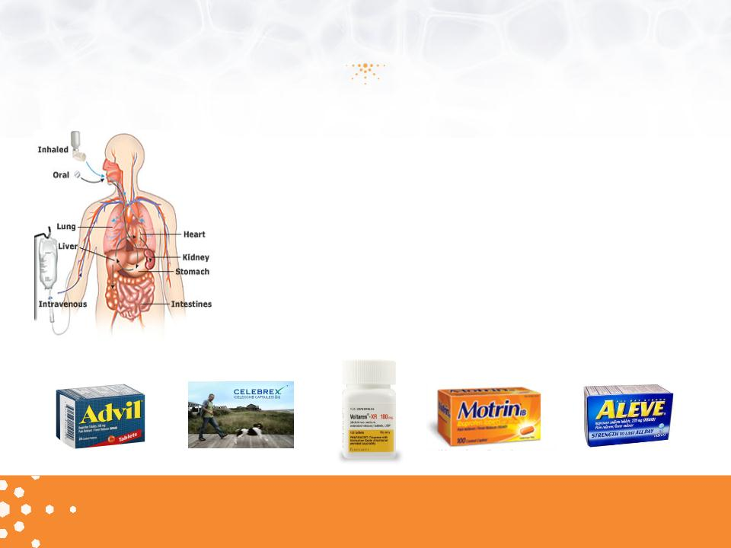

29

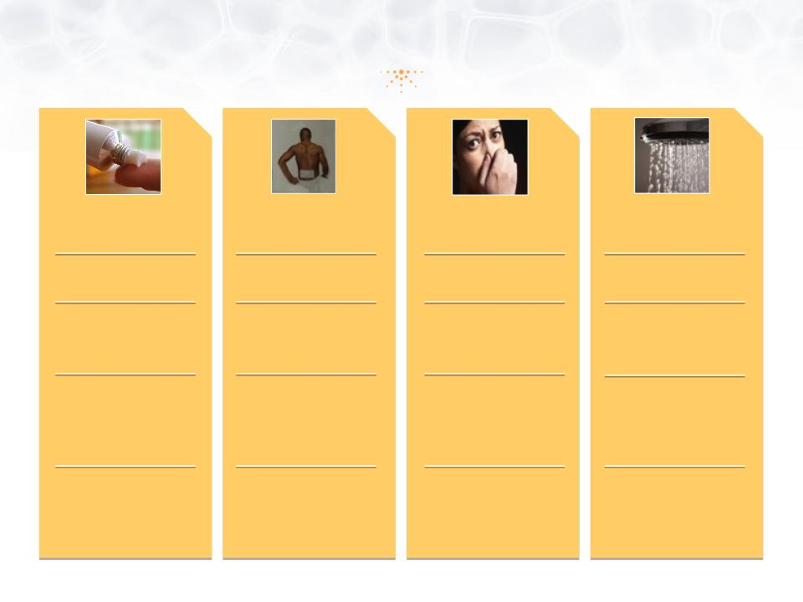

30

31

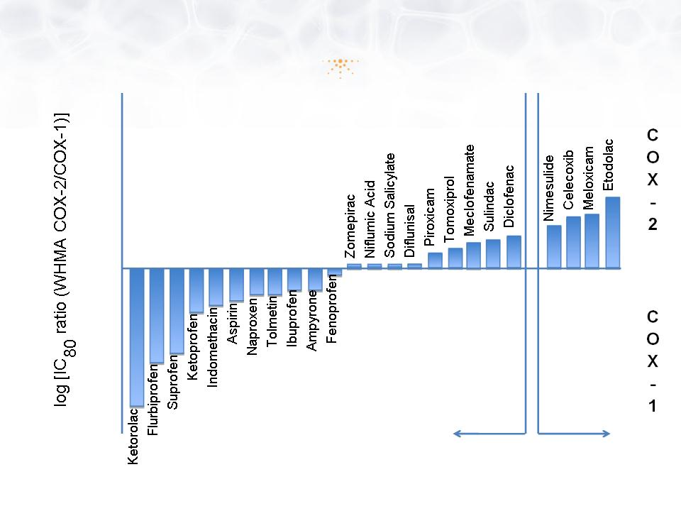

32

33

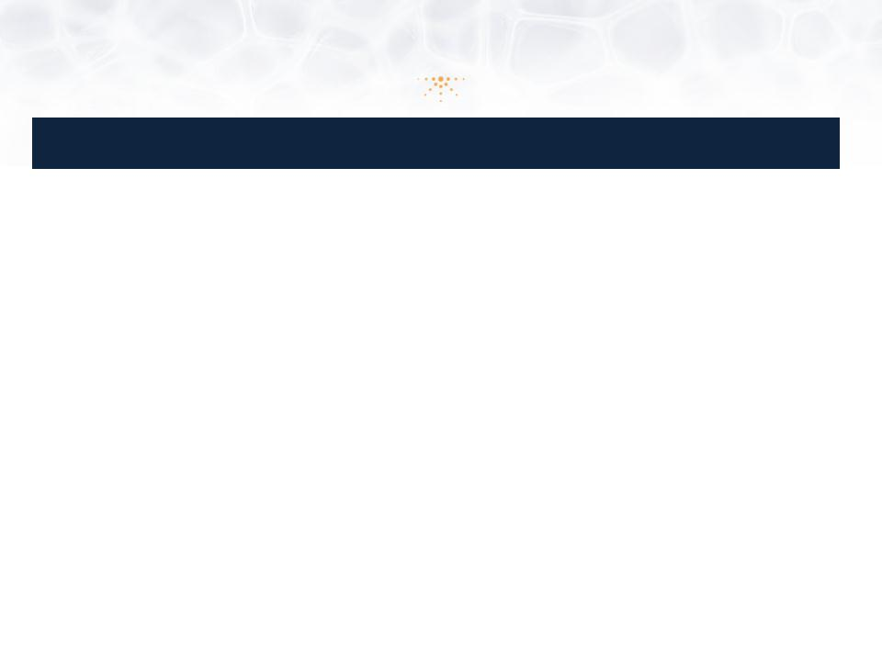
 | Ketoprofen 20% Patch  (ENDO) | Ketoprofen Transfersome  Gel, Diractin™ (IDEA) | Diclofenac Solution  Pennsaid™ (Nuvo)
Phase | 3 | 2/3 | 2
Study Dates | Aug 2006 - May 2007 | Jul 2003 - Jan 2004 | Jul 2010 - Mar 2011
# of Subjects/ Age | 309 / above 18 years | 397/ above 40 years | 248 / 18 -80 years
Regimen/ Duration | Ketoprofen Patch applied o.d.  4 weeks | 110 mg ketoprofen b.i.d. (n=138)  6 weeks  (1 placebo capsule b.i.d.  100 mg celecoxib capsule b.i.d.) | 1.3 mL applied to front, back and sides of knee  b.i.d. (n=84)  Vehicle and placebo controlled  4 weeks
Selection | Diagnosis of knee (unilateral or bilateral),  CRO: PPD | Morning stiffness < 30’, crepitus, at least 3 on  Likert’s 5 point scale, not on NSAIDS | Patients using NSAIDs underwent a 1-week  washout  This was a non-flare study
Primary Endpoint | WOMAC (pain) week 2 | WOMAC (pain ) week 6• | WOMAC (pain ) week 4
Secondary Endpoints | Pain Intensity/ relief (diary)  WOMAC (function), Rescue Medication,  quality of sleep, lost days of work. Pat./Phys.  global assessment | WOMAC (function)-week 6.  Patient global assessment  (5 Point Likert)• | WOMAC (stiffness) , WOMAC (function), WOMAC  (pain on walking) - - week 4  Patient global assessment  Pain assessment 11 point scale
Conclusions | ITT Primary Endpoint met: Significant  differences vs placebo (p=0.014). All  secondary endpoints met. Previously two  Phase 3 sprain/strain trials failed,  program discontinued. ENDO 10Q 2007 | WOMAC pain LS mean reduction - 18.2 (-22.1 to -  14.3), -20.3 (-24.3 to -16.2) and -9.9 (-13.9 to -  5.8) osteoarthritis (p <0.01)  All WOMAC subscale scores were normalized to  a scale of 0 to 100 by dividing the sum subscale  score by the number of questions of each score.  Ann Rheum Dis. 2007; 66(9): 1178-83.  Swissmedic approval based on single study | WOMAC pain reduction (5-Point Likert) from  baseline (-3.9 [- 4.8 to -2.9]) compared with vehicle  -control solution (-2.5 [- 3.3 to -1.7]; p = 0.023) or  the placebo solution (-2.5 [-3.3 to -1.7]; p = 0.016).  CMAJ • AUG. 17, 2004; 171 (4)  5 Phase 3 trials have achieved all 3 primary end  points in OA.

34

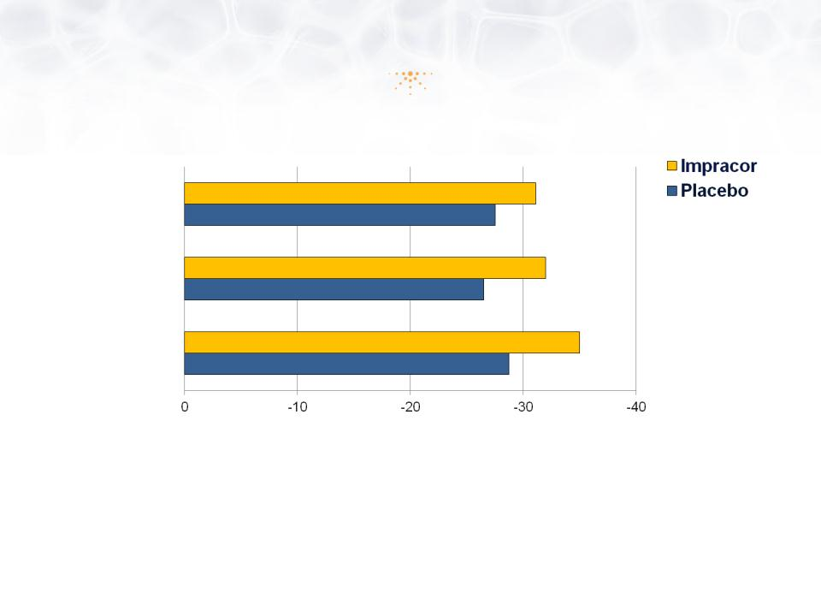

35

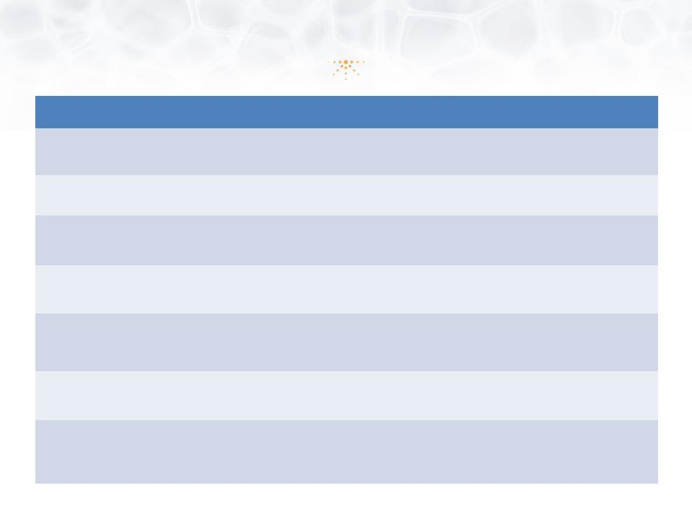
Old Phase 3 Trial | New Phase 3 Trial
Many sprains and strains trials have failed | • Acute OA flare (as a pain model) provides a more  reliable population with better chance for separation
High placebo responses | • Utilize analgesia-specific proprietary implements and  methodologies to identify placebo responders
Insufficient monitoring for patient eligibility | • Invest in trial design and management  • Use only experienced pain trial investigators
Patients were entered into the ITT up to 72 hours  after injury | • OA flare model designed for NSAID “wash-out” and  immediate randomization of eligible patients
People were allowed in if they had 6/10 pain level  over last 24 hours - regardless of pain at baseline | • OA flare model has defined entry criteria for pain  intensity after NSAID “wash-out” and before  randomization
30 subjects used un-allowed drugs | • Local laboratory for eligibility (drugs, liver, kidney,  hematology)
Major dosing compliance problems related to  smaller size of tube orifice vs. applicator card box | • Provide scales and weigh tubes at any office visit

36

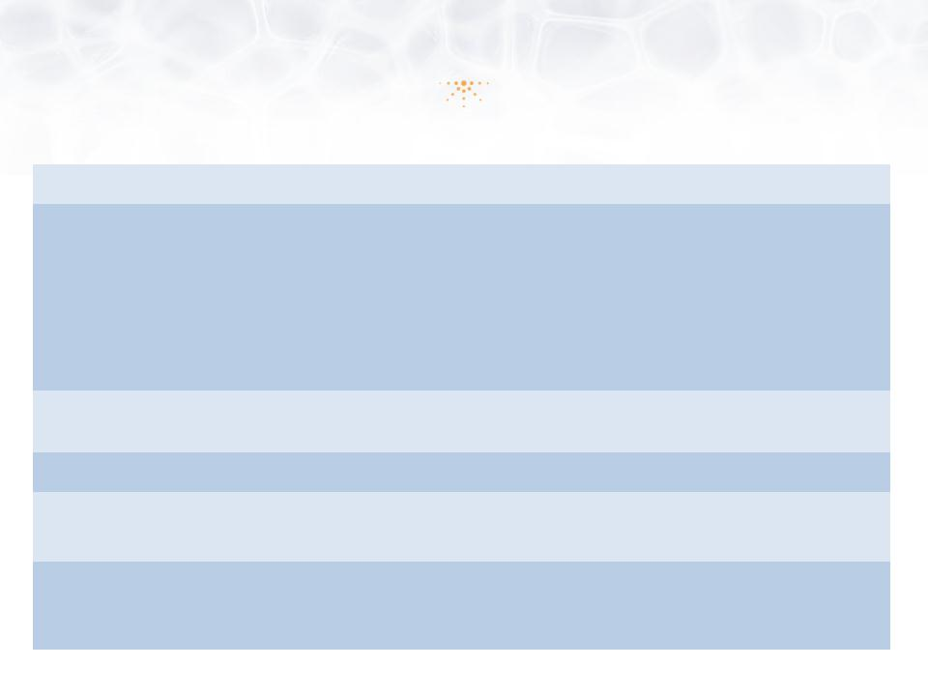
Design: | Randomized, double-blind, placebo-controlled at 26 sites
Study Population: | Efficacy, n = 361  Uncomplicated acute soft tissue injuries  Ankle (n=97), Shoulder (n=87), Knee (n=59), Wrist (n=57), Elbow (n=30), Calf/Anterior Tibialis  (n=11), Hamstring/Quadriceps (n=8), Forearm (n=5), Biceps/Triceps (n=3), Hand (n=3)  Safety, n = 364  Ranging in age from 18 - 75 years
Key Entry Criteria: | Injury occurred within 72 hours, pain intensity ≥ 60mm on 100 mm Visual Analogue Scale  (VAS); no intake of unallowable medication
Dosing Regimen: | Impracor vs. Placebo (Vehicle) cream, 1g t.i.d. x 7 days
Primary Endpoint: | Change from baseline in pain intensity during daily activities on Day 3 office  visit (+1, +2 days) with 100 mm VAS measurement
Secondary  Endpoints: | • Change from baseline in three times daily pain intensity immediately prior to medication  • Various other treatment satisfaction and safety assessments  • Pharmacokinetics in subset of patients

37

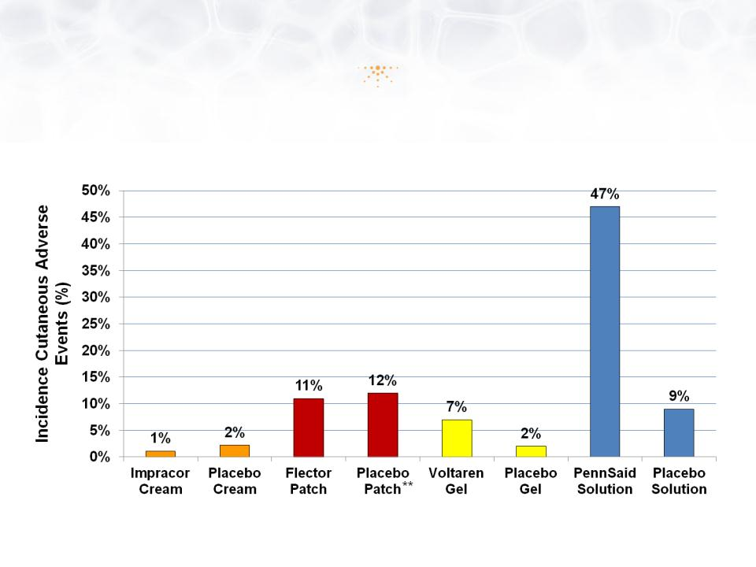

38

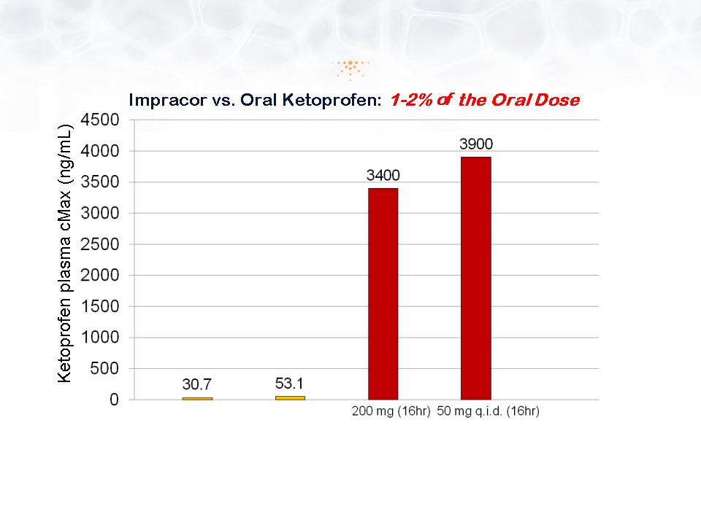

39

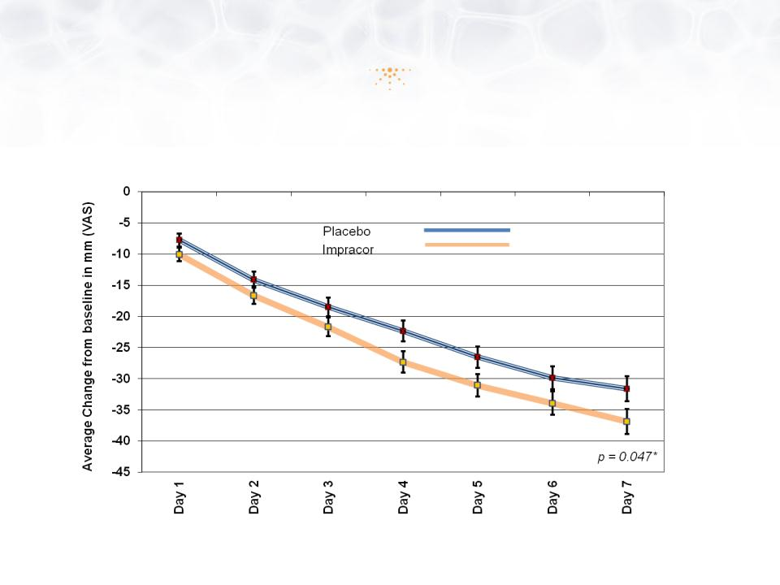

40

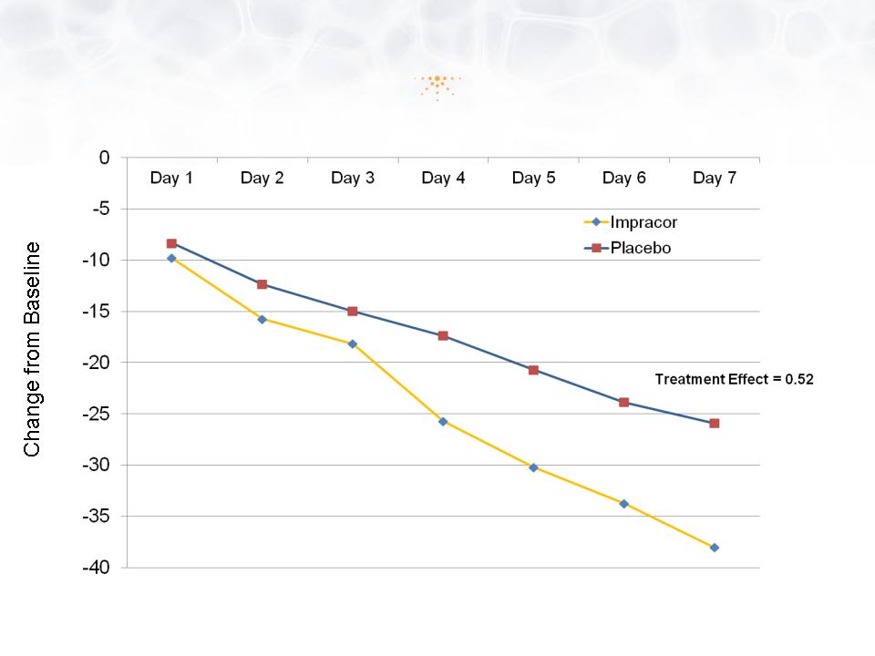

41

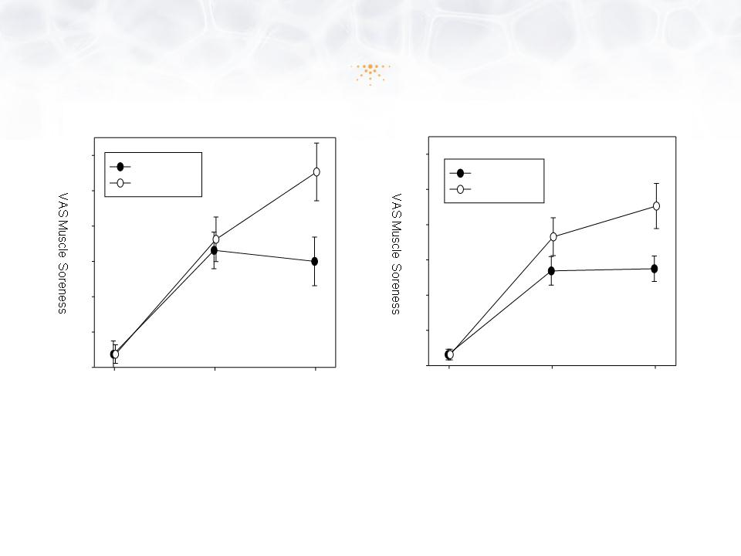

42

43

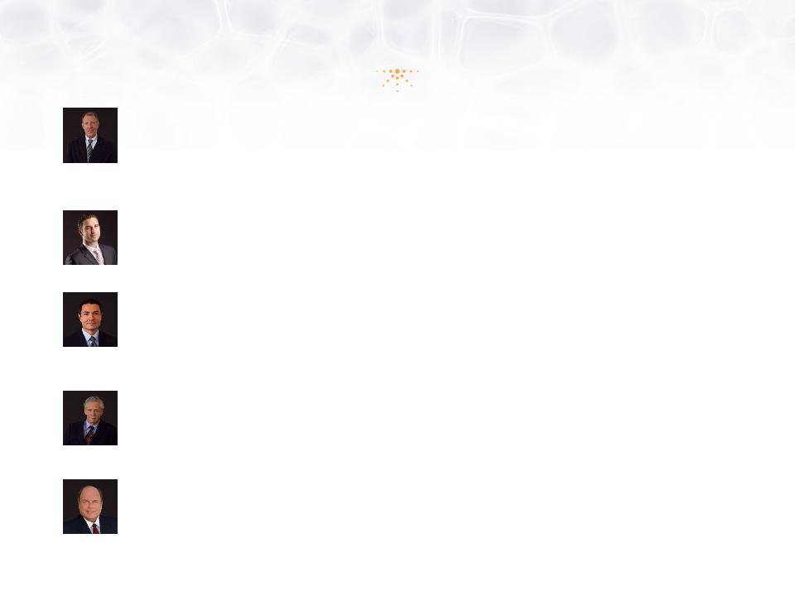

44

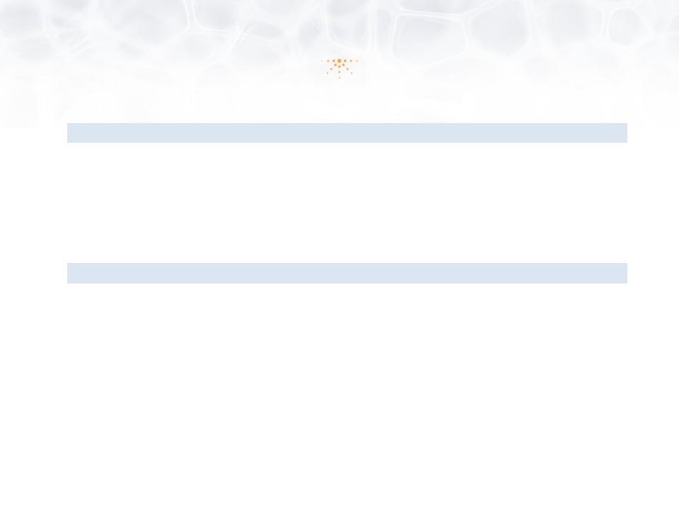
ASSETS |  |  |  | December 31, 2012
Current Assets
 | Cash and cash equivalents |  | $ | 10,035,615
 | Other assets |  |  | 670,381
 |  | TOTAL ASSETS | $ | 10,705,996
LIABILITIES AND STOCKHOLDERS' EQUITY
 | Accounts payable and accrued expenses |  | $ | 709,559
 |  | TOTAL LIABILITIES |  | 709,559
Stockholder’s Equity
Common stock, $0.001 par value, 395,000,000 shares
authorized,
 |  | 6,772,066 shares issued and outstanding |  | 6,772
 | Additional paid-in capital |  |  | 34,093,933
 | Deficit accumulated during the development stage |  |  | (24,104,268)
 |  | TOTAL STOCKHOLDERS' EQUITY |  | 9,996,437
 |  | TOTAL LIABILITIES AND STOCKHOLDERS' EQUITY | $ | 10,705,996

45

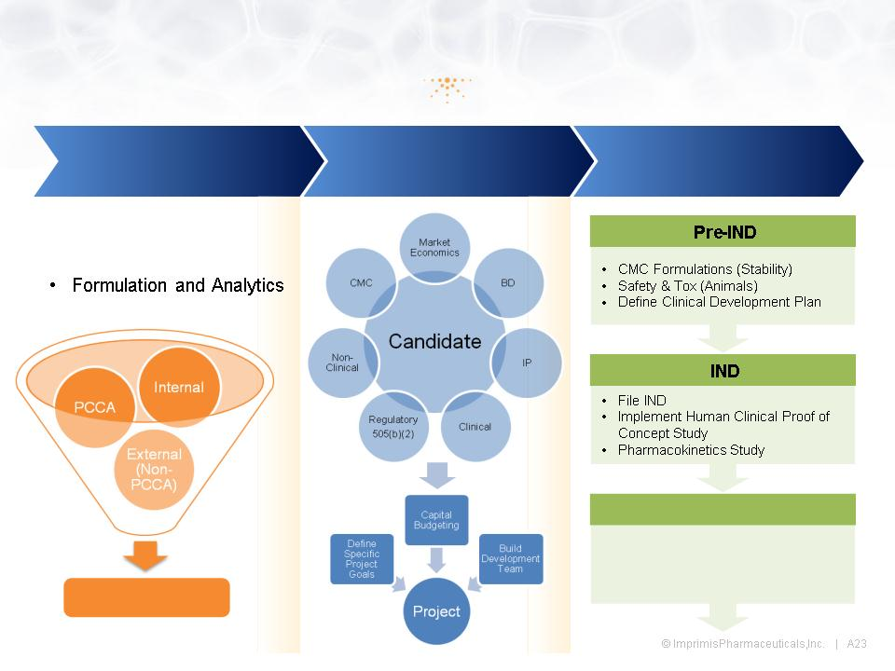

46

