UNITED STATES

SECURITIES AND EXCHANGE COMMISSION
Washington, D.C. 20549

FORM 8-K

CURRENT REPORT

Pursuant to Section 13 OR 15(d) of The Securities Exchange Act of 1934

Date of Report (Date of earliest event reported): July 18, 2023

HARROW HEALTH, INC.

(Exact name of registrant as specified in its charter)

Delaware |  | 001-35814 |  |  |  |  | 45-0567010
(State or other jurisdiction |  |  |  | (Commission |  |  |  | (IRS Employer
of incorporation) |  |  |  | File Number) |  |  |  | Identification No.)
102 Woodmont Blvd., Suite 610
Nashville, Tennessee |  |  |  |  |  |  | 37205
(Address of principal executive offices) |  |  |  |  |  |  | (Zip Code)
 |  | Registrant’s telephone number, including area code: (615) 733-4730
 |  |  |  | Not Applicable
 |  | (Former Name or Former Address, if Changed Since Last Report)
Securities registered pursuant to Section 12(b) of the Act:
Title of each class |  |  |  | Trading Symbol(s) |  |  | Name on exchange on which registered
Common Stock, $0.001 par value per share |  |  |  | HROW |  |  | The NASDAQ Stock Market LLC
8.625% Senior Notes due 2026 |  |  |  | HROWL |  |  | The NASDAQ Stock Market LLC
11.875% Senior Notes due 2027 |  |  |  | HROWM |  |  | The NASDAQ Stock Market LLC

Check the appropriate box below if the Form 8-K filing is intended to simultaneously satisfy the filing obligation of the registrant under any of the following provisions:

- Written communications pursuant to Rule 425 under the Securities Act (17 CFR 230.425)

- Soliciting material pursuant to Rule 14a-12 under the Exchange Act (17 CFR 240.14a-12)

- Pre-commencement communications pursuant to Rule 14d-2(b) under the Exchange Act (17 CFR 240.14d-2(b))

- Pre-commencement communications pursuant to Rule 13e-4(c) under the Exchange Act (17 CFR 240.13e-4(c))

Indicate by check mark whether the registrant is an emerging growth company as defined in Rule 405 of the Securities Act of 1933 or Rule 12b-2 of the Securities Act of 1934: Emerging growth company ☐

If any emerging growth company, indicate by check mark if the registrant has elected not to use the extended transition period for complying with any new or revised financial accounting standards provided pursuant to Section 13(a) of the Exchange Act. ☐

Item 1.01 Entry into a Material Definitive Agreement.

On July 18, 2023, Harrow Health, Inc. (the “Company”) entered into the First Amendment to Credit Agreement and Guaranty and Consent (the “Oaktree Amendment”) to the Credit Agreement and Guaranty (the “Oaktree Loan”) originally entered into on March 27, 2023, with the lenders from time to time party thereto and Oaktree Fund Administration, LLC, as administrative agent for the lenders (together, “Oaktree”). Under the Oaktree Amendment, the overall credit facility size was increased from $100,000,000 to $112,500,000, and the Company made other changes related to the Santen Products Acquisition (described further below under Item 8.01). Upon satisfaction of certain conditions to funding, the Company will draw down a principal amount of $12,500,000 (the “Loan Increase”) to fund the initial one-time payment associated with the Santen Products Acquisition and for other working capital and general corporate purposes. No other material changes to the Oaktree Loan were provided in the Oaktree Amendment. Following entry into the Oaktree Amendment and the funding of the Loan Increase upon closing of the Santen Products Acquisition, the Company will have drawn down a total principal loan amount of $77,500,000 under the Oaktree Loan and an additional principal loan amount of up to $35,000,000 remains available to the Company upon the commercialization of TRIESENCE.

The foregoing description of the Oaktree Amendment does not purport to be complete and is qualified in its entirety by reference to the full text of the Oaktree Amendment, which the Company expects to file as an exhibit to its Quarterly Report on Form 10-Q for the three months ended June 30, 2023.

Item 2.02 Results of Operations and Financial Condition.

Management expects the Company to record over $31,000,000 of total revenues and over $9,300,000 of Adjusted EBITDA (a non-GAAP measure) for the three-month period ended June 30,

2023.

Management utilizes Adjusted EBITDA, an unaudited financial measure that is not calculated in accordance with generally accepted accounting principles (“GAAP”), to evaluate the Company’s financial results and performance and to plan and forecast future periods. Investors are encouraged to review the Company’s complete results of operations and additional information provided in the Company’s Annual Report on Form 10-K for the year ended December 31, 2022 and Quarterly Report on Form 10-Q for the quarter ended March 31, 2023. Management believes that Adjusted EBITDA reflects an additional way of viewing aspects of the Company’s operations that, when viewed in conjunction with GAAP results, provides a more complete understanding of the Company’s results of operations and the factors and trends affecting its business.

Although the Company is providing management guidance on anticipated Adjusted EBITDA, management is unable to determine with reasonable certainty the ultimate outcome of certain items necessary to calculate net income, the most directly comparable GAAP measure, without unreasonable effort. These items include, but are not limited to, final calculation of investment related gains/losses, inventory reserves, profit transfers, revenue discounts, returns, chargebacks and stock-based compensation. These items are uncertain, depend on various factors, and could have a material impact on the GAAP reported results for the period. All estimates presented are subject to completion of the applicable quarter-end closing procedures. The Company’s actual results for such period are not expected to be available until early August 2023 and may vary from these estimates. In addition, estimated financial information is necessarily speculative in nature, and it can be expected that some or all of the assumptions underlying the estimated financial information described above will not materialize or will vary significantly from actual results. Accordingly, undue reliance should not be placed on this estimate. The preliminary estimate is not necessarily indicative of any future period and should be read together with the sections titled “Risk Factors” and “Special Note Regarding Forward-Looking Statements,” and under similar headings in the documents filed by the Company with the Securities and Exchange Commission (“SEC”) as well as the financial statements, related notes and other financial information included in the Company’s filings with the SEC.

The foregoing guidance on anticipated results for the three months ended June 30, 2023 has not been reviewed by Company’s auditors, is based on preliminary information as of the date hereof and is subject to material changes following completion of the quarter-end review process and other adjustments that may be made before the Company’s financial results are finalized. In addition, these preliminary unaudited results are not comprehensive financial results for the quarter ended June 30, 2023, should not be viewed as a substitute for complete GAAP financial statements or more comprehensive financial information, and are not indicative of the results for any future period.

A copy of the press release announcing the second quarter 2023 management guidance is being furnished as Exhibit 99.1 to this Current Report on Form 8-K.

Item 7.01 Regulation FD Disclosure.

On July 18, 2023, the Company issued a press release announcing an offering of shares of the Company’s common stock, par value $0.001 (the “Common Stock”) (the “Offering”).

A copy of the press release for the Offering is being furnished as Exhibit 99.2 to this Current Report on Form 8-K.

In connection with the Offering, the Company will be making road show presentations to certain existing and potential securityholders of the Company. The road show materials are being furnished as Exhibit 99.3 to this Current Report on Form 8-K.

The information furnished under Items 2.02 and 7.01 of this Current Report on Form 8-K, including Exhibit 99.1, Exhibit 99.2, and Exhibit 99.3 shall not be deemed to be “filed” for the purposes of Section 18 of the Securities Exchange Act of 1934, as amended (the “Exchange Act”), or otherwise subject to the liabilities of that Section. The information in Items 2.02 and 7.01, including Exhibit 99.1, Exhibit 99.2, and Exhibit 99.3 shall not be deemed incorporated by reference into any filing under the Securities Act of 1933, as amended, or the Exchange Act, except to the extent it is specifically incorporated by reference but regardless of any general incorporation language in such filing.

Item 8.01 Other Items.

Acquisition of VEVYETM U.S. and Canadian Commercial Rights

On July 18, 2023, the Company announced that it had acquired commercial rights of VEVYE (cyclosporine ophthalmic solution) 0.1%, an ophthalmic drug product, for the U.S. and Canadian markets (the “VEVYE Acquisition”). VEVYE, which is dispensed topically in a unique ten microliter per one drop and is labeled for twice-daily (BID) dosing, is the first and only cyclosporine-based product indicated for the treatment of both signs and symptoms of dry eye disease (DED). VEVYE was approved on May 30, 2023 by the Food and Drug Administration. The Company acquired the commercial rights to VEVYE by entering into a license agreement with Novaliq GmbH (“Novaliq”). As consideration, the Company will make initial payments to Novaliq totaling $8,000,000 and will pay low double-digit royalties on net sales of VEVYE along with potential commercial milestone payments.

A copy of the press release announcing the VEVYE Acquisition is being filed as Exhibit 99.4 to this Current Report on Form 8-K.

Acquisition of Certain U.S. and Canadian Commercial Rights to Santen and Eyevance Products

On July 18, 2023, the Company entered into an Asset Purchase Agreement with Eyevance Pharmaceuticals, LLC and a License Agreement with Santen S.A.S. (collectively, the “Santen Agreements”), each a subsidiary of Santen Pharmaceuticals Co., Ltd. (collectively, “Santen”). Pursuant to the Santen Agreements, we will be acquiring the exclusive commercial rights to assets associated with certain ophthalmic products identified in the Santen Agreements and described in the press release issued on July 18, 2023 (collectively, the “Santen Products”):

The transactions pursuant to the Santen Agreements are referred to in this Current Report on Form 8-K as the “Santen Products Acquisition.”

Under the terms of the Santen Agreements, the Company is required to make an initial one-time payment of $8,000,000. In addition, the agreements provide for various one-time milestone payments associated with certain manufacturing-related events as well as low-double digit royalty payments on net sales of Verkazia and high-single digit royalty payments on net sales of Cationorm Plus. Under the Santen Agreements, the Company also assumed certain obligations associated with other third parties that require mid-single digit royalties on sales of Freshkote and Zerviate. Immediately following the closing and subject to certain conditions, for a period that the Company expects to last approximately four months, and prior to the transfer of the Santen Products NDAs and other marketing authorizations to the Company, Santen will continue to sell the Santen Products on the Company’s behalf and transfer the net profit from the sale of the Santen Products to the Company.

A copy of the press release announcing the Santen Products Acquisition is being filed as Exhibit 99.5 to this Current Report on Form 8-K.

Cautionary Note Regarding Forward-Looking Statements

This Current Report on Form 8-K (and the exhibits attached hereto) may contain “forward-looking” statements as defined by the Private Securities Litigation Reform Act of 1995 or by the SEC in its rules, regulations and releases. These statements include, but are not limited to, the Company’s plans, objectives, expectations and intentions regarding the performance of its business, statements regarding the Company’s anticipated results for the second quarter of 2023, the terms and conditions and timing of the Offering, the intended use of proceeds of the Offering and other non-historical statements. These statements can be identified by the use of words such as “believes,” “anticipates,” “expects,” “intends,” “plans,” “continues,” “estimates,” “predicts,” “projects,” “forecasts,” and similar expressions. All forward looking statements are based on management’s current expectations and beliefs only as of the date of this report and are subject to risks, uncertainties and assumptions that could cause actual results to differ materially from those discussed in, or implied by, the forward-looking statements, including the risks identified and discussed from time to time in the Company’s reports filed with the SEC, including the Company’s Annual Report on Form 10-K for the year ended December 31, 2022 and Quarterly Report on Form 10-Q for the three months ended March 31, 2023. Readers are strongly encouraged to review carefully the full cautionary statements described in these reports. Except as required by law, the Company undertakes no obligation to revise or update publicly any forward-looking statements to reflect events or circumstances after the date of this report, or to reflect the occurrence of unanticipated events or circumstances.

Item 9.01. Financial Statements and Exhibits

(d) Exhibits

No. Description

99.1 Second Quarter 2023 Guidance Press Release issued by Harrow Health, Inc. on July 18, 2023

99.2 Common Stock Offering Press Release issued by Harrow Health, Inc. on July 18, 2023

99.3 Harrow Health Corporate Presentation dated July 2023

99.4 VEVYE Acquisition Press Release issued by Harrow Health, Inc. on July 18, 2023

99.5 Santen Products Acquisition Press Release issued by Harrow Health, Inc. on July 18, 2023

104 Cover Page Interactive Data File (embedded within the Inline XBRL document)

SIGNATURES

Pursuant to the requirements of the Securities Exchange Act of 1934, the registrant has duly caused this report to be signed on its behalf by the undersigned hereunto duly authorized.

HARROW HEALTH, INC.

Dated: July 18, 2023 By: /s/ Andrew R. Boll

Andrew R. Boll

Chief Financial Officer

Exhibit 99.1
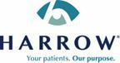

Harrow Provides Select Preliminary Second Quarter 2023 Financial Guidance

NASHVILLE, Tenn., July 18, 2023 – Harrow (Nasdaq: HROW), a leading U.S. eyecare pharmaceutical company, today announced the following select preliminary second quarter 2023 financial guidance:

- Second quarter 2023 revenues in excess of $31.0 million compared with prior-year second quarter revenues of $23.3 million

- Second quarter 2023 Adjusted EBITDA (a non-GAAP measure) in excess of $9.3 million

Management expects to release full second quarter 2023 financial results on August 9, 2023.

About Harrow

Harrow Health, Inc. (Nasdaq: HROW) is a leading U.S. eyecare pharmaceutical company engaged in the discovery, development, and commercialization of innovative ophthalmic prescription therapies that are accessible and affordable. Harrow owns U.S. commercial rights to ten branded FDA-approved ophthalmic pharmaceutical products. Harrow also owns and operates ImprimisRx, a leading U.S. ophthalmic-focused pharmaceutical compounding business, which also serves as a mail-order pharmacy licensed to ship prescription medications in all 50 states. Harrow has non-controlling equity positions in Surface Ophthalmics, Inc. and Melt Pharmaceuticals, Inc., companies that began as subsidiaries of Harrow. Harrow also owns royalty rights in four late-stage drug candidates being developed by Surface and Melt.

Non-GAAP Measures

Management utilizes Adjusted EBITDA, an unaudited financial measure that is not calculated in accordance with General Accepted Accounting Principles (“GAAP”), to evaluate the Company’s financial results and performance and to plan and forecast future periods. Investors are encouraged to review the Company’s complete results of operations and additional information provided in the Company’s Annual Report on Form 10-K for the year ended December 31, 2022 and Quarterly Report on Form 10-Q for the quarter ended March 31, 2023. Management believes that Adjusted EBITDA reflects an additional way of viewing aspects of the Company’s operations that, when viewed in conjunction with GAAP results, provides a more complete understanding of the Company’s results of operations and the factors and trends affecting its business.

Although we are providing management guidance on anticipated Adjusted EBITDA, we are unable to determine with reasonable certainty the ultimate outcome of certain items necessary to calculate net income, the most directly comparable GAAP measure, without unreasonable effort. These items include, but are not limited to, final calculation of investment related gains/losses, inventory reserves, profit transfers, revenue discounts, returns, chargebacks and stock-based compensation. These items are uncertain, depend on various factors, and could have a material impact on the GAAP reported results for the period. All estimates presented are subject to completion of the applicable quarter-end closing procedures. Our actual results for such period are not expected to be available until early August 2023 and may vary from these estimates. In addition, estimated financial information is necessarily speculative in nature, and it can be expected that some or all of the assumptions underlying the estimated financial information described above will not materialize or will vary significantly from actual results. Accordingly, undue reliance should not be placed on this estimate. The preliminary estimate is not necessarily indicative of any future period and should be read together with the sections titled “Risk Factors” and “Special Note Regarding Forward-Looking Statements,” and under similar headings in the documents filed by the Company with the U.S. Securities and Exchange Commission (“SEC”) as well as our financial statements, related notes and other financial information included in the Company’s filings with the SEC.

-MORE-

HROW Provides Select Preliminary Second Quarter 2023 Financial Guidance

Page 2

July 18, 2023

The foregoing guidance on anticipated results for the three months ended June 30, 2023, has not been reviewed by our auditors, is based on preliminary information as of the date hereof and is subject to material changes following completion of the quarter-end review process and other adjustments that may be made before our financial results are finalized. In addition, these preliminary unaudited results are not comprehensive financial results for the quarter ended June 30, 2023, should not be viewed as a substitute for complete GAAP financial statements or more comprehensive financial information, and are not indicative of the results for any future period.

Forward-Looking Statements

This press release contains “forward-looking statements” within the meaning of the U.S. Private Securities Litigation Reform Act of 1995. Any statements in this release that are not historical facts may be considered such “forward-looking statements.” Forward-looking statements are based on management’s current expectations and are subject to risks and uncertainties which may cause results to differ materially and adversely from the statements contained herein. Some of the potential risks and uncertainties that could cause actual results to differ from those predicted include, among others, risks related to completion of applicable quarter-end closing procedures. Additional risks and uncertainties are more fully described in Harrow’s filings with the Securities and Exchange Commission (“SEC”), including its Annual Report on Form 10-K and its Quarterly Reports on Form 10-Q. Such documents may be read free of charge on the SEC’s web site at sec.gov. Undue reliance should not be placed on forward-looking statements, which speak only as of the date they are made. Except as required by law, Harrow undertakes no obligation to update any forward-looking statements to reflect new information, events, or circumstances after the date they are made, or to reflect the occurrence of unanticipated events.

Contact:

Jamie Webb

Director of Communications and Investor Relations

jwebb@harrowinc.com

615-733-4737

-END-

Exhibit 99.2

Harrow Announces Proposed Public Offering of Common Stock

NASHVILLE, Tenn., July 18, 2023 – Harrow (Nasdaq: HROW), a leading U.S. eyecare pharmaceutical company, today announced a proposed underwritten registered public offering of its common stock, subject to market and certain other conditions. Harrow expects to grant the underwriters a 30-day option to purchase additional shares of its common stock in connection with the offering.

The Company expects to use the net proceeds from the sale of the common stock to fund the initial amount payable for an acquisition, with the remaining net proceeds available for general corporate purposes, including funding future strategic product acquisitions and related investments, making capital expenditures, and funding working capital and other cash needs, including tax withholding obligations in connection with the settlement of outstanding equity awards vesting as a result of the achievement of stock price targets.

B. Riley Securities, Inc. is acting as book-running manager for this offering. Lake Street Capital Markets, LLC is acting as lead-manager and Ladenburg Thalmann & Co. Inc. is acting as co-manager for this offering.

The common stock will be offered by Harrow under its shelf registration statement on Form S-3, which was declared effective by the Securities and Exchange Commission (the “SEC”) on June 6, 2022. The offering of the common stock will be made solely by means of a prospectus supplement and accompanying base prospectus, which will be filed with the SEC. Copies of the prospectus supplement and the accompanying base prospectus may be obtained on the SEC’s website at www.sec.gov, or by contacting B. Riley Securities by phone at (703) 312-9580, or by emailing prospectuses@brileyfin.com.

This press release shall not constitute an offer to sell or the solicitation of an offer to buy, and shall not constitute an offer, solicitation or sale in any jurisdiction in which such offer, solicitation or sale is unlawful.

About Harrow

Harrow Health, Inc. (Nasdaq: HROW) is a leading U.S. eyecare pharmaceutical company engaged in the discovery, development, and commercialization of innovative ophthalmic prescription therapies that are accessible and affordable. Harrow owns U.S. commercial rights to ten branded FDA-approved ophthalmic pharmaceutical products. Harrow also owns and operates ImprimisRx, a leading U.S. ophthalmic-focused pharmaceutical compounding business, which also serves as a mail-order pharmacy licensed to ship prescription medications in all 50 states. Harrow has non-controlling equity positions in Surface Ophthalmics, Inc. and Melt Pharmaceuticals, Inc., companies that began as subsidiaries of Harrow. Harrow also owns royalty rights in four late-stage drug candidates being developed by Surface and Melt.

-MORE-

HROW Announces Proposed Public Offering of Common Stock

Page 2

July 18, 2023

Forward-Looking Statements

This press release contains “forward-looking statements” within the meaning of the U.S. Private Securities Litigation Reform Act of 1995. Any statements in this release that are not historical facts may be considered such “forward-looking statements.” Forward-looking statements are based on management’s current expectations and are subject to risks and uncertainties which may cause results to differ materially and adversely from the statements contained herein. Some of the potential risks and uncertainties that could cause actual results to differ from those predicted include, among others, risks related to: liquidity or results of operations; our ability to successfully implement our business plan, develop and commercialize our products, product candidates and proprietary formulations in a timely manner or at all, identify and acquire additional products, manage our pharmacy operations, service our debt, obtain financing necessary to operate our business, recruit and retain qualified personnel, manage any growth we may experience and successfully realize the benefits of our previous acquisitions and any other acquisitions and collaborative arrangements we may pursue; competition from pharmaceutical companies, outsourcing facilities and pharmacies; general economic and business conditions, including inflation and supply chain challenges; regulatory and legal risks and uncertainties related to our pharmacy operations and the pharmacy and pharmaceutical business in general; and physician interest in and market acceptance of our current and any future formulations and compounding pharmacies generally. These and additional risks and uncertainties are more fully described in Harrow’s filings with the Securities and Exchange Commission (“SEC”), including its Annual Report on Form 10-K and its Quarterly Reports on Form 10-Q. Such documents may be read free of charge on the SEC’s web site at sec.gov. Undue reliance should not be placed on forward-looking statements, which speak only as of the date they are made. Except as required by law, Harrow undertakes no obligation to update any forward-looking statements to reflect new information, events, or circumstances after the date they are made, or to reflect the occurrence of unanticipated events.

Contact:

Jamie Webb

Director of Communications and Investor Relations

jwebb@harrowinc.com

615-733-4737

-END-

Exhibit 99.3


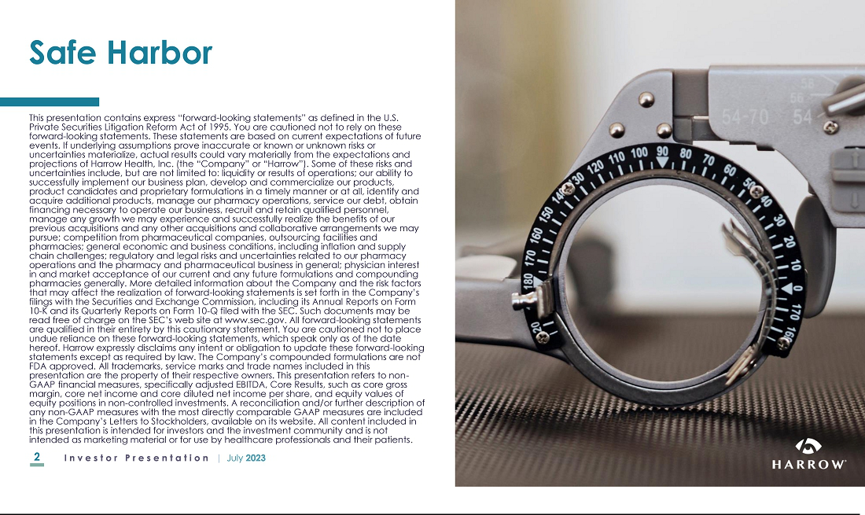

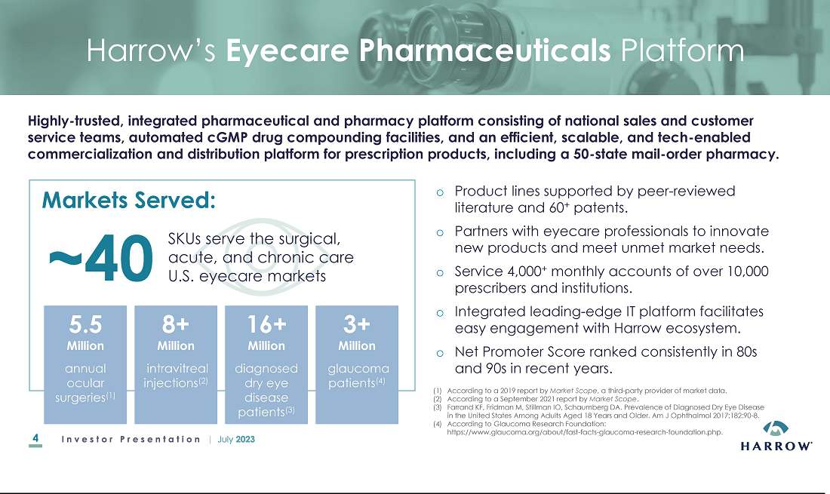

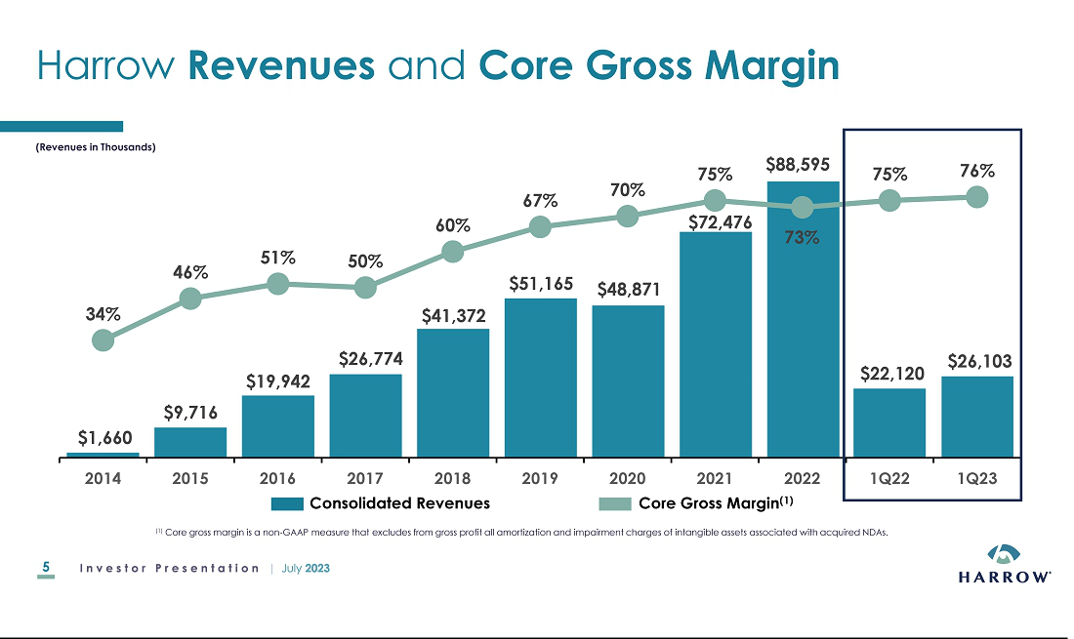

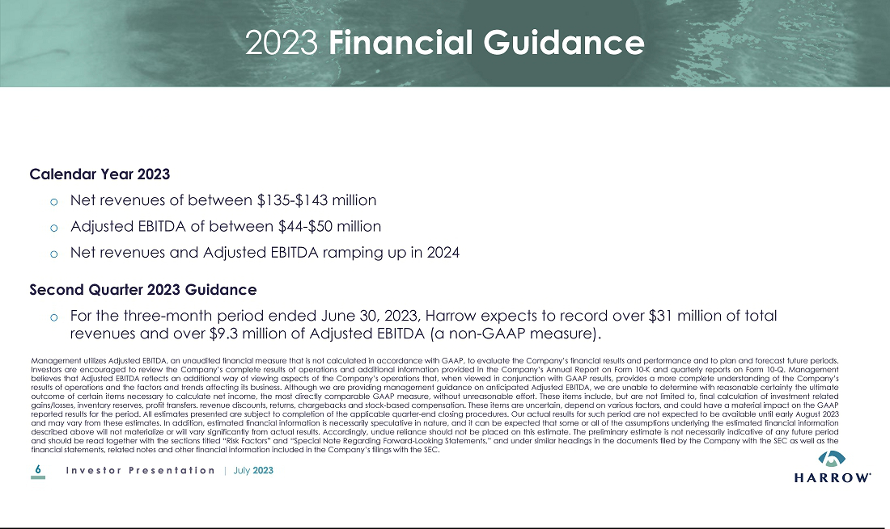

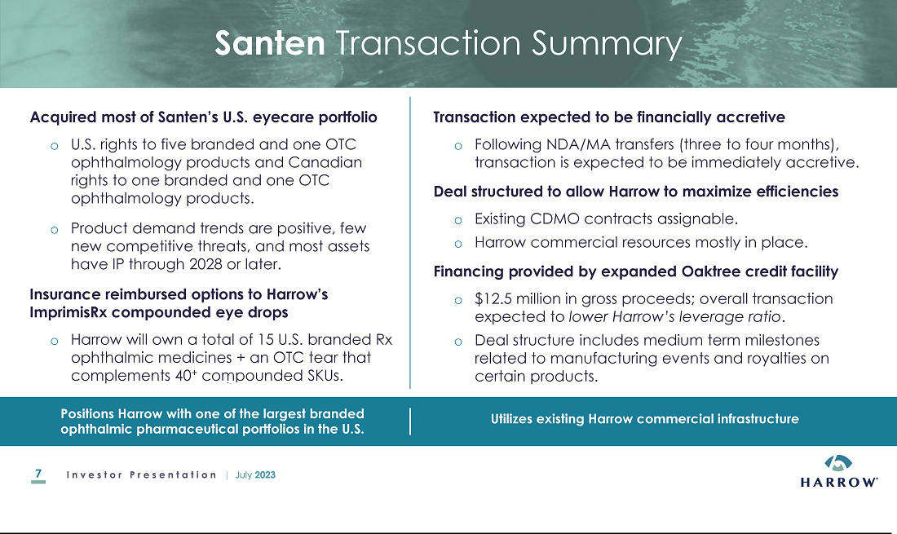

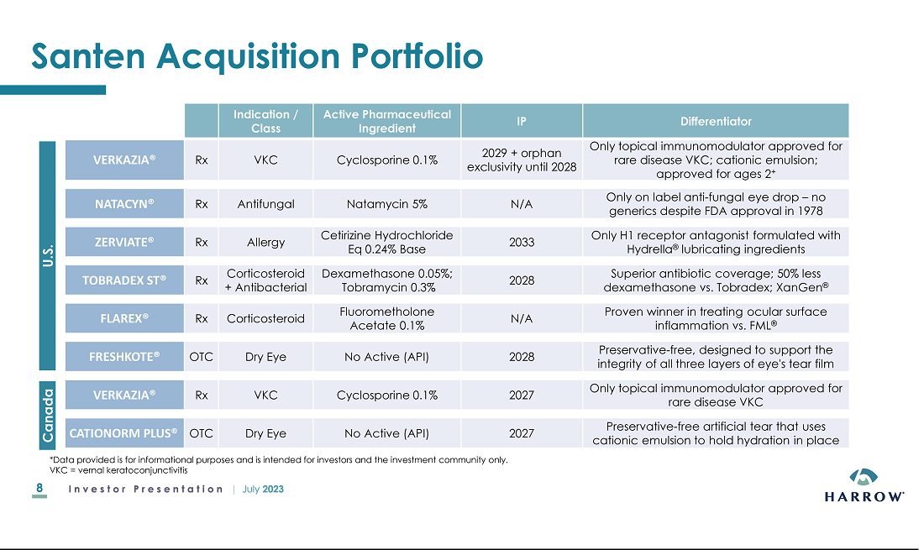

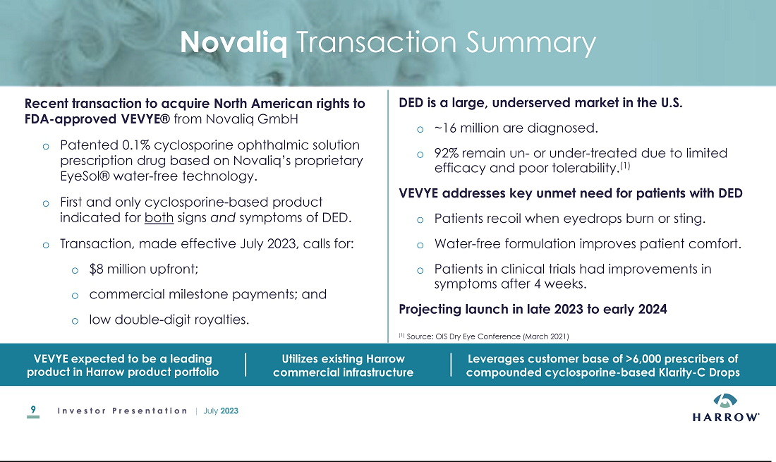

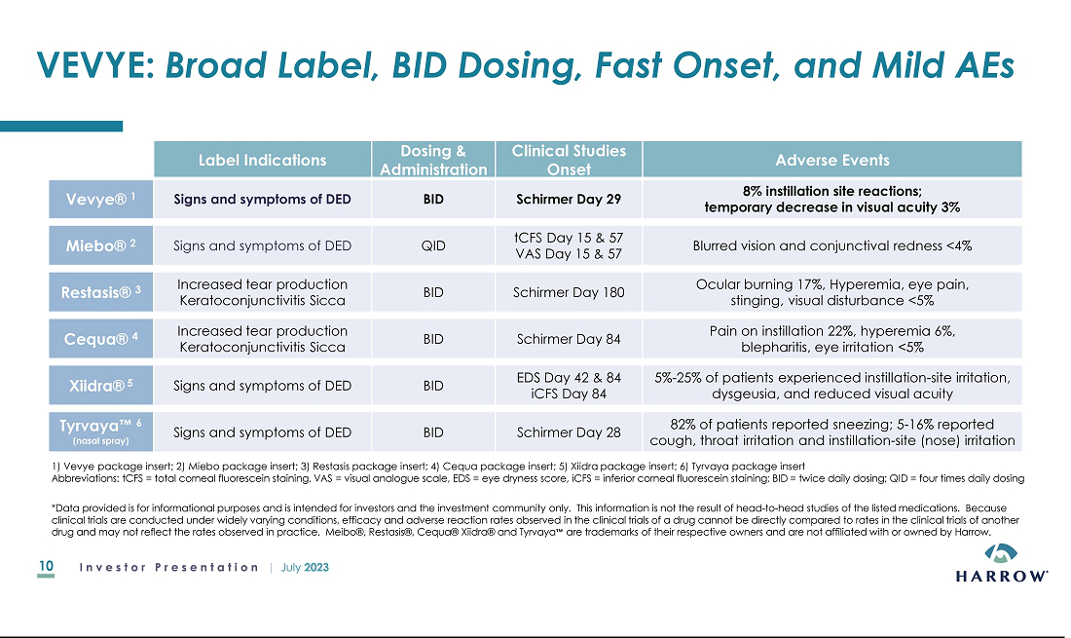

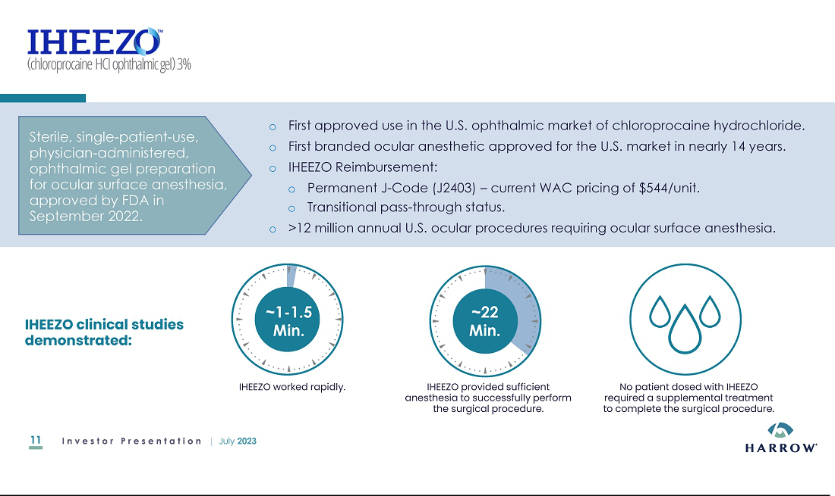

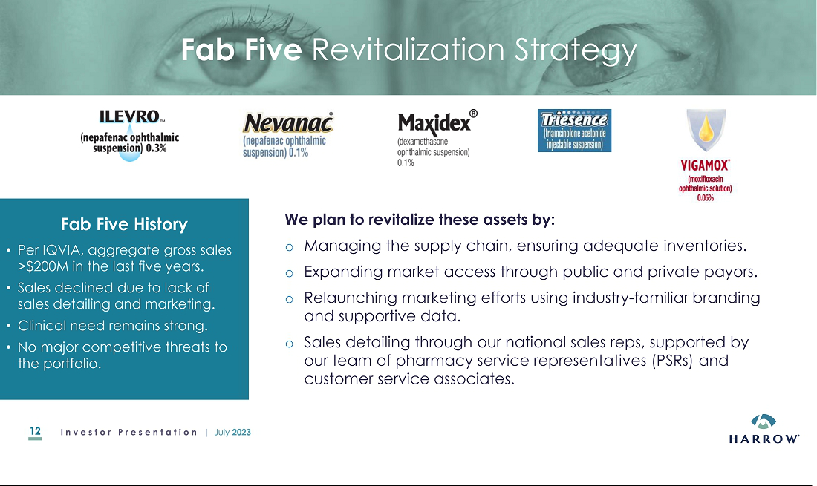

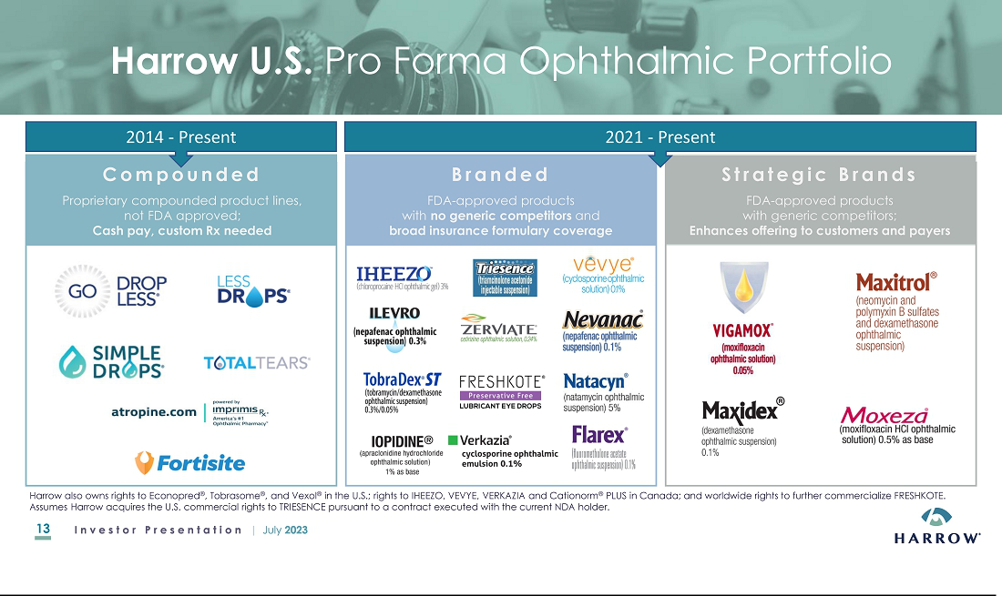

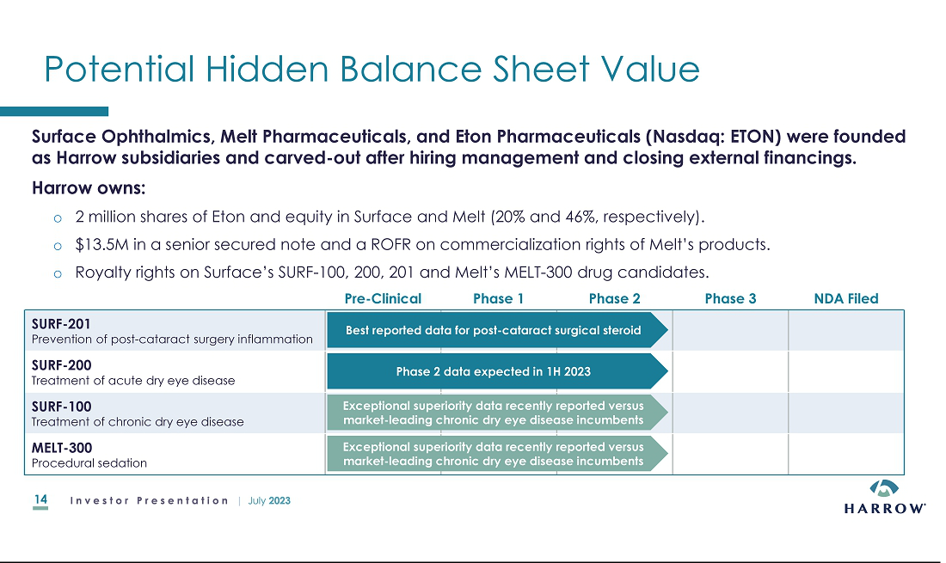

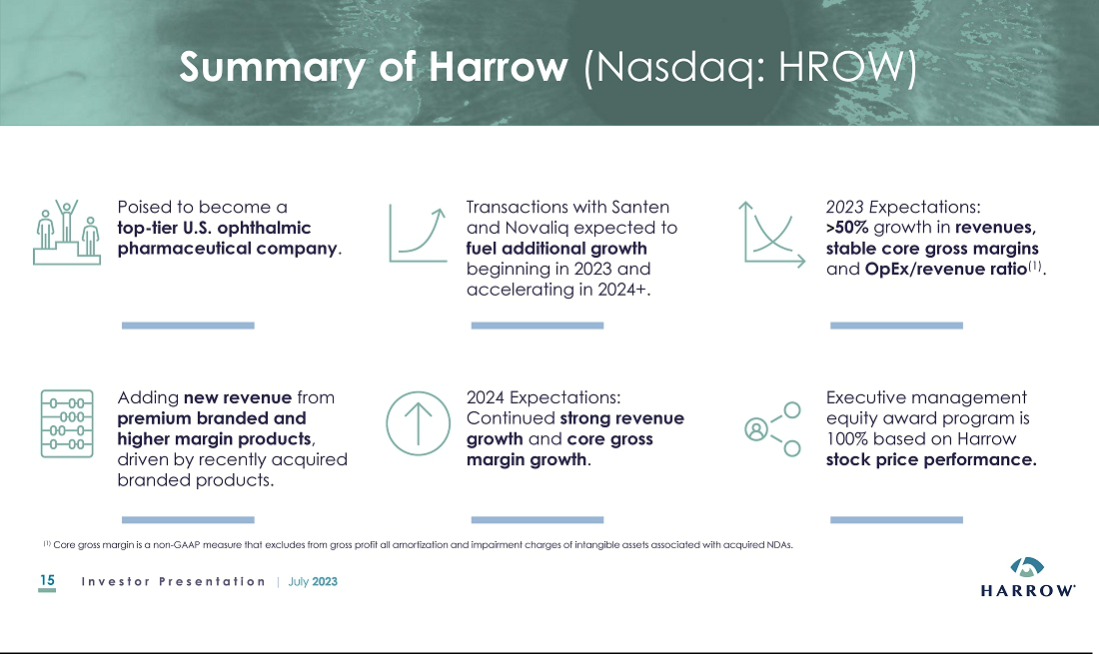

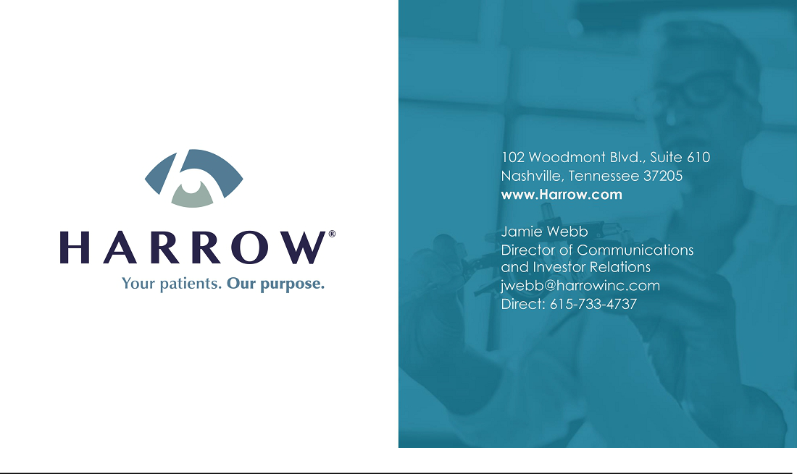

Exhibit 99.4
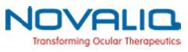

Harrow Acquires U.S. and Canadian Commercial Rights to VEVYE®

(Cyclosporine Ophthalmic Solution) 0.1% from Novaliq

VEVYE® is the First and Only Cyclosporine-Based Product Indicated for the Treatment

of Both Signs and Symptoms of Dry Eye Disease with Efficacy Demonstrated After Four Weeks

VEVYE® is the Only Water-Free Ophthalmic Product with Convenient Twice-Daily (BID) Dosing

NASHVILLE, Tenn. And HEIDELBERG, Germany, July 18, 2023 – Harrow (Nasdaq: HROW), a leading U.S. eyecare pharmaceutical company, and Novaliq GmbH, a German biopharmaceutical company focusing on first- and best-in-class ocular therapeutics, today announced an agreement under which Harrow will acquire the U.S. and Canadian commercial rights for VEVYE® (cyclosporine ophthalmic solution) 0.1%, a patented, non-preserved, ophthalmic solution prescription drug based on Novaliq’s proprietary EyeSol® water-free technology. VEVYE, which is dispensed topically in a unique 10 microliter per one drop and is labeled for twice-daily (BID) dosing, is the first and only cyclosporine-based product indicated for the treatment of both signs and symptoms of dry eye disease (DED). VEVYE was approved on May 30, 2023, by the U.S. Food and Drug Administration (FDA).

In commenting on the transaction, Mark L. Baum, Chairman and Chief Executive Officer of Harrow, said, “The acquisition of the U.S. and Canadian commercial rights to VEVYE demonstrates our commitment to the highly underserved dry eye and ocular surface inflammation markets. We are particularly excited about adding VEVYE to our portfolio because of our strong belief that the U.S. DED market is in need of a cyclosporine-based product that is generally well tolerated, improves both the signs and symptoms of DED and, critically, reduces the time it takes for patients to experience relief from this all-too-common and, in many cases, debilitating disease. VEVYE not only feels better in the eye, but it performs differently, and we believe it addresses the numerous unmet needs in the large and growing U.S. DED market. We look forward to making VEVYE available in the U.S. later this year.”

“There’s good news for dry eye patients and for our colleagues,” commented Laura M. Periman, M.D., Director of Dry Eye Services and Clinical Research, Periman Eye Institute, in Seattle, Washington. “VEVYE, which is expected to be available soon, is a unique cyclosporine formulation indicated for treatment of the signs and symptoms of DED. The rapid onset and magnitude of improvements on ocular surface epithelial damage, combined with the tolerability of the non-aqueous vehicle, are key differentiators to existing cyclosporin formulations. These features represent an exciting advancement in addressing the medical needs of dry eye patients and clinicians.”

“For patients with chronic and symptomatic dry eye disease, the tolerability profile of the medication can be critical for compliance and treatment success,” said Paul Karpecki, O.D., director, Cornea and External Disease, Kentucky Eye Institute, and associate professor, University of Pikeville, Kentucky College of Optometry. “Most patients are not comfortable with drops in their eyes that cause burning or stinging. As a water-free drug product, VEVYE does not require potentially irritating ingredients, such as preservatives, oils or surfactants, and has demonstrated in clinical trials a high patient satisfaction rate. Having a new treatment option with a favorable comfort and tolerability profile is a significant advancement for the dry eye patient, especially those who experience burning and stinging with topical eye medications.”

Christian Roesky, Ph.D., Chief Executive Officer of Novaliq, stated, “We are excited to partner with Harrow, one of the fastest growing and most dynamic ophthalmic pharmaceutical companies in the U.S., to commercialize VEVYE in the U.S. and Canadian markets. Harrow and its commercial team have a distinguished track record for successfully commercializing new and clinically important pharmaceutical products in the U.S. market, and they specifically have many years of experience successfully marketing cyclosporine-based formulations to U.S. eyecare professionals. The Novaliq team looks forward to supporting Harrow during the launch of VEVYE, a truly unique and powerful new treatment option for U.S. eyecare professionals and the more than 16 million Americans who have been diagnosed with DED.”

-MORE-

HROW Acquires U.S. and Canadian Rights to VEVYE® (Cyclosporine Ophthalmic Solution) 0.1%

Page 2

July 18, 2023

VEVYE Clinical Data

The safety and efficacy of VEVYE (development name: CyclASol®) for the treatment of dry eye disease were assessed in a total of 1,369 patients with dry eye disease, of which 738 received VEVYE.

Study CYS-001 (NCT02113293) was the first-in-human study and was conducted to investigate the safety, tolerability, and pharmacokinetics (PK) in healthy volunteers. In this study, VEVYE was shown to be safe, and no systemic exposure of cyclosporin was observed after ocular administration.

Study CYS-002 (NCT02617667, Wirta et al 2019) demonstrated that VEVYE-dosed patients showed a statistically significant early and clinically meaningful increase in Schirmer’s tear test score at Day 29 compared to vehicle. Additionally, VEVYE showed greater improvement in corneal and conjunctival staining compared to (i) vehicle and (ii) Restasis® over the four-month treatment period. The favorable safety and tolerability profile of VEVYE was confirmed.

Study CYS-003 (ESSENCE-1; NCT03292809, Sheppard et al 2021) confirmed the effects seen in CYS-002. Compared to vehicle at the end of treatment, there was a statistically significant higher percentage of patients with increases of ≥10 mm from baseline in Schirmer’s tear test score at Day 85. Notably, the study demonstrated statistically significant reduction in total, central corneal fluorescein and conjunctival staining scores favoring VEVYE at all time points, in addition to VEVYE meeting the primary endpoint of the study. 52.9% of patients responded within four weeks with a clinically meaningful improvement of ≥3 grades in total corneal staining, which was significantly higher compared to vehicle. Responders showed statistically significant improvements in a variety of symptoms compared to non-responders. VEVYE was safe, well tolerated, and comfortable over the three-month treatment duration.

Study CYS-004 (ESSENCE-2; NCT04523129, Akpek et al 2023) was designed to replicate CYS-003 and met the primary corneal staining endpoint. In this study, 71.6% of patients responded within four weeks with a clinically meaningful improvement of ≥3 grades in total corneal staining. Again, responders showed statistically significant improvements in a variety of symptoms compared to non-responders at Day 29. Subjects with high central corneal staining at baseline were shown to benefit from VEVYE with statistically significant improvements in their blurred vision score compared to vehicle CYS-004 studies as shown in CYS-003. Schirmer’s tear test responses of ≥10 mm increase was statistically significantly higher in the VEVYE compared vehicle at Day 29. VEVYE was safe, well tolerated, and comfortable over the one-month duration.

Study CYS-005 (NCT04523142, Wirta et al 2023) was an open label extension study of CYS-004. VEVYE was shown to be safe and well tolerated during long-term use over 12 months. Sign and symptom endpoints continued to improve over the course of the study demonstrating sustained efficacy over 52 weeks of therapy in both signs and symptoms.

- Wirta DL, Torkildsen GL, Moreira HR, Lonsdale JD, Ciolino JB, Jentsch G, Beckert M, Ousler GM, Steven P, Krösser S. A Clinical Phase II Study to Assess Efficacy, Safety, and Tolerability of Waterfree Cyclosporine Formulation for Treatment of Dry Eye Disease. Ophthalmology. 2019; 126:793-800
- Sheppard JD, Wirta DL, McLaurin E, Boehmer BE, Ciolino CB, Meides AS, Schlüter T, Ousler GW, Usner D, Krösser S. A Water-free 0.1% Cyclosporine A Solution for Treatment of Dry Eye Disease: Results of the Randomized Phase II/III ESSENCE Study. Cornea. 2021; 40:1290-1297
- Akpek EK, Wirta DL, Downing JE, Tauber J, Sheppard JD, Ciolino JB, Meides AS, Krösser S: Efficacy and Safety of a Water-Free Topical Cyclosporine, 0.1%, Solution for the Treatment of

Moderate to Severe Dry Eye Disease: The ESSENCE-2 Randomized Clinical Trial. JAMA Ophthalmology. 2023; 141(5):459-466.

- Wirta DL, Krösser S, Long -Term Safety and Efficacy of a Water-Free Cyclosporine Ophthalmic Solution for the Treatment of Dry-Eye Disease: ESSENCE-2-OLE study. ASCRS 2023 paper presentation.

-MORE-

HROW Acquires U.S. and Canadian Rights to VEVYE® (Cyclosporine Ophthalmic Solution) 0.1%

Page 3

July 18, 2023

About VEVYE® (cyclosporine ophthalmic solution) 0.1%

VEVYE (cyclosporine ophthalmic solution) 0.1%, non-preserved, for topical ophthalmic use.

INDICATIONS AND USAGE

VEVYE is indicated for the treatment of the signs and symptoms of dry eye disease.

CONTRAINDICATIONS

None.

WARNINGS AND PRECAUTIONS

Potential for Eye Injury and Contamination. To avoid the potential for eye injury and/or contamination, patients should not touch the bottle tip to the eye or other surfaces.

Use with Contact Lenses. VEVYE should not be administered while wearing contact lenses. If contact lenses are worn, they should be removed prior to administration of the solution. Lenses may be reinserted 15 minutes following administration of VEVYE ophthalmic solution.

ADVERSE REACTIONS

Clinical Trials Experience. Because clinical trials are conducted under widely varying conditions, adverse reaction rates observed in the clinical trials of a drug cannot be directly compared to rates in the clinical trials of another drug and may not reflect the rates observed in practice. In clinical trials with 738 subjects receiving at least 1 dose of VEVYE, the most common adverse reactions were instillation site reactions (8%) and temporary decreases in visual acuity (3%).

USE IN SPECIAL POPULATIONS

Pregnancy. There are no adequate and well-controlled studies of VEVYE administration in pregnant women to inform a drug-associated risk.

Lactation. Caution should be exercised when VEVYE is administered to a nursing woman.

For additional information about VEVYE®, please see the Full Prescribing Information.

About Novaliq

Novaliq is a private biopharmaceutical company focusing on the development and commercialization of first- and best-in-class ocular therapeutics based on EyeSol®, the worldwide first water-free technology. Novaliq GmbH is headquartered in Heidelberg, Germany, and Novaliq Inc. has an office in Cambridge, MA, USA. The long-term shareholder is dievini Hopp BioTech holding GmbH & Co. KG, an active investor in Life and Health Sciences companies. More on novaliq.com.

About Harrow

Harrow Health, Inc. (Nasdaq: HROW) is a leading U.S. eyecare pharmaceutical company engaged in the discovery, development, and commercialization of innovative ophthalmic prescription therapies that are accessible and affordable. Harrow owns U.S. commercial rights to ten branded FDA-approved ophthalmic pharmaceutical products. Harrow also owns and operates ImprimisRx, a leading U.S. ophthalmic-focused pharmaceutical compounding business, which also serves as a mail-order pharmacy licensed to ship prescription medications in all 50 states. Harrow has non-controlling equity positions in Surface Ophthalmics, Inc. and Melt Pharmaceuticals, Inc., companies that began as subsidiaries of Harrow. Harrow also owns royalty rights in four late-stage drug candidates being developed by Surface and Melt.

-MORE-

HROW Acquires U.S. and Canadian Rights to VEVYE® (Cyclosporine Ophthalmic Solution) 0.1%

Page 4

July 18, 2023

Harrow Forward-Looking Statements

This press release contains “forward-looking statements” within the meaning of the U.S. Private Securities Litigation Reform Act of 1995. Any statements in this release that are not historical facts may be considered such “forward-looking statements.” Forward-looking statements are based on management’s current expectations and are subject to risks and uncertainties which may cause results to differ materially and adversely from the statements contained herein. Some of the potential risks and uncertainties that could cause actual results to differ from those predicted include, among others, risks related to: liquidity or results of operations; our ability to successfully implement our business plan, develop and commercialize our products, product candidates and proprietary formulations in a timely manner or at all, identify and acquire additional products, manage our pharmacy operations, service our debt, obtain financing necessary to operate our business, recruit and retain qualified personnel, manage any growth we may experience and successfully realize the benefits of our previous acquisitions and any other acquisitions and collaborative arrangements we may pursue; competition from pharmaceutical companies, outsourcing facilities and pharmacies; general economic and business conditions, including inflation and supply chain challenges; regulatory and legal risks and uncertainties related to our pharmacy operations and the pharmacy and pharmaceutical business in general; and physician interest in and market acceptance of our current and any future formulations and compounding pharmacies generally. These and additional risks and uncertainties are more fully described in Harrow’s filings with the Securities and Exchange Commission (“SEC”), including its Annual Report on Form 10-K and its Quarterly Reports on Form 10-Q. Such documents may be read free of charge on the SEC’s web site at sec.gov. Undue reliance should not be placed on forward-looking statements, which speak only as of the date they are made. Except as required by law, Harrow undertakes no obligation to update any forward-looking statements to reflect new information, events, or circumstances after the date they are made, or to reflect the occurrence of unanticipated events.

Contacts:
Harrow: |  |  | Novaliq:
Investors |  |  | Media
Jamie Webb |  |  | Simone Angstmann-Mehr
Director of Communications and Investor Relations |  |  | info@novaliq.com
jwebb@harrowinc.com
615-733-4737

Media

Deb Holliday

Holliday Communications, Inc.

deb@hollidaycommunications.net

412-877-4519

-END-

Exhibit 99.5
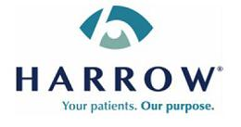

Harrow Acquires Santen’s Branded Ophthalmic Portfolio

Transaction Includes U.S. and Canadian Commercial Rights to FLAREX®, NATACYN®, TOBRADEX® ST, VERKAZIA®, ZERVIATE®, and Non-Prescription Brands FRESHKOTE® and Cationorm® PLUS

NASHVILLE, Tenn., July 18, 2023 – Harrow (Nasdaq: HROW), a leading U.S. eyecare pharmaceutical company, today announced the signing of agreements with affiliates of Santen Pharmaceutical Co., Ltd. (“Santen”) under which Harrow will acquire certain U.S. and Canadian commercial rights for the following branded products from Santen:

U.S. Products:

- FLAREX® (fluorometholone acetate ophthalmic suspension) 0.1%, a corticosteroid indicated for use in the treatment of steroid-responsive inflammatory conditions of the palpebral and bulbar conjunctiva, cornea, and anterior segment of the eye.

- NATACYN® (natamycin ophthalmic suspension) 5%, a sterile antifungal indicated for the treatment of fungal blepharitis, conjunctivitis, and keratitis caused by susceptible organisms, including Fusarium solani keratitis.

- TOBRADEX® ST (tobramycin and dexamethasone ophthalmic suspension) 0.3%/0.05%, an antibiotic and corticosteroid combination for steroid-responsive inflammatory ocular conditions for which a corticosteroid is indicated and where superficial bacterial ocular infection or a risk of bacterial ocular infection exists.

- VERKAZIA® (cyclosporine ophthalmic emulsion) 0.1%, a calcineurin inhibitor immunosuppressant indicated for the treatment of vernal keratoconjunctivitis (VKC) in children and adults and holds orphan-drug exclusivity.

- ZERVIATE® (cetirizine ophthalmic solution) 0.24%, a histamine-1 (H1) receptor antagonist indicated for treatment of ocular itching associated with allergic conjunctivitis.

- FRESHKOTE®, used as a lubricant to reduce further irritation or to relieve dryness of the eye.

Canadian Products:

- VERKAZIA® (cyclosporine ophthalmic emulsion) 0.1%, a calcineurin inhibitor immunosuppressant indicated for the treatment of vernal keratoconjunctivitis (VKC) in children from four years of age through adolescence.

- Cationorm® PLUS, a preservative-free emulsion for the treatment of dry eye symptoms and for the treatment of signs and symptoms of ocular allergy.

Please see select Important Safety Information for these products and links to the Full Prescribing Information at the end of this release.

In commenting on the transaction, Mark L. Baum, Chairman and Chief Executive Officer of Harrow, stated, “This acquisition furthers Harrow’s goal of becoming a leader in the top tier of U.S. ophthalmic pharmaceutical companies, makes Harrow’s branded portfolio one of the most comprehensive in the U.S. market, and is expected to be immediately financially accretive upon the transfer of the product marketing authorizations. We are excited to add several high utility and trusted products that serve the ophthalmic surgical market, a market in which we already have a strong presence, and significantly expand the breadth of our portfolio, which will now include the only FDA-approved ophthalmic antifungal; a patented and ‘orphan-designated’ product for the nearly 50,000 Americans suffering from the rare disease vernal keratoconjunctivitis (or VKC); a patented prescription drug to treat ocular itching associated with allergies; and two patented non-prescription brands serving patients managing dry eye symptoms.”

-MORE-

HROW Acquires Santen’s Branded Ophthalmic Portfolio

Page 2

July 18, 2023

Richard L. Lindstrom, M.D. added, “As an ophthalmic surgeon of nearly 50 years and an advisor to Mark and the Harrow leadership team for many years, I am pleased to see Harrow step up and assemble not only a formidable posterior segment offering with products like IHEEZO® and TRIESENCE®, but also an impressive array of innovative anterior segment products that U.S. ophthalmologists and optometrists rely on to care for their patients. While some ophthalmic pharmaceutical companies have decided to place less emphasis on the anterior segment despite the growing demand in this category of eyecare, with this acquisition, few companies, if any, can match the scope and depth of Harrow’s ophthalmic product offerings, especially in the anterior segment. I believe this level of commitment to the eyecare professional should further strengthen and expand the many relationships Harrow has been able to forge over the past 10 years.”

Financing for the transaction was provided through the expansion of Harrow’s secured credit facility with funds managed by Oaktree Capital Management, L.P. Harrow management expects the transaction to reduce the Company’s aggregate leverage ratio of adjusted EBITDA to debt.

About Harrow

Harrow Health, Inc. (Nasdaq: HROW) is a leading U.S. eyecare pharmaceutical company engaged in the discovery, development, and commercialization of innovative ophthalmic prescription therapies that are accessible and affordable. Harrow owns U.S. commercial rights to ten branded FDA-approved ophthalmic pharmaceutical products. Harrow also owns and operates ImprimisRx, a leading U.S. ophthalmic-focused pharmaceutical compounding business, which also serves as a mail-order pharmacy licensed to ship prescription medications in all 50 states. Harrow has non-controlling equity positions in Surface Ophthalmics, Inc. and Melt Pharmaceuticals, Inc., companies that began as subsidiaries of Harrow. Harrow also owns royalty rights in four late-stage drug candidates being developed by Surface and Melt.

Forward-Looking Statements

This press release contains “forward-looking statements” within the meaning of the U.S. Private Securities Litigation Reform Act of 1995. Any statements in this release that are not historical facts may be considered such “forward-looking statements.” Forward-looking statements are based on management’s current expectations and are subject to risks and uncertainties which may cause results to differ materially and adversely from the statements contained herein. Some of the potential risks and uncertainties that could cause actual results to differ from those predicted include, among others, risks related to: liquidity or results of operations; our ability to successfully implement our business plan, develop and commercialize our products, product candidates and proprietary formulations in a timely manner or at all, identify and acquire additional products, manage our pharmacy operations, service our debt, obtain financing necessary to operate our business, recruit and retain qualified personnel, manage any growth we may experience and successfully realize the benefits of our previous acquisitions and any other acquisitions and collaborative arrangements we may pursue; competition from pharmaceutical companies, outsourcing facilities and pharmacies; general economic and business conditions, including inflation and supply chain challenges; regulatory and legal risks and uncertainties related to our pharmacy operations and the pharmacy and pharmaceutical business in general; and physician interest in and market acceptance of our current and any future formulations and compounding pharmacies generally. These and additional risks and uncertainties are more fully described in Harrow’s filings with the Securities and Exchange Commission (“SEC”), including its Annual Report on Form 10-K and its Quarterly Reports on Form 10-Q. Such documents may be read free of charge on the SEC’s web site at sec.gov. Undue reliance should not be placed on forward-looking statements, which speak only as of the date they are made. Except as required by law, Harrow undertakes no obligation to update any forward-looking statements to reflect new information, events, or circumstances after the date they are made, or to reflect the occurrence of unanticipated events.

Contacts:
Investors |  |  |  | Media
Jamie Webb |  |  |  | Deb Holliday
Director of Communications and Investor Relations |  |  |  | Holliday Communications, Inc.
jwebb@harrowinc.com |  |  |  | deb@hollidaycommunications.net
615-733-4737 |  |  | 412-877-4519
 |  |  | -MORE-

HROW Acquires Santen’s Branded Ophthalmic Portfolio

Page 3

July 18, 2023

Information for U.S. Products:

About FLAREX® (fluorometholone acetate ophthalmic suspension) 0.1%

INDICATIONS AND USAGE

FLAREX® (fluorometholone acetate ophthalmic suspension) 0.1% is indicated for use in the treatment of steroid responsive inflammatory conditions of the palpebral and bulbar conjunctiva, cornea, and anterior segment of the eye.

CONTRAINDICATIONS

Contraindicated in acute superficial herpes simplex keratitis, vaccinia, varicella, and most other viral diseases of cornea and conjunctiva; mycobacterial infection of the eye; fungal diseases; acute purulent untreated infections, which like other diseases caused by microorganisms, may be masked or enhanced by the presence of the steroid; and in those persons who have known hypersensitivity to any component of this preparation.

SELECT WARNINGS

FOR TOPICAL OPHTHALMIC USE. NOT FOR INJECTION. Use in the treatment of herpes simplex infection requires great caution. Prolonged use may result in glaucoma, damage to the optic nerve, defect in visual acuity and visual field, cataract formation and/or may aid in the establishment of secondary ocular infections from pathogens due to suppression of host response. Acute purulent infections of the eye may be masked or exacerbated by presence of steroid medication. Topical ophthalmic corticosteroids may slow corneal wound healing. In those diseases causing thinning of the cornea or sclera, perforation has been known to occur. If these products are used for 10 days or longer, intraocular pressure (IOP) should be routinely monitored.

ADVERSE REACTIONS

Glaucoma with optic nerve damage, visual acuity and field defects, cataract formation, secondary ocular infection following suppression of host response, and perforation of the globe may occur.

For complete product information about FLAREX®, including important safety information, please visit: https://dailymed.nlm.nih.gov/dailymed/drugInfo.cfm?setid=19918ea5-8568-44d6-b8ee-7b2197cee85c.

About NATACYN® (natamycin ophthalmic suspension) 5%

INDICATIONS AND USAGE

NATACYN® (natamycin ophthalmic suspension) 5% is indicated for the treatment of fungal blepharitis, conjunctivitis, and keratitis caused by susceptible organisms including Fusarium solani keratitis. As in other forms of suppurative keratitis, initial and sustained therapy of fungal keratitis should be determined by the clinical diagnosis, laboratory diagnosis by smear and culture of corneal scrapings and drug response. Whenever possible the in vitro activity of natamycin against the responsible fungus should be determined. The effectiveness of natamycin as a single agent in fungal endophthalmitis has not been established.

CONTRAINDICATIONS

NATACYN® (natamycin ophthalmic suspension) 5% is contraindicated in individuals with a history of hypersensitivity to any of its components.

SELECT PRECAUTIONS

General: FOR TOPICAL OPHTHALMIC USE ONLY — NOT FOR INJECTION. Failure of improvement of keratitis following 7-10 days of administration of the drug suggests that the infection may be caused by a microorganism not susceptible to natamycin.

-MORE-

HROW Acquires Santen’s Branded Ophthalmic Portfolio

Page 4

July 18, 2023

ADVERSE REACTIONS

The following events have been identified during post-marketing use of NATACYN ® (natamycin ophthalmic suspension) 5% in clinical practice: allergic reaction, change in vision, chest pain, corneal opacity, dyspnea, eye discomfort, eye edema, eye hyperemia, eye irritation, eye pain, foreign body sensation, paresthesia, and tearing.

For complete product information about NATACYN®, including important safety information, please visit: https://dailymed.nlm.nih.gov/dailymed/drugInfo.cfm?setid=2818fcb8-5bac-41fb-864e-3b598308a428.

About TOBRADEX® ST (tobramycin and dexamethasone ophthalmic suspension) 0.3%/0.05%

INDICATIONS AND USAGE

TOBRADEX® ST ophthalmic suspension is indicated for steroid-responsive inflammatory ocular conditions for which a corticosteroid is indicated and where superficial bacterial ocular infection or a risk of bacterial ocular infection exists.

CONTRAINDICATIONS

Nonbacterial Etiology: TOBRADEX® ST, as with other ophthalmic corticosteroids, is contraindicated in most viral diseases of the cornea and conjunctiva, including epithelial herpes simplex keratitis (dendritic keratitis), vaccinia, and varicella, and also in mycobacterial infection of the eye and fungal diseases of ocular structures.

Hypersensitivity: Hypersensitivity to a component of the medication.

SELECT WARNINGS AND PRECAUTIONS

Intraocular Pressure Increase: Prolonged use of corticosteroids may result in glaucoma with damage to the optic nerve, defects in visual acuity and fields of vision. If this product is used for 10 days or longer, intraocular pressure (IOP) should be monitored.

Aminoglycoside Sensitivity: Sensitivity to topically applied aminoglycosides may occur.

Cataracts: Use of corticosteroids may result in posterior subcapsular cataract formation.

Delayed Healing: The use of steroids after cataract surgery may delay healing.

Bacterial Infections: Prolonged use of corticosteroids may suppress the host response and thus increase the hazard of secondary ocular infections.

Viral Infections: Use in patients with a history of herpes simplex requires great caution as it may prolong the course and may exacerbate the severity of many viral infections of the eye (including herpes simplex).

Fungal Infections: Fungal infections of the cornea are particularly prone to develop coincidentally with long-term local steroid application.

Vision Blurred: Vision may be temporarily blurred following dosing with TOBRADEX ST. Care should be exercised in operating machinery or driving a motor vehicle.

Risk of Contamination: Do not touch the dropper tip of the bottle to any surface, as this may contaminate the contents.

Contact Lens Use: TOBRADEX® ST contains benzalkonium chloride, an antimicrobial preservative, that may be absorbed by soft contact lenses. Contact lenses should not be worn during the use of TOBRADEX ST.

-MORE-

HROW Acquires Santen’s Branded Ophthalmic Portfolio

Page 5

July 18, 2023

ADVERSE REACTIONS

Clinical Trials Experience: The most frequent adverse reactions to topical ocular tobramycin (TOBREX ®) are hypersensitivity and localized ocular toxicity, including eye pain, eyelids pruritus, eyelid edema, and conjunctival hyperemia. These reactions occur in less than 4% of patients.

For complete product information about TOBRADEX® ST, including important safety information, please visit: https://dailymed.nlm.nih.gov/dailymed/drugInfo.cfm?setid=c2d7325e-4f58-5590-e053-2a95a90ace1b.

About VERKAZIA® (cyclosporine ophthalmic emulsion) 0.1%

INDICATIONS AND USAGE

VERKAZIA® ophthalmic emulsion is indicated for the treatment of vernal keratoconjunctivitis (VKC) in children and adults.

ADVERSE REACTIONS

The most common adverse reactions reported in greater than 5% of patients were eye pain (12%) and eye pruritus (8%) which were usually transitory and occurred during instillation.

For complete product information about VERKAZIA®, including important safety information, please visit: https://dailymed.nlm.nih.gov/dailymed/drugInfo.cfm?setid=c795cd2f-89da-78e3-e053-2a95a90a9422.

About ZERVIATE® (cetirizine ophthalmic solution) 0.24%

INDICATIONS AND USAGE

ZERVIATE® (cetirizine ophthalmic solution) 0.24% is indicated for the treatment of ocular itching associated with allergic conjunctivitis.

SELECT WARNINGS AND PRECAUTIONS

Contamination of Tip and Solution: As with any eye drop, care should be taken not to touch the eyelids or surrounding areas with the dropper tip of the bottle or tip of the single-use container in order to avoid injury to the eye and to prevent contaminating the tip and solution. Keep the multi-dose bottle closed when not in use. Discard the single-use container after using in each eye.

Contact Lens Wear: Patients should be advised not to wear a contact lens if their eye is red.

ZERVIATE should not be instilled while wearing contact lenses.

ADVERSE REACTIONS

The most commonly reported adverse reactions occurred in approximately 1–7% of patients treated with either ZERVIATE or vehicle. These reactions were ocular hyperemia, instillation site pain, and visual acuity reduced.

For complete product information about ZERVIATE®, including important safety information, please visit: https://dailymed.nlm.nih.gov/dailymed/drugInfo.cfm?setid=3e6fecc1-df71-4c01-a654-f55635617a7f

-MORE-

HROW Acquires Santen’s Branded Ophthalmic Portfolio

Page 6

July 18, 2023

Information for Canadian Products

About VERKAZIA® (cyclosporine topical ophthalmic emulsion) 0.1% w/v

Verkazia (cyclosporine) is indicated for treatment of severe vernal keratoconjunctivitis in children from four years of age through adolescence.

For complete Canadian product information about Verkazia, including important safety information, please visit: https://pdf.hres.ca/dpd_pm/00048991.PDF.

About Cationorm® PLUS

Cationorm® PLUS is an ophthalmic sterile preservative-free eye drop emulsion used for:

treatment of dry eye symptoms: It helps to hydrate, lubricate and protect the ocular surface. It is recommended for the relief of dry eye symptoms characterized by stinging, itching or burning eyes or by a foreign body sensation (sand, dust, etc.).

treatment of signs and symptoms of ocular allergy: It is recommended for the relief of ocular allergy symptoms characterized by itching, tearing, mucous discharge and photophobia, and the protection of the ocular surface (corneal staining improvement). Cationorm® PLUS can be used in children from four years old.

Do not use Cationorm® PLUS if you are allergic to any of the components of the product. This product is not intended for treating other eye conditions. Please consult your doctor or pharmacist if you have any questions. If you currently use other eye drops, you should wait at least 5 minutes between the administrations of each successive eye drop. It is recommended to use Cationorm® PLUS last.

Cationorm® PLUS is compatible with all kinds of contact lenses.

In very rare cases, a transient ocular discomfort such as: eye irritation, eye pain, eye redness, watery eyes, eye discharge, temporarily blurred vision, eyelids inflammation, eyelids edema or transient discomfort at instillation can appear. These symptoms are also part of typical symptoms of dry eye disease linked to the underlying existing medical conditions in the patient’s eyes suffering from dry eye or ocular allergy.

-END-

