UNITED STATES

SECURITIES AND EXCHANGE COMMISSION
Washington, D.C. 20549

FORM 8-K

CURRENT REPORT

Pursuant to Section 13 OR 15(d) of The Securities Exchange Act of 1934

Date of Report (Date of earliest event reported): January 10, 2022

HARROW HEALTH, INC.

(Exact name of registrant as specified in its charter)

Delaware

(State or other jurisdiction

of incorporation)

001-35814

(Commission

File Number)

45-0567010

(IRS Employer

Identification No.)

102 Woodmont Blvd., Suite 610

Nashville, Tennessee

(Address of principal executive offices)

37205

(Zip Code)

Registrant’s telephone number, including area code: (615) 733-4730

Not Applicable

(Former Name or Former Address, if Changed Since Last Report)

Securities registered pursuant to Section 12(b) of the Act:
Title of each class |  | Trading Symbol(s) |  | Name on exchange on which registered
Common Stock, $0.001 par value per share |  | HROW |  | The NASDAQ Global Market
8.625% Senior Notes due April 2026 |  | HROWL |  | The NASDAQ Global Market

Check the appropriate box below if the Form 8-K filing is intended to simultaneously satisfy the filing obligation of the registrant under any of the following provisions:

- Written communications pursuant to Rule 425 under the Securities Act (17 CFR 230.425)

- Soliciting material pursuant to Rule 14a-12 under the Exchange Act (17 CFR 240.14a-12)

- Pre-commencement communications pursuant to Rule 14d-2(b) under the Exchange Act (17 CFR 240.14d-2(b))

- Pre-commencement communications pursuant to Rule 13e-4(c) under the Exchange Act (17 CFR 240.13e-4(c))

Indicate by check mark whether the registrant is an emerging growth company as defined in Rule 405 of the Securities Act of 1933 or Rule 12b-2 of the Securities Act of 1934: Emerging growth company ☐

If any emerging growth company, indicate by check mark if the registrant has elected not to use the extended transition period for complying with any new or revised financial accounting standards provided pursuant to Section 13(a) of the Exchange Act. ☐

Item 7.01. Regulation FD Disclosure

Attached as Exhibit 99.1 and Exhibit 99.2 to this Item 7.01 are a presentation and information sheet, respectively, of Harrow Health, Inc. (the “Company”), that may be used by the management of the Company at investor conferences and at meetings describing the Company.

The information contained in Item 7.01 of this report and in Exhibits 99.1 and 99.2 shall not be deemed “filed” for purposes of Section 18 of the Securities Exchange Act of 1934, as amended (the “Exchange Act”), or incorporated by reference in any filing under the Securities Act of 1933, as amended, or the Exchange Act, except as shall be expressly set forth by specific reference in such a filing.

Item 9.01. Financial Statements and Exhibits

(d) Exhibits

Item Description

99.1 Harrow Health, Inc. Corporate Presentation dated January 2022

99.2 Harrow Health, Inc. Tear Sheet dated January 2022

104 Cover Page Interactive Data File (embedded within the Inline XBRL document)

SIGNATURES

Pursuant to the requirements of the Securities Exchange Act of 1934, the registrant has duly caused this report to be signed on its behalf by the undersigned hereunto duly authorized.

 | HARROW HEALTH, INC.
Dated: January 10, 2022 | By: | /s/ Andrew R. Boll
 | Name: | Andrew R. Boll
 | Title: | Chief Financial Officer

Exhibit 99.1
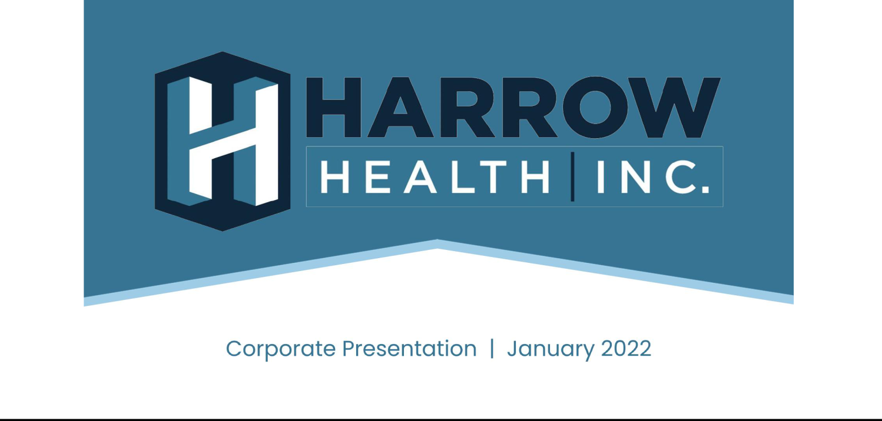

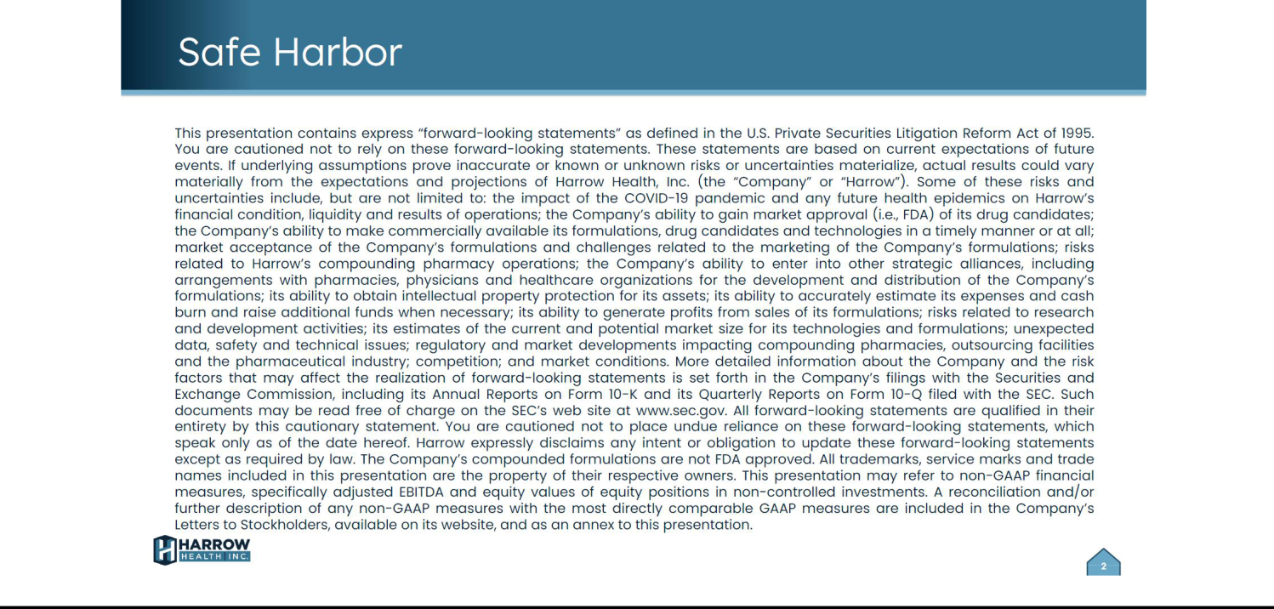

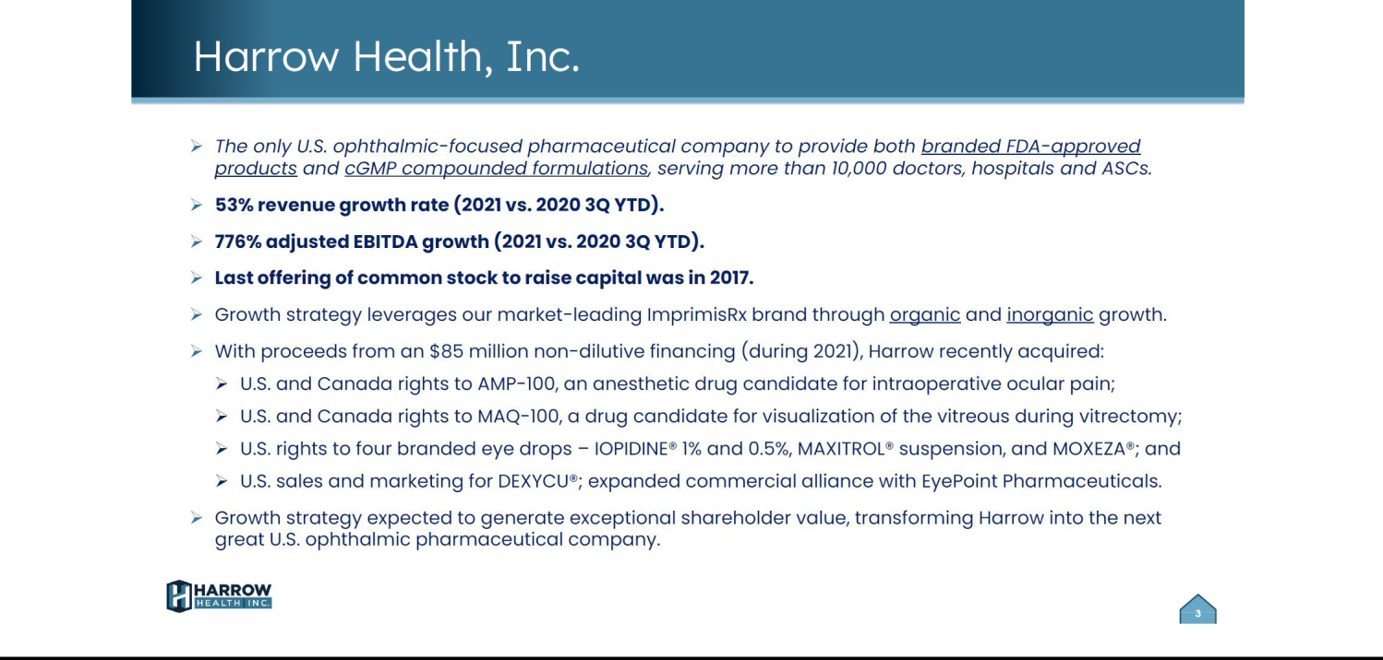

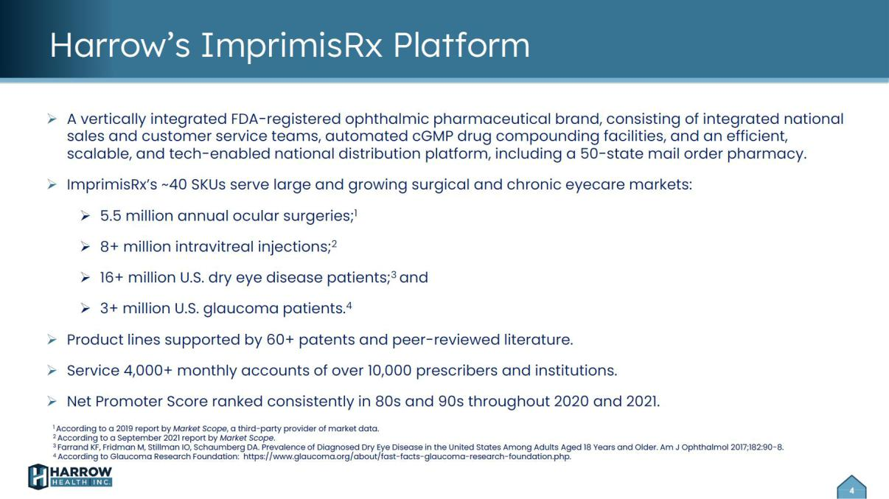.

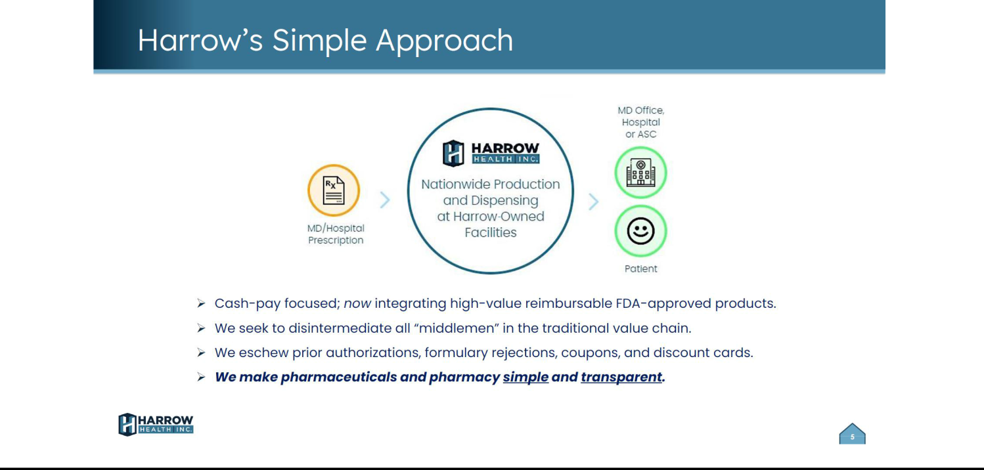

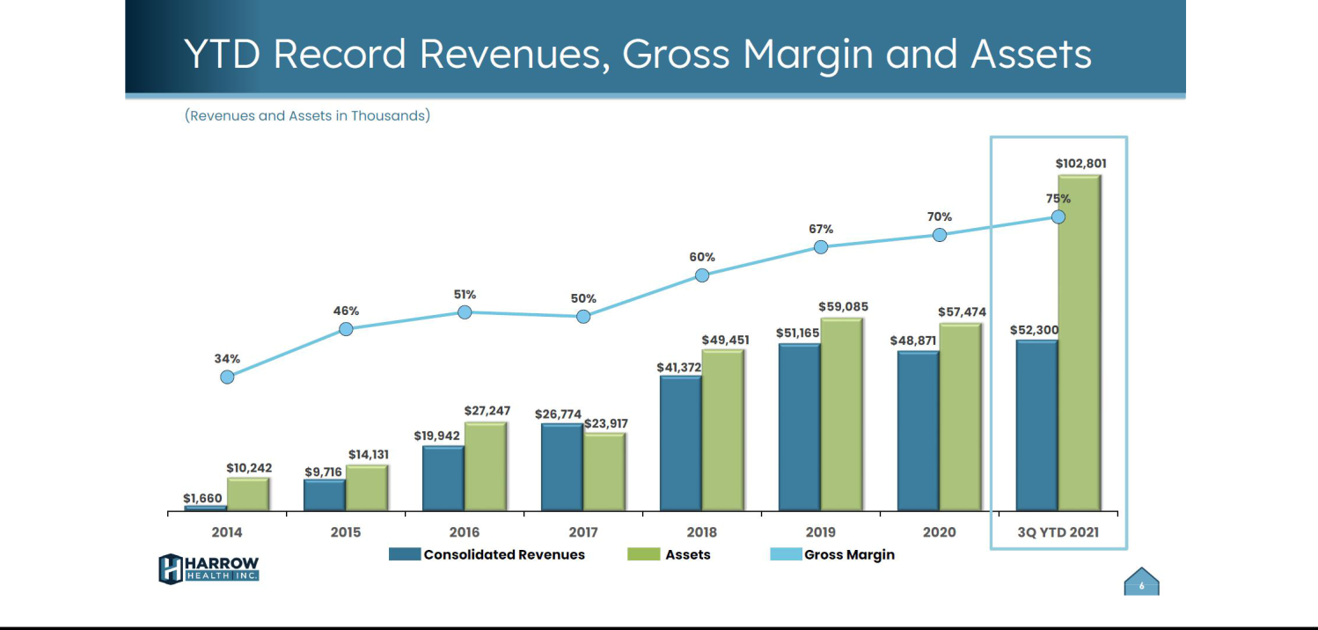

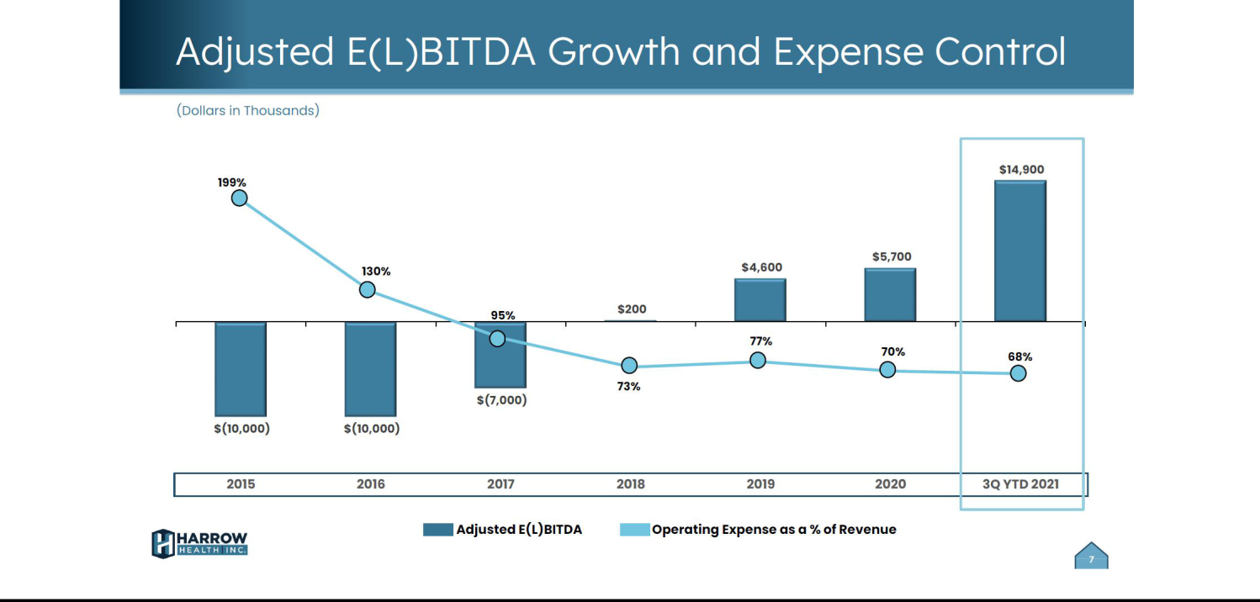

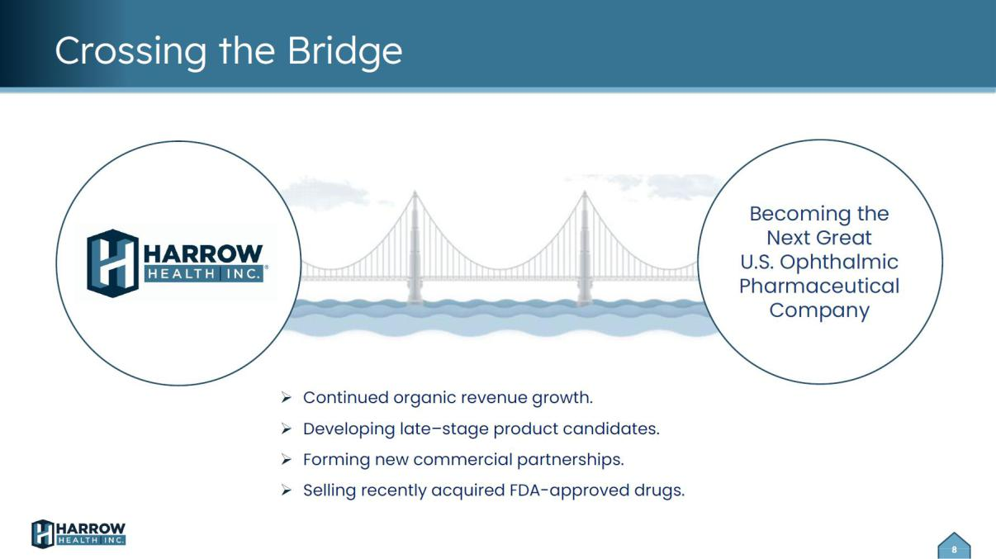

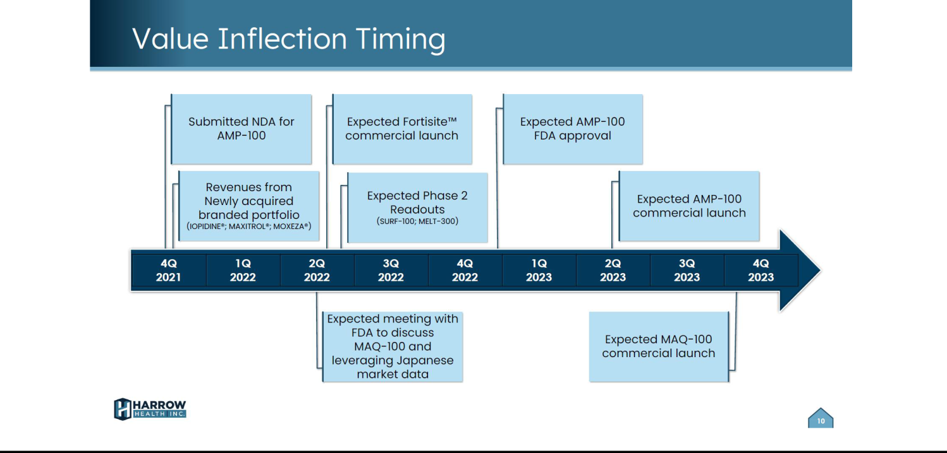

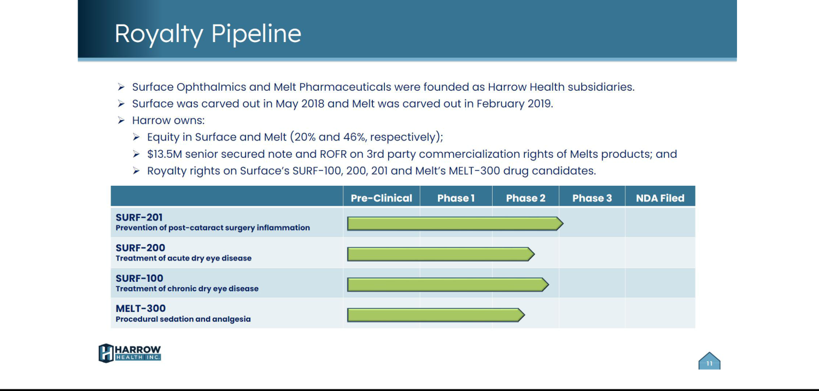

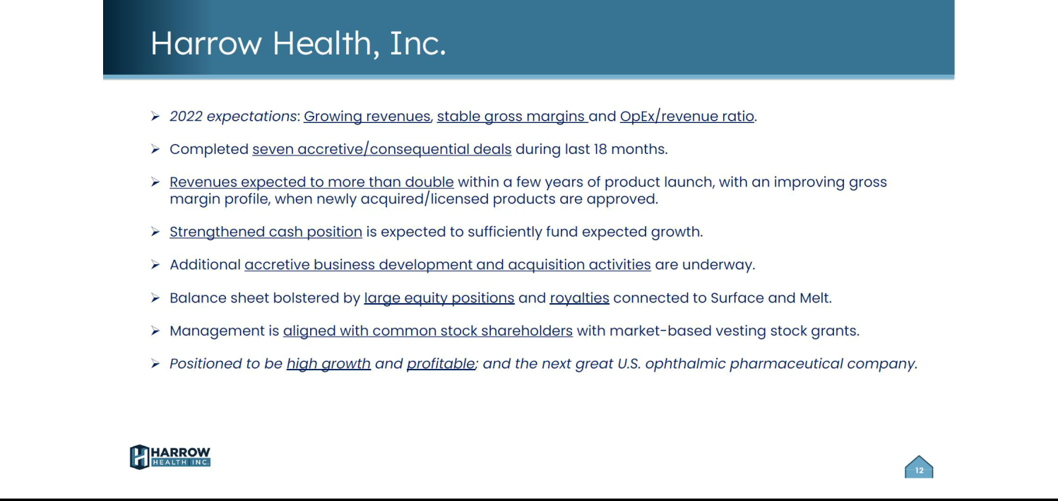

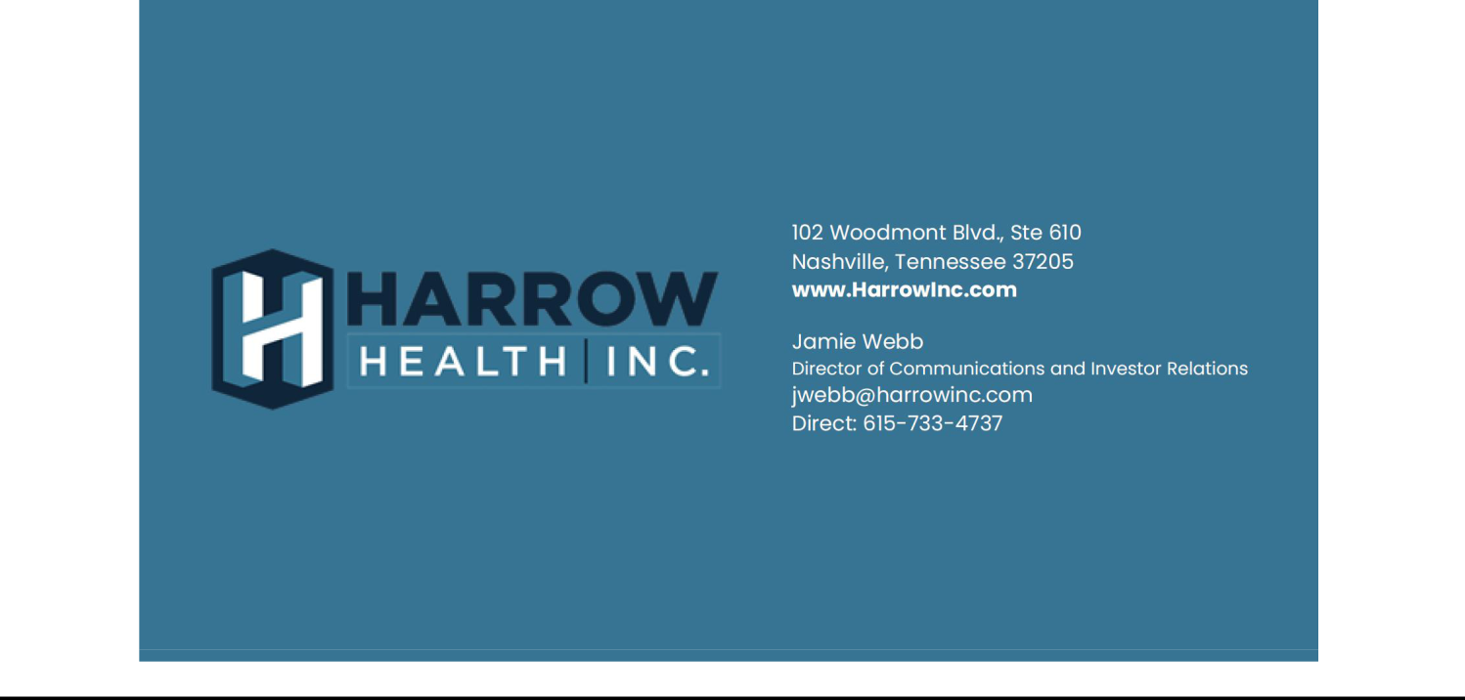

Exhibit 99.2


